Listening Speaking Reading Grammar Writing
Topic: Make Your Own Inventions

Instructor:  Gowoon | Students Competency Level  Intermediate | Number of Students:  12 | Lesson Length:  60 minutes
Materials: (List the Names of all materials used in the lesson. Materials must be shown at the end of this document)
- White Board and Markers
- “Speaking Aid” Worksheet
- Large paper
- Paper Money
Aims: (What students will be able to achieve by participating in the activities of the lesson. (Ss gain or get by doing…)
- Improve speaking skills by responding to teacher, discussing within a group and presenting to the class.
- Improve listening skills by listening to teacher and their peer.
- Improve writing skills by making up an advertisement on their worksheet
- Improve logical thinking by breaking down their thoughts and solving problems step by step
- Improve communication and interaction skills by having a discussion in a group
- Learn words and phrases used in advertising
Language Skills: (Lists what activities language skills students will be using by participating in the activities of the lesson.)
- Reading: (Where did reading occur in the lesson?)
Instructions on “Speaking Aid” worksheet
- Listening: (Where did listening occur in the lesson?)
Teacher talking, discussion, presentation
- Speaking: (Where did speaking occur in the lesson?)
Answering teacher, discussion, presentation
- Writing: (Where did writing occur in the lesson?)
Notes, writing an advertisement on invention
Language Systems: (Lists what language systems students will be using by participating in the activities of the lesson.)
- Phonology: (sound)
Discussion, teacher talk.
- Function: (situation)
Advertising
- Lexis: (meaning)
Vocabulary about inventions and advertising
- Grammar: (language structure)
Description, Persuasive speaking
- Discourse: (communication)
Discussion, responding to the teacher, Presenting
Assumptions: (What students must already be able to do and what concepts must already be mastered before the lesson in order to achieve the aims of the lesson.)
- All Ss know ‘Thomas Edison’ and why invention takes place.
- All Ss are able to come up with creative ideas.
- All Ss can act as an advertiser.
- All Ss understand how bidding works.
Anticipated Errors and Solutions: (What things might go wrong in the lesson and what the solution will be. An SOS activity should also be included)
- If Ss may not have many ideas. → Solution: T gives them little examples.
- If activity takes too long. → Solution: T cuts unnecessary parts.
- If activity finishes too soon. → Solution: T makes suggestions and shares ideas.
- If certain Ss are shy. → Solution: T encourages them, gives positive feedback, and give them minimum role and presenting.
- If Ss do not know some words. → Solution: T shares new words as a class.
References:

Lead-In or Pre-Task Part (Warm-Up Part to activate and create interest in the lesson.)
Materials: (List the Names of all materials used in the Lead-In or Pre-Task Part of the lesson. Materials must be shown at the end of this document)
- White Board and Markers
Time: | Classroom Set Up: | Student Activity and Goals: | Teacher Procedure & Instructions:
1 min  1 min  3 min  3 min | Whole  Whole  Whole  Whole | Ss greet the teacher.  Ss listen to the teacher and guess the topic.  Talk about their background knowledge and opinions  Ss listen to T says | Greeting.  Elicit the topic ‘Inventions’ from students by introducing a famous quote from ‘Thomas Edison’.  Talk about Thomas Edison’s inventions and Ask Ss why invention is useful and how it takes place  Take Thomas Edison’s invention as an example and break down into ‘Noticing a problem’, ‘Ideas to solve the problem’ ‘How it works’

Pre-Activity or Task Familiarization Part (Presentation Part Presenting the language structure to be covered in the lesson. Prepares students for the communication activity.)
Materials: (List the Names of all materials used in the Pre-Activity or Task Familiarization Part of the lesson. Materials must be shown at the end of this document)
- White Board and Markers
- “Speaking Aid” Worksheet
- Large paper
Time: | Classroom Set Up: | Student Activity and Goals: | Teacher Procedure & Instructions:
5min  1min  1min  2min  10min | Whole/Ss  Group  Group  Group  Group | Ss listen to and answer T’s questions  Ss move into group  Ss listen T’s explanation and pick up a problem. Make notes.  Ss listen to T.  Ss prepare for presentation  Draw pictures of their  invention and make  notes for advertisement | Ask Ss what difficulties or inconvenience they have in everyday life and write down on board. List Ss suggestions on the board.  Divide Ss into 3 groups  Explain the activity. As a group, pick one ‘problem’ on the board and come up with a solution and make an advertisement.  T teaches some useful phrases for presentation and give out worksheet.  T monitors Ss’ discussion and assists if they have difficulty. T Encourages Ss and facilitates.

Main Activity or Task Realization Part (Practice to Production Part Teacher lead practice of the language presented and move to communication based more student centered activity)
Materials: (List the Names of all materials used in the Main Activity or Task Realization Part of the lesson. Materials must be shown at the end of this document)
- White Board and Markers
- Large paper
Time: | Classroom Set Up: | Student Activity and Goals: | Teacher Procedure & Instructions:
1min  3X  5 min  (15min altogether)  3 min | Whole  Groups  Groups  Whole | Ss get ready for PT  * happens 3 times  Ss do activity. One group  at a time, other groups  watch, listen  Ss listen to what T says.  Ss applaud other Ss. | T gives instruction for each group to come to front and present. T encourages Ss to enjoy presentation and starts it.  * happens 3 times  T monitors Pt. Gives encouragement to each group and facilitates class feed back to the presenting group.  Give Ss positive feedback, and comments. Facilitates class members’ feedback

Post Activity or Post Task Part (Wrap-Up Part Close the Lesson on a high note to and consolidate language learned in a communication based activity new situation.)
Materials: (List the Names of all materials used in the Post Activity or Post Task Part of the lesson. Materials must be shown at the end of this document)
- Paper Money
Time: | Classroom Set Up: | Student Activity and Goals: | Teacher Procedure Instructions:
1min  4min  (12mins altogether)  2min | Group  Ss  Whole | Listen to T and receive paper money.  * Happens 3 times  S from one group comes to the front and sells their product and others participate in bidding.  Ss receive award and listen. | Give 3 groups paper money and put all the inventions into auction.  * Happens 3 times  Pick 1 (all 3) from each group as the action seller. T observes, encourages Ss.  Reward the winner group and show appreciation for participation. Close by giving Ss feedback about their accomplishment and improvement

“Speaking Aid” Worksheet
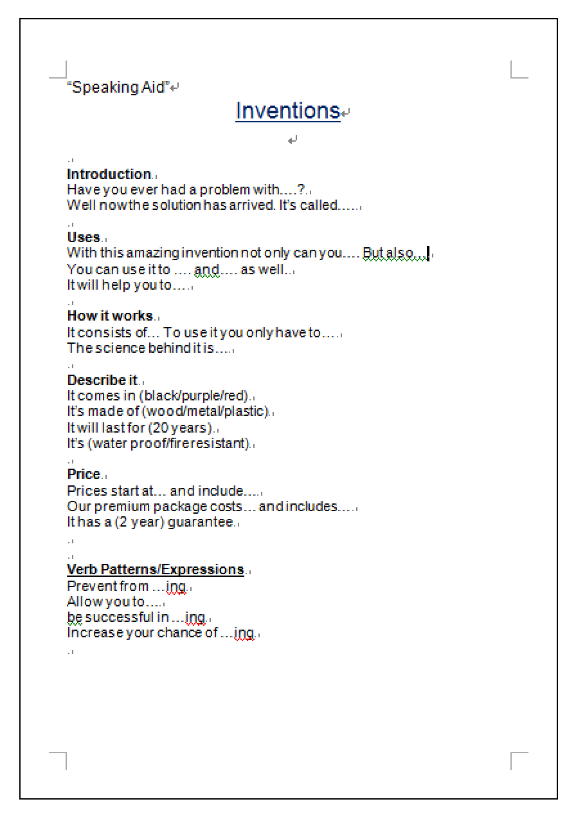

Paper Money





