☐Listening ☐Speaking ☐ Reading ☐ Grammar ☐ Writing
Topic: What is the Most Expensive Coffee in the World?

Instructor:  Julie/Euna | Students Competency Level Intermediate | Number of Students: 10 | Lesson Length:  50 minutes
Materials: (List the Names of all materials used in the lesson. Materials must be shown at the end of this document)

Computer/Screen Projector
White Board and Markers
“What is True or False about Coffee” Worksheet
“The World’s Most Expensive Coffee!” Article
“What We Learned Today?” Worksheet
The Beverage Images
The Coffee Images
The Civet Images
The Luwak Coffee Images

Aims: (What students will be able to achieve by participating in the activities of the lesson. (Ss gain or get by doing…)

The students will be able to learn new vocabularies of “The World Most Expensive Coffee” article
- The students will be able to improve their reading skills by reading “The World’s Most Expensive Coffee” article
- The students will build up their own idea based on given a question after reading “The World’s Most Expensive Coffee” article
- The students will learn and become comfortable to express their own opinion in a group discussion about a given question

Language Skills: (Lists what language systems students will be using by participating in the activities of the lesson.)

- Reading: The students will “The World’s Most Expensive Coffee” article
- Listening: The students listen to other students’ opinion through a group discussion
- Speaking: The students will speak true or false about the facts about coffee and discuss their ideas to support their opinion
- Writing: The students write their thought on their own note before a group discussion and “What You Learned Today” Worksheet
Language Systems: (Lists what language systems students will be using by participating in the activities of the lesson.)

- Lexis: Learning new vocabularies of “The World’s Most Expensive Coffee” article
(Acidity, Enzymes, Civet-ogling)
- Function: Convincing others (Civets can be a good resource for Indonesians or they should protect civets?)
- Discourse: A group discussion
Assumptions: (What students must already be able to do and what concepts must already be mastered before the lesson in order to achieve the aims of the lesson.)

- The students are actively participating in the class
- How the class is set up and run (Ss will sit with their partners for pair work)
- The teacher’s teaching style and the pace of the course
- Four language skills(Listening/Reading/Grammar/Speaking)
Anticipated Errors and Solutions: (What things might go wrong in the lesson and what the solution will be. An SOS activity should also be included)

- The students may need more time to complete a group discussion
→Skip the last step of sharing “what we learn today”
(if necessary, assign for homework)
- The students may finish their tasks earlier than anticipated
→Share their answers or ideas with a different partner
- The students may not know the answers to questions
→Ask different students for the answer, encourage students to be creative and expressive
- If the students do not want to participate in class
→Ask a few questions regarding the topic so that they can pay attention to the class better
- Students who don’t understand in lesson or wrong answer
→Encourage them that they can do it
References:
Breaking News English: http://www.breakingnewsenglish.com/1511/151119-coffee-5.html
http://news.nationalgeographic.com/2016/04/160429-kopi-luwak-captive-civet-coffee-Indonesia

Lead-In or Pre-Task Part (Warm-Up Part to activate and create interest in the lesson.)
Materials: (List the Names of all materials used in the Lead-In or Pre-Task Part of the lesson. Materials must be shown at the end of this document)

Computer and Screen Projector
The Beverage Images
The Coffee Images

Time: | Classroom Set Up: | Student Activity and Goals: | Teacher Procedure & Instructions:
3mins  3mins | Whole class | Listen to/answer teacher’s questions  Look at the images and listen to a teacher | Step1: Show “The Beverage Images (that includes coffee)” with a screen projector  Step2: Lead in student’s attention by asking “What types of beverages do you drink most?”  Step3: Show “The Coffee Images” with the screen projector  Step4: Talk about Teacher’s story about Coffee
Pre-Activity or Task Familiarization Part (Presentation Part Presenting the language structure to be covered in the lesson. Prepares students for the communication activity.)
Materials: (List the Names of all materials used in the Pre-Activity or Task Familiarization Part of the lesson. Materials must be shown at the end of this document)

Computer and Screen Projector
“What is True or False about Coffee” Worksheet

Time: | Classroom Set Up: | Student Activity and Goals: | Teacher Procedure & Instructions:
3mins  2mins  5mins | Individual  Whole  Class  Whole  Class | Guess true or false about facts of Coffee  Answer teacher’s questions  Guess the meaning of the vocabularies | Step1: Hand out “What is True or False about Coffee” Worksheet to Students Step2: Let students have 3-4minutes to think about answers  Step3: Show “What is True or False about Coffee” question image and Share answers  Step4: Show Key vocabularies (Civet, Digestive Enzymes, Acidity) for “The World’s Most Expensive Coffee!” Article  Step5: Let students guess the meaning of the vocabularies

Main Activity or Task Realization Part (Practice to Production Part Teacher lead practice of the language presented and move to communication based more student centered activity)
Materials: (List the Names of all materials used in the Main Activity or Task Realization Part of the lesson. Materials must be shown at the end of this document)

“The World’s Most Expensive Coffee!” Article
Computer/Screen Projector

Time: | Classroom Set Up: | Student Activity and Goals: | Teacher Procedure & Instructions:
2mins  5mins  7mins  5mins  10mins | Whole class  Individual  Whole class  Whole  Class | Listen to/answer teacher’s questions  Read the article  Discuss the question with group members  Present their opinion and raise an objection if they disagree with other group’s opinion | Step1: Ask guiding questions  - Do you know what the world’s most expensive coffee is?  Kopi Luwak  - Do you know how much it is? $ 80, a cup of coffee in USA>  - Do you have any idea how to make the coffee?  it is made from cat’s poop>  Step2: Students are going to read “The World’s Most Expensive Coffee!” Article  Step3: Reading Exercise  - Coffee beans are partially digested and then pooped out by the civet, a _________ creature. <catlike>  - the civets eat ____________, _____________________,____________ in the wild life. < insects, small reptile, fruit like coffee cherries and mangoes>  3. In Indonesia, the civet, which raids commercial fruit farms, is often seen as ____.  <a pest>  Reading exercise (2)  - How the kopi luwak changed, after the civet digestion? <their digestive enzymes change the structure of proteins in the coffee beans, which removes~coffee>  - Why the coffee farmer confine the civet in a cage? < 1. get kopi luwak beans /2. get money from tourists who want to come and see the civet>  Step4: Put 3 students into a group and they are going to discuss the question “Civets can be a good resource of income for Indonesians but many farmers are uneducated on how to care for civets so they end up in dead or fight or gnaw at their own limbs due to mental distress and illness how we can solve the problem?”  Step5: Share their ideas

Post Activity or Post Task Part (Wrap-Up Part Close the Lesson on a high note to and consolidate language learned in a communication based activity new situation.)
Materials: (List the Names of all materials used in the Post Activity or Post Task Part of the lesson. Materials must be shown at the end of this document)

“What We Learned today?” Worksheet

Time: | Classroom Set Up: | Student Activity and Goals: | Teacher Procedure Instructions:
2mins  3mins | Individual | By sharing what they learn in the class, reinforce their reading skill after the activity. | Step1: After the group discussion, give students the worksheet and let them fill out what they learned in the class,  - could be vocabularies/expression/etc.  Step2: By sharing what they learned in the class today, reinforce their language skills

Materials

The Beverage Image
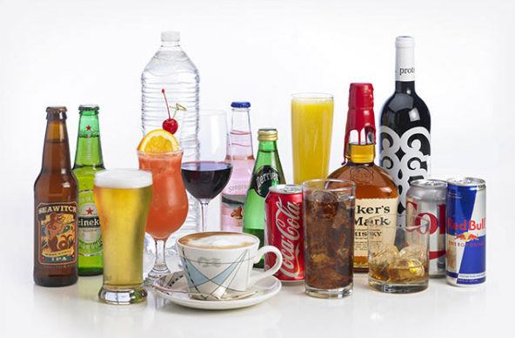
The Coffee Image

“What is True or False about Coffee” Worksheet

- Coffee is the second most traded product in the world after petroleum. - T/F(T)
- America is the largest coffee-producing nation, accounting for 40 per cent of total world output. -T/F (F: Brazil)
- Fair trade coffee is cheaper than multi-national coffee companies - T/F (F: more expensive to help the poor coffee farmer)

“What is True or False about Coffee” Worksheet

There is good news for coffee lovers. A new report claims that regular coffee drinkers may live longer than those who do not drink coffee. Researchers say there is growing evidence that coffee benefits the health, makes you live longer, and reduces the risk of heart disease, type 2 diabetes, other life-threatening illnesses, and even suicide. The study was published by the American Heart Association. It looked at the coffee-drinking habits of over 200,000 people who drank between one and five cups of coffee a day. Researcher Dr Frank Hu said: "This study provides further evidence that moderate consumption of coffee may confer health benefits in terms of reducing premature death due to several diseases."

TRUE / FALSE: Read the headline. Guess if a-d below are true (T) or false (F).
a. | The article says there is good news for all lovers. | T / F
b. | Research suggests coffee can reduce the risk of type 2 diabetes. | T / F
c. | Researchers looked at more than 200,000 coffee drinkers. | T / F
d. | Researchers say coffee can reduce levels of premature deaths. | T / F

“The World’s Most Expensive Coffee!”

It’s the world’s most expensive coffee, and it’s made from poop. Or rather, it’s made from coffee beans that are partially digested and then pooped out by the civet, a catlike creature. A cup of kopi luwak, as it’s known, can sell for as much as $80 in the United States.

Found in Southeast Asia and sub-Saharan Africa, the civet has a long tail like a monkey, face markings like a raccoon, and stripes or spots on its body. It plays an important role in the food chain, eating insects and small reptiles in addition to fruits like coffee cherries and mangoes, and being eaten in turn by leopards, large snakes, and crocodiles.

At first the civet coffee trade boded well for these creatures. In Indonesia, the Asian palm civet, which raids commercial fruit farms, is often seen as a pest, so the growth in the kopi luwak industry encouraged local people to protect civets for their valuable dung. Their digestive enzymes change the structure of proteins in the coffee beans, which removes some of the acidity to make a smoother cup of coffee.

But as civet coffee has gained popularity, and with Indonesia growing as a tourist destination where visitors want to see and interact with wildlife, more wild civets are being confined to cages on coffee plantations. In part, this is for coffee production, but it’s also so money can be made from civet-ogling tourists.

“The Kopi Luwak Coffee Making Process” Worksheet
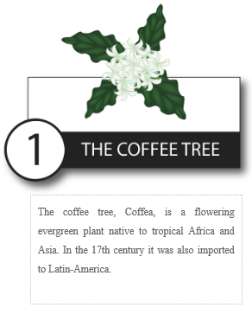 | 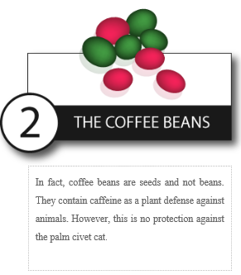 | 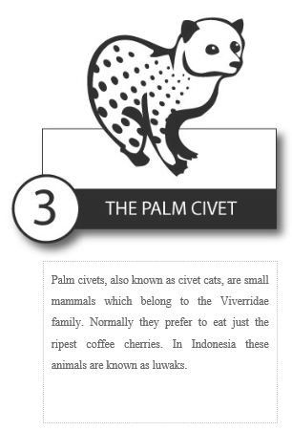
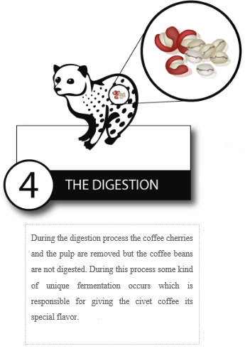 | 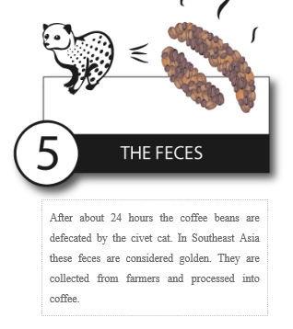 | 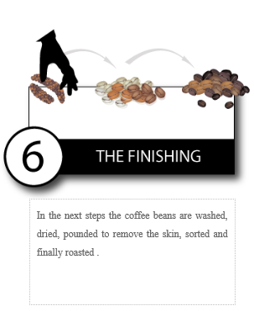

The Civet Images
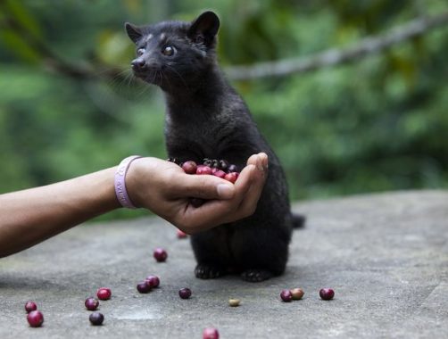
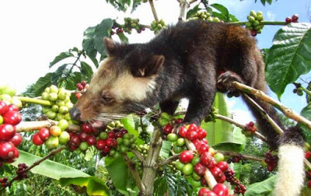
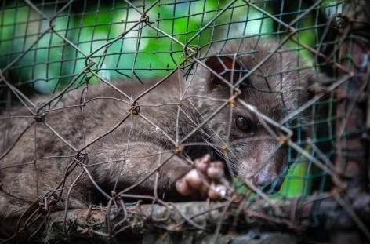

The Luwak Coffee Images

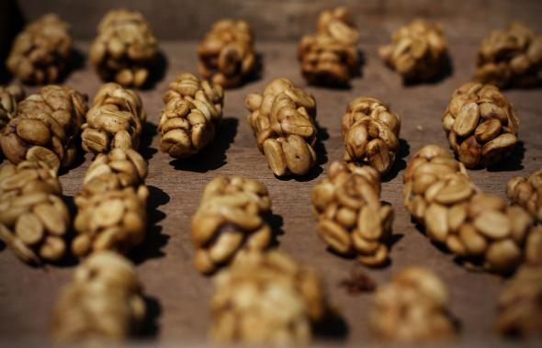

“The World’s Most Expensive Coffee!” Reading Exercise” Worksheet

Please fill in the blank after reading the article

1. Coffee beans are partially digested and then pooped out by the civet, a __ creature.
2. the civets eat ____________, _____________________,__________ in the wild life.
3 . In Indonesia, the civet, which raids commercial fruit farms, is often seen as ____.
4. How the kopi luwak changed, after the civet digestion?
5. Why the coffee farmer confine the civet in a cage?

Please discuss this problem with your group member

“Civets can be a good resource of income for Indonesians but many farmers are uneducated on how to care for civets so they end up in dead or fight or gnaw at their own limbs due to mental distress and illness how we can solve the problem?”

