|  |  |  |  |
| --- | --- | --- | --- |
| √ Listening  Speaking  Reading  Grammar  Writing | | | |
| **Topic: How to eat-well in consideration of nutrients** | | | |
| Instructor:  MIN JEONG KIM  (Jen) | Level:  **Intermediate(Adult)** | Students:  **12 students** | Length:  **30 Minutes** |

|  |
| --- |
| Materials:  ● Realia: the pictures of Eatwell Guide(12copies)  ● White board and board markers  ● Fill in the blanks worksheet #1 Nutrition Song (12copies)  ● Q&A worksheet #2 (12copies)  ● Draw your plate worksheet #3 (12 copies)  ● Computer for playing YouTube video clips |

|  |
| --- |
| Aims:  ● Main aim: Students will be able to improve their listening skills by the song about nutrition.  ● Secondary aim: Students will be able to talk and share different eating habit.  ● Personal aim: I want them to know the importance of nutrition and have a good eating habit. |

|  |
| --- |
| Language Skills:  ● Reading: Students will read the lyrics of nutrition song  ● Listening: Students will listen to the nutrition song  ● Speaking: Students will discuss “What nutrition we need and how to eat healthy  ● Writing: Students will take notes on lyrics and their opinions |

|  |
| --- |
| Language Systems:  ● Phonology: starch [tʃ], protein[iː], carbohydrate [eit]  ● Lexis: New vocabulary in the song  ● Function: request  ● Grammar: present progressive  ● Discourse: song and students’ opinions |

|  |
| --- |
| Assumptions: Students already know  ● How the class is set up and run(there will be 3-4 students at each table)  ● Four language skills and language systems  ● Difference understanding of nutrients and eating habit |

|  |
| --- |
| Anticipated Errors and Solutions:  ● If Students need linguistic help to express their opinions during discussion  - give them linguistic support by providing definitions and some examples.  ● If some students keep quiet for fear of upsetting other people during discussion – encourage them to speak and advise them to be clear about their point  ● If certain students dominates the discussion  - ask them to give other students a chance to speak |

|  |
| --- |
| References:  ● English definitions:[http://www.dictionary.com](http://www.dictionary.com/)  ● Visual aid: Listening File & Script  <https://www.youtube.com/watch?v=6fhSGWdbm9g>  [https://www.youtube.com/watch?v=KBI_fiFxKAs](%20%20%20https://www.youtube.com/watch?v=KBI_fiFxKAs) |

|  |  |  |  |
| --- | --- | --- | --- |
| **Lead-In** | | | |
| Materials: None | | | |
| Time | Set Up | Student Activity | Teacher Talk |
| 1min | Whole class | Answering teacher’s questions | Good morning! How are you today?  Do you know about nutrition?  Are you eating meals in consideration of nutrition?  What do you think about how to eat healthy? |

|  |  |  |  |
| --- | --- | --- | --- |
| **Pre-Activity** | | | |
| Materials: Board, Board makers, Visual Aid | | | |
| Time | Set Up | Student Activity | Teacher Talk |
| 3min | Whole class | Answering teacher’s questions | Procedure:   1. Brainstorming   Elicit  (Show the students visual aid-picture)  There are Eatwell guide in the picture.  How many food groups are there?  What foods are there in each group?  Additional explanation  This Eatwell Guide is to help you get a balance of healthier and more sustainable food. It shows how much of what you eat overall should come from each food group.  Model  Write the subject “How to eat healthy in consideration of nutrition” on the board  CCQ  What do you think is most important for your health?  What kinds of nutrients are there?  How does nutrition function in our body?  Do you have a eating healthy habit? |

|  |  |  |  |
| --- | --- | --- | --- |
| **Main Activity** | | | |
| Materials: computer for listening, song(video clip), worksheet#1 | | | |
| Time | Set Up | Student Activity | Teacher Talk |
| 2min  10min  2min | individually  Partner | Students understand the function and importance of nutrition in their body by related song  Listening & watching  Students check answers. | 1. Prediction   “As I mentioned, today’s topic is how to eat healthy in consideration of nutrition.  We can know how to eat healthy by this. We have to eat meals balanced with each group like this picture.  Then which food should we eat the most?  What foods should be avoided?  There is a nutrition song. We will learn about nutrition by listening to the song.  Instruction  “I will give you a worksheet before listening. We can overview by this worksheet. Fill in the blanks by guessing with your partner while listening.  I’ll play this video clip twice.  (Distribute the worksheet #1)  ICQ  Are you working in pairs?  Do you guess the words in the blanks?  Do you know about the function of nutrition?  Is it easy to fill in the blanks?    “OK, everybody, the time is up. I think you are doing well. Then let’s listen to the song and check the answers. See if your prediction is right or wrong.   1. Watching the video clip   Instruction  “Let’s watch the video listening carefully. There are lyrics in the video. Find answers and fill in the blanks perfectly.  ICQ  Can you fill in the blanks listening once?  What is the title of song we will listen?  (Play the listening video clip without pausing or stopping)  Check answers  “Now, check your vocabulary in the blank by yourself”  Check answers with teacher |

|  |  |  |  |
| --- | --- | --- | --- |
| **Post Activity** | | | |
| Materials: Computer for listening, Worksheet #2 | | | |
| Time | Set Up | Student Activity | Teacher Talk |
| 10min  3 min | Group  Whole class | Students in groups talk about the discussion topic after watching a video clip  Answers elicited questions of today’s | 1. Free production  (Discussion and speech)  Instruction  “Now, I will show another video clip about how to create a healthy plate. After watching, we will have discussion in three groups. Each group will discuss ”What’s your eating habit?  Do you think you eat balanced foods? What nutrients do you think is insufficient for you? “  (Distribute the worksheet #2)  ICQ  Are you working in groups?  What do you need to discuss?  Do you need a writer and a reporter to present?  “Let’s begin”  Monitoring  Monitor discreetly. Answer students if they ask questions  Feedback  “it is time to listen to each group’s reporter about their discussions. Please stand up and report your opinions. Speak loudly and clearly.  Other students have to pay attention to the reporter“  3. Conclude Lesson  Summarize today’s lesson by checking new vocabulary and the answers in the worksheet. Then do error correction about grammar and pronunciation during discussion and speech.  “ You did the great job today. Please remember what we learned today and thank you for participating in class and have a good day.” |

|  |  |  |  |
| --- | --- | --- | --- |
| **SOS Activity** | | | |
| Materials: Worksheet #3 | | | |
| Time | Set Up | Student Activity | Teacher Talk |
| 5min  3min | individually | Students draw my plate with balanced food  Students explain their drawings in rotation | Draw my plate with balanced food  Instruction  “ Now, we’ve learned about nutrition and how to eat rightly. Then draw my plate before and after this class.  How is your plate with foods going to be changed?  Work individually please.  (Distribute the worksheet #3)  ICQ  Do you feel the need you change the eating habit?  What changes does a good eating habit make for you?  Explain the picture  “ Are you all done? Then let’s explain each drawing about eating habits of present and future within 1 min” |

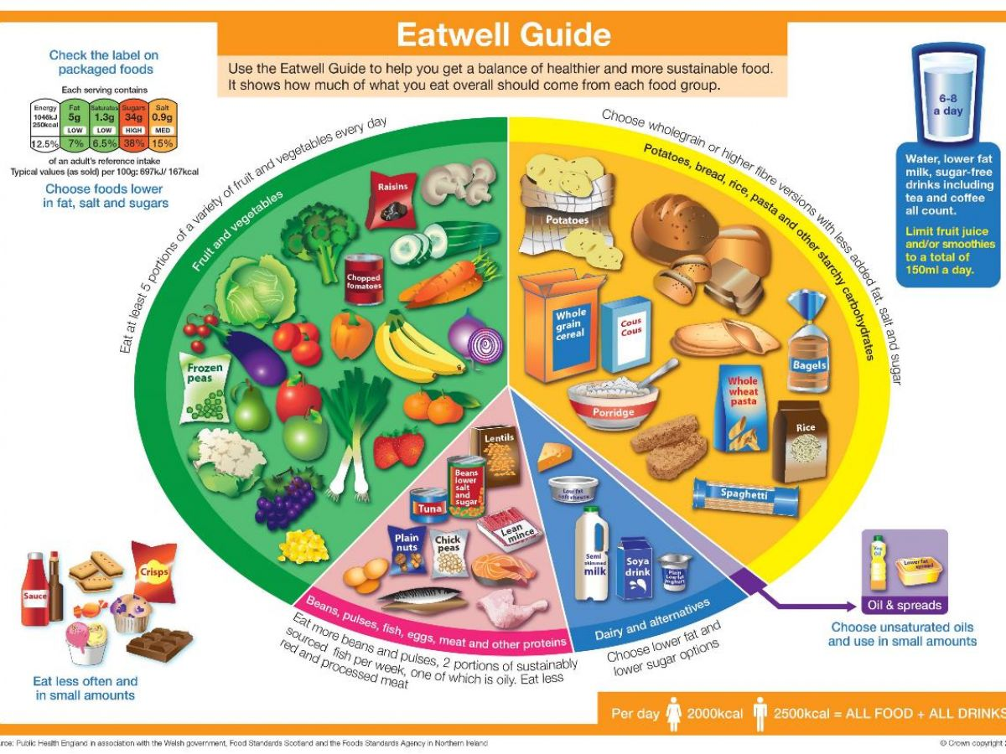**● Visual Aid**

**● Worksheet # 1 (Nutrition Song)**

It's just food and diet

Keep you healthy tonight

You're not along in this fight

We're talking 'bout nutrition, yeah

, , fats are called nutrients

Add accessory foods (repeat)

Something 'bout sugar

,

Giving energy

Break down digestion

is the name

Energy producing

Liver stores it up

Yeah your body needing

Growth and repair

Body tissue better

Other vital jobs

Make your body grow stronger

When you're eating meat, fish, and nuts

It's a fact

simple chemicals called amino acids

I can see your body needs warmth

Storing energy up in there

Your body counting up the fat

Still storing it holding

Up in places under skin

Right how body really keeping hold it

Hanging on till it needs it later

These fats coming in two types

fats and

(repeat)

We're talking 'bout nutrition, yeah

We're talking 'bout nutrition, yeah

Next up Part of accessory

Health diet giving body all its needing

Cause they're chemical or organic

Contains , fifteen kinds you’re having

They're not only important

They are needed for life

Now inorganic like , Sodium, iodine

Twenty different minerals to grow up higher

in here

find it in bran

Intestines counting on this bulk

Still squeezing it downhill

Cause it helps push out the waste

Right now intestines need a soldier

Helping the food out through

Assisting to get rid of waste

to survive, cause the...

(repeat)

You'll feel the way you feel

From the food and your diet

Well this is from the healthy foods your body needs

Nutrients and accessory

Helping body work properly

, fats, (nutrients for ya)

and (these are accessory)

It’s just food and diet (nutrients, accessory)

It’s just food and diet (they're right here for you)

We're talking 'bout nutrition

**● Worksheet # 2 (Q & A)**

1. What’s your eating habit?

2. Do you think you eat balanced foods?

3. What nutrients do you think is insufficient for you?

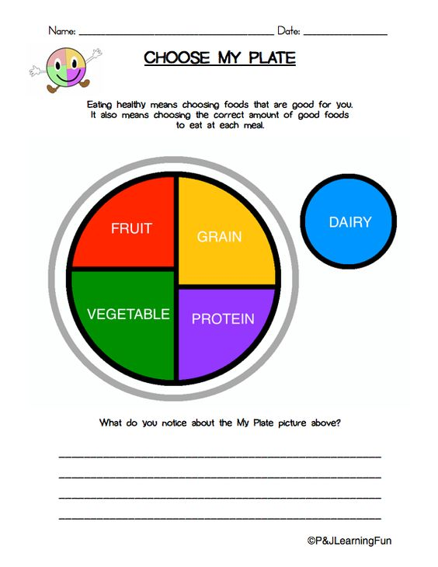

**● Worksheet #3(The change of my eating habit : Draw my plate with foods) ↓**