Listening Speaking Reading Grammar Writing

Topic: Past experience discussion using “Have you ever…?” and “Never have I ever”

Instructor:  Sophie Kim | Level:  Intermediate(Adult) | Students:  12 Students | Length:  30 Minutes

Materials:
- Realia: The pictures of 10 must go places in the world
- White board and board markers
- Worksheet #1: Vocabulary worksheet (12 copies)
- Worksheet #2: Before-listing and post-listening worksheet (12 copies)
- Worksheet #3: Fill-in-the-blanks worksheet (12 copies)
- Computer for video files

Aims:
- Main aim: Students will be able to improve their listening skills by listening to and understanding the topic in the video.
- Secondary aim: Students will be able to ask and answer their past experiences.
- Personal aim: I want to speak clearly in front of the students and manage my time well in each section.

Language Skills:
- Reading: Students will read scripts for each topic.
- Listening: Students will listen to the video about the Never Have I ever game
- Speaking: Students will ask and answer “Have you ever…?”and “Never have I ever”
- Writing: Students will write down vocabularies and phases from the video

Language Systems:
- Phonology: V pronunciation for never and ever / have I = [hae va]
honked [hɔ́ŋkt] / thrown [θróun] / touched [[tʌtʃt]
- Lexis: new vocabularies from the video
impersonate, expiration date, trap, Frisbee, circle back,
jaywalk, witness, cabin, maniac, honk
- Function: question (asking)
- Grammar: negative statement, present perfect, past participle
- Discourse: script

Assumptions:
- How the class is set and run (U-shaped seating arrangement)
- Four language skills and language systems
- Students have different travel experiences

Anticipated Errors and Solutions:
- If students need linguistic help to express their opinions during discussion
give them linguistic support by providing definitions and some examples
- If some students keep quiet for fear of upsetting other people during discussion
encourage them to speak and advise them to be clear about their point
- If certain students dominate the discussion
ask them to give other students a chance to speak

References:
- English definitions: Vocabularies and past participles
www.dictionary.com
www.merriam-webster.com
- Visual aid: Top 10 lists you must go before you die from Gayot
http://www.gayot.com/Travel/Attractions/Top-10-Lists/World-s-Best/Bucket-List-Destinations
- Visual aid: Video files and scripts from Big Bang Theory
https://www.youtube.com/watch?v=XUMEvSp95LY
https://www.youtube.com/watch?v=9bx08yTckk4

Lead-In
Materials: None
Time | Set Up | Student Activity | Teacher Talk
1 min | Whole class | Answering teacher’s questions | Good morning, everyone! How are you today? Where is your favorite travel place? Where have you visited in Korea and other countries?

Pre-Activity
Materials: Board, Board makers, Visual Aid, Worksheet #1
Time | Set Up | Student Activity | Teacher Talk
3 min  4 min  2 min | Whole  class  Pairs | Answering teacher’s questions.  Students answer ICQ questions.  Students write down answers and work in pairs  Students check answers. | Procedure:  1. Warm-up activity  Elicit  (Show the students visual aid-picture of the travel lists)  “There are 10 travel places in the picture. Where have you been? Where and why do you want to go?”  Additional explanation  “This is the 10 must-see travel destinations in the world before you die from the travel website, Gayot.”  “Do you agree? Do you want to add other places?”  Model  Write down the subject “My past experiences” on the board.  “Today, we are going to discuss the past experiences”  CCQ  How can we ask their personal experiences to others?  If you have not done something, how would you answer it?  When do you want to ask the experiences?  What can we learn from the partner by asking “have you ever been” questions?  2. New vocabulary  Instruction  “Today, we are going to watch the video clip from the American TV series Big Bang Theory. Before we watch, let’s go over the vocabulary list first.”  (Distribute the worksheet #1)  “Does everyone get a worksheet #1? For the first question, read the definitions of words and match the correct word from the box below.  Then, for the second question, you need to write down the past participles of the verbs.  After finishing filling in the blanks by yourself, work together with your partners. I will give 4 minutes to finish”  Demonstration  “Look at the worksheet, we will do the first one together”  “What is ….? Right. It means …”  “What is ….? Right. The past participle of …”  ICQ  What do you write in the blanks?  Who are you working with after doing your work?  How much time do you have?  “Okay. Let’s get it started”  Monitoring  Monitor discreetly by walking around the class. Get close to students. Listen and answer to students if they ask questions.  Give time warning:  1 minute; 30 seconds left  (Be flexible with time. Give 1 more minute if they need it.)  “Time’s up”  Check answers  “Let’s check the answers together.”  After checking the answers, do complement.

Main Activity
Materials: Video file for listening, Worksheet #2, Worksheet #3
Time | Set Up | Student Activity | Teacher Talk
2 min  4 min  4 min  5 min | Pairs  Individually  Individually  Whole class | Students ask questions from the worksheet #2 to their partner.  Students answer ICQ questions.  Watching and listening to the first video file (1:53 min)  Filling in the blanks in the worksheet  Students answer ICQ questions.  Watching and listening to the second video file  (1:24 min)  Filling in the blanks in the worksheet  Students check answers together | 1. Before-listening activity  “As I mentioned, we are going to learn about the experiences today.”  Instruction  I will give you another worksheet before listening. With your partners, ask 3 questions from the worksheet about their experiences. Share your experiences briefly. I’ll give you 2 min to finish.  (Distribute the worksheet #2)  ICQ  Are you working in pairs?  How many questions do we have?  How much time do you have?  “Okay, everyone. The time is up. You did very well.”  2. Listening for the main video files  Instruction  (Distribute the worksheet #3)  “Now, we are going to watch the video file from the Big Bang Theory. Listen carefully and fill in the blanks with the right words on the worksheet while watching and listening. Work individually please.”  ICQ  Do you fill in the gaps while listening or after listening?  Are you working in group?  (Teacher plays the video. Let students to fill the blanks while listening.)  “Let’s watch and listen one more time”  “Let’s watch the second episode and do the same thing again”  “Let’s watch and listen one more time”  Check answer  “Let’s check the answers  together. Let’s read the script loud together.”  (Go through all the answers in the worksheet #3)

Post Activity
Materials: Worksheet #2
Time | Set Up | Student Activity | Teacher Talk
3 min  2min | Group | Students in groups talk about the discussion topic  One person from each group will give a short speech  Answers elicited questions of today’s lesson | 1. Free production  (Discussion and speech)  Instruction  “Now, we will have discussion in four groups. Each group will discuss the personal experiences using two questions from the worksheet #2.  Please discuss post-listening activity questions. I will give you 3 minutes.”  ICQ  Are you working in groups?  What questions do you need to answer?  Monitoring  Monitor discreetly by walking around the class. Get close to students. Listen and answer to students if they ask questions.  Feedback  “Okay, everyone. Let’s select one person from each group and give a speech about their experiences”  2. Conclude Lesson  Summarize today’s lesson by checking new vocabulary and the contents in the text.  Then do error correction about grammar and pronunciation during discussion and speech.  “Everyone did the great job today! What have you done so far? What haven’t you done so far? Life is a long journey. Let’s try and do more experiences with a lot of courage!”

SOS Activity
Materials: Worksheet #3
Time | Set Up | Student Activity | Teacher Talk
4 min  4 min  4 min | Pair | Speak loudly by reading the script | 1.Speaking by role playing  Instruction  “We are going to practice the speaking from the script. Please work with your partner. Take each character and read each line loudly.”  (If you need more time)  “After finishing reading, change the role and read it again”  ICQ  How are you reading?  After finishing reading, what do you do?  “Okay. Let’s start”  Monitoring  Monitor discreetly by walking around the class. Get close to students. Listen to their pronunciation and give help if needed.  (If you need more time do following activity)  More Activity  “Let’s read it together”  Pick four people for each character from episode 1. Pick two people for each character from episode 2. Let students stand up and read it loud.  Conclude  “Great job, everyone. Please be careful of the following pronunciation. Do you want to play Never Have I ever game later? Have a good day!”

Visual Aid
1. Ankor Wat, Cambodia: World’s largest monument | 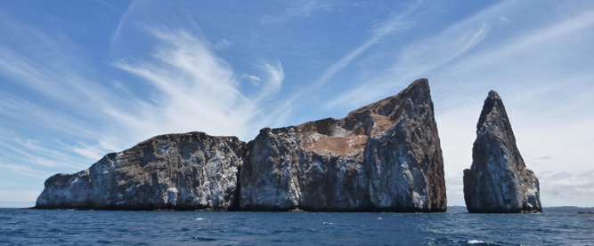  2. Galapagos Island, Ecuador: Wildlife-viewing islands
3. Grand Canyon, USA: North America’s greatest natural wonder | 4. Great Wall of China, China: The largest cultural relic human ever built
5. Iguazu Falls, Brazil: The largest water falls system in the world | 6. Machu Picchu, Peru: The sophisticated dry-stone walls from Incan
7. Pyramids of Giza, Egypt: The oldest and largest of the three Giza pyramids | 8. Taj Mahal, India: A tomb of Indian King Shah Jahan’s favorite wife
9. Teotihuacan, Mexico: Old Mexican city established around 100 BC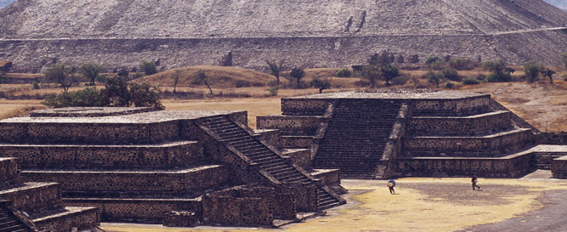 | 10. Uluru: An inspiring massive sandstone in Australia
Worksheet #1 Vocabulary
Fill in the blanks with the vocabularies in the box. Matching the definition.
1. _______________: the need to discuss an issue at a later time
2. _______________: to cross a street at a place other than regular crossing
3. _______________: to place in a restricted position or in a dangerous situation
4. _______________: a small wooden hut or house
5. _______________: an insane, mad, lunatic, or crazy person
6. _______________: to see, hear, or know by personal presence for an event or a fact
7. _______________: to pretend be a character or to act the character of
8. _______________: the last date that a product, as food, should be used before it is considered spoiled or ineffective
9. _______________: to cause an automobile (ex.car) horn to sound
10. ______________: a plastic disk for tossing and catching between game players
cabin impersonate Frisbee circle back honk
maniac witness jaywalk expiration date trap

Fill in the blanks with past participles of the verbs.
Present | Past | Past Participles
be | was/were
drink | drank
put | put
honk | honked
throw | threw
touch | touched
catch | caught
Worksheet #1 Vocabulary Answer
Fill in the blanks with the vocabularies in the box. Matching the definition.
1. circle back
2. jaywalk
3. trap
4. cabin
5. maniac
6. witness
7. impersonate
8. expiration date
9. honk
10. Frisbee

Fill in the blanks with past participles of the verbs.
1. be – was/were – been
2. drink – drank – drunk
3. put – put – put
4. honk – honked – honked
5. throw – threw – thrown
6. touch – touched – touched
7. catch – caught – caught

Worksheet #2 Before Listening / Post Activity

Before Listing Activity
Answer yes or no from the following sentences.
1. Have you played “Never Have I Ever” game? YES / NO
2. Have you honked when you are driving? YES / NO
3. Have you played Frisbee before? YES / NO
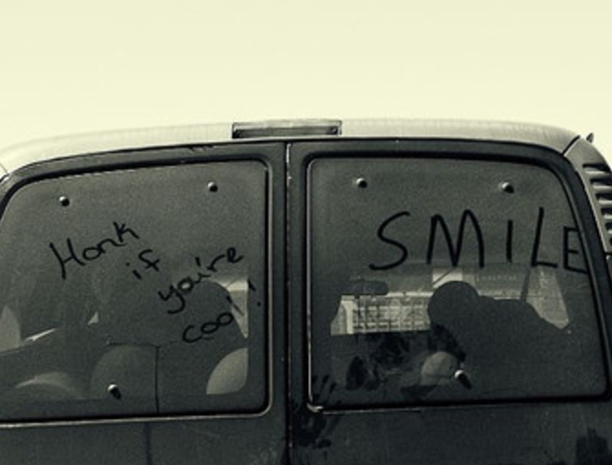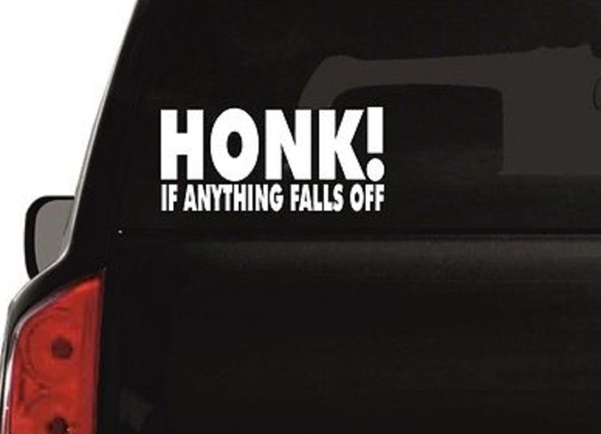

Post Listening Activity
Discuss following questions in the group.
Q1. Have you ever been to other countries? How was it?
A) I have been to ... It was …
Q2. What haven’t you never done? Why is that?
A) Never have I ever … Because …

Worksheet #3 Gap fill
Fill in the blanks while watching and listening to the Big Bang Theory episodes
Episode 1
Penny: Hey, do you guys want to play a drinking game?
Sheldon: Oh, well now, we will never win. You always play the drinking game.
Penny: Not _____ drinking game, ____ drinking game.
Leonard: To be ______, good at both.
Amy: What’s the game?
Penny: All right. It’s called _________ _______ ____ _____. The rules are simple. Someone says something they’ve never done, but if you ________ done it, you take a drink.
Leonard: I’ve never played that before.
Sheldon: Hey, now, wait. Have we started? Do I drink? What is happening?
Penny: Okay. Calm down. I’ll go first. Let’s see. Never _________ ____ ________
Amy: She is trying to think of something she has never done before. This could take a while.
Penny: Very funny. Okay. __________ ________ ____ _________Yeah, you know what? Let’s just _____________ ________.
Leonard: Okay. I’ll go. Never have I ever _______ ________.
Sheldon: So I drink?
Amy: No. It’s only if you’ve ___________ it.
Sheldon: Got it.
Amy: I can’t believe you’ve been _______________.
Sheldon: I can’t believe Penny ____________.
Penny: Sheldon, what did you do?
Sheldon: Well, I’m not proud of it but I _____________.
Leonard: Oh, no, it is like a horror movie. We’re _____________ in a cabin with a _____________.
Amy: I’m surprised you would do that.
Sheldon: No. I crossed in the middle of the street. And normally, I __________, but I saw an aggressive-looking Girl Scout, and that was the heart of cookie season. Anyway, there was a police officer. He _____________ the whole thing.
Penny: But he _____________ you for that?
Sheldon: No. he didn’t do anything. So I said, you just saw me jaywalk, why aren’t you doing your job? You know? May, maybe I should arrest you for, for ________________ a police officer.
Penny: And then you got arrested.
Sheldon: Oh, and how.

Episode 2
Sheldon: Oh, ___________ have I ever drunk milk past its _____________ _______.
Amy: Never ________ I ever cancelled a dentist __________________.
Sheldon: Oh, uh, never have ____ ever put my foot in the ocean.
Amy: Never have I ever _________ if I liked anything.
Sheldon: Oh, uh. Never have I ever __________, ___________, _________ a Frisbee.
Amy: Never have I __________ put salt on my food without trying it first.
Sheldon: Oh. Never have I ever ____________ all the buttons in an elevator.
Amy: Well, we all have a ____________.
Worksheet #3 Script Answer
Episode 1
Penny: Hey, do you guys want to play a drinking game?
Sheldon: Oh, well now, we will never win. You always play the drinking game.
Penny: Not the drinking game, A drinking game.
Leonard: To be fair, good at both.
Amy: What’s the game?
Penny: All right. It’s called Never Have I Ever. The rules are simple. Someone says something they’ve never done, but if you have done it, you take a drink.
Leonard: I’ve never played that before.
Sheldon: Hey, now, wait. Have we started? Do I drink? What is happening?
Penny: Okay. Calm down. I’ll go first. Let’s see. Never have I ever…
Amy: She is trying to think of something she has never done before. This could take a while.
Penny: Very funny. Okay. Never have I ever… Yeah, you know what? Let’s just circle back.
Leonard: Okay. I’ll go. Never have I ever been arrested.
Sheldon: So I drink?
Amy: No. It’s only if you’ve done) it.
Sheldon: Got it.
Amy: I can’t believe you’ve been arrested.
Sheldon: I can’t believe Penny hasn’t.
Penny: Sheldon, what did you do?
Sheldon: Well, I’m not proud of it but I jaywalked.
Leonard: Oh, no, it is like a horror movie. We’re trapped in a cabin with a maniac.
Amy: I’m surprised you would do that.
Sheldon: No. I crossed in the middle of the street. And normally, I wouldn’t, but I saw an aggressive-looking Girl Scout, and that was the heart of cookie season. Anyway, there was a police officer. He witnessed the whole thing.
Penny: But he arrested you for that?
Sheldon: No. he didn’t do anything. So I said, you just saw me jaywalk, why aren’t you doing your job? You know? May, maybe I should arrest you for, for impersonating a police officer.
Penny: And then you got arrested.
Sheldon: Oh, and how.

Episode 2
Sheldon: Oh, never have I ever drunk milk past its expiration date.
Amy: Never have I ever cancelled a dentist appointment.
Sheldon: Oh, uh, never have I ever put my foot in the ocean.
Amy: Never have I ever honked if I liked anything.
Sheldon: Oh, uh. Never have I ever thrown, caught, touched a Frisbee.
Amy: Never have I ever put salt on my food without trying it first.
Sheldon: Oh. Never have I ever pushed all the buttons in an elevator.
Amy: Well, we all have a past.

