Listening Speaking Reading Grammar Writing
Topic: Aesop’s Fables
Instructor:  Eve & Sarah | Students Competency Level  Pre-intermediate | Number of Students:  10 | Lesson Length:  65mins
Materials :(List the Names of all materials used in the lesson. Materials must be shown at the end of this document)
Before Reading Worksheet.
Whiteboards and Markers
The Town Mouse And The Country Mouse
After Reading Worksheet
Let’s Make a Story Worksheet
Group 1
Group 2
Cat Mask
Dog Mask
Mouse Mask
Mouse Mask
Aims: (What students will be able to achieve by participating in the activities of the lesson. (Ss gain or get by doing…)
- Improve speaking skills by storytelling, doing lead-in activity and answering teacher
- Improve self-planning skills by preparing for Ss’ storytelling.
- Activate, increase interest, and participate with fun in an English communication activity by sharing stories of teacher and students
- Improve listening skills by storytelling, doing lead-in activity and responding to teacher.
- Improve interaction and communication skills by doing lead-in activity with other students and discussion as a whole class.

Language Skills: (Lists what activities language skills students will be using by participating in the activities of the lesson.)
- Reading: (Where did reading occur in the lesson?)
The story, role play scripts
- Listening: (Where did listening occur in the lesson?)
Teacher talk, listening to other Ss’ role play, discussion
- Speaking: (Where did speaking occur in the lesson?)
Role play, class discussion, answering teacher, group discussion
- Writing: (Where did writing occur in the lesson?)
Notes, planning for role play
Language Systems: (Lists what language systems students will be using by participating in the activities of the lesson.)
- Phonology: (sound)
Role play, discussion, teacher talk
- Function: (situation)
Introduction, respect, dream
- Lexis: (meaning)
Vocabulary about creative writing (adjectives: describing the words)
- Grammar:(language structure)
Writing a script
- Discourse: (communication)
Discussion, responding the teacher, preparing role play

Assumptions: (What students must already be able to do and what concepts must already be mastered before the lesson in order to achieve the aims of the lesson.)
- All Ss understand the basis of role play and will enjoy planning the scripts.
- All Ss probably have thought about living in different environments.
- All Ss have opinions about pros/cons of living in different environments.
- All Ss have opinions about how to write a creative story.
- All Ss have some interests on Aesop’s Fables.
Anticipated Errors and Solutions: (What things might go wrong in the lesson and what the solution will be. An SOS activity should also be included)
- If Ss may not have many ideas.☞Solution: T gives them little examples
- If activity lasts too long ☞Solution: T cuts the unnecessary parts or shorten the task
- If activity finished too soon ☞Solution: T makes suggestions and shares ideas.
- If Ss may not understand ☞Solution: T shows demonstration
- If certain Ss are shy: ☞Solution: T encourages them, gives positive feedback, and helps presentation of them.
- If certain Ss makes negative feedbacks towards other Ss: ☞Solution: T warns them, stops them and finally punished them.
References:
http://www.pitt.edu/~dash/type0112.html#aesop
https://mrprintables.com/printable-animal-masks.html

Lead-In or Pre-Task Part (Warm-Up Part to activate and create interest in the lesson.)
Materials: (List the Names of all materials used in the Lead-In or Pre-Task Part of the lesson. Materials must be shown at the end of this document)
Before Reading Worksheet.
Whiteboards and Markers
Time: | Classroom Set Up: | Student Activity and Goals: | Teacher Procedure & Instructions:
1 min | Whole | Ss greet the T | Greeting
3 min | T | Ss listen what T says | Introduce what Aesop’s Fables using the famous quotes.
1 min | T | Ss listen what T says. | T hands out the worksheet and briefly explain about the worksheet.
5 min | Group | Ss discuss their opinions and write down. | Ss Discuss with their partner and write down the answers.
3 min | S-T | Ss share their opinions | Ask Ss to share their opinions.  Tip:. T should also ask Ss to share one of their group member’s opinion rather than his/her own opinion.

Pre-Activity or Task Familiarization Part (Presentation PartPresenting the language structure to be covered in the lesson. Prepares students for the communication activity.)
Materials: (List the Names of all materials used in the Pre-Activity or Task Familiarization Part of the lesson. Materials must be shown at the end of this document)
The Town Mouse And The Country Mouse
After Reading Worksheet
Whiteboards and Markers

Time: | Classroom Set Up: | Student Activity and Goals: | Teacher Procedure & Instructions:
1 min | T | Ss listen what T says | Introduce “The Story: The Town Mouse And The Country Mouse”
2 min | T-S | Ss listen what T says and answer to T | Discuss the key-phrases as a whole class  Key-Phrases:  - The town mouse rather turned up his long nose at this country fare.  - Better beans and bacon in peace than cakes and ale in fear.
5 min | Ss | Ss read the story | Hand out the story.  Tell Ss to read the story.
7 min | Group | Ss discuss their opinions | Hand out the After Reading Worksheet  Ask Ss to discuss in a group of 3~4 and write down their answers
3 min | S-T | Ss share their answers | Ask Ss to share their answers.

Main Activity or Task Realization Part(Practice to Production Part Teacher lead practice of the language presented and move to communication based more student centered activity)
Materials: (List the Names of all materials used in the Main Activity or Task Realization Part of the lesson. Materials must be shown at the end of this document)
The Town Mouse And The Country Mouse
Let’s Make a Story Worksheet
Group 1
Group 2
Time: | Classroom Set Up: | Student Activity and Goals: | Teacher Procedure & Instructions:
3 min | T | Ss listen what T says and answer to T | Ask Ss to think how the story will be different, “if Country Mouse was a House Mouse with a garden and Town Mouse was an Apartment Mouse”
4 min | T | Ss watch Ts’ role play | Ts do role play based on previous question. “Apartment Mouse and House Mouse”
2 min | T | Ss listen what T says | Divide into group of 5.  T hand out Let’s Make A Story Worksheet to each group.  Please give only one worksheet to each group.  Tell Ss to not share the story  Introduce the activity “Writing a script”
7 min | Group | Ss do activity. | Ss write down the scripts as group of 5.

Post Activity or Post Task Part (Wrap-Up Part) Close the Lesson on a high note to and consolidate language learned in a communication based activity new situation.)
Materials: (List the Names of all materials used in the Post Activity or Post Task Part of the lesson. Materials must be shown at the end of this document)
The Town Mouse And The Country Mouse
Let’s Make a Story Worksheet
Group 1
Group 2
Cat Mask
Dog Mask
Mouse Mask
Mouse Mask
Time: | Classroom Set Up: | Student Activity and Goals: | Teacher Procedure Instructions:
1 min | T | Ss listen what T says | Ask to change the script with other group.  This is a surprise event so that T should not mention it before.  Swap the scripts.
10min | Ss | Ss listen what T says | Introduce the activity “role play”  Ss prepare the role play with pervious group.
6 min | Group | Ss do activity. One group at a time. Other Ss watch, listen and enjoy. | T monitors role play. Gives encouragement to each Ss and facilitates class feedback to role play group.
1 min | T | Ss listen what T says. | T close the class by explaining the moral behind the key pharse.

From following page, it is materials used for this lesson plan:

Aesop’s Fables

The Town Mouse And The Country Mouse
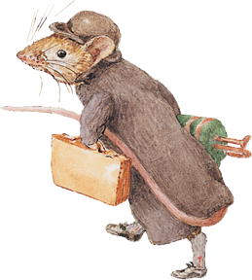
Now you must know that a town mouse once upon a time went on a visit to his cousin in the country. He was rough and ready, this cousin, but he loved his town friend and made him heartily welcome. Beans and bacon, cheese and bread, were all he had to offer, but he offered them freely. The town mouse rather turned up his long nose at this country fare, and said, "I cannot understand, cousin, how you can put up with such poor food as this, but of course you cannot expect anything better in the country; come you with me and I will show you how to live. When you have been in town a week you will wonder how you could ever have stood a country life." No sooner said than done: The two mice set off for the town and arrived at the town mouse's residence late at night.
"You will want some refreshment after our long journey," said the polite town mouse, and took his friend into the grand dining room. There they found the remains of a fine feast, and soon the two mice were eating up jellies and cakes and all that was nice. Suddenly they heard growling and barking.
"What is that?" said the country mouse.
"It is only the dogs of the house," answered the other.
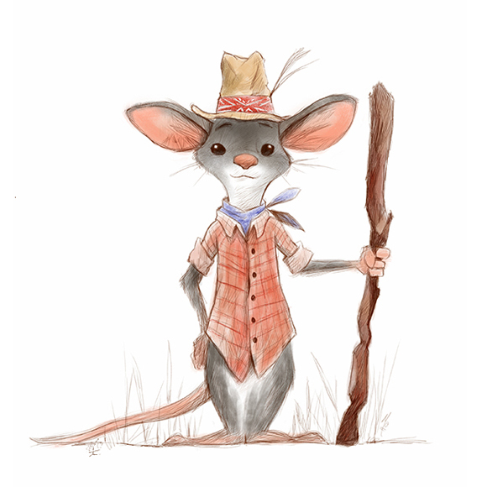
"Only," said the country mouse, "I do not like that music at my dinner!" Just at that moment the door flew open; in came two huge mastiffs; and the two mice had to scamper down and run off.
"Good-bye, cousin," said the country mouse.
"What! Going so soon?" said the other.
"Yes," he replied. "Better beans and bacon in peace than cakes and ale in fear."

Animal masks (cat, mouse, and dog)
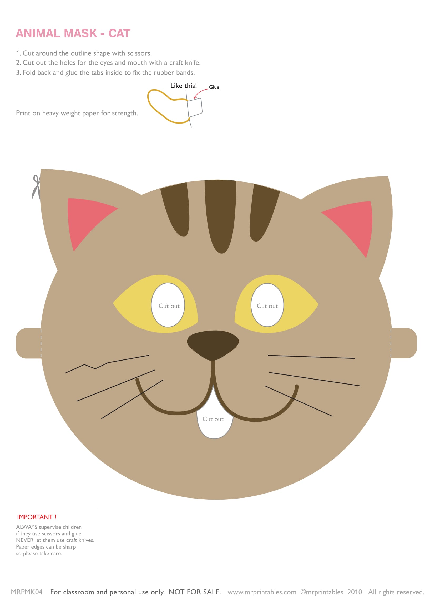
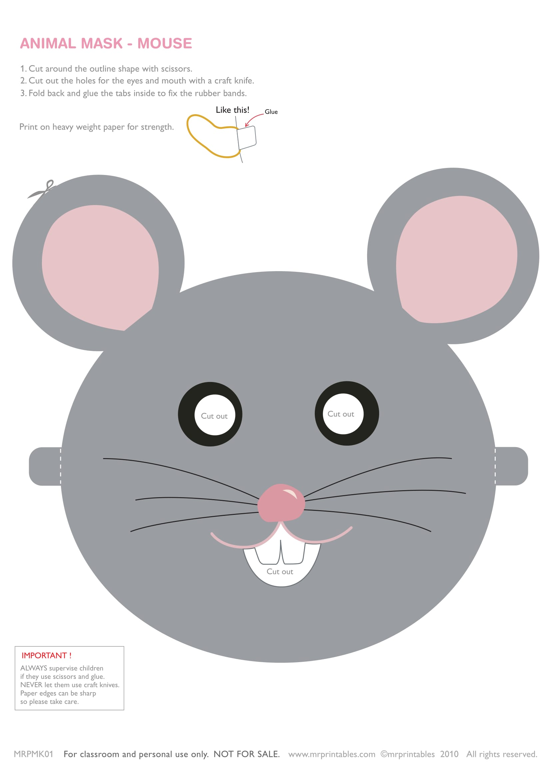
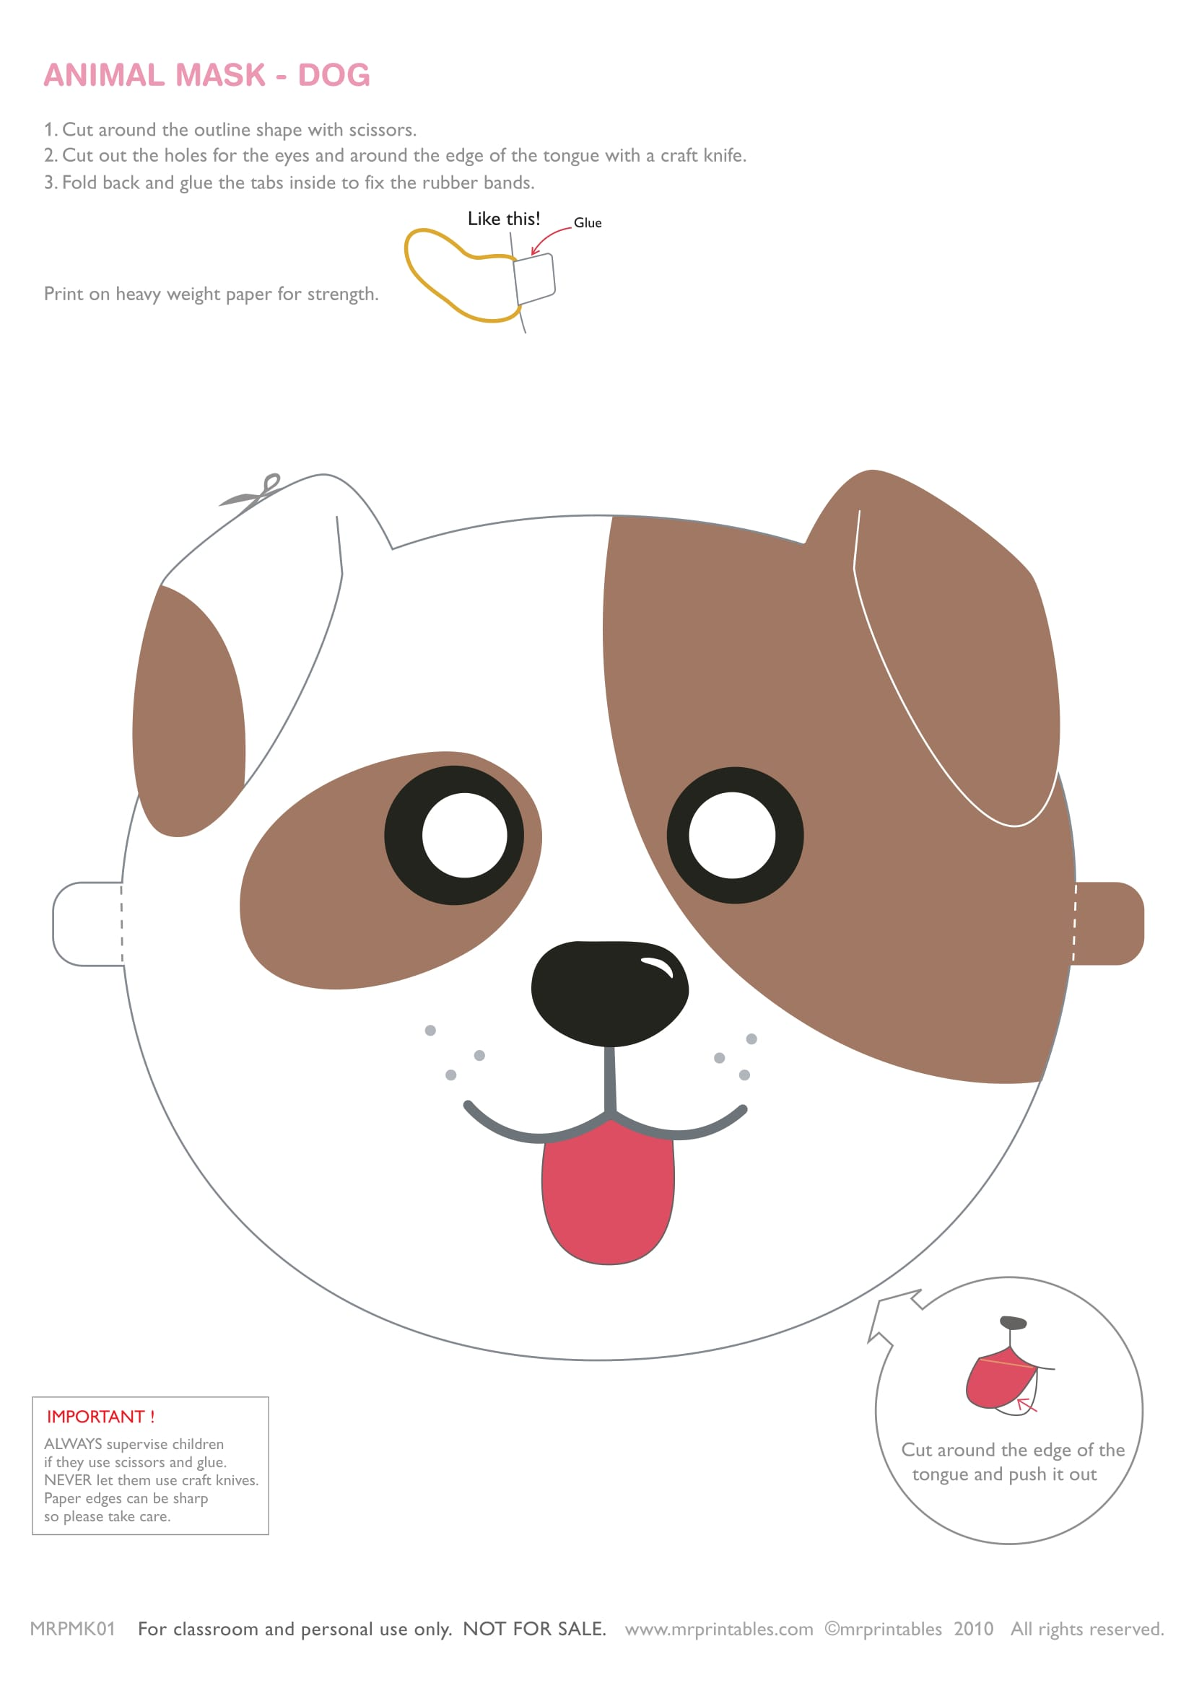
What do you think?
Before reading, please discuss as a group.
- Would you rather live in a comfortable and busy place or quiet and eco-friendly place? And why?
_______________________________________________________________________________________________________________________________________________________________
- Have you ever visit your relatives or friends that they live in a different environment? And how do you feel living there?
______________________________________________________________________________________________________________________________________________________________________________________________________________________________________________________________________________
- When you choose habitats, what is your most important values?
______________________________________________________________________________________________________________________________________________________________________________________________________________________________________________________________________________
- What do you think it would feel like living in these places?

________________________________________________________________________________________________________________________________________________________________________________________________________________________

What do you think?
After read a story, please answer the questions as a pair

- What was the town mouse's reaction to the food the country mouse gave him?
__________________________________________________________________________________________________________________________________________________________________
- What does 'turn up one's nose' mean?
__________________________________________________________________________________________________________________________________________________________________
- Why did the town mouse go to the country?
__________________________________________________________________________________________________________________________________________________________________
- What did the country mouse have to offer the town mouse?
__________________________________________________________________________________________________________________________________________________________________
- What was the town mouse used to?
________________________________________________________________________________________________________________________________________________________________________________________________________________________
- Where did the mice feast on tarts and cakes?
__________________________________________________________________________________________________________________________________________________________________
- What lesson do you think the author is trying to teach us in this tale?
__________________________________________________________________________________________________________________________________________________________________

Let’s Make a Story
Please read a question first and write down a script as a group.

If the Country Mouse was a dog and the Town Mouse was a cat, what will happen in your story????
In your story, you need to add following characters:
- Country Dog
- Town Cat
- Human
- Mystery Character

1.
2.
3.
4.
5.
6.
7.
8.
9.
10.
Let’s Make a Story
Please read a question first and write down a script as a group.

If the Town Mouse was the friend of the dog, what will happen in your story????
In your story, you need to add following characters:
- Dog
- Country Mouse
- Town Mouse
- Mystery Character

1.
2.
3.
4.
5.
6.
7.
8.
9.
10.

