Listening Speaking Reading Grammar Writing
Topic: Are You a Planner?
Language Target: Going To vs. Will

Instructor:  James Chun | Students Competency Level: Intermediate | Number of Students: 12 | Lesson Length:  56 Minutes
Materials: (List the Names of all materials used in the lesson. Materials must be shown at the end of this document)
- White Board and Markers
- Picture of Phone Booth
- ‘Going To vs. Will’ Substitution Drill Table
- ‘What’s Your Plan on Lunar New Year Holiday?’ Work Sheet
- ‘Are You a Planner?’ Work Sheet
- ‘What Is Your Choice?’ Work Sheets
1st Stage
2nd Stage
Aims: (What students will be able to achieve by participating in the activities of the lesson. (Ss gain or get by doing…)
- Enhance speaking skills through role play, and group discussion and responding to teacher.
- Stimulate and increase interest, as well as participate in an English communication activity through sharing stories of teacher and students.
- Enhance listening skills through role play and group discussion, responding to teacher.
- Enhance writing skills through working on work sheets, role play planning and note taking.
- Enhance interactions and communication skills through group discussion and role play planning.
Language Skills: (Lists what activities language skills students will be using by participating in the activities of the lesson.)
- Reading: (Where did reading occur in the lesson?)
Understanding Work Sheet Instructions, Note Taking
- Listening: (Where did listening occur in the lesson?)
Teacher Instruction during grammar drill, role play and group discussion
- Speaking: (Where did speaking occur in the lesson?)
Role play, group discussion and response to teacher
- Writing: (Where did writing occur in the lesson?)
Note Taking, Planning overall Lesson Plan including role play cards
Language Systems: (Lists what language systems students will be using by participating in the activities of the lesson.)
- Phonology: (sound)
Role play, Whole-class & Group discussion, Teacher’s instruction and discussion with T
- Function:(situation)
Introduction, understanding and interpretation of different situation and circumstance.
- Lexis: (meaning)
Vocabularies describing differences in characteristics of people and topics to be discussed.
- Grammar:(language structure)
Be verbs and description, ‘Going to’ and base verbs and descriptions as well as modal ‘Will’ verbs and descriptions.
- Discourse: (communication)
Group & Whole-class discussion, response to the teacher and role play
Assumptions: (What students must already be able to do and what concepts must already be mastered before the lesson in order to achieve the aims of the lesson.)
- All Ss have used future tenses using ‘Going to’ and ‘Will’.
- All Ss do not know that there is the main difference in their usage of ‘Going to’ vs. Will’.
- All Ss recognize that they need more time and efforts to use ‘Going to’ (planned) vs. Will’ (possibility) differently and use them for different situations and circumstances.
Anticipated Errors and Solutions: (What things might go wrong in the lesson and what the solutions will be. An SOS activity should also be included)
- If Ss may not appreciate the major grammatical difference between ‘Going to’ and ‘Will’. ►Solution: T gives them explanations and shows some demonstrations using Drill Substitution Table.
- If activity may last too long. ►Solution: T shortens the unnecessary parts.
- If activity may end too soon. ►Solution: T makes additional suggestions and T & Ss share ideas.
- If certain Ss may feel uncomfortable in playing a particular role. ►Solution: T asks them to try out roles given, gives positive feedback and then may change roles for them.
- If certain Ss may feel uncomfortable in sharing their stories during the lesson. ►Solution: T provides Ss with his stories first and then may ask them to share their stories with the class.

References:

Lead-In or Pre-Task Part (Warm-Up Part to activate and create interest in the lesson.)
Materials: (List the Names of all materials used in the Lead-In or Pre-Task Part of the lesson. Materials must be shown at the end of this document)
- Picture of Phone booth
Time: | Classroom Set Up: | Student Activity and Goals: | Teacher Procedure &Instructions:
1 M | W | Ss greet the teacher | Greet Ss.
4 M | W | Ss Listen to the teacher | Share T’s stories on planning using ‘Going to vs. Will’ sentence
2 M | W | Ss share their stories | Elicit stories on planning from Ss  Rephrase Ss’ sentences and respond by using ‘Going to vs. Will’

Pre-Activity or Task Familiarization Part (Presentation Part Presenting the language structure to be covered in the lesson. Prepares students for the communication activity.)
Materials: (List the Names of all materials used in the Pre-Activity or Task Familiarization Part of the lesson. Materials must be shown at the end of this document)
- White Board and Markers
- ‘Going To vs. Will’ Substitution Drill Table
- ‘What’s Your Plan on Lunar New Year Holiday?’ Activity Work Sheet
Time: | Classroom Set Up: | Student Activity and Goals: | Teacher Procedure &Instructions:
4 M | W | Ss read, listen, speak and drill to learn and become familiar with ‘Going to vs. Will’ | Introduce Drilling Wall Chart on the white board  Do drilling with Ss on ‘Going to vs. Will’
1 M | G | Listen to T and observe T drawing on board | Introduce and explain ‘What’s Your Plan on Luna New Year Holiday’ activity.  Put Ss in pairs and hand out ‘What’s Your Plan on Lunar New Year Holiday’ work sheet.
3 M | G | Receive the work sheet and start writing their schedules using ‘Going to vs. Will’ sentences. | Ask Ss to prepare their current schedule for four days on the sheets and to write sentences using ‘Going to vs. Will’.
4 M | W | Share their scheduler and sentences with partner  Ss present partner’s sentences  Listen T rephrasing the sentences using ‘Going to vs. Will’ | Tell Ss to present partner’s sentences to the class.  Rephrase Ss’ sentences and respond by using ‘Going to vs. Will’.

Main Activity or Task Realization Part (Practice to Production Part Teacher lead practice of the language presented and move to communication based more student centered activity)
Materials: (List the Names of all materials used in the Main Activity or Task Realization Part of the lesson. Materials must be shown at the end of this document)
- White Board and Markers
- ‘Are You a Planner?’ Activity Sheet
Time: | Classroom Set Up: | Student Activity and Goals: | Teacher Procedure &Instructions:
1 M | W | Listen T  Receive the work sheet | Introduce ‘Are You a Planner?’ activity.  Explain the simple role-play activity.  Hand out ‘Are You a Planner?’ Activity Sheet.
3 M | G | Read the work sheet and write sentences using ‘Going to vs. Will’  Work in pairs for the role-play | Tell Ss to discuss in pairs on the topics using ‘Going to vs. Will’  Give Ss time to prepare the role-play
12 M | W | Listen and enjoy each group’s role play. | Ask Ss to present their role-play to class using ‘Going to vs. Will’ sentences.  Facilitates class responses and feedbacks.
1 M | W | Discuss as whole class. | Provide Ss with positive feedback and comments on their performance.  Facilitates class’s feedback on each other.

Post Activity or Post Task Part (Wrap-Up Part Close the Lesson on a high note to and consolidate language learned in a communication based activity new situation.)
Materials: (List the Names of all materials used in the Post Activity or Post Task Part of the lesson. Materials must be shown at the end of this document)
- White Board and Markers
- ‘What Is Your Choice?’ Work Sheets
1st Stage Work Sheet
2nd Stage Work Sheet
Time: | Classroom Set Up: | Student Activity and Goals: | Teacher Procedure Instructions:
1 M | G | Listen T’s instructions and prepare  Receive the work sheet | Introduce ‘What Is Your Choice?’ Activity.  Divide Ss into three groups.  Hand out ‘What Is Your Choice?’ 1st Work Sheet.  Give instruction on the activity and tell Ss to prepare the work sheet.
4 M | G | Discuss in group and complete the work sheet | Give Ss time to prepare the 1st work sheet.
9 M | G | Ss do a new round of role play  Ss listen and enjoy each groups’ presentations | Ask the leaders of the groups to come up to and present their ideas on 1st work sheet.  After they finished, ask them to stay in the stage.
5 M | G | Ss listen, participate and overall activity. | Hand out ‘What is Your Choice?’ 2nd work sheet on the spot.  Ask the leaders to read out loud to the class and ask them what to do.  Allow Ss 30 seconds to share ideas with their group members and respond.
1 M | G | Ss listen and provide feedback in class discussion | Close by giving Ss feedback about their performances and accomplishments.

Picture of Phone Booth

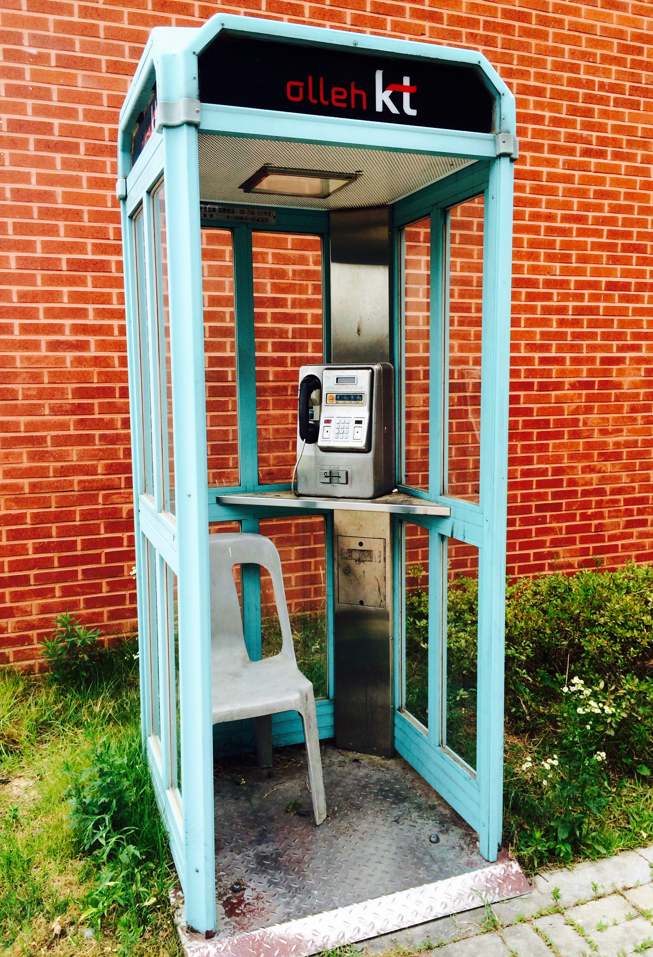

Going to vs. Will

Present
I | Am | Going to | Visit France  Get married  in June
You  We  They | Are | Going to | Visit France  Get married  in June
She (He) | Is | Going to | Visit France  Get married  in June

Past
I  She (He) | Was | Going to | Visit France  Get married  in June last year
You  We  They | Were | Going to | Visit France  Get married  in June last year

Present
I  You  We  They  She (He) | Will | Visit France  Get married  some day

Past
I  You  We  They  She (He) | Would | Visit France  Get married  in the future

What’s Your Plan in Lunar New Year Holiday?

 | Jan 27 | Jan 28 | Jan 29 | Jan 30
Dining-out
Visit Relatives
Shopping
Watch Movies
Meeting Friend
Trips
Visit Clinics
No Idea (Plan)

Are You a Planner?

Topic for Role Play | Sub-issues to discuss | Obsessive  Planner | Not so much Interested
Dating | Date course (Dinner, Movie, Theme Park, Trip)  When to go (Hourly, Daily, Weekly, Anniversary)  What to eat (Korean, Chinese, Italian, Japanese)
Marriage | Whether to get married at all  When (ideal date for wedding)  Where (wedding ceremony, honeymoon & residence)  How much to spend (the ceremony, honey moon & living together)
Travel | Where to go (Overseas & Domestic)  When to leave (Vacation, Holiday & Day trip)  How long (Day, Weekend & Holiday Vacation)  How much money to spend (Budget)  Package vs. Free style
Child | Whether to have a child  How many children  Where to raise the children  How much money to spend on their education
Shopping | What items to buy  Which shopping malls to visit  When to go for shopping  How long stay for shopping  How much budget for shopping
Family (In-Law) | Whether to introduce the parents  When to introduce the parents  Where to meet the parents  How often to meet the parents  What to wear when meeting the parents

What is Your Choice?

1st Stage

Expedition Trip to North-Pole
You have been selected for and are about to begin North-Pole Expedition tour. List up materials you will bring to the trip:

1._________________________

2._________________________

3._________________________

4._________________________

5._________________________

6._________________________

Your Ideal Date
You are going to meet and date a man you have dreamed of. Describe characteristics of your ideal date:

1._________________________

2._________________________

3._________________________

4._________________________

5._________________________

6._________________________

Furniture to Buy for New House
You have recently purchased a new house.
List up furniture items to fill the new house (you just donated all the major furniture items to charity)

1._________________________

2._________________________

3._________________________

4._________________________

5._________________________

6._________________________

2nd Stage

Expedition Trip to North-Pole
After a dinner was served, the captain suddenly announced:

“This is your captain. Due to unexpected mysterious weather conditions, we will make emergency landing an island located in South Pacific nearby”.

The planed landed in the south pacific 20 minutes later without anyone harmed fortunately. However, the captain had decided to vacant the luggage department before landing for safety purpose.

Now you are stranded in the island without any luggage.

What will you do?

Your Ideal Date
You have dated this person over the last two weeks.

The person has been just way you had imagined and hoped for.

Now, he invited you for the dinner at a very expensive, luxurious restaurant.

When you meet the person, he said the following:

_______________________________

What will you do?

Furniture to Buy for New House
One day after you decorated the house with all the newly purchased furniture, you visited your friend’s house located in different city.

Unfortunately, there was earthquake in your city, destroying all the houses including yours. Luckily, you are safe as you have been away from your home.

When you returned to your house you have found that your home was completely destroyed including your newly purchased furniture.

What will you do?

You are going to date with a dream man. Describe qualities without limit. Your wish will be granted

1.__________________________

2.__________________________

3.__________________________

4.__________________________

5.__________________________

6.__________________________

