☐Listening ☐Speaking ☐ Reading ☐ Grammar ☐ Writing
Topic: Where is it?
( Language Target : Prepositions of Location )
Instructor:  Kayla & Julie | Students Competency Level Intermediate | Number of Students: 10 | Lesson Length:  55 minutes
Materials: (List the Names of all materials used in the lesson. Materials must be shown at the end of this document)

- Computer/Screen Projector
- White Board and Markers
- “Emma’s Room Picture”
- Prepositions Substitution Table
- Fill in the Blanks Worksheet
- Giving Directions Worksheet
- Map A
- Map B

Aims: (What students will be able to achieve by participating in the activities of the lesson. (Ss gain or get by doing…)

- Improve Ss using preposition skills by watching the several example, making sentences with target languages and drilling, pair and group activity
- Improve Ss listening skills by listening to T’s story, drilling, Playing a game of a pair and group
- Improve Ss speaking skills by answering T, Ss presentations, sharing stories, drilling and pair and group activity

Language Skills: (Lists what language systems students will be using by participating in the activities of the lesson.)

- Listening : Teacher talk, Ss talk, Pair activity, Group Activity
- Speaking : Drilling, Pair activity, Group activity
- Reading : Drilling wall chart, writing Sentence in activities
- Writing : Writing sentences when pair activity

Language Systems: (Lists what language systems students will be using by participating in the activities of the lesson.)

- Phonology : Drilling, T and Ss talk
- Lexis : Making sentences with target language
- Grammar : In/Out of/On/Under/Besides/Up/Down/Next to/In front of
- Discourse : T-S,S-S, Drilling, Pair activity, Group activity

Assumptions: (What students will be able to achieve by participating in the activities of the lesson.)

- Ss will be able to define a preposition
- Ss will learn prepositions that indicate location and direction
- Ss will be able identify the prepositions in the given sentences
- Ss will use suitable preposition to make sentences

Anticipated Errors and Solutions: (What things might go wrong in the lesson and what the solution will be. An SOS activity should also be included)

- The students may need more time to complete a pair activity
→ Shorten the group activity _ drawing 3 items as fast as they can _ faster team is the winning team
- The students may finish their tasks earlier than anticipated
→ Give more time for group activity
- The students may not know the answers to questions
→Ask different students for the answer, encourage students to be creative and expressive
- Students who don’t understand in lesson or wrong answer
→Encourage them that they can do it

References:
- Google : Preposition of Location or Direction

Lead-In or Pre-Task Part (Warm-Up Part to activate and create interest in the lesson.)
Materials: (List the Names of all materials used in the Lead-In or Pre-Task Part of the lesson. Materials must be shown at the end of this document)

- Computer/Screen Projector
- White Board and Markers

Time: | Classroom Set Up: | Student Activity and Goals: | Teacher Procedure & Instructions:
1 min  5 min  5 min | Whole  Whole  Ss | Ss greet the teacher  Share S story  Ss think about T’s question and answer | Greeting  Talk about “Looking for Julie’s friend’s house” _ had difficulty in looking for the house of Julie’s friend without prepositions  Ask Ss if they can understand the several sentences without prepositions
Pre-Activity or Task Familiarization Part (Presentation Part Presenting the language structure to be covered in the lesson. Prepares students for the communication activity.)
Materials: (List the Names of all materials used in the Pre-Activity or Task Familiarization Part of the lesson. Materials must be shown at the end of this document)

- Computer/Screen Projector
- White Board and Markers
- Substitution Table
- Preposition Questions

Time: | Classroom Set Up: | Student Activity and Goals: | Teacher Procedure & Instructions:
3 min  3 min  2 min  4 min  2 min | Whole  Whole  Whole  Individual  Whole | Listen to T  Ss read, listen, speak and drill to learn and become familiar with prepositions  Ss listen to the T and answer to the T  Ss receive the preposition questions (worksheet) and answer the questions individually  Ss answer the questions | T introduces the substitution table and tells the students about the function of preposition.  Put drilling substitution table on the projector and do drilling with students. Accuracy is very important.  Ask Ss related to the preposition that they learned today.  T introduces the preposition questions (worksheet) and Ask Ss to answer the questions and T will monitor Ss work.  T will ask answer of the worksheet and response to the Ss.

Main Activity or Task Realization Part (Practice to Production Part Teacher lead practice of the language presented and move to communication based more student centered activity)
Materials: (List the Names of all materials used in the Main Activity or Task Realization Part of the lesson. Materials must be shown at the end of this document)

- Computer/Screen Projector
- White Board and Markers
- Substitution Table
- Giving Directions

Time: | Classroom Set Up: | Student Activity and Goals: | Teacher Procedure & Instructions:
2 min  10min  4 min | Whole  In pairs  Whole | Ss listen to the T  Ss do the activity  Ss do the activity again | T introduces about the activity of Giving Directions. T shows how to do the activity and let them do the activity in pairs.  T monitors Ss and encourages the Ss to do the activity more naturally and joyfully.  T pick 2 Ss and ask another question that is not in the worksheet and let them do in front of the class and response Ss’ work.

Post Activity or Post Task Part (Wrap-Up Part Close the Lesson on a high note to and consolidate language learned in a communication based activity new situation.)
Materials: (List the Names of all materials used in the Post Activity or Post Task Part of the lesson. Materials must be shown at the end of this document)

- Computer/Screen Projector
- White Board and Markers
- “Emma’s House Picture” Worksheet for A group
- “Emma’s House Picture” Worksheet for B group

Time: | Classroom Set Up: | Student Activity and Goals: | Teacher Procedure Instructions:
2min  8 min  2 min  2 min | Groups (2x)  Groups (2x)  Whole  Whole | Listen T’s instructions and make 2 groups  Ss do the activity  Ss finish their work and listen to the T  Ss listen to the T | Introduce the activity: Each group picks one artist for drawing on the white board.  The rest of group need to explain what they see in the picture T gave with preposition which is learned today.  T will give Ss ‘A Part Of Emma’s Room’ picture. Each group will compete to draw what they are given.  T will check similarity between Emma’s room picture and Ss drawing.  The closer drawing to the picture will be the winning team’  Congratulate the winners and thank all students for activity participating in the class and close by giving feedback about their work done and T’s impression of the class.

- Preposition Substitution Table
A bottle  A Cellphone  Markers  An Eraser  A Pen  A Pencil Case  A person  A cup  A card  A wallet  A bag | are  is | in  out of  on  under  next to  in front of  beside  up  down | the desk  the class  the bag  the cup  the pencil case  my house  my car  the chair  the book  the cellphone  my hand

- Fill in The Blank Worksheet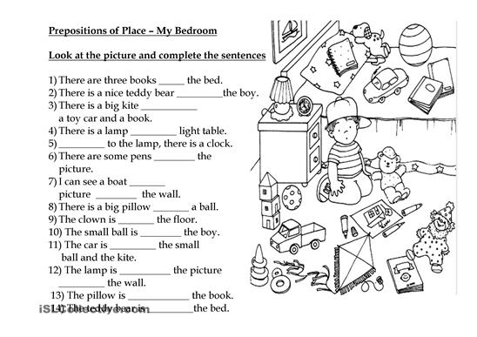

- Giving Directions Map A
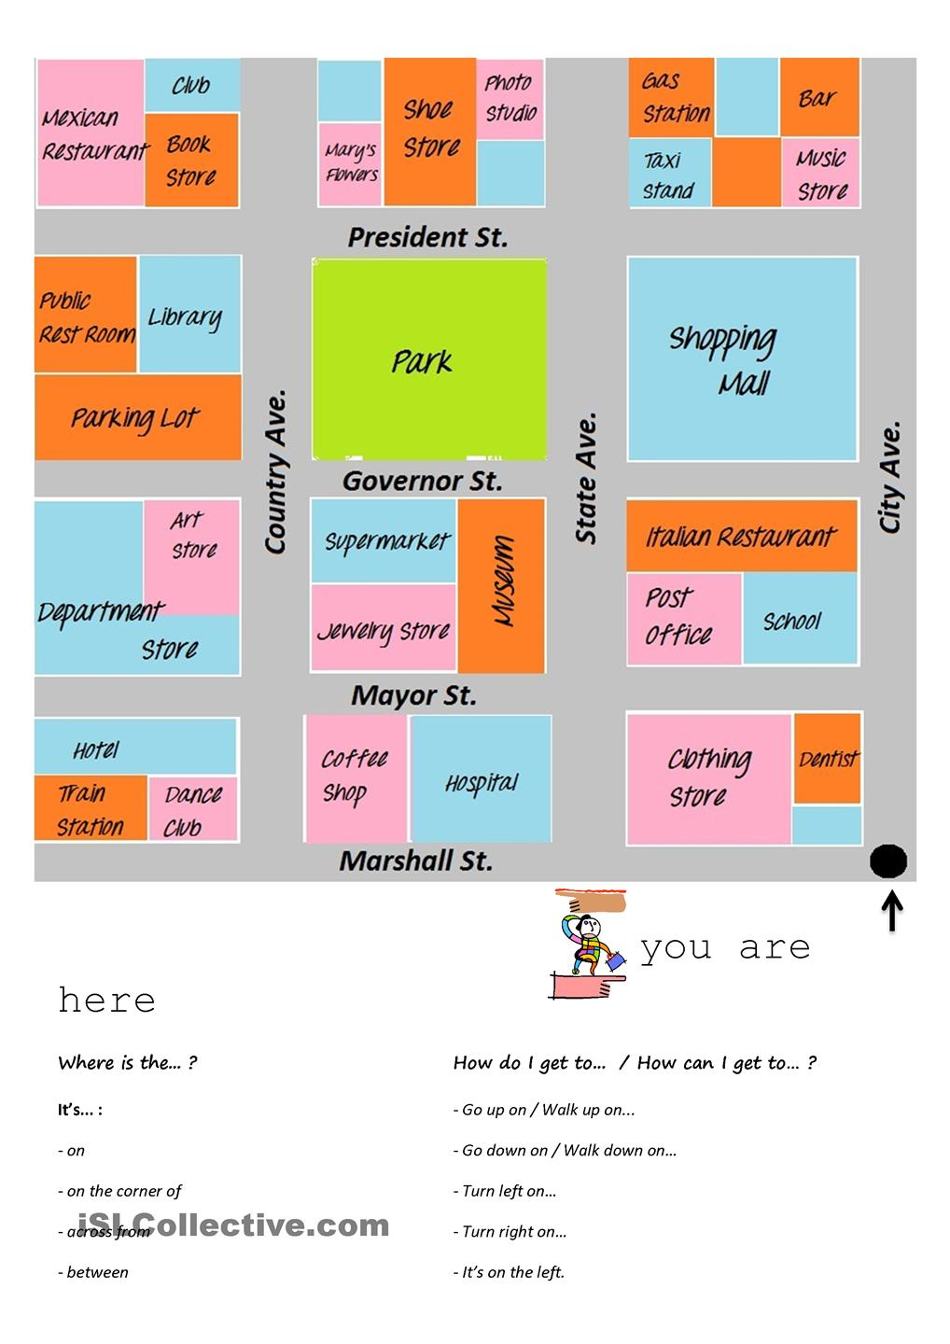
A
- Giving Directions Map B
B
- Emma’s Room Picture

