Listening Speaking Reading Grammar Writing
Topic: ‘Four Continent’s Crown Jewels’
Instructor:  Gamin Kim & James Chun | Students Competency Level: Intermediate | Number of Students: 12 | Lesson Length:  57 Minutes
Materials: (List the Names of all materials used in the lesson. Materials must be shown at the end of this document)
- Board and Markers
- Flash Cards:
  - Hitch Hiking
  - Great Barrier Reef
  - Grand Canyon
  - Cairo (Sphinx & Pyramid)
  - Argentine Patagonia
- Pictures for ‘Let’s Learn Vocabulary’ Activity:
- Hub
- Boisterous
- Unfurl
- Reading Text ‘Four Continent’s Crown Jewels’
- ‘Reading Comprehension Exercise’ Work Sheet
- Marketing Poster Example:
  - Teacher’s Example Cairo
Aims: (What students will be able to achieve by participating in the activities of the lesson. (Ss gain or get by doing…)
- Enhance Ss Listening skill by listening to T lead-in, questions, ICQ-CCQs as well as other Ss during pre, main, post activities.
- Improve Ss Speaking skill through responding to T eliciting and questions, as well as participating in group and class discussion.
- Develop Ss’ Reading skill further through reading various work sheets and reading text.
- Enhance Ss Writing skill through completing Vocabulary Work Sheets in pre activity, note-taking and working on Marketing Poster during main activity, as well as filling out after reading activity during post activity.
Language Skills: (Lists what activities language skills students will be using by participating in the activities of the lesson.)
- Reading: (Where did reading occur in the lesson?)
Worksheets and reading Text
- Listening: (Where did listening occur in the lesson?)
T lead-in story and instructions, as well as group and class discussion
- Speaking: (Where did speaking occur in the lesson?)
Responding to T (Eliciting, instructions) and other Ss within groups and class discussion, as well as group presentation
- Writing: (Where did writing occur in the lesson?)
Completing Vocabulary Matching Work Sheet and My Tour Destination Wish List Work Sheet, taking notes during group discussion and filling out Comprehension Work Sheet
Language Systems: (Lists what language systems students will be using by participating in the activities of the lesson.)
- Phonology: (sound)
Repeating after T in vocabulary activity, Ss discussion and other activities.
- Function:(situation)
Working on marketing materials for four tourism destinations
- Lexis: (meaning)
Learning vocabulary related to the four tourism destinations
- Grammar:(language structure)
Grammar is not emphasized
- Discourse: (communication)
Discuss with T, other group members and class
Assumptions: (What students must already be able to do and what concepts must already be mastered before the lesson in order to achieve the aims of the lesson.)
- Ss would be motivated in the planning and preparing tour destination poster.
- Ss would greatly be interested in tourism and tour destination in general.
- Ss know how to encourage customers’ minds for the tour destinations
Anticipated Errors and Solutions: (What things might go wrong in the lesson and what the solution will be. An SOS activity should also be included)
- Some Ss may not be greatly interested in traveling itself, preparing marketing posters or certain specific destination. ►Solution: encourage Ss to try out preparing marketing poster, and assign the destination choice to other group.
- Some Ss may find the T’s instructions are confusing. ►Solution: provides Ss with explanations, and demonstrates what and how to do.
- Time to prepare marketing poster may not enough. ►Solution: carefully managing time and ask Ss to come up with simplistic description and drawing.
- Activities may end too early. ►Solutions: prepare extra activities to make up time.
References:
http://travel.usnews.com/rankings/worlds_best_vacations/
http://travel.usnews.com/Great_Barrier_Reef_Australia/
http://travel.usnews.com/Grand_Canyon_AZ/
http://travel.usnews.com/Argentine_Patagonia/
http://travel.usnews.com/Cairo_Egypt/
other reading lesson plan examples (KNT & Internet)

Lead-In or Pre-Task Part (Warm-Up Part to activate and create interest in the lesson.)
Materials: (List the Names of all materials used in the Lead-Inor Pre-Task Partof the lesson. Materials must be shown at the end of this document)
- Flash Card
  - Hitch Hiking
Time: | Classroom Set Up: | Student Activity and Goals: | Teacher Procedure &Instructions:
1 M | W | Greet T | Greet Ss
4 M | W | Listen to T telling story | Show 'Hitch Hiking' flashcard to the Ss  Tells Ss interesting story about travelling
2 M | W | Talk about their memorable travel experiences | Elicits memorable travel experiences from Ss

Pre-Activity or Task Familiarization Part (Presentation PartPresenting the language structure to be covered in the lesson. Prepares students for the communication activity.)
Materials: (List the Names of all materials used in the Pre-Activity or Task Familiarization Part of the lesson. Materials must be shown at the end of this document)
- Board and Markers
- Pictures for ‘Let’s Learn Vocabulary’ Activity
- Hub
- Boisterous
- Unfurl
Time: | Classroom Set Up: | Student Activity and Goals: | Teacher Procedure &Instructions:
12 M | G | Watch pictures  Listen T’s explanation  Read the vocabulary  Repeat the vocabulary after T  Respond to T’s CCQ | Start ‘Let’s Learn Vocabulary’ Activity  Show pictures to explain the meaning of vocabulary ‘Hub’  Write down the vocabulary on the board  Conduct CCQ to check whether Ss understand the meaning of the vocabulary  Show pictures to explain the meaning of vocabulary ‘Boisterous’  Write down the vocabulary on the board  Conduct CCQ to check whether Ss understand the meaning of the vocabulary  Show pictures to explain the meaning of vocabulary ‘Unfurl’  Write down the vocabulary on the board  Conduct CCQ to check whether Ss understand the meaning of the vocabulary

Main Activity or Task Realization Part (Practice to Production PartTeacher lead practice of the language presented and move to communication based more student centered activity)
Materials: (List the Names of all materials used in the Main Activity or Task Realization Partof the lesson. Materials must be shown at the end of this document)
- Board and Markers
- Reading Text ‘Four Continent’s Crown Jewels’
- Flashcards
  - Great Barrier Reef
  - Grand Canyon
  - Cairo (Sphinx & Pyramid)
  - Argentine Patagonia
- ‘Reading Comprehension Exercise’ Work Sheet
Time: | Classroom Set Up: | Student Activity and Goals: | Teacher Procedure &Instructions:
7 M | G | Listen to T’s instructions  Read Text | Hand out ‘Four Continent’s Crown Jewels’ Reading Text  Give Ss time to read the text
10 M | G | Share their thoughts on the text based upon the Reading Comprehension Work Sheet | Hand out ‘Reading Comprehension Exercise’ Work Sheet  Ask Ss to share their thoughts about the text  Facilitate class room discussion and feedback (Use flash cards including 'Great Barrier Reef', 'Grand Canyon', 'Cairo (Sphinx & Pyramid) and 'Argentine Patagonia')

Post Activity or Post Task Part (Wrap-Up Part
Close the Lesson on a high note to and consolidate language learned in a communication based activity new situation.)
Materials: (List the Names of all materials used in the Post Activity or Post Task Part of the lesson. Materials must be shown at the end of this document)
- Board and Markers
- Reading Text ‘Four Continent’s Crown Jewels’
- Flashcards
  - Great Barrier Reef
  - Grand Canyon
  - Cairo (Sphinx & Pyramid)
  - Argentine Patagonia
- ‘Reading Comprehension Exercise’ Work Sheet
- Marketing Poster Example
  - Teacher’s Example Cairo
Time: | Classroom Set Up: | Student Activity and Goals: | Teacher Procedure Instructions:
1M | G | Divide into groups | Divide the class into 3 groups
1 M | G | Choose one destination | Ask Ss to choose one destination from the Reading Text
2 M | G | Listen to T’s instructions  Read Marketing Poster Example T prepared | Start ‘Let’s Make Marketing Poster’ Activity  Use flashcards including 'Great Barrier Reef', 'Grand Canyon', 'Cairo (Sphinx &Pyramid) and 'Argentine Patagonia'.  Give instruction to conduct the post activity, 'Let's Make Marketing Poster'.  Instruction-> Draw a marketing poster that  makes people want to visit the location that  you have been assigned.  Demonstrate an example using Marketing Poster Example 'Teacher's Example Cairo'
8 M | G | Prepare Marketing Poster | Ask Ss to prepare Marketing Poster using the Reading Text and the flash cards ('Great Barrier Reef', 'Grand Canyon', 'Cairo (Sphinx &Pyramid) and 'Argentine Patagonia')
6 M | G | Listen to other G’s presentations | Ask each G to come up front and present their Marketing Poster to class
3 M | G | Listen to and respond to T  Provides feedback to T and other students on key take-away of the class activities, and how to improve the activities in the future | Provide Ss positive feedbacks on their works and performances  Wrap up the class by reviewing what were discussed  Ask Ss how the activities can be further improved
1 M | G | Listen to T | Close the activities  Thanks Ss for active participations

Flash Cards

Hitch Hiking | Great Barrier Reef
 | 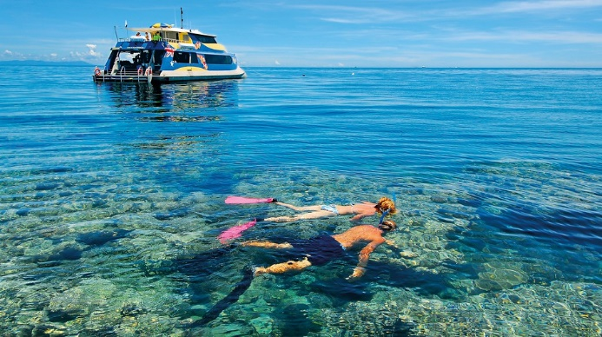
Grand Canyon | Cairo (Sphinx & Pyramid)
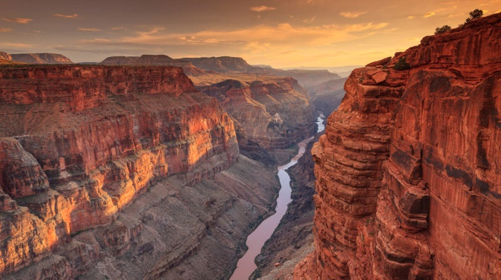 | 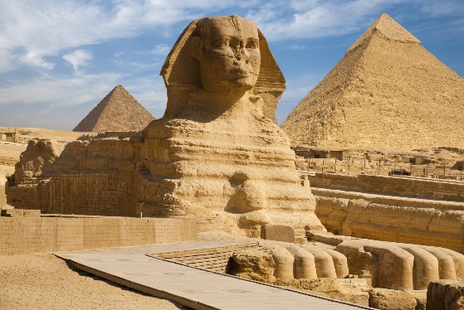

Argentine Patagonia
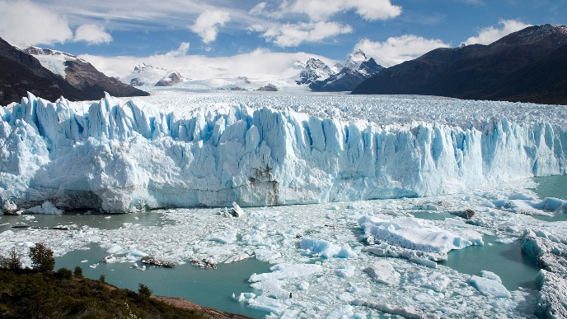

Pictures for ‘Let’s Learn Vocabulary’

Boisterous

Picture 1

Picture 2

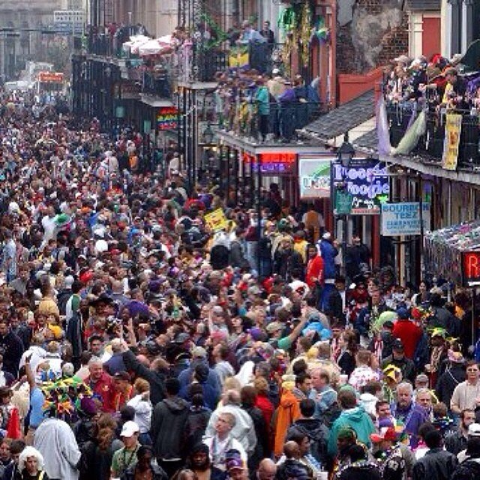

Picture 3

Hub

Picture 1

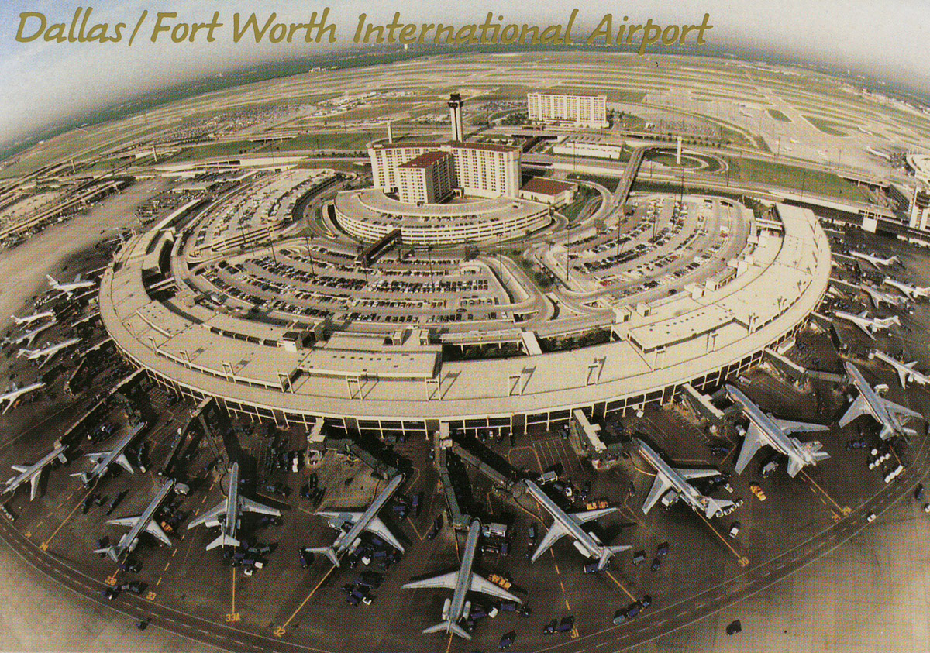

Picture 2

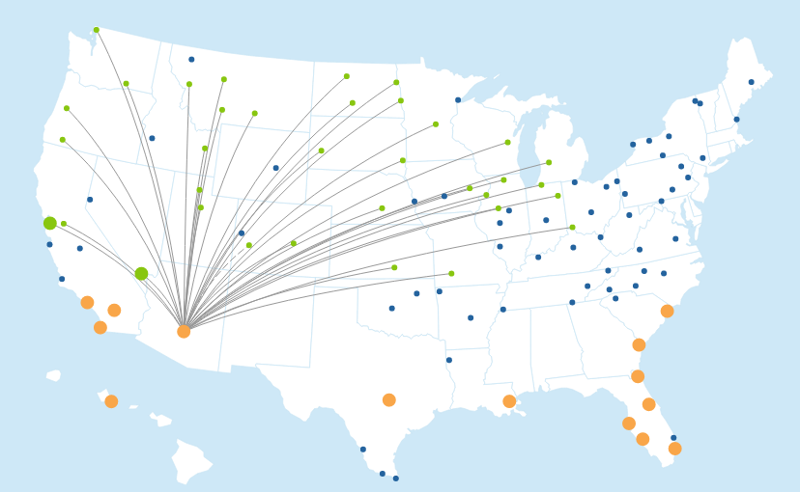

Picture 3

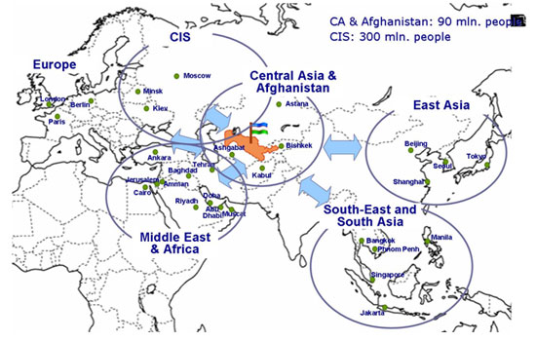
Unfurl

Picture 1

Picture 2

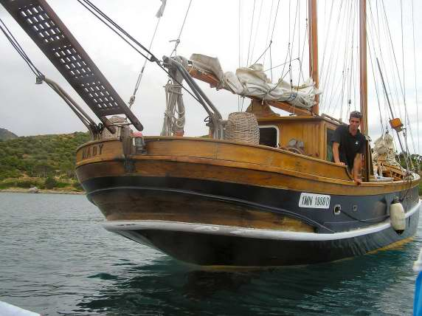

Picture 3

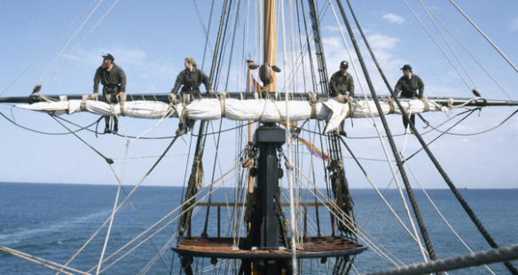

Marketing Poster Example – Teacher’s Example Cairo

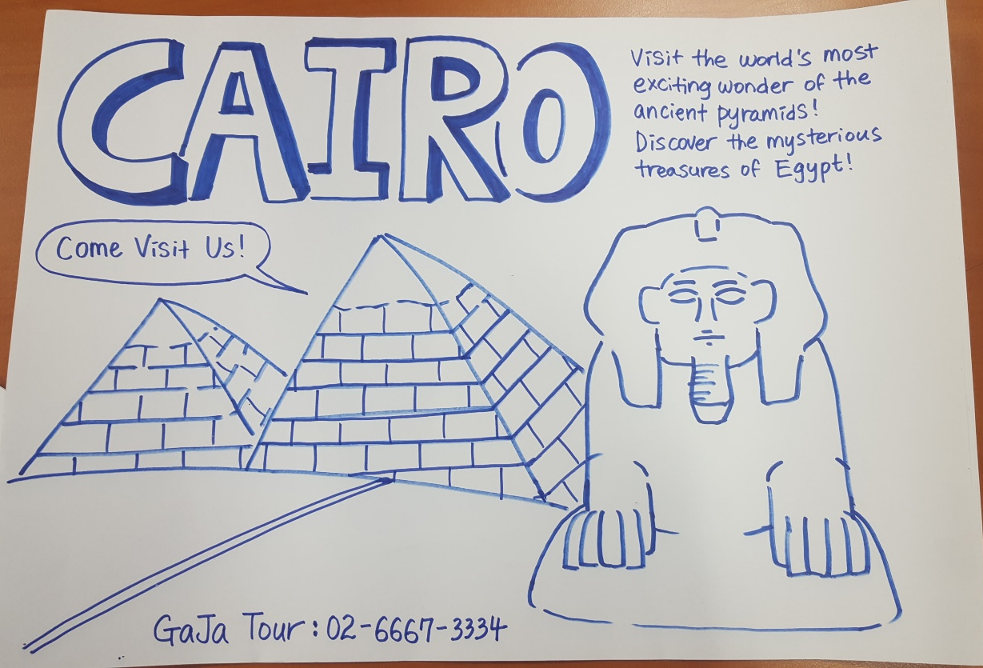

‘Four Continent’s Crown Jewels’

Great Barrier Reef
As one of the Seven Natural Wonders of the World, the Great Barrier Reef hugs the east coast of Queensland, Australia, extending a total of 1,250 miles, with roughly 3,000 coral reefs, 600 islands and 1,625 species of fish.
The northern half of the reef runs from the Cape York Peninsula to Cairns. Providing the closest reef access from the mainland, Cairns possesses a few attractions of its own, like the Kuranda Scenic Railway and the Wildlife Habitat Port Douglas. Travel farther down the coast and you'll run into the southern half of the reef, which stretches from the Capricorn Coast (along the Tropic of Capricorn) to Gladstone and Fraser Island. Airlie Beach is a tourists’ favored hub in the south thanks to its array of stylish resorts and its close proximity to the 74 islands known as the Whitsundays.
The Great Barrier Reef is a hidden treasure of once-in-a-lifetime experiences. Whether you're gazing at marine life through a scuba mask, letting the tropical breeze unfurl your sail, or in a plane gliding high above it all, the possibilities for exploration are nearly limitless.

Grand Canyon
Measuring approximately 277 miles in length, up to 18 miles in width and a mile deep, Grand Canyon, the massive chasm in northern Arizona is truly a natural wonder. For six million years, the Grand Canyon has expanded with the help of the mighty Colorado River, and for centuries, people from all over the globe have traveled to gaze out over its red and orange vastness. Officially designated as a UNESCO World Heritage site, the Grand Canyon leaves its approximately 4.5 million visitors per year awestruck.
The South Rim — home to the Grand Canyon Village and the well-worn Bright Angel Trail — is particularly popular for sightseers and hikers. It is on this side that you'll find the most amenities. However, for a true vigorous experience, head to the North Rim. This is the place for backwoods camping and hardcore hiking.
Cairo
The desert heat, the noisy streets and the sheer size of Cairo will leave even the most adaptable traveler with a serious case of culture shock. The endless number of street vendors, the inescapable aroma of livestock and the seemingly chaotic way of life will joggle the senses. But be patient. Take some time to relax over a cup of tea, to wander the ancient streets and to watch the sun lower over the mighty Nile River. It won't take long for the city's treasures to reveal themselves.
With most visitors heading to Egypt's capital to explore the wonders of the ancient world, following the footsteps of the pharaohs, the city's residents embrace their history and rejoice in their progress. The ancient pyramids of Giza, Dahshur and Saqqara fight with the trendy bars of the Zamalek and Heliopolis neighborhoods for spotlight. And the traditional Islamic call to prayer, lounge music and boisterous chitchats can be heard simultaneously. The only way to get a true sense of Cairo is to take the old with the new.

Argentine Patagonia
With Cobalt lakes, azure-tinted glaciers, emerald trees, and turquoise skies stretching as far as the eye can see, Patagonia's beauty knows no bounds. Visit Argentina's Lake District and you'll discover villages brushing against snowy mountain peaks. Travel east and you'll find whales gliding through Peninsula Valdés' marine wildlife sanctuary. Venture to Southern Patagonia, and you'll stumble upon deserts extending into rugged estancias (cattle-ranges) and melting glaciers. And, if you continue downward to the Chilean border at Cape Horn, you'll come across an expansive horizon reaching out to Antarctica's frosty edge.
Rustic roads lead to dramatic natural wonders like Perito Moreno Glacier and Mount Fitz Roy. Look around this beautiful landscape and discover a region buzzing with life. Magellanic penguins and albatross gather in the Punta Tombo wildlife reserve, while history survives on the walls of the Cave of the Hands.

Reading Comprehension Exercises

Please answer the following questions by taking notes and discussing with your groups, based on the given text.
- Which destination do you think is ideal place to visit for hikers? Why?
- Which destination do you think is likely most densely populated? Why?
- For which destination you would recommend that tourist bring thick, warm clothes such as winter coat? Why?
- In which destination will you be likely to find very different cultural aspects coexisting together? Why?

- If you are marine biologist, which destination you would choose? Why?

- What is your favorite destination from the text that you would like to visit? Why?

