Flash Cards

Hitch Hiking | Great Barrier Reef
 | 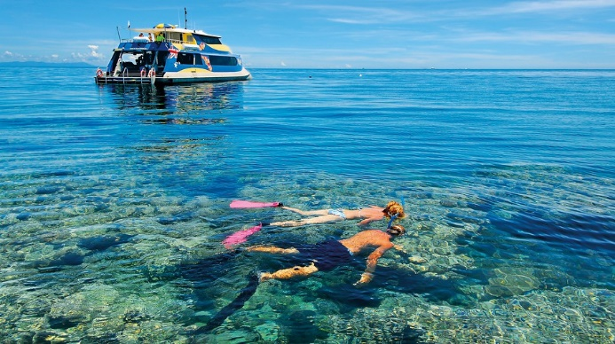
Grand Canyon | Cairo (Sphinx & Pyramid)
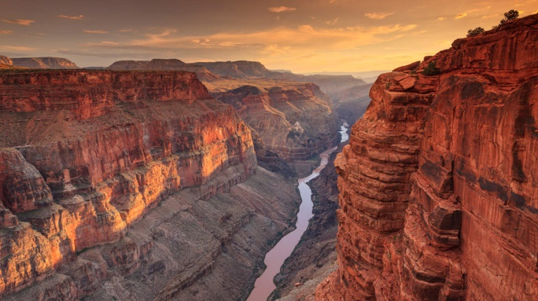 | 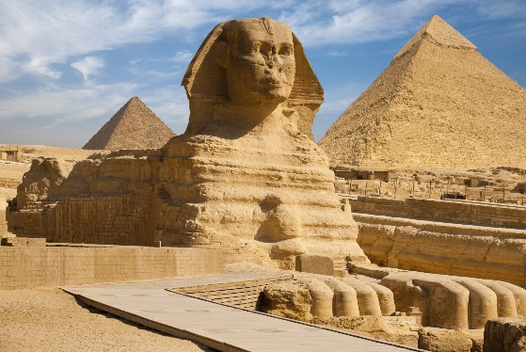

Argentine Patagonia
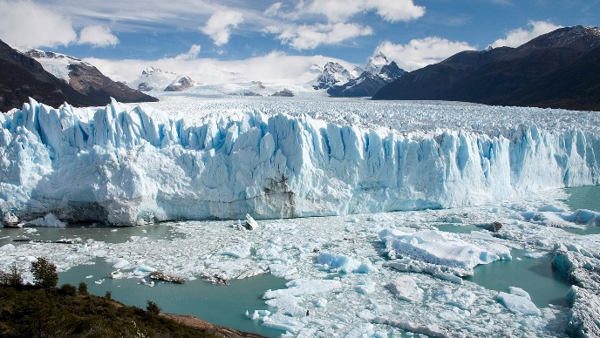

Pictures for ‘Let’s Learn Vocabulary’

Boisterous

Picture 1

Picture 2

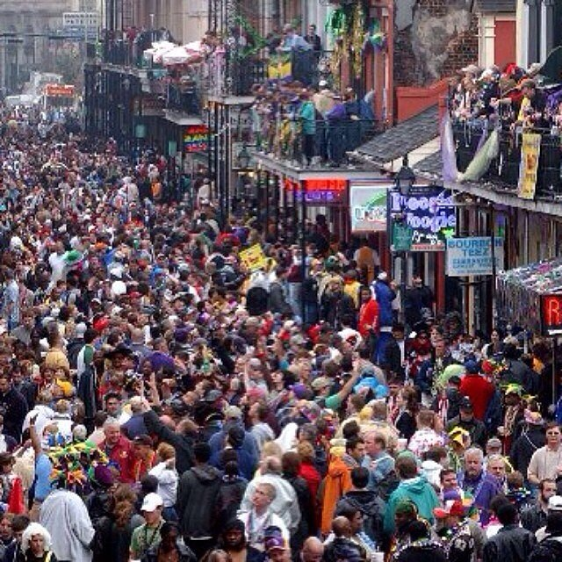

Picture 3

Hub

Picture 1

Picture 2

Picture 3

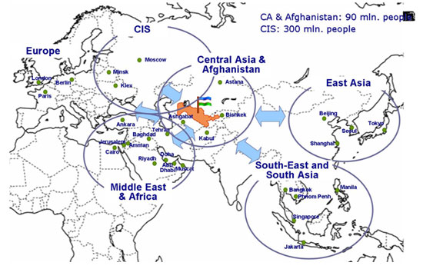
Unfurl

Picture 1

Picture 2

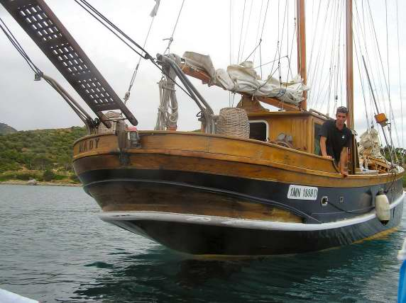

Picture 3

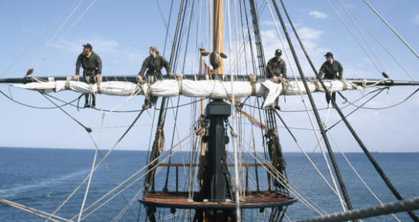

Marketing Poster Example – Teacher’s Example Cairo

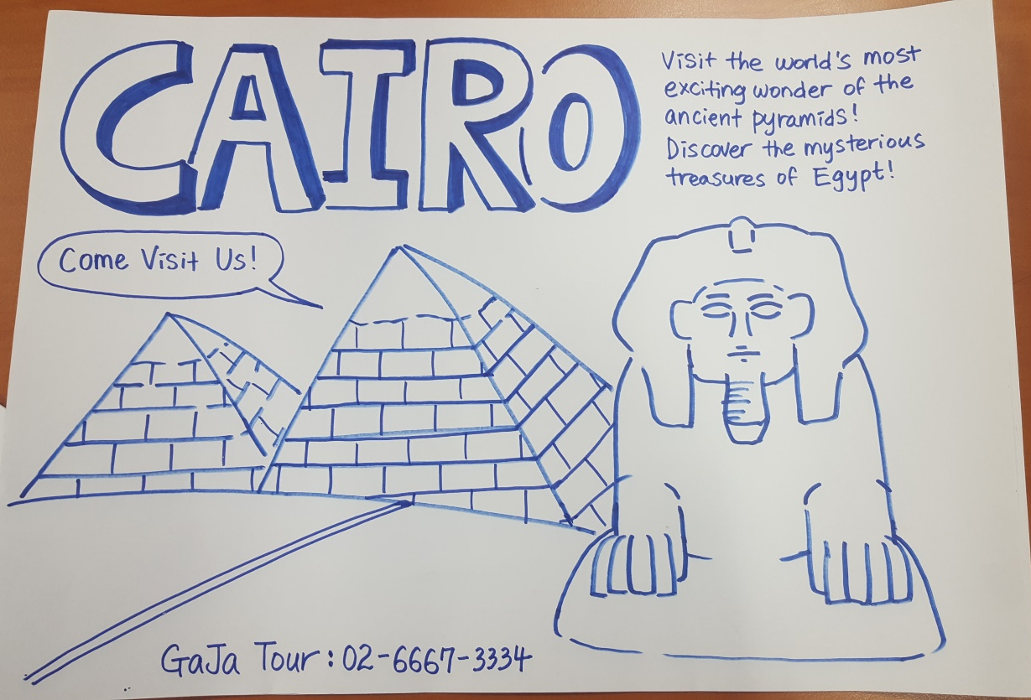

‘Four Continent’s Crown Jewels’

Great Barrier Reef
As one of the Seven Natural Wonders of the World, the Great Barrier Reef hugs the east coast of Queensland, Australia, extending a total of 1,250 miles, with roughly 3,000 coral reefs, 600 islands and 1,625 species of fish.
The northern half of the reef runs from the Cape York Peninsula to Cairns. Providing the closest reef access from the mainland, Cairns possesses a few attractions of its own, like the Kuranda Scenic Railway and the Wildlife Habitat Port Douglas. Travel farther down the coast and you'll run into the southern half of the reef, which stretches from the Capricorn Coast (along the Tropic of Capricorn) to Gladstone and Fraser Island. Airlie Beach is a tourists’ favored hub in the south thanks to its array of stylish resorts and its close proximity to the 74 islands known as the Whitsundays.
The Great Barrier Reef is a hidden treasure of once-in-a-lifetime experiences. Whether you're gazing at marine life through a scuba mask, letting the tropical breeze unfurl your sail, or in a plane gliding high above it all, the possibilities for exploration are nearly limitless.

Grand Canyon
Measuring approximately 277 miles in length, up to 18 miles in width and a mile deep, Grand Canyon, the massive chasm in northern Arizona is truly a natural wonder. For six million years, the Grand Canyon has expanded with the help of the mighty Colorado River, and for centuries, people from all over the globe have traveled to gaze out over its red and orange vastness. Officially designated as a UNESCO World Heritage site, the Grand Canyon leaves its approximately 4.5 million visitors per year awestruck.
The South Rim — home to the Grand Canyon Village and the well-worn Bright Angel Trail — is particularly popular for sightseers and hikers. It is on this side that you'll find the most amenities. However, for a true vigorous experience, head to the North Rim. This is the place for backwoods camping and hardcore hiking.
Cairo
The desert heat, the noisy streets and the sheer size of Cairo will leave even the most adaptable traveler with a serious case of culture shock. The endless number of street vendors, the inescapable aroma of livestock and the seemingly chaotic way of life will joggle the senses. But be patient. Take some time to relax over a cup of tea, to wander the ancient streets and to watch the sun lower over the mighty Nile River. It won't take long for the city's treasures to reveal themselves.
With most visitors heading to Egypt's capital to explore the wonders of the ancient world, following the footsteps of the pharaohs, the city's residents embrace their history and rejoice in their progress. The ancient pyramids of Giza, Dahshur and Saqqara fight with the trendy bars of the Zamalek and Heliopolis neighborhoods for spotlight. And the traditional Islamic call to prayer, lounge music and boisterous chitchats can be heard simultaneously. The only way to get a true sense of Cairo is to take the old with the new.

Argentine Patagonia
With Cobalt lakes, azure-tinted glaciers, emerald trees, and turquoise skies stretching as far as the eye can see, Patagonia's beauty knows no bounds. Visit Argentina's Lake District and you'll discover villages brushing against snowy mountain peaks. Travel east and you'll find whales gliding through Peninsula Valdés' marine wildlife sanctuary. Venture to Southern Patagonia, and you'll stumble upon deserts extending into rugged estancias (cattle-ranges) and melting glaciers. And, if you continue downward to the Chilean border at Cape Horn, you'll come across an expansive horizon reaching out to Antarctica's frosty edge.
Rustic roads lead to dramatic natural wonders like Perito Moreno Glacier and Mount Fitz Roy. Look around this beautiful landscape and discover a region buzzing with life. Magellanic penguins and albatross gather in the Punta Tombo wildlife reserve, while history survives on the walls of the Cave of the Hands.

Reading Comprehension Exercises

Please answer the following questions by taking notes and discussing with your groups, based on the given text.
- Which destination do you think is ideal place to visit for hikers? Why?
- Which destination do you think is likely most densely populated? Why?
- For which destination you would recommend that tourist bring thick, warm clothes such as winter coat? Why?
- In which destination will you be likely to find very different cultural aspects coexisting together? Why?

- If you are marine biologist, which destination you would choose? Why?

- What is your favorite destination from the text that you would like to visit? Why?

