< Anna’s Schedule >
The table below is Anna’s schedule. Based on this, please answer the questions, using the frequency adverbs that you learned today.
Sun | Mon | Tue | Wed | Thu | Fri | Sat

1. How often does Anna go to church?
Anna goes to church sometimes.
2. How often does Anna drink coffee?
________________________________________________
3. How often does Anna go to the movies?
________________________________________________
4. How often does Anna go to the groceries?
________________________________________________
5. How often does Anna go swimming?
________________________________________________
Wall Charts
- Frequency Adverb Pyramid
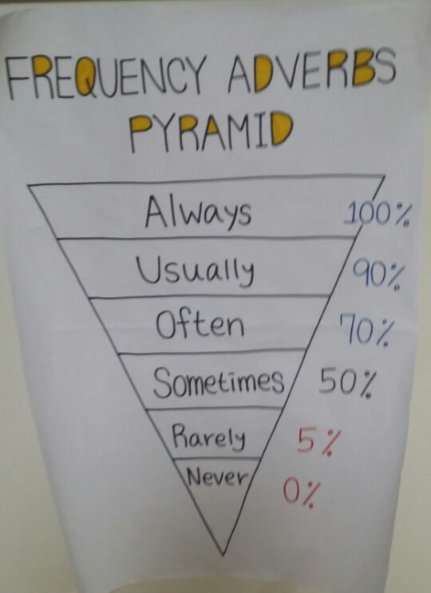

- How Often Do You ______?
