Background Information Sheet – Complete all sections accurately.
Name & Class |  | Date & Place | Lesson Type |  |  | Plan |  | Topic |  |  | Length | Level
Sook Hee Kim  Amy Kim |  | 26th.Jan  Listening Classroom | Listening |  |  | PPP |  | Discovered Machu Picchu |  |  | 40min | Intermediate
Class profile
Number of students: 8 Age: Adults Nationality: Korean
Motivations:
Individual or class hobbies and interests:
Special considerations:
Main aim
- Students will practice their listening comprehension skills using a bottom-up and a top-down model.
Subsidiary aims
- Students will practice their oral fluency during the productive stage.
Description of any language skills specifically used/practiced:  - Listening: Ss listen to the recorded article  - Reading: Ss read the transcript to understand  - Speaking: Ss discuss what they understood  - Writing: Ss write the answer about worksheet |  |  |  |  |  |  | Description of any language systems specifically used/practiced:  - Lexis: New vocabularies (ancient, defeat, terraces, pottery, hidden)  - Grammar: Past tense  - Function: Giving Information  - Discourse: An article  - Phonology: z[zi:]

Anticipated difficulties with lesson activities and classroom management:

Ss may not understand the easily.

If Ss need linguistic support

How I can deal with these difficulties:
- Repeat till they can understand what they have trouble with.
- I will encourage them to look at the context clue, and provide them with the examples
Assumptions:
Ss already know - 1. how the class organized and operated (4 at each table)
2. which group they belong to group discussion time
Material(s) needed: White Board, Board Maker, Board Eraser, Projector(pictures, vocabulary list, etc), worksheet 1(8 copies – for write answer)
Script(8 copies), Audio clip(using computer),Wall chart(for cross the line), worksheet 2(8 copies-fill the blanks),
worksheet 3(2 copies - for activity),

Checklist. Mark down those included in this lesson plan ( or N/A)
 | model sentences for target language |  |  |  | concept questions for target language |  |  |  |  | analysis sheet for target language
 | stages clearly titled and separated |  |  |  | purpose of each stage indicated |  |  |  |  | anticipated timing included
 | interaction pattern marked |  |  |  | a board plan (if relevant) |  |  |  |  | examples of all tasks used
 | answer sheet to all exercises |  |  |  | Tape or text script |  |  |  |  | all materials labelled and numbered
Personal aim : By the end of lesson Ss will be able to understand an article easily.

Stage 1:_Lead-in  The purpose of this stage is to ease into the topic, relaxing both teacher and students by focusing their attention on an interesting subject and encouraging the class to share their opinions freely, thus increasing STT and participation. This stage may be used to create a basis from which to elicit ideas and lexis relating to the text. | Inter  action | Time | Instructor’s comments
Hello, everyone? How are you today? I’m good too.  Look at this wall chart. (Stick an wall chart on board to pictures and the flags)  Have you ever seen these remains in other countries?  Up here (in front of board) and connect nations picture with appropriate nations?  (If nobody hands up, the teacher will pick one student)  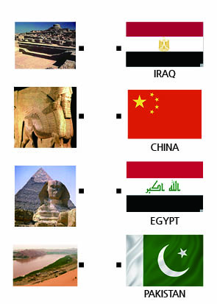  What do those countries have in common?  Share what you think with your partners. Ill give you 1min. | S-S  Ss | 2min  1min

Stage 2: Presentation  The purpose of this stage is to make the listening less challenging to the students by making use of guiding questions which help predict expected content; answers to these questions may be guessed during this stage and checked later in the lesson; pre-teaching keywords and phrases from the text. Knowledge of the purpose of the text, form and style could be highlighted to further aid comprehension. Thus, schema is activated. | Inter  action | Time | Instructor’s comments
Eliciting “Civilization”  Look at these pictures.  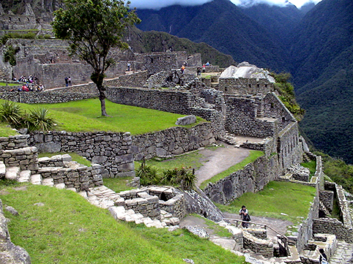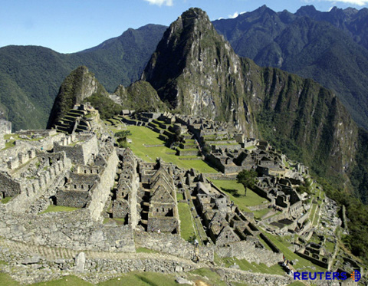  Eliciting: Have seen these pictures? Two pictures are same place.  What comes up into your mind?  CCQs: Where is it?  Does it look like an ancient city or a sculpture by an artist?  Drilling: Okay. Good. Listen. Civilization. Civilization. Listen again and repeat. –  Board: write “Civilization” on board and teach them how to pronounce with [zi:] | T  T-S | 1min  3min

Stage 3: Practice - Listening for gist comprehension  The purpose of this stage is to allow the students to practice gist skills to identify the main idea of the text. Specific and authentic exercises designed to encourage this skill should be used in a natural way. Students draw on their world-knowledge (top-down) to make an initial impression and general sense of the text and perhaps comparing the accuracy of their guesses to the guiding questions used for the text. | Inter  action | Time | Instructor’s comments
Guiding Question  Do you know the only city that was not conquered by Spain in Peru?  Depends on Ss response – Yes(they know name of the city) / No  Then, let’s check this up! Ill play an audio clip, please write on worksheet the answer after listen.  (While telling this, give them the worksheet 1)  Play the recorded audio clip once.  After Listening , “Do you understand what they talked about?”  Give them some time to think and ask “Did you answer the questions?”  If they response – No –Repeat / if they want to listen only a part, repeat that part till they understand.  Yes- Good job / Check the answers for feedback together.  (Show Ss new vocabularies in the article by PPT first.)  Listen ancient, defeat, terraces, pottery, hidden, Listen and repeat. Ancient …  Fill the blank what | T-S  Ss | 2min  5min

Stage 4: Practice - Literal comprehension  The purpose of this stage is for students to focus on literal understanding e.g. of facts, ideas etc. A variety of exercises may be used and should be constructed for short responses e.g. objective questions. The information highlighted should, ideally, be of significance to the next stage. | Inter  action | Time | Instructor’s comments
(Show Ss new vocabularies in the article by PPT first and give Ss worksheet 2)  Listen ancient, defeat, terraces, pottery, hidden, Listen and repeat. Ancient …  Read the definitions of those words below and then fill in the blanks.  ancient, defeat, terraces, pottery, hidden  belonging to times long past especially of the historical period before the fall of the Western Roman Empire  an unsuccessful ending to a struggle or contest  a level shelf of land interrupting a declivity (with steep slopes above and below)  ceramic ware made from clay and baked in a kiln  not accessible to view  Literal Questions  - Who searched for the Machu Picchu?  - When did Spanish forces from Europe arrive in Peru?  - Which of the following is not mentioned about the Machu Picchu?  - What did he see as soon as he reached the top of the mountain?  (If they feel tough to response, repeat the audio.)  Give them discuss time to the answers.  Okay guys. Check the answers with your partner for 2mins.  Give them feedback about their responses about the literal questions. | T-S  T-S  S-S  T-S | 1min  4min  2min  1min

Stage 5: Practice - Interpretive comprehension  The purpose of this stage is to allow student to listen intensively for inference. Discriminating between fact and opinion and understanding the writer’s true thinking are possible considerations during this stage. Contrasting ideas may be highlighted, and use of certain language which affects meaning can be analysed in context. | Inter  action | Time | Instructor’s comments
Interpretive Questions  - From many ancient objects discovered, how did native Peruvians make use of them?  - Do you have any idea what made it difficult for people to get to Machu Picchu?  - What made the Machu Picchu mysterious?  Give them discuss time to the answers.  Okay guys. Have a conversation with your partner how they thought about the questions for 2mins.  Give them feedback about their responses about the questions. | T-S  S-S  T-S | 4min  2min  1min

Stage 6:_Production - Applied Comprehension  The purpose of this stage is to complete the final step in reading comprehension by getting students to apply to themselves the information from the text and which was focused on during the practice stages. The task should take into account your students’ background information in order to be suitable as an applied task. Speaking or writing skills may be practiced here. This stage is an important part of language acquisition. | Inter  action | Time | Instructor’s comments
Applied Questions  Do you know any story about other civilizations?  Talk with your partner for 3 minutes and then come to the front and speak about it.  Listening Activity to apply  Here goes another paragraph. And listen my explain carefully.  (Give them worksheet 3 for Dictogloss)  EXPLAIN DICTOGLOSS  - Divide into 2 groups of 4.  - One person read the paragraph at normal speed twice and the others take notes.  - Based on the notes, the students work in groups and reconstruct the text they have heard.  - When everyone has finished, the three students check together and reconstruct the paragraph.  The paragraph for activity  Experts believe that Machu Picchu had a particular purpose.  But they do not know what it was. They wonder why a city was built so high in the mountains.  Some people believe Machu Picchu was a military city.  Others believe it was a religious or government center.  -----------------------------------------------------------------------------------------------------------------------------------------------  ICQ  What should you do while the reader is reading?  What should you do after we take note? | T-S  S-S  T-S | 4min  5min  1min

Stage 7:_Wrap-up  The purpose of this stage is to end the lesson with some positive feedback about the lesson and the students’ participation. Review the ideas from the production stage if possible, and perhaps offer error correction. Classroom management should be considered, such are collecting worksheets, giving homework, stimulate interest in the next class or arranging the desks etc. | Inter  action | Time | Instructor’s comments
Close lesson  Good job guys.  What did we listen today?  Right. I hope you enjoyed this lesson.  Next time, we will review what we learned today.  Have a good time and see you next time. Bye | T-S | 1min

