Background Information Sheet – Complete all sections accurately.
Name & Class |  | Date & Place | Lesson Type |  |  | Plan |  | Topic |  |  | Length | Level
Emma Jang  Amy Kim |  | 1st. Feb.2017 | Reading |  |  | PPP |  | Tower of Terror |  |  | 40min | U.I.
Class profile
Number of students: 7 Age: Adults Nationality: Korean
Motivations: to understand the reading text
Individual or class hobbies and interests: like to do activity
Special considerations: differences in understanding the text
Main aim
- Students practice their reading comprehension
Subsidiary aims
- Students practice / learn speaking by doing a role play
Description of language skills specifically used/practiced:  - Reading : Worksheets, Text  - Speaking : Role-play, Discussion  - Writing : Dialogue, Worksheets(Answering questions) |  |  |  |  |  |  | Description of language systems specifically used/practiced:  - Lexis : Vocabulary used in the text(main vocabulary)

Anticipated difficulties with lesson activities and classroom management:
- Students may not finish reading the text in limited time.
- Students may not understand what the main idea is after they read.

How I can deal with these difficulties:

Give an extra time to finish reading.
2. Give them time to have a conversation with a partner
Assumptions:
- Some students might feel easy to read (text)
- Students might not be interested in historical story

Material(s) needed: 2 Pictures, White board, Board marker, Board eraser, Worksheet 1(Matching questions-7copies), Worksheet 2(Literal/Interpretive questions-7copies), Reading paper (Text to read-7copies), Realia

Checklist. Mark down those included in this lesson plan ( or N/A)
 | model sentences for target language |  |  |  | concept questions for target language |  |  |  |  | analysis sheet for target language
 | stages clearly titled and separated |  |  |  | purpose of each stage indicated |  |  |  |  | anticipated timing included
 | interaction pattern marked |  |  |  | a board plan (if relevant) |  |  |  |  | examples of all tasks used
 | answer sheet to all exercises |  |  |  | Tape or text script |  |  |  |  | all materials labelled and numbered
Personal aim : Students to have fun during the class.

Stage 1:_Lead-in  The purpose of this stage is relax the students and the teacher. It should focus their attention on the lesson by talking about something interesting. It should lead in to the topic in some way. | Inter  action | Time | Instructor’s comments
Instruction  Hello everyone. Good morning. How are you today?  Look at this picture here.  (Show a picture of Tower of London 1)  What kind of people do you think might live here?  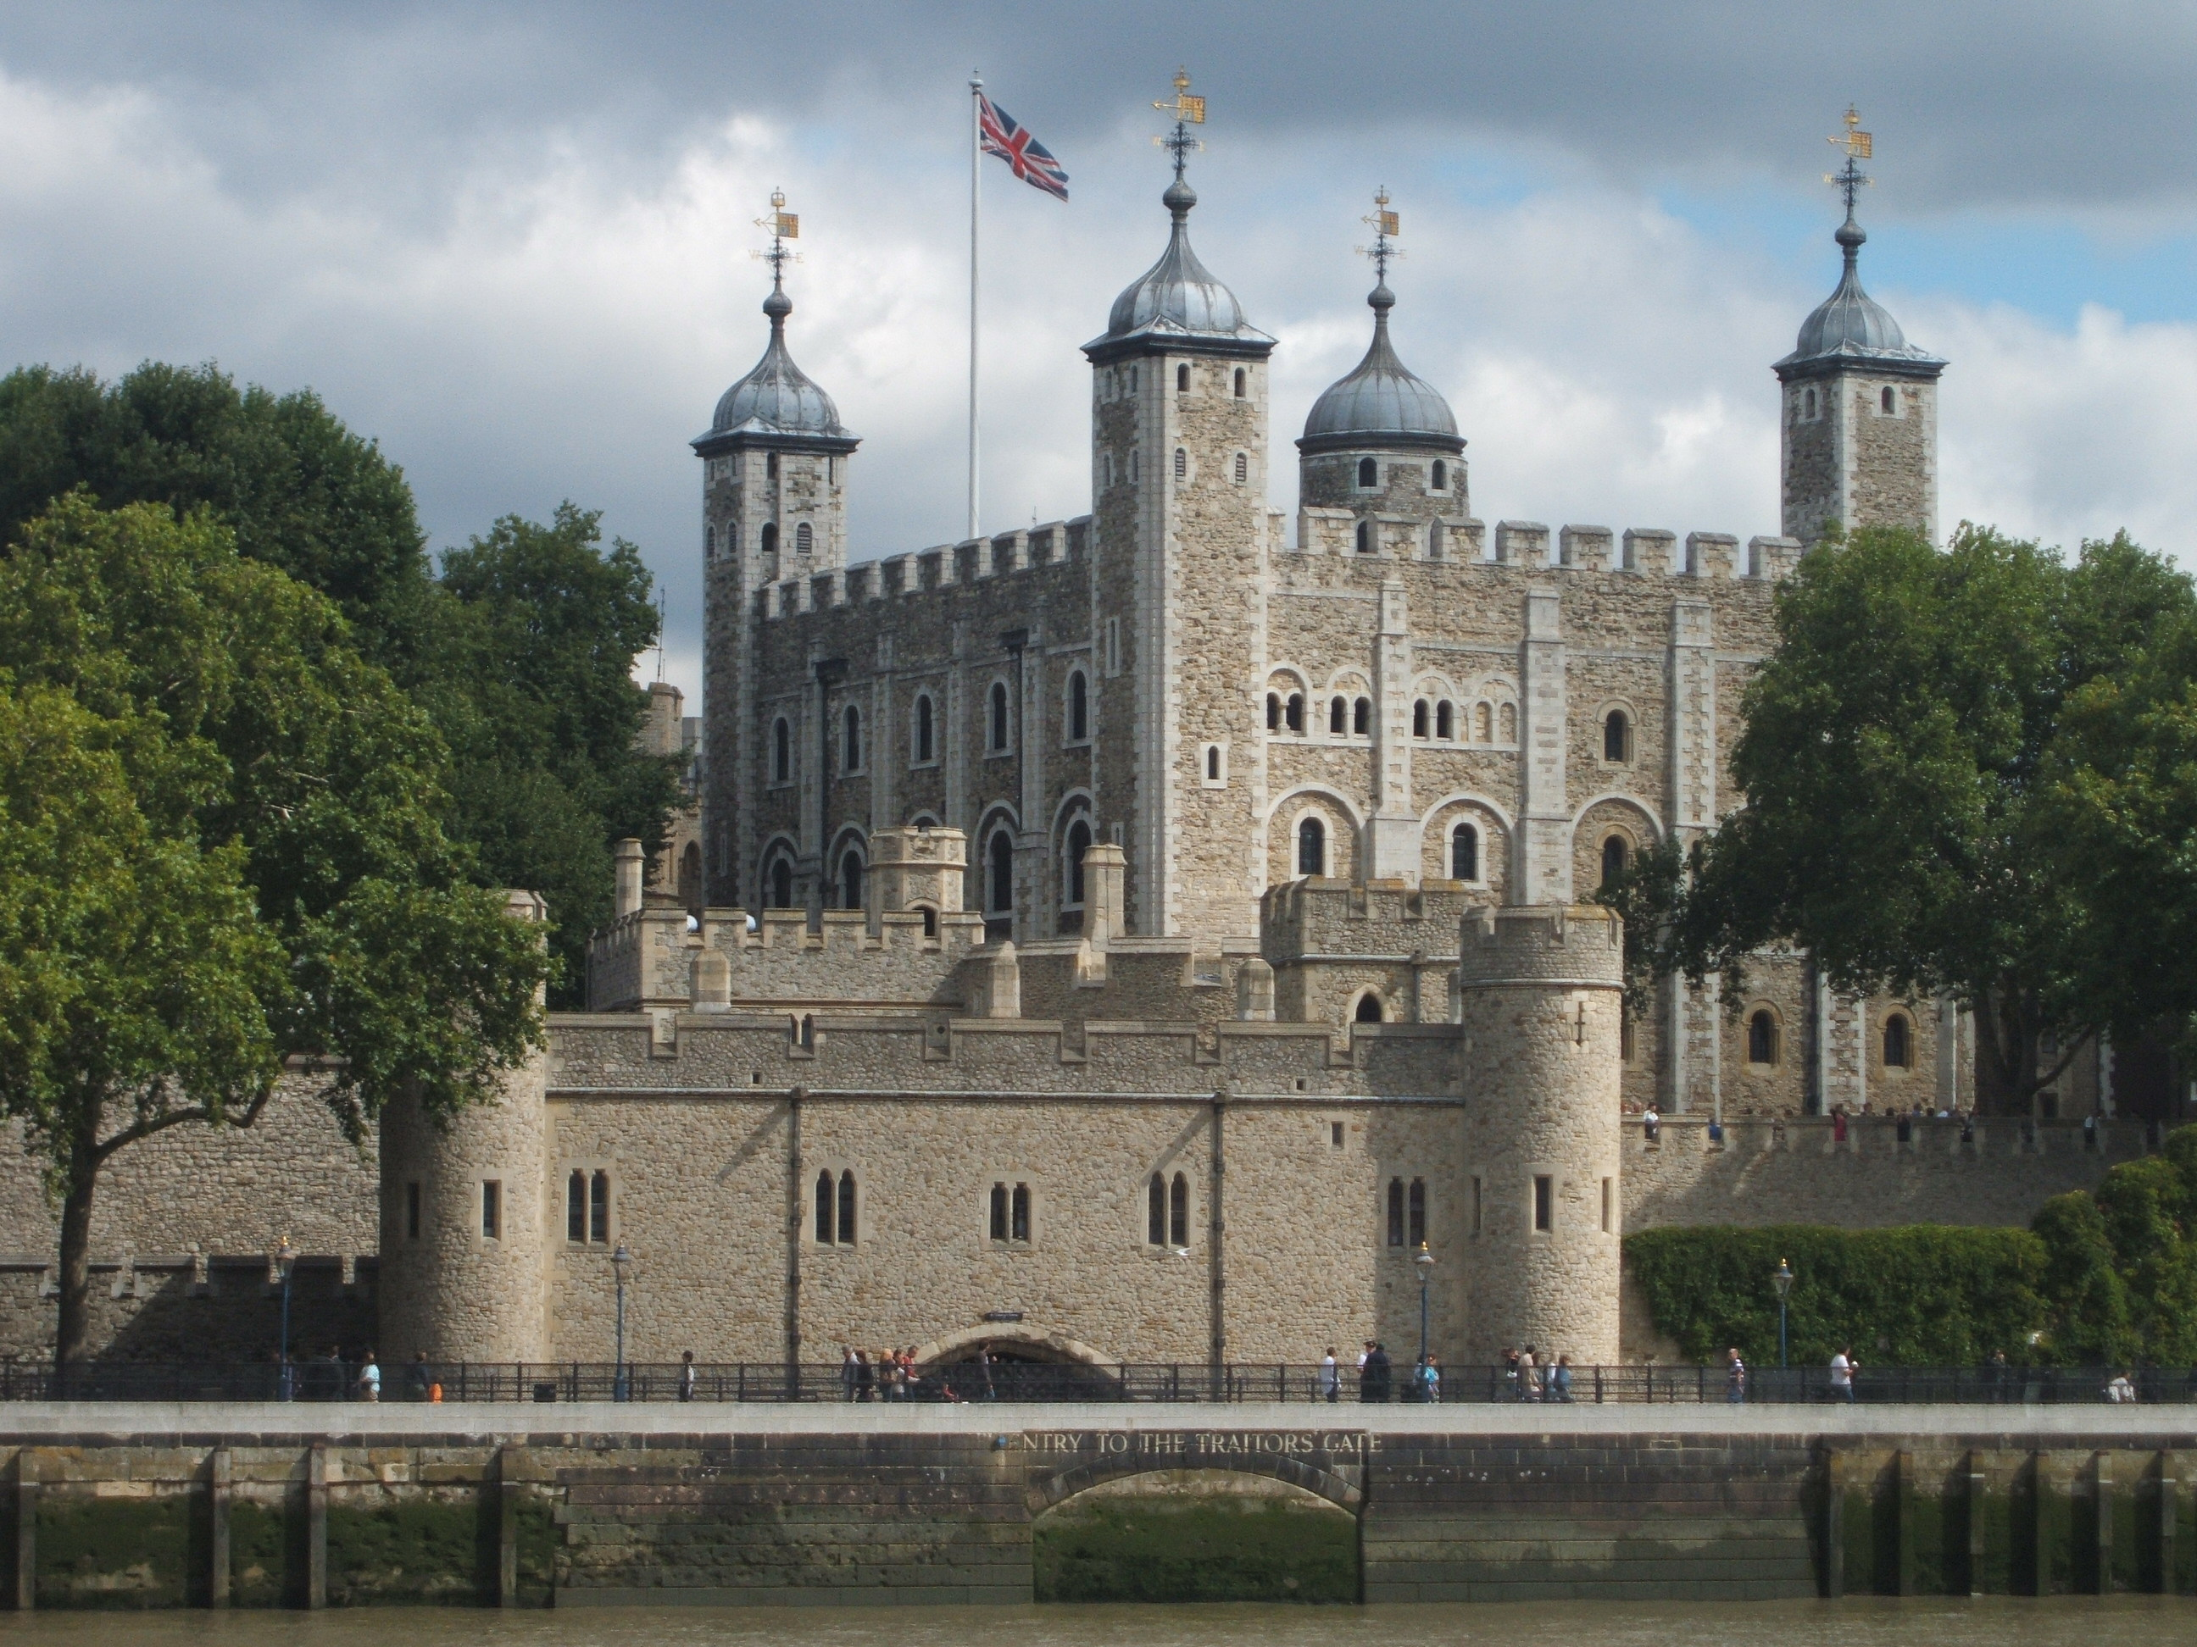  (Ss: King, Queen, Royal family)  Great. How about this picture?  (Show a picture of Tower of London 2)  What kind of people do you think might live here?  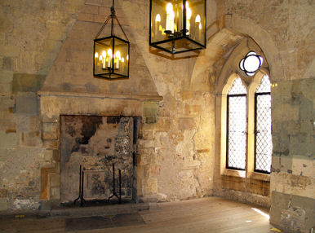  (Ss: King, Queen, Royal family)  Right. I also heard that ghosts live there. I know you guys don’t believe what I said.  But what we are going to talk about is the title called “Tower of Terror”. | T-S | 3 min

Stage 2: Presentation  The purpose of this stage is to help the students with their reading comprehension. To do this, you can pre-teach a few keywords. Guiding questions may also be used. | Inter  action | Time | Instructor’s comments
Instruction  Pre-teach Keywords  But before you reading the text, let’s learn vocabulary.  1. Fortress  - Eliciting: where do king and queen live?  - Ss: castle, palace  (Drawing a castle on the board)  Then what if there's a wall in front of the castle.  (Drawing the wall on board)  How do you call it?  - CCQ: Do we live here?  Does a beggar live here?  - Drilling (3 times)  - Write the word on the board  - syllable  - stress  2. Torture  - Eliciting: (role-play with Emma to give an example.)  I’ll show you an example. Pay attention to what I am doing. Help me Emma.  A: Tell me what happened last night!!  E: I’m not going to tell!!  A: What?!?!  (hang her hands and start to hit her)  A: Still you are not going to tell?!?!  E: Never!!!  Now what I did to her?  - Ss: hit, torture  - CCQ: Do you feel painful?  Is it a good way to punish people?  - Drilling (3 time s)  - Write the word on the board  - syllable  - stress  Guiding Question  Good job everyone. I’ll show you a picture once again. Look at this picture and think about the two questions.  (Showing the previous picture Tower of London 1)  - Can you guess where this is?  - Do you know why it’s a famous place?  Talk with your partner. I’ll give you 3 minutes.  ICQ: - Are you working with your partner?  - How many questions do you have to talk?  Now, let’s move to a reading section. When you read the text, check whether your guesses are right or not. | T-S  S-S | 7 min  3 min

Stage 3: Practice - Skimming and scanning for gist comprehension  The purpose of this stage is for students to practice their fast reading skills to identify the main idea of the text. Using visual aids such as pictures, diagrams, graphs or tables as well as headlines, subheadings and captions are useful sources of information in many authentic texts. | Inter  action | Time | Instructor’s comments
Instruction  Pre-reading (Skimming)  I’ll give you text first.  (Hand out the text)  Now, we are going to do an activity.  Match each paragraph box to a right picture by drawing a line.  You have 1 minute to do. Work individually.  (Hand out the worksheet 1)  ICQ: - Do you work in pairs?  - How many lines do you have to draw?  Are you done?  - Yes => Let’s check the answers together.  What do you think the 1~4th paragraph is?  - No => I’ll give you 30 seconds more. | T  S  T-S | 2 min  1 min  1 min

Stage 4: Practice – Detailed/Literal comprehension  The purpose of this stage is for students to locate specific information in the text quickly. | Inter  action | Time | Instructor’s comments
Instruction  Reading comprehension (Literal)  Good job everyone. I’ll give you another worksheet to do.  This time, read the text carefully and answer these first 4 questions.  I’ll give you 3 minutes to complete the task. Work by yourself.  (Hand out worksheet 2)  [Literal comprehension questions in worksheet 2]  - When was the Tower of London built?  - Later in its history, the Tower of London was used as a royal  - What is in the Tower of London?  - How often are the crown jewels worn?  ICQ: - How many questions do you have to answer?  - Do you discuss the questions with your partner?  Did you finish?  - Yes => Let’s check the answer.  (Pick one person to each the question randomly)  What do you think the question #1~4?  (After answering a question)  Did you all get the same answer?  - No => I’ll give you 30 sec more. | T  S  T-S | 3 min  2 min

Stage 5: Practice - More detailed/Interpretive comprehension  The purpose of this stage is for students to deeply understand the meaning of what is written, often by reading between the lines. | Inter  action | Time | Instructor’s comments
Instruction  Reading comprehension (Interpretive)  Good job everyone. Now, let’s do the last 2 questions.  Discuss the answers with your partner. You have 3 minutes to finish.  ICQ: - For how long?  - Are you working individually?  [Interpretive comprehension questions in worksheet 2]  - What can you guess about the Tower based on ghost stories?  - Why is the Tower of London still a popular place to visit?  (Walk around the classroom to see how well students are doing)  Do need more time?  - Yes => Okay. I’ll give you 30 seconds more.  - No => Good. Then let’s check the answers.  What do you think the answer to question 5~6?  (Get the answer from each group/pair)  (After that, explain the answer using the board) | T  S-S  T-S | 3 min  3 min

Stage 6:_Production - Applied Comprehension  The purpose of this stage is for students to practice their speaking fluency by doing some sort of communicative task. | Inter  action | Time | Instructor’s comments
Instruction  Role-play  Okay guys. We are going to do a role-play. Excited right? I will divide into group a, b, and c.  Based on the paragraph 4th starting from line 4 to 8, make dialogues about King Henry the 8th and his wife.  You have to include 3 scenes of ‘Why King Henry got mad at his wife’ ‘How he killed her’ and ‘What happened after his wife became a ghost’.  (Use the board to write key words: why, how, what)  Write 3 lines for each scene.  I’ll show you an example of scene 3.  A: Look at the moon.  E: You killed me. How could you….!!  A: Oh my God!!! Help!  Use your own imagination. You can also use realia in the classroom.  You have 4 minutes to complete.  ICQ: - What group are you?  - How many scenes are there?  - How may lines do you need for each scene?  (After that pick the group)  Come up here and show it to us.  Good job guys! | T  S-S | 4 min  7 min

Stage 7:_Wrap-up  The purpose of this stage is to close the lesson on a positive note so students are encouraged. Reviewing, summarising, giving homework, lesson feedback are all possibilities. | Inter  action | Time | Instructor’s comments
Instruction  Review  Did you all enjoy today’s lesson? What was your most favorite part?  (After listening to each student’s answer)  Good. Thank you. See you in the next time. | T-S  T | 1 min

Instructor’s Final Comments
Overall strengths of this lesson (planning and teaching) | Areas to work on

Overall comment

For this stage of the course, your lesson today was

- Above standard

- To standard

- Below Standard

Instructor: …………………………… Date: …………/……………/…………

Pre-reading

Match each paragraph box and picture by drawing a line.

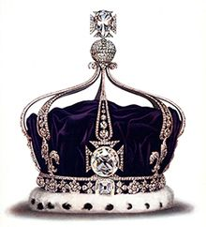
The 1st paragraph

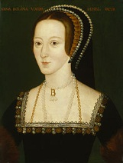
The 2nd paragraph

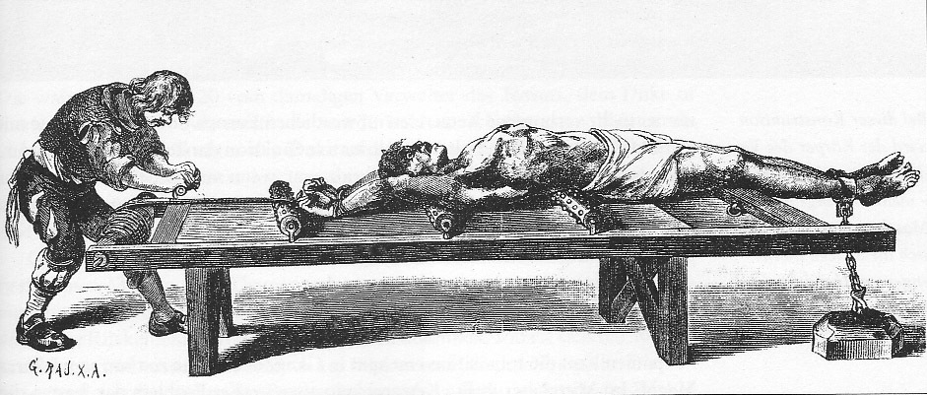
The 3rd paragraph

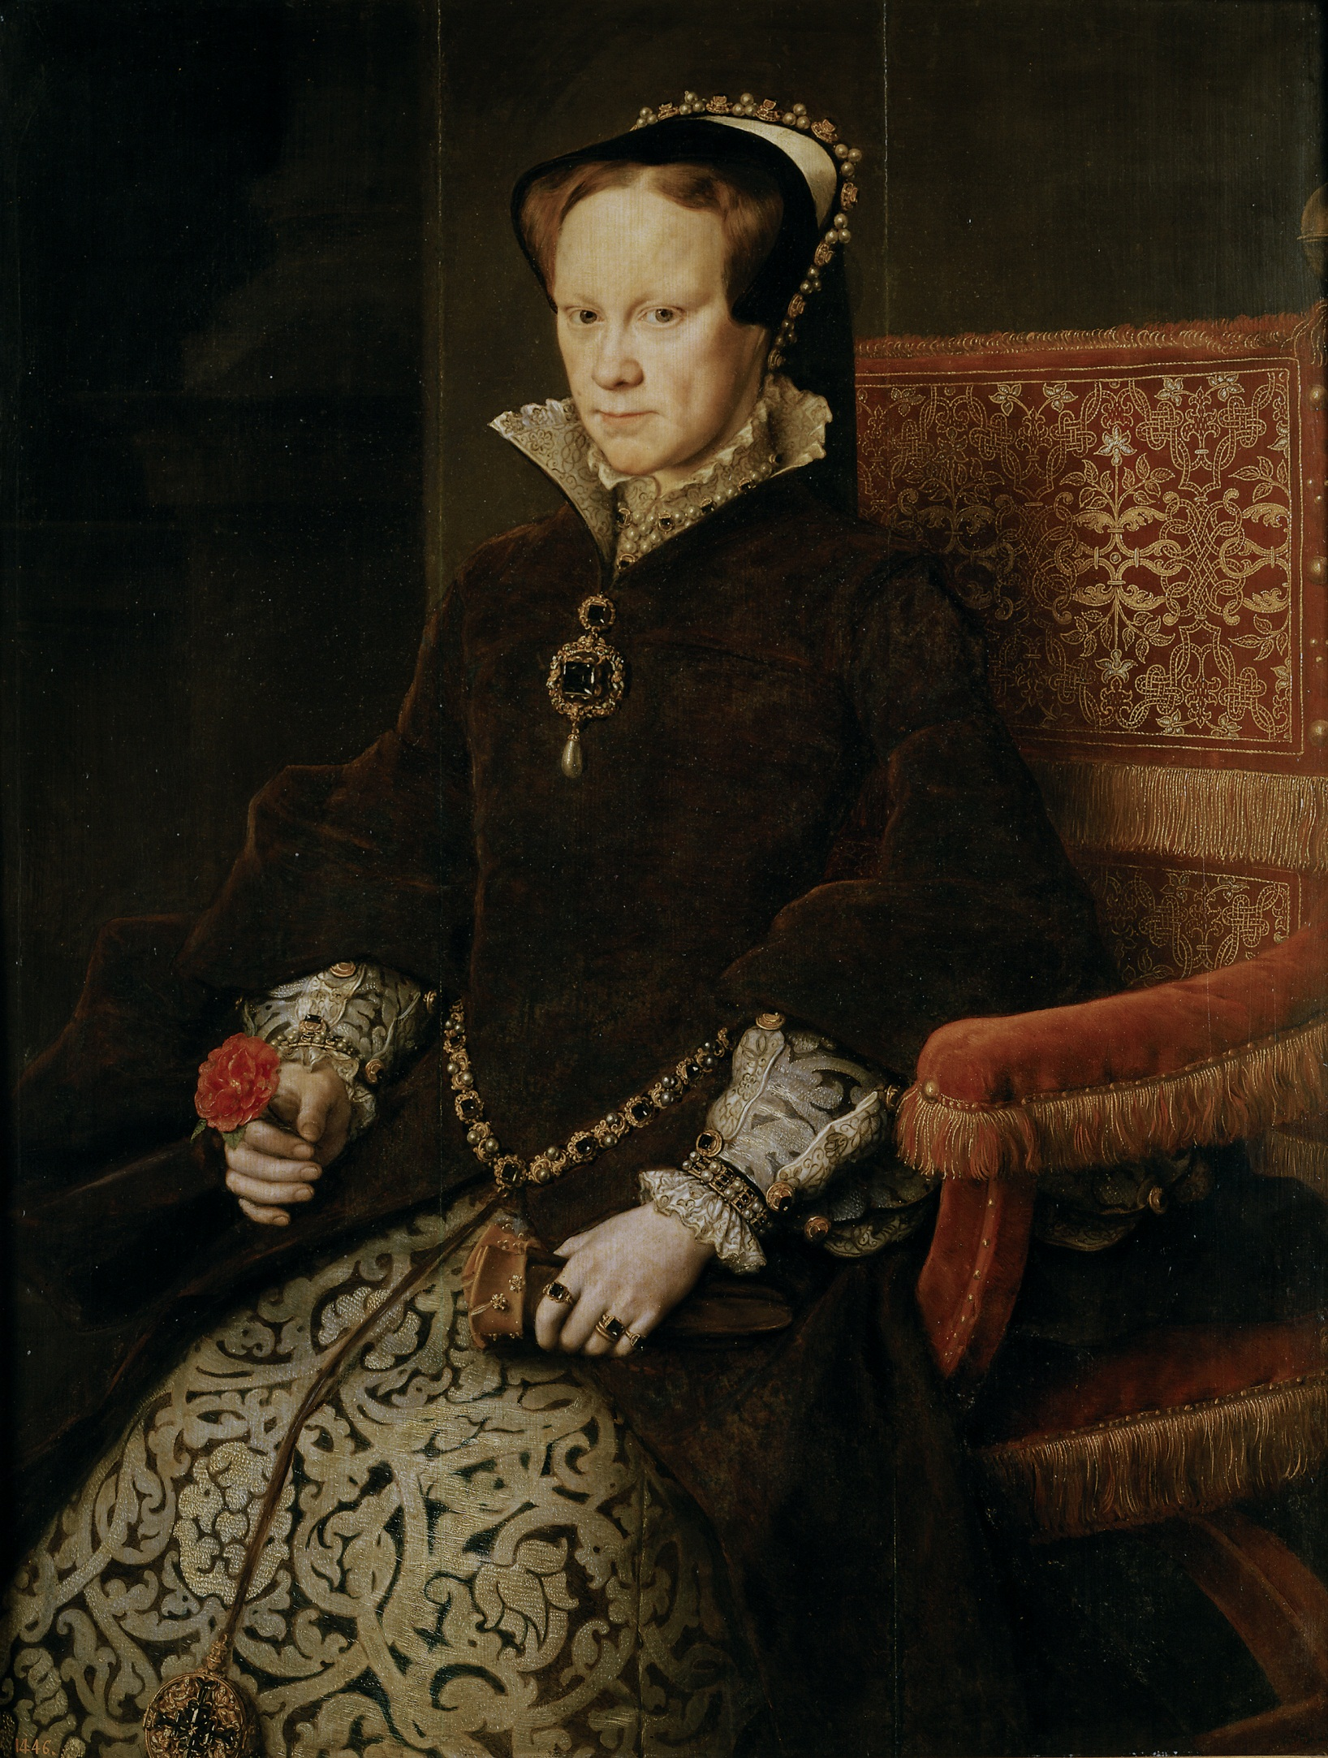
The 4th paragraph

Reading Comprehension

Answer the following questions.

1. When was the Tower of London built?
2. Later in its history, the Tower of London was used as a royal ______________.
3. What is in the Tower of London?
4. How often are the crown jewels worn?
5. What can you guess about the Tower of London based on ghost stories?
6. Why is the Tower of London still a popular place to visit?

Answer for Pre-reading

Match each paragraph box and picture by drawing a line.

The 1st paragraph

The 2nd paragraph

The 3rd paragraph

The 4th paragraph

Answer for Reading Comprehension

Answer the following questions.

1. When was the Tower of London built?
It was built in 1078.
2. Later in its history, the Tower of London was used as a royal ____jail/prison____.
3. What is in the Tower of London?
There are Queen’s crown jewels and precious treasures.
4. How often are the crown jewels worn?
There are worn a few times each year for important events.
5. What can you guess about the Tower of London based on ghost stories?
- (1st paragraph 5th line) In history, it was also used as a royal prison.
- (3rd paragraph 1-2nd line) Many people died in The Tower. Sometimes, guards would torture them to death.
→ Prisoner got killed in The Tower.
6. Why is the Tower of London still a popular place to visit?
- (1st paragraph 3rd line) It was home to English royal family…/(2nd paragraph 1st line) The royal family of England still owns The Tower.
- (2nd paragraph 2&4th line) …watch over her crown jewels there./There are many other precious treasures…
- (4th paragraph 1-2nd line) Today, many people believe that ghosts live in The Tower.

