Listening Speaking Reading Grammar Writing

Topic: Talking about “Movie”

Instructor:  Ji Soo Kim  (Jisoo),  Sun Ock Lee  (Helen) | Level:  Intermediate (Adult) | Students:  12 students | Length:  30 Minutes

Materials:
- Movie Poster (2ea)
- Topic card (6ea) & Paper cups (6ea)
- White board and board markers
- Student worksheet (12 copies)

Aims:

- Main aim: Ss will be able to improve their speaking skills by knowing and talking about their watched favorite movies & their opinions about the movies
- Secondary aim: Ss will be able to learn about useful expression & vocabulary about “Movie”
- Personal aim: I want them to enjoy talking about their personal view about the movie in English

Language Skills:
- Reading : Ss will read meanings of words about Movie & useful expressions when they talk about their personal opinion
- Listening : Ss will listen to the partner’s personal view & experience about Movie
- Speaking: Ss will talk about their personal experience & opinions about the movie as much as possible with the learned expression & words
- Writing : Ss will write 4 categories of their own film which they would like to make if they can

Language Systems:

- Phonology : pronunciation of world (genre)
- Lexis : New vocabularies in the article.(flashback, chick flick, villain, etc)
- Function : Statement of personal opinion
- Grammar : Past tense (telling about their experience to the partner)
- Discourse : Dialogue

Assumptions:
Students already know
- How the class is set up and run (there will be 12 students who already know each other)
- Four language skills and language systems
- Basic structure of sentence to me made

Anticipated Errors and Solutions:
- If students need linguistic help to express their opinions during discussion
- Give them linguistic support by providing definitions and some examples
- If some students keep quiet for fear of upsetting other people during discussion
- Encourage them to speak and advise them to be clear about their point.
- If certain students dominate the discussion
- Ask them to give other students a chance to speak

References:

-English dictionary
http://dic.daum.net/index.do?dic=ee

-Picture-

-crossword puzzle
http://www.clien.net/cs2/bbs/board.php?bo_table=useful&wr_id=216779

Lead-In
Materials:
Time | Set Up | Student Activity | Teacher Talk
1min | Whole class | Answering teacher’s questions | Good morning! How are you today?  Today, we are going to talk about “Movie”. Have you seen any movie recently? What is recent best seen movie do you think?

Pre-Activity
Materials: Worksheet #1

Time | Set Up | Student Activity | Teacher Talk
2 min | Whole class | Answering teacher’s questions | Elicit  (Show the students posters of 2 movies)  What is this?  (Poster, Movie poster)  Right. It is a Movie Poster.  Have you ever seen this movie?  Then, could you tell me what kind of movie genre is it?  (Additional explanation can be added)  Right, Good job.  Additional explanation / Model  “Today, we are going to talk about Movie & how to express our opinion about Movie.”  Write the subject “Talk about Movie” on the board
5min | Pairs | Students start writing down the words. | New words & expression related “Movie”  Instruction  “Before we start talking about our Movie experience, we should learn about some related vocabulary & knowledge. I will give you worksheet first. Read the explanation of words and fill in the blanks with the correct word from the list above. Try to guess by your own knowledge. And at the very last, you can search the word on the internet or dictionary.  Let’s do this job in pair.  (Teacher instruct the partner for each)  Work together with your partners. I will give you 5 minutes to finish.  (Distribute the worksheet #1)  ICQ  Are you working in groups or pairs?  How much time do you have?  “Let’s get it started”
2min | Whole class | Students check answers | Monitoring  Monitor discreetly. Answers students if they ask questions.  After monitoring & watching how much Ss filled in blanks, give time warning:  1 minute: 30 seconds left.  (Be flexible with time. Give 1 more minute if they need it.)  “Time’s up”  Check answers  Let’s check the answers together.  Please look at the screen for the answer, And check with your partner together.  (Answer key will appear on the screen)  (After checking, Teacher can ask some question to the students.)

Main Activity
Materials: Question cards & cups (6ea), Worksheet #2 (12 copies)

Time | Set Up | Student Activity | Teacher Talk
5min  10min | Whole class  Pair | Students ask a question to their partners after they chose a question card from a cup.  Students ask a question to their partners after they chose a question card from a cup. | Talk about each other’s experience about Movie  Instruction  Now, we are going to have Movie talk with your partner, too  (Distribute the worksheet #2 individually and cups for each team in pair)  “As you can see, there is a cup. And in the cup, there are some question cards which you will ask to your partner. Pick up one of them, and ask to your partner in turn.  And before you talk, please read this worksheet #2 and use this when you answer to your partner.  I will give you 15 minutes for this talk.  Demonstration  I will show you demonstration for your understanding.  T: “Helen, What’s the best movie you have ever seen? Explain why.  A: “My favorite movie was “XXXX”. Because the plot was so moving to me. And especially, the main actor, Leonardo dicaprio’s acting was really excellent.”  (Teacher will pick a card from cup and read the sentence and ask to one student. And the student will answer about that question.)  Work together with your partners. I will give you 10 minutes to finish.  ICQ  “Are you working in group or pair?”  (pair)  “Will you try to use this worksheet when you talk with your partner?  (wait Ss answer)  “How much time do you have? (Ss answer)  Okay, let’s begin”  Monitoring  Monitor discreetly. Answers students if they ask questions.  Give time warning:  1 minute: 30 seconds left.  (Be flexible with time. Give 1 more minute if they need it.)  “Time’s up”  Check answer  “Okay, did you enjoy the activity?”  “(call a student’ name), What kind of movies do you like? Can you tell me the reason to your friends?  (The Student answer it)  “Okay, good job.”  “(Other student name), Could you tell us your best & worst films ever?  (The student answer it)  “Okay, good job.”

Post Activity
Materials:
Worksheet #3

Time | Set Up | Student Activity | Teacher Talk
5min | Whole class | One student can be asked by Teacher for demonstration | Make your own film  Instruction  (Distribute the worksheet #3)  “Okay, Hi everybody, now, We will do another mission which is called “Make your own film”. Let’s look at the worksheet #3. As you probably know, there are 4 items which constitutes movie’s basic structure. (noticing some student),  T: “XX, Could you tell me the 4 elements of the movie in the worksheet ?  S: “genre, plot, casting & location..”  Right, so, genre is ~~~  Plot is ~~~~  Casting is ~~~  And Location is ~~~  So, here we will make our own film by these 4 elements.  Now, let’s look at the 1st example.  T: “(noticing some student by T) Could you tell me what is the genre of this film?  (S answer)  T: What is its plot?  And how about the casting?  What about the location?  (Student will answer it)  Okay, like this, you should make your own film. Please write down your own films’ 4 items. I will give you 4 minutes.”  ICQ  How much time do you have?
4min  1min  2min  1min | Individually  One student  Whole class | Students write their own film after brainstorming.  One student can volunteer to present his/her own film after completion | Monitoring  Ss will fill in the blank table individually  Check the answer  “OK, everybody, the time is up. I think you are doing well. Then let’s check the each other’s own film. Is there anybody who volunteer the presentation?”  (wait Ss response)  (if there is none, pick some student and ask them to present that out)  Conclude lesson  Review & check today’s lesson related movie together especially for new words that they didn’t know related Movie.  Feedback  “It was great that share your experience about Movie. It made you share your feeling & opinion about movie with your partner & friends.  Things to remember  “Please remember the genres of movie & other related vocabulary and try to use them as much as possible when you have a chance to talk in English with your friends.  Good job every one  You did a great work today, Thank you for participating class. I hope you enjoy the rest of your day.

SOS Activity
Materials: Worksheet # 4
Time | Set Up | Student Activity | Teacher Talk
5 min | Whole class | Students fill in the cross puzzle for review | Instruction  “Now, we have some time to review.  Do you remember the vocabularies that we have learned today?  (wait S answer)  Okay I will give you crossword puzzle work sheet  (distribute worksheet #4).  please find the word for review.  I will give you 5 minutes. Please do with your partner. Let’s get it started.  (monitoring the student’s activity)  Everybody finished?  Teacher showed the Answer key to the student.  Okay, Let’s wrap up the class and everybody, Thank you & have a nice day~!”

<Realia : Movie Poster>
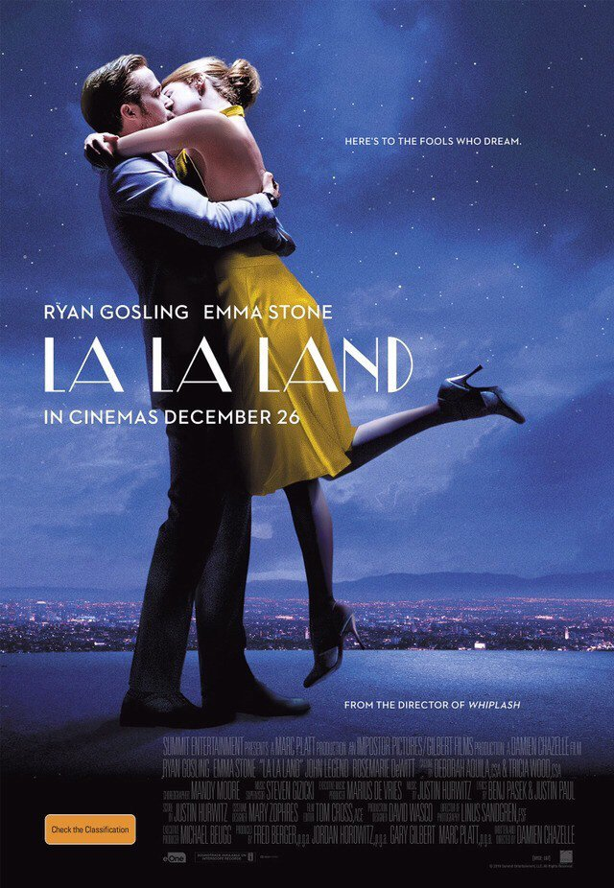

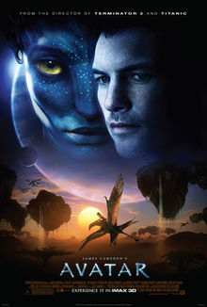
★ worksheet #1
<Words>
Fill in the blank with the word below. Match the definition.
flashback horrible breathtaking genre

heartwarming implausible animation scene

1. __________ is extremely unpleasant. It is used to emphasize how bad something.
2. something that is __________causes you to feel happy, usually
because something nice has happened to people.
3. ___________ is not having the appearance of truth
4. If you say that something is _________, you are emphasizing that it is extremely beautiful or amazing.
5. A _________ is a particular type of literature, painting, music, film, or other art from which people consider as a class.
6. A _________ is in a play, movie, or book is part of it in which a series of events happen in the same place.
7. An_________ is a film in which drawings puppets appear to move.
8. In a movie, novel, or play, ________ is that returns to events
events in the past.
<Movie Genres> Match the expressions to their meaning.
- Chick flick  - Guy movie  - Feel-good movie  - Disaster film  - Slasher film | ( ) a movie with a mysterious villain who kills multiple victims.  ( ) a movie of interest to females  ( ) a movie that has ongoing natural disasters or accidents  ( ) a movie that encourages a feeling of happiness  ( ) a movie of interest to males
Answer check
1. _horrible_ is extremely unpleasant. It is used to emphasize how bad something.
2. something that is __heartwarming _causes you to feel happy, usually because something nice has happened to people.
3. __ implausible__ is not having the appearance of truth
4. If you say that something is __breathtaking__, you are emphasizing that it is extremely beautiful or amazing.
5. A __genre__ is a particular type of literature, painting, music, film, or other art from which people consider as a class.
6. A __scene__ is in a play, movie, or book is part of it in which a series of events happen in the same place.
7. An_animation_ is a film in which drawings puppets appear to move.
8. In a movie, novel, or play, a is a __flashback__ that returns to events in the past.

<Answer check>

(5) a movie with a mysterious villain who kills multiple victims.
(1) a movie of interest to females
(4) a movie that has ongoing natural disasters or accidents
(3) a movie that encourages a feeling of happiness
(2) a movie of interest to males

★ worksheet #2

* Topic Card Game (what do you think, tell your partner)

<Answering Expression & Phrase>

<When you express about your total feeing about the Movie>

I enjoyed it./ It was great./ It was really good./I thought it was rubbish/

It was one of the best films I've seen for ages.

<…About Acting>

The acting was.../

She's a very good actress.

<About the Plot>

The plot was quite complex.

It had a good plot./

It was too slow-moving./

<Teacher’s material: Cut and let them choose in pair work>

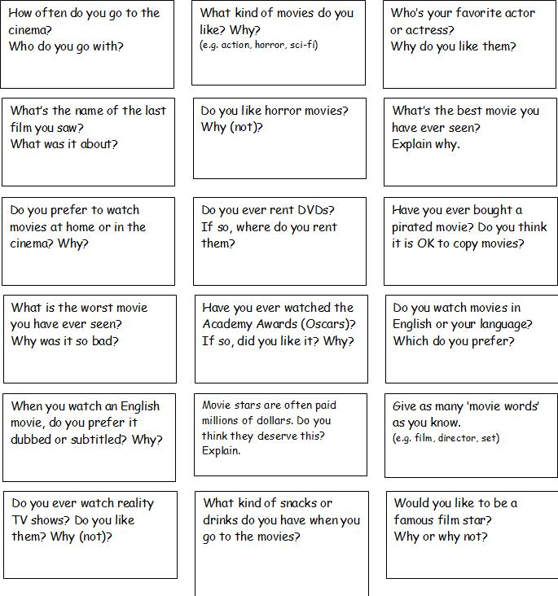Conversation cards
★ worksheet #3
If You want to make a movie, think about 4 categories as below
- Genre -------------- What kind of movie will it be?
- Plot ----------------- What is the story?
- Casting ------------ Who will be in it?
- Location ----------- Where/when will it take place?
<<Example>>
Genre
Plot | experience a variety of adventures in the alien satellite "Pandora" to solve the problem of energy
Casting
Location | Zhangjiajie National Forest Park in China
James Cameron's Avata

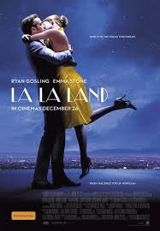
Genre
Plot | a musician and an actress who meet and fall in love, supporting each other's dream
Casting | and
Location
Damien chazelle's LaLa Land

<Make your own film~!>
Genre
Plot
Casting
Location

★ worksheet #4 <Let’s review what we learned today!!>

    - Talk about Movie
양식의 맨 위
 |  | 1
2 |  |  |  |  |  |  |  |  | 3
 |  |  |  |  |  |  |  |  |  |  | 4
 |  |  |  |  | 5
6
7
 |  |  |  | 8
 |  |  |  | 9

Across  2. you are emphasizing that it is extremely beautiful or amazing  5. someone who deliberately harms other people or breaks the law to get what he or she wants.  7. (adj.) extremely unpleasant. It is used to emphasize how bad something.  8. In a movie, novel, or play, that returns to events in the past.  9. criminally attacks others with a gun, knife, razor. | Down  1. causes you to feel happy, usually because something nice has happened to people  3. not having the appearance of truth  4. particular type of literature, painting, music, film, or other art from which people consider as a class  6. a girl or young woman (slang)

<Answer Key>
