Listening Speaking Reading Grammar Writing

Topic: Cooking Your Team’s Midnight Snack

Instructor:  CK & Jen | Level:  Intermediate(Adult) | Students:  10 students | Length:  30 Minutes

Materials:
- Brain Storming PPT
- New Vocabulary PPT
- New Vocabulary Worksheet(10 copies)
- Recipe Packet(Ingredient Handout, Sample)(10 copies)
- Recipe Template(3 copies)
- Information Gap Activity Worksheet A(5 copies)
- Information Gap Activity Worksheet B(5 copies)
- Computer, Screen, Projector, White board, Board markers

Aims:
- Main Aim: Ss will be able to improve their speaking skills by discussing their thoughts with their teammates to create their team’s midnight snack recipe.
- Secondary Aims: Ss will be able to improve their instructional writing skills by writing down their team’s midnight snack recipe.
- Personal Aim: Jen) I want them to think creatively
CK) I want to give my instructions short and simple.

Language Skills:
  - Reading: Ss will read the information given on the Receipt Worksheet to choose ingredients for their recipe.
  - Listening: Ss will listen to their teammates’ ideas on the team midnight snack.
  - Speaking: Ss will talk and share about which snack to make, which ingredients to use, and the instructions to make it.
  - Writing: Ss will write the recipe for their team’s midnight snack.

Language Systems:
- Phonology: /ē/, /n-/, /ə/
- Lexis: New vocabularies used in recipe instructions.
(mash, dice, steam, knead, beat, shred, roast, stir, simmer, poach)
- Grammar: Present Tense
- Function: Giving Information(instruction)
- Discourse: Food Recipe

Assumptions:
Students already know
- How the class is organized and operated (3 or 4 at each table)
- Which team they belong to in for team work time.
- How to structure questions and answer them grammatically.
- How to read the information given on receipts.
- What “ingredients” are.
- Four language skills and systems.
Some students may already know
- Some of the new vocabularies presented.
- Cooking vocabularies other than the presented ones.

Anticipated Errors and Solutions:
- If students need linguistic support,
    - I will encourage them to look at the context clue, and then provide them with the definition and examples.
- If a certain student contributes too much to the discussion,
    - I will introduce the round robin form of discussion to that team(There is a speaking ball. A person can only speak when he/she has the ball. When one person is done, he/she gives the ball to the next person).
- If presenters find it scary to present their team idea in front of the class,
    - I will allow them to stand up and present from their team area.

References:
Picture for Eliciting “Midnight Snack”
http://www.tiba.co.kr/upload/menu/sp_v.jpg

Recipe Template
https://kr.pinterest.com/pin/134263632610511003/

Phonetic Symbols for New Vocabulary
https://www.merriam-webster.com/

Definition of New Vocabulary
http://www.dictionary.com/

Video Clips for the Explanation of New Vocabularies
https://www.youtube.com/watch?v=en2Ur9tqFxo
https://www.youtube.com/watch?v=XpIrMRBEoLo\
https://www.youtube.com/watch?v=hqU4_5E2NGQ
https://www.youtube.com/watch?v=HbXjlFaPzOM
https://www.youtube.com/watch?v=So2CpIHTf84
https://www.youtube.com/watch?v=-AE0wqFRVo4
https://www.youtube.com/watch?v=vl7OBBTv7KY
https://www.youtube.com/watch?v=ORNiBOoLwCY
https://www.youtube.com/watch?v=N1dc_gGZIbM
https://www.youtube.com/watch?v=kIt2D8Ws64o
Lead-In
Materials: None
Time | Set Up | Student Activity | Teacher Talk
1 min | Whole class | Answering to the teacher’s questions | Good afternoon, everyone! How are you all doing? Aren't you all hungry?  (This is subject to change on when we will be presenting this lesson.)

Pre-Activity
Materials: Brain Storming PPT, New Vocabulary PPT, New Vocabulary Worksheet(10 copies), Computer, Screen, Projector, white board, board markers
Time | Set Up | Student Activity | Teacher Talk
4 min  1 min  1 min  3 min | Whole Class  Whole Class  Whole Class  Individ  ually | Brainstorming about the topic of today’s class.  Students listen to instruction.  Students work on Worksheet #1  Students answer the question. | Procedure:  - Brainstorming  Elicit  (Project Brainstorming PPT)  What is this food?  (As soon as the students say “chicken” or “fried chicken” T writes it down on the board.)  When do you eat this?  (As soon as the students say “at night” or “for Ya-Sheek” T writes “Midnight Snack” on the board.)  What are ingredients for this?  (As soon as the students say ingredients, T writes them on the board.)  How would you cook this?  (Write down the cooking order the students say on the board.)  Model  (Write the topic on the board.)  Today’s topic is “Cooking Your Team’s Midnight Snack.”  - New Vocabulary  Instruction  We are going to learn new vocabularies before we move on.  (Project New Vocabulary PPT)  After looking at the power point, connect the words with its possible meaning in the worksheet.  I’ll ask one student for one question.  ICQ  Will you work in pairs?  Are you going to connect before looking at the power point?  I will now hand out a worksheet.  (Hand out worksheet #1)  Demonstration  Look at the power point. We’ll solve #1 together. Look at #1.  (After watching the video clip)  What would be the possible meaning of the word “mash”? Right, it means…  Start activity  (After showing each video clip)  What would be the possible meaning of this word?  (Ss answer the question by turns.)

Main Activity
Materials: Recipe Packet(Recipe Ingredient, Sample)(10 copies), Recipe Template(3 opies)
Time | Set Up | Student Activity | Teacher Talk
2 min  8 min | Whole Class  Team Work | Students listen to instruction.  Students discuss and write down their team midnight snack recipe | - Overview of the Ingredients  Instruction  Let's begin our activity.  (Hand out Recipe Packet and Recipe Template)  Choose a writer, presenter, and artist in your team.  (After students chose their roles)  Writers (presenters, artists) raise your hand.  Look at the first page. Your team will make ONE midnight snack recipe using these ingredients.  Look at the second page. You may look at this sample for ideas.  Look at the recipe template. Writers, you may write the recipe on this template. Use the vocabularies we learned.  You will be given 8 minutes to complete.  ICQ  Will you work individually?  What will your team do?  How much time do you have?  You may start now.  Monitoring  (Quietly walk around the classroom. Check to see if the students are on track. Answer to questions.)  (After 5 minutes,,)  You have 3 minutes left.  (After 3 minutes,,)  Time’s up. You did a great job.

Post Activity
Materials: Recipe Packets from Main Activity, white board, board markers
Time | Set Up | Student Activity | Teacher Talk
5 min  3 min  2 min | Whole Class  Whole Class  Whole Class | Teams present their recipes in front of the class.  Students vote for the best team with the best recipe.  Students listen and answer to the teacher’s questions. | 1. Presentation  Instruction  Each team will present their recipes in front of the class. Audience, please listen to the recipes because we will vote for the best midnight snack after this. You have 2 minutes to present.  ICQ  What will the teams do?  What will the audience do?  Sharing  Group 1, presenter and artist come up.  (After Group 1, call out Group 2, and then Group 3)  Voting  Let’s vote for the best team, individually. You may vote for 1 team only. Raise your hand to vote for them.  If you win, you will get a prize.  ICQ  Will you vote as a team?  How many will you vote for?  How will you vote for them?  Who votes for group 1(group 2, group 3)?  (After counting all the votes)  The winner is group ____!  Congratulations.  (Give out prize)  - Conclusion  Let’s review today’s lesson.  What are the new vocabularies?  Some are hard to pronounce.  Error Correction  - Stir: [stər] instead of *[steer]  - Simmer: [simmər] instead of [simmer]  - Steam: [stēm] instead of *[steam]  - Knead: [nēd] instead of *[kneed]  - Beat: [bēt] instead of [bit]  You did a great job today! Try to keep in mind of the content and vocabulary we’ve learned. Thank you.

SOS Activity
Materials: Information Gap Activity Worksheet A(5 copies), Information Gap Activity Worksheet B(5 copies)
Time | Set Up | Student Activity | Teacher Talk
5 min  2 min | Partner  Whole class | Students complete the information gap worksheets.  Students check answers | 1. Information Gap Activity  Instruction  Now, we are going to complete an information gap activity with partners. So, ask and answer questions to your partners to fill the information up. However, please do not show your papers to your partner. You will have 5 minutes to do so.  (Hand out Information Gap Worksheet A to one of the partners, and B to the other partner)  ICQ  Will you work alone?  What will you do with your partner?  How much time will you have?  You may start now.  Monitoring  (Quietly walk around the classroom. Check to see if the students are on track. Answer to questions.)  (After 3 minutes,,)  You have 2 minutes left.  (After 2 minute,,)  Time’s up. You did a great job.  Check answer  Each student will go around and read each sentence with the vocab out loud.
<Brainstorming PPT>
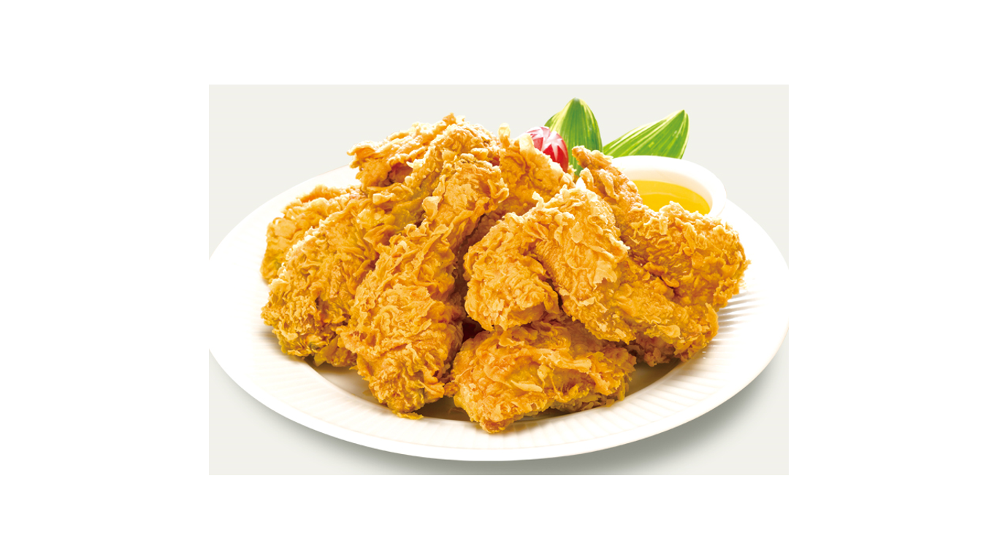
<New Vocabulary PPT>

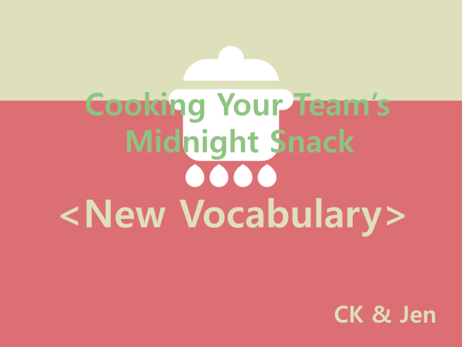
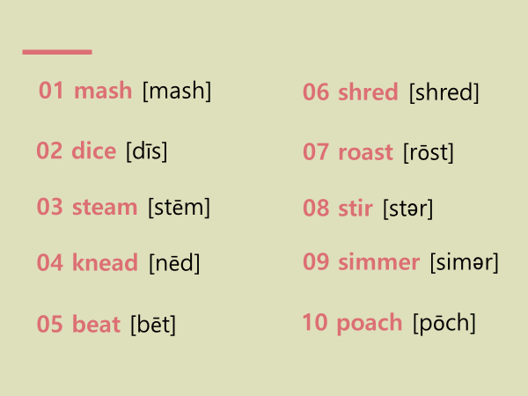

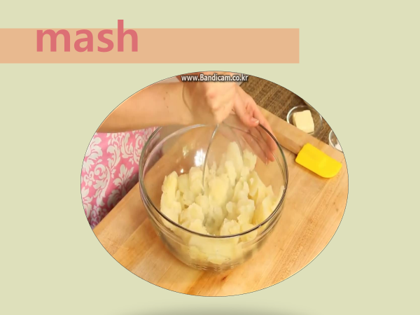

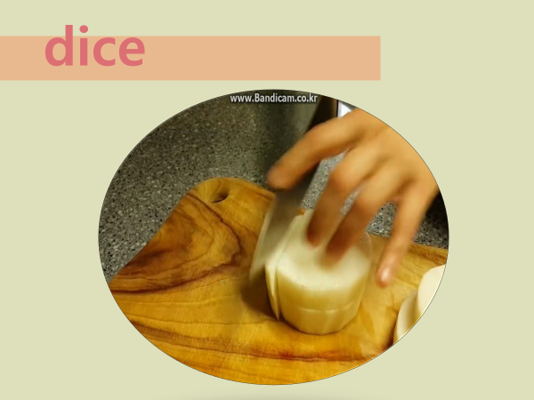

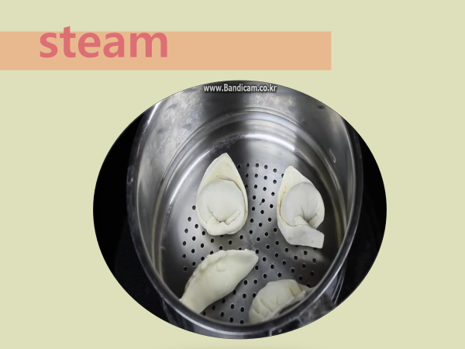

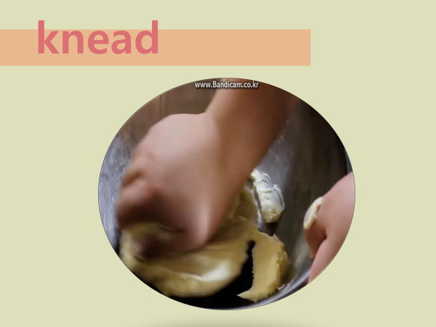

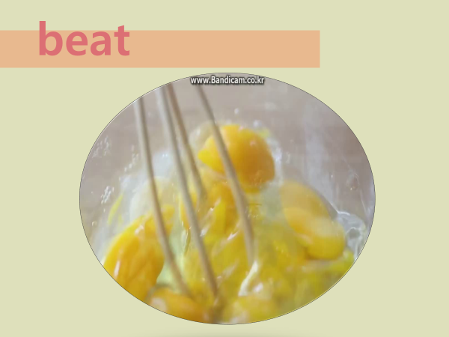

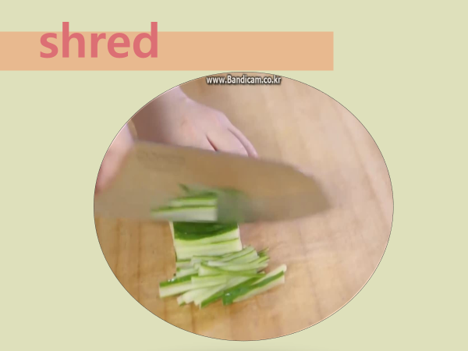

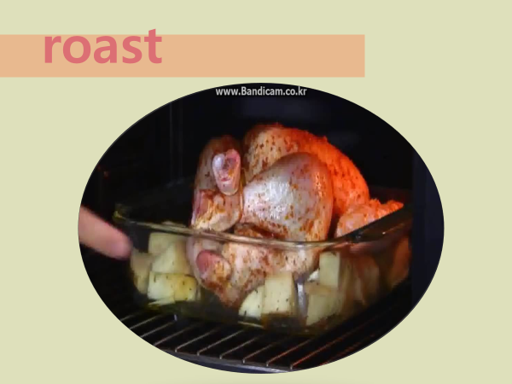

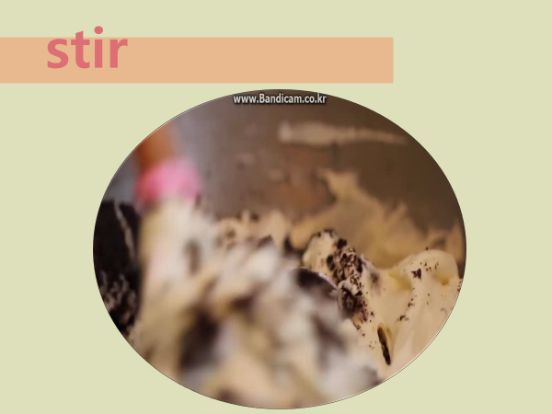

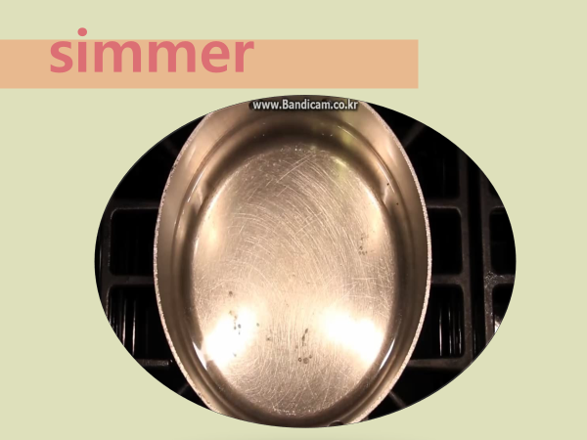

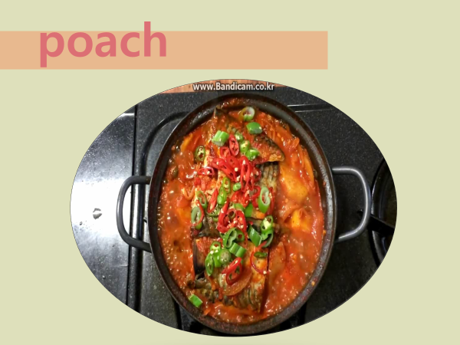

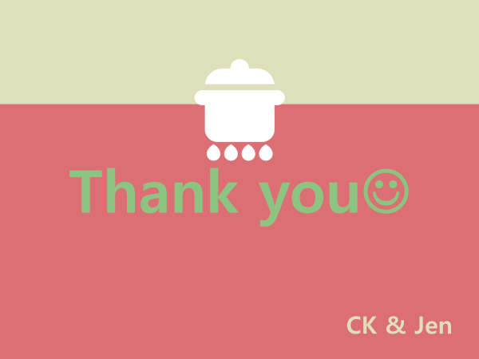

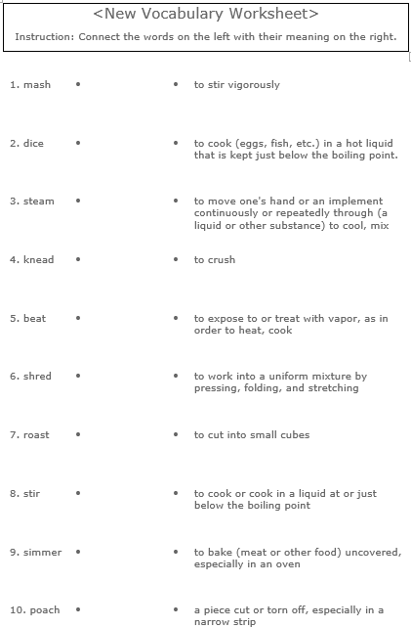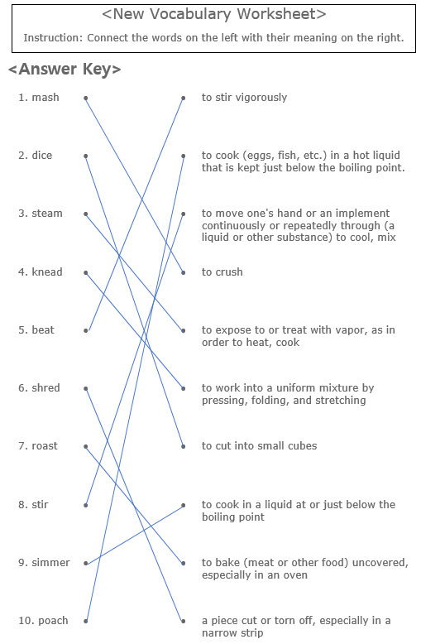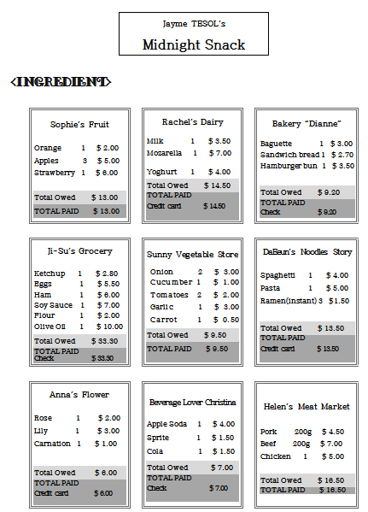

<Recipe Template>

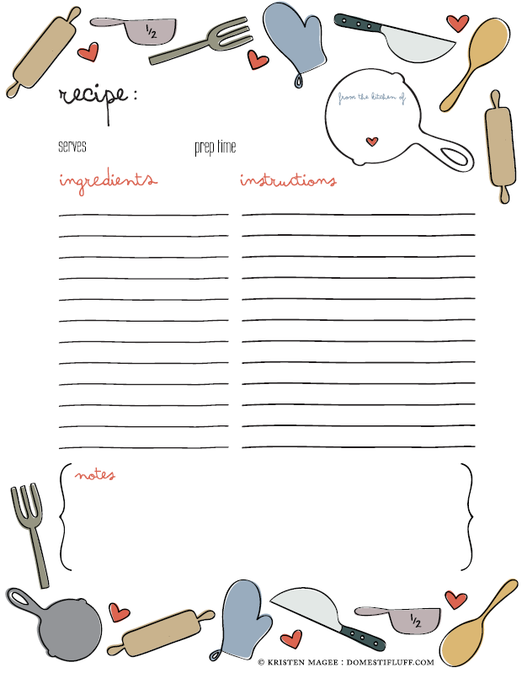

<Recipe Sample>
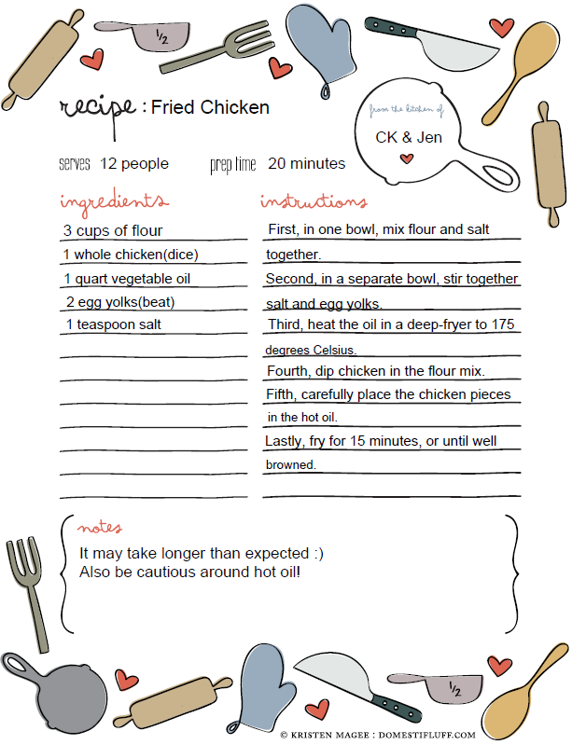

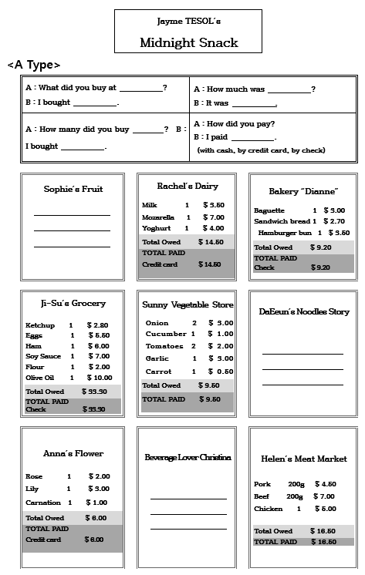
<SOS Activity – Information Gap Activity>

