Worksheet #1
- Fill the blank individually and check the answer with your partner.
1 Practice
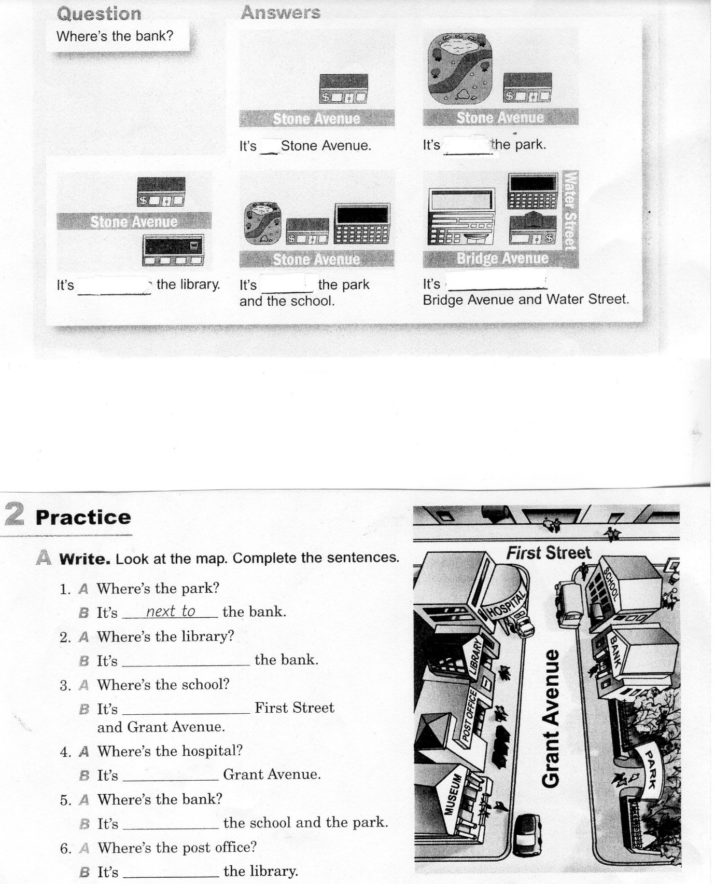
Worksheet #2 : Grammar game
- Work in a group. Solve the map puzzle. Read the clues. Write the names of the places.
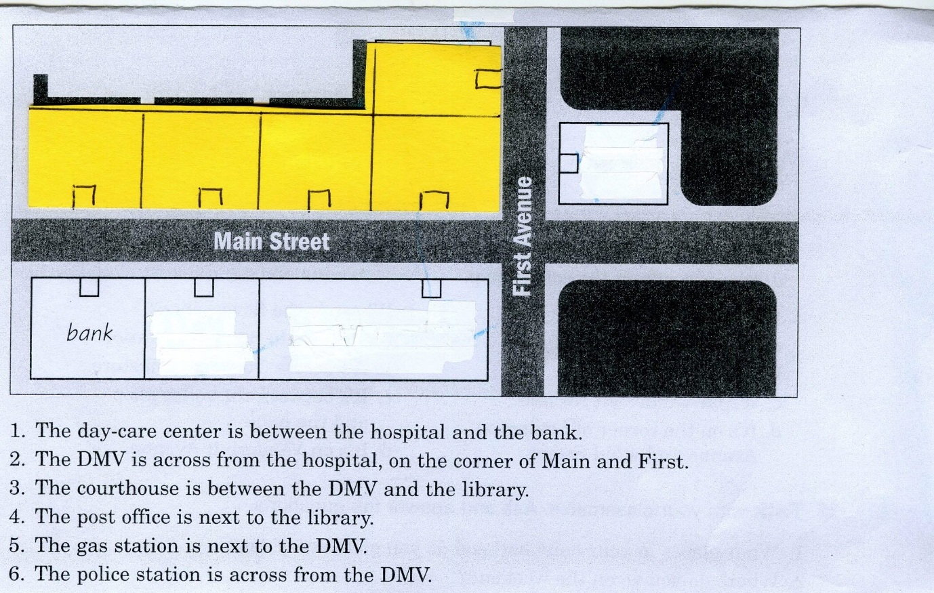

B. Look at the map and answer the questions.
1. Where is the bank?
2. Where is the library?
3. Where is the post office?

Worksheet#3 : Role play
Create simple role play with your partner describing the location of a building.
