Listening Speaking Reading Grammar Writing

Topic: Can You Follow Instructions?

Instructor:  CK | Level:  Intermediate(Adult) | Students:  11 students | Length:  20 Minutes

Materials:
- Brain Storming PPT
- New Vocabulary PPT
- New Vocabulary Worksheet (11 copies)
- Main Activity PPT
- Main Activity Worksheet (11 copies)
- Answer PPT
- Lined Paper (11 sheets)
- SOS Worksheet A and B each 12 copies
- Computer, Screen, Projector, White board, Board markers

Aims:
- Main Aim: Ss will be able to improve their reading skills by reading and following the instructions on the main activity worksheet.
- Secondary Aims: Ss will be able to improve their writing skills by writing their own instructions for their instructional games.
- Personal Aim: I want to give my instructions short and simple.

Language Skills:
  - Reading: Ss will read the information given on the main activity worksheet and other’s instructional game.
  - Listening: Ss will listen to the teacher’s Instruction Check Questions.
  - Speaking: Ss will answer to the teacher’s Instruction Check Questions and other questions.
  - Writing: Ss will write their own instructional game.

Language Systems:
- Phonology: / i / , / ə /
- Lexis: New Vocabularies
(reverse, punch, nearly)
- Grammar: Present Tense
- Function: Following Instructions
- Discourse: Information

Assumptions:
Students already know
- How the class is organized and operated
- How to structure grammatical sentences.
- How to multiply two-digit numbers by one-digit number.
- How to add greater numbers.
- What even numbers are.
- Four language skills and systems.
Some students may already know
- Some of the new vocabularies presented.

Anticipated Errors and Solutions:
- If students need linguistic support,
    - I will encourage them to look at the context clue, and then provide them with the definition and examples.

References:
Example Sentences of New Vocabulary
http://www.dictionary.com/
Synonyms of New Vocabulary:
http://www.thesaurus.com/
SOS Activity Drawing: http://www.makinglearningfun.com/themepages/FollowingDirectionsDirectory.html

Lead-In
Materials: None
Time | Set Up | Student Activity | Teacher Talk
1 min | Whole class | Answer to the teacher’s questions | Good afternoon, everyone! How are you all doing?

Pre-Activity
Materials: Brainstorming PPT, New Vocabulary PPT, New Vocabulary Worksheet 11 copies
Time | Set Up | Student Activity | Teacher Talk
2 min  2 min  1 min | Whole Class  Indivi-dual  Whole Class | Brainstorm about the topic of today’s class.  Listen to instruction and then complete worksheet.  Check answer together. | Procedure:  - Brainstorm  Elicit  (Project Brainstorming PPT)  What do you see?  Yes, but the words are scrambled.  How would you unscramble this?  Correct, “Draw 2 squares in the center.”, “Put a triangle around each square.”  Model  (Write the topic on the board.)  Today’s topic is “Following Directions.”  - New Vocabulary  Instruction  We are going to learn new vocabularies before we move on.  (Project New Vocabulary PPT)  You will do this individually. When you get the handouts, first, read the words on the left. Then, write the letter of the synonym on the blank. You will have one minute to finish.  ICQ  Will you work individually?  What is the first step?  What is the second step?  How much time do you have?  Monitoring  (Quietly walk around the classroom. Check to see if the students are on track. Answer to questions.)  (After 30 seconds,,)  You now have 30 seconds left.  Time’s up.  Check Answers  Let’s check the answers together.

Main Activity
Materials: Main Activity PPT, Main Activity Worksheet 11 copies
Time | Set Up | Student Activity | Teacher Talk
2 min  4 min  2 min | Whole Class  Indivi-dual  Whole Class | Listen to instruction.  Complete activity.  Check answer together. | - Introduction to Main Activity  Instruction  We will now do an activity named, “Can You Follow Instructions?” There are a lot of instructions on the paper. Your goal is to follow the instructions on the page correctly! You will do this individually. You will be given 3 minutes to complete.  Demonstration  (Project Main Activity PPT)  Let’s do #1 and 2 together.  ICQ  Will you work individually?  What will you do?  How much time do you have?  (Hand out Main Activity Worksheet)  You may start now.  Monitoring  (Quietly walk around the classroom. Check to see if the students are on track. Answer to questions.)  (After 2 minutes,,)  You have 1 minute left.  (After 1 minute,,)  Time’s up. You did a great job.  Check Answers  Let’s check the answers together.

Post Activity
Materials: lined paper(11 sheets)
Time | Set Up | Student Activity | Teacher Talk
1 min  4 min  1 min | Whole Class  Indivi-dual  Whole Class | Listen to instructions  Make own game  Answer to teacher’s questions | - Introduction to Post Activity  Instruction  Now it’s your turn to make an instruction game. You will have five-instructions in your game. After you’re done, we’re going to switch with each other, and play someone else’s game. You will be given 3 minutes to complete.  ICQ  How many instructions will you have?  How much time do you have?  What will you do after you’re done?  (Hand out lined paper)  You may start now.  Monitoring  (Quietly walk around the classroom. Check to see if the students are on track. Answer to questions.)  (After 2 minutes,,)  You have 1 minute left.  (After 1 minute,,)  Time’s up. You did a great job.  Playing  Pass your game to the person on the left. You have 1 minute to complete the mission.  You may start now.  (After 1 minute,,)  Time’s up.  - Conclusion  Let’s review today’s lesson.  What are the new vocabularies?  (Do error correction if students found it hard to pronounce these words)  Some are hard to pronounce.  Error Correction  - Reverse: [ri-vərs] instead of *[re-vers]  - Punch: [pənch] instead of *[poonch]  You did a great job today! Try to keep in mind of the content and vocabulary we’ve learned. Thank you.

SOS Activity
Materials: SOS Worksheet A and B each 12 copies
Time | Set Up | Student Activity | Teacher Talk
1 min  2 min  2 min | Whole Class  Indivi-dual  partner | Listen to instructions  Make own instructions  Play game | - Introduction to SOS Activity  Instruction  Your goal is to make 3 instructions for a drawing. You will do this individually. You will be given 2 minutes to complete.  ICQ  Will you work individually?  What will you do?  How much time do you have?  (Hand out SOS Worksheet)  You may start now.  Monitoring  (Quietly walk around the classroom. Check to see if the students are on track. Answer to questions.)  (After 2 minutes,,)  Time’s up. You did a great job.  Instruction  Now partner up. You will read out the instructions you wrote down, and your partner will listen to it and do it. You will have 1 minute.  (After 1 minute,,)  Time’s up. You did a great job.  Now the other partner will have a turn.  You will have 1 minute.  (After 1 minute,,)  Time’s up. You did a great job.

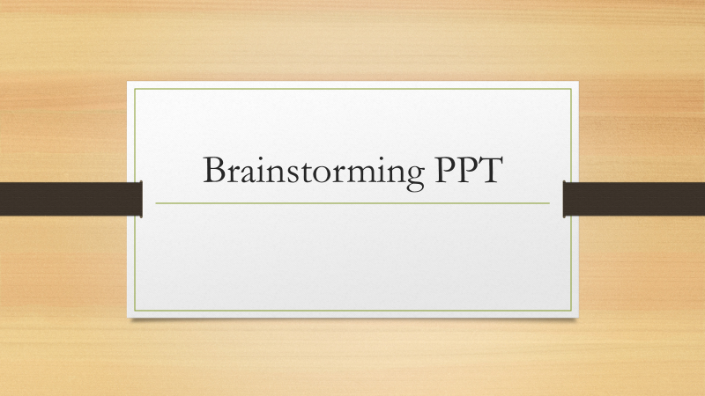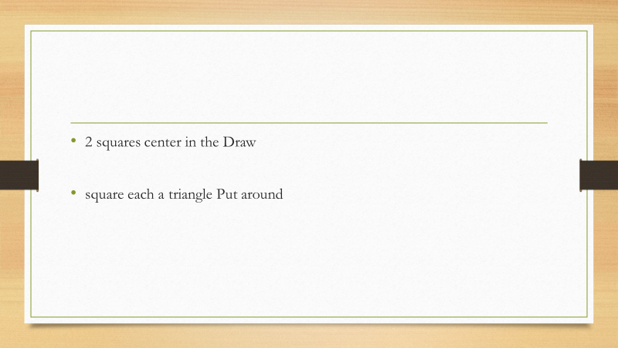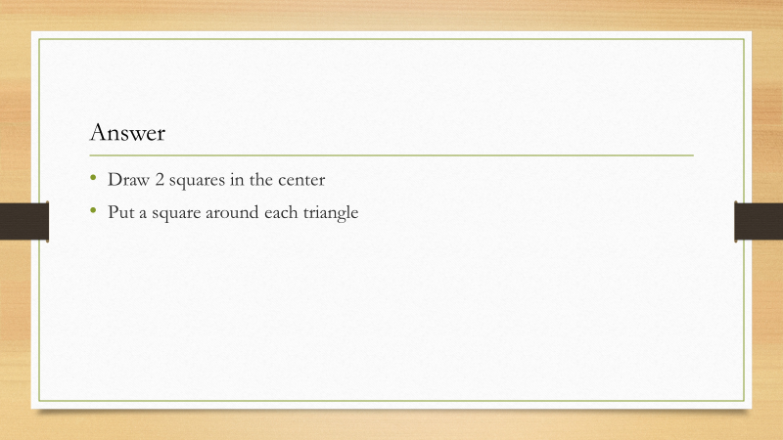

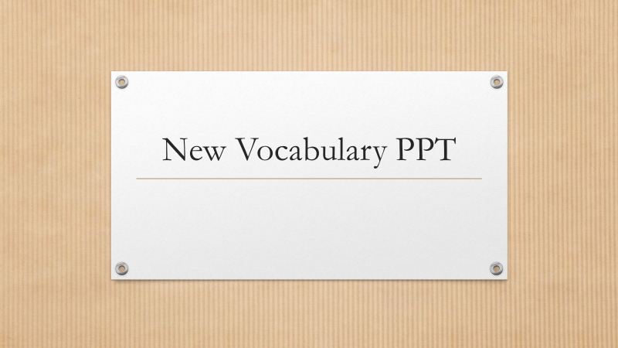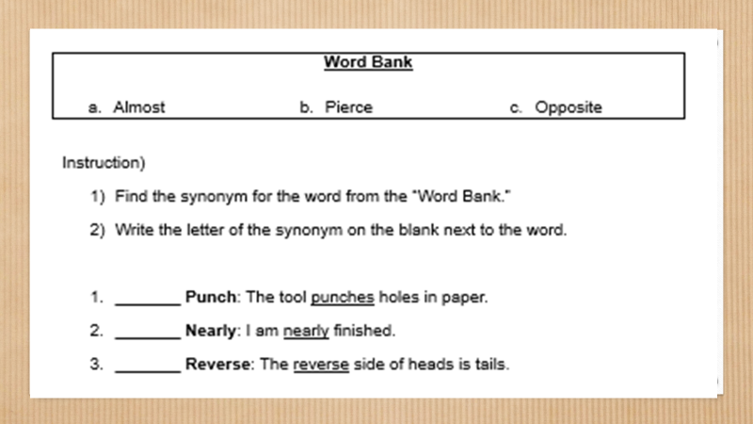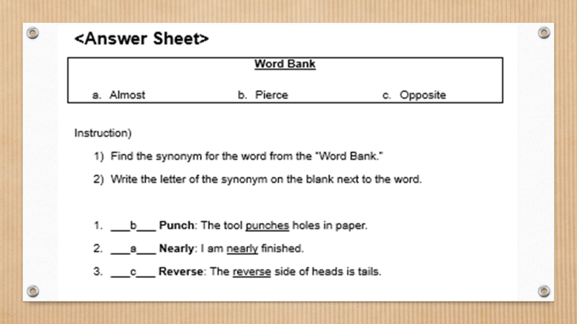

<New Vocabulary Worksheet>
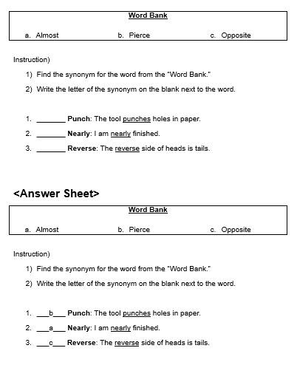

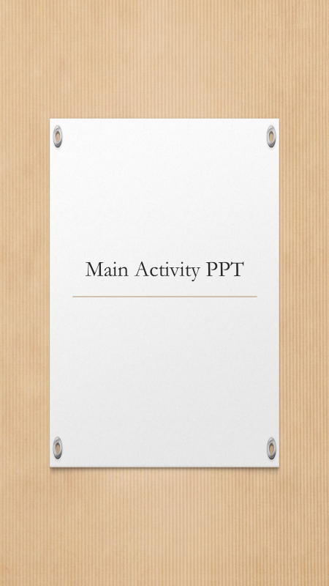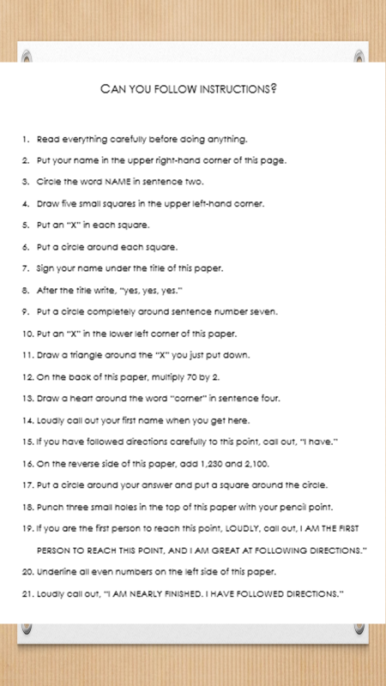
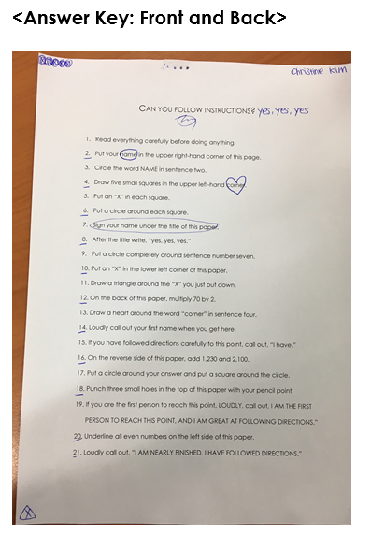
<SOS Activity Worksheet A and B>
