☐ Listening ☐ Speaking ☐ Reading ☐ Writing
☐ Intergrated ☐ Grammar
Topic:
Clothes - What are you wearing?

Instructor:  Florence | Level:  10 | Students:  12 | Length:  30 Minutes

Materials:
Real clothes (T Already wearing)
- hats, socks, pants, blouse /
Flashcards (colors, patterns, kind of Clothes)
- Rainbow colors, Black and White colors / Dot, Stripes, star, Flowers,
Diamonds patterns /
Dress, Socks, Pants, Tee-shirt, Skirt, Hat, Blouse /
Activity boards (Using belcros) / pieces of various kind of clothes / Pockets /
Worksheet (Clothing match) /
Hello song / Good-bye song / Speaker / Phone

Aims:
Main Aim : Ss will practice clothing vocabulary and Answer the Q "What are
you~?" by doing the paper doll activity.
Secondary Aim : Ss practice speaking by talking to each other about what
they are wearing.
Personal Aim : I aim to Ss will feel more comfortable when they are talking.

Language Skills:
Speaking : Ss communicate with each other by talking about what they are
wearing.
Reading : Ss read the flash cards about clothing.
Listening : Ss listen to the T's explain and other S's talking.
Writing : Ss write about what they learned in class on worksheet. (clothing match)

Language Systems:
Phonology : Ss prononciate the “-th” and “-ing”.
Lexis : Ss can learn the vocabulary about clothing. (Blouse, Pants, Dress)
Grammar : Continuous - "What are you wearing?" OR "Are you wearing a ~?"
"I'm wearing a ~." OR "Yes/No. I'm wearing a ~."
Discourse : Quastion and Answer by doing paper doll activity.
("What are you wearing?" , "I'm wearing ~.")
Function : Ss know how to Q&A about what they are wearing.

Assumptions:
S Already know -
1. Ss already know about the kind of colors.
(Rainbow colors, Black and White)
2. Ss already know about the kind of clothes.
(Dress, Socks, Pants, Tee-shirts, Skirts, Hats, Blouse)
3. Ss already know about the kind of patterns.
(Dot, Stripes, star, Flowers, Diamond)
4. Ss can sing Hello and Good-bye songs.
5. Ss can read short sentence.
6. Ss know the order of wearing clothes.

Anticipated Errors and Solutions:
1. If some Ss don't understand T's instruction about Paper doll activity.
- T can teach by doing together little at the first time.
2. If some Ss don't know the kind of clothes because of absent.
- T can review the kinds of clothes by showing her wearing clothes.
3. If some Ss don't want to join the paper doll activity.
- T ask them the reason and suggest them to join the activity or to make a team with other S who accept it.
4. If Ss can't express what they want to talk.
- T can help them by wispering to each of them.

References:
- SOS worksheet
https://www.slideshare.net/MJSIMOES/clothes-crossword
- Hello song
https://www.youtube.com/watch?v=tVlcKp3bWH8
- Good-bye song
https://www.youtube.com/watch?v=PraN5ZoSjiY

Lead-In
Materials:
T wearing clothes that S can check the colors, patterns.
Hello song (Speaker, Phone, Mp4 File)
Time | Set Up | Student Activity | Teacher Talk
1m  2m |  | (Answer the Q) I'm happy!  Sing hello song together.  (Answer the Q) Pretty! | - Greeting  T : Hello, everyone!  How are you today?  T : Are you happy today?  Good!  T : (Hello song) Let's sing hello song!  T : (Showing clothes)  everyone, look at me!  Today, i'm wearing a blue-stripe  blouse! isn't it pretty?  Also, i'm wearing a blue pants and  white socks.

Pre-Activity
Materials:
Flashcards / Picture
Time | Set Up | Student Activity | Teacher Talk
6m |  | Guess what colors, patterns,  kind of clothes.  Answer the eliciting Q  (Watching picture.) | - Review Quiz  T : Everyone! here is my flashcards.  Can you remember the colors,  patterns, and kind of clothes?  T : Let's check it out!  T : This is the rainbow colors.  Guess What it is!  T : Red, Orange, Yellow, Green,  Blue, Navy, Purple.  T : And there are 2 more colors.  Can you remember?  T : Yes! Black and White! Good!  T : And Let's see patterns.  T : There are many lines in this  pattern.  T : Yes, it's a stripe pattern!  (Review other patterns and clothes  like this way - Quiz)  - Eliciting  T : Let's see this picture.  What colors can you see?  T : Yes! You can see the red colors.  And what pattern can you see?  Yes! You can see the dot pattern.

Main Activity
Materials:
Flashcards / Activity Board (Paper doll Activity materials)

Time | Set Up | Student Activity | Teacher Talk
4/15m  2/15  m  7/15  m  2/15m |  | Take materials.  Response to drill  C! : I will ask to sam,  "Are you wearing a  blue star pattern pants?"  Dress-up paper doll.  Communicate with others  to guess what they dressed-up.  C1 : what are you wearing?  Are you wearing a blue  dot pants?  C2 : yes. I'm wear a blue  dot pants.  How about you?  What are you wearing?  Are you wearing a  red stripe socks?  C1 : No. I'm wearing a  yellow socks.  .  .  .  asking to friends, they  dress-up another paper  doll to guess their friend's  dress-up.  C2 : I'm done!  Wait other friends finish the  activity by answering C1's  quastion.  All of Ss finish the activity.  Show their paper dolls.  Compare their guess with  others paper doll.  Answer the Q. | - Instruction  T : Now it's time to activity~! Yeah!!  T : Let me explain how to do it.  - All of you take a activity  board and some belcro pieces  of clothes. There are many  clothes.  - And you can dress-up your paper doll by using these  belcro clothes. Let me show  you.  - Demonstration  T : I want this yellow stripe blouse  and red socks and blue star  pattern pants! See! It's done.  but it is very important that don't  see others dress-up. Okay?  T : And when we finish the dress-up,  we can ask to each other.  - Drilling (Utterance Response Drill)  T : Let's say "What are you wearing?"  "Are you wearing a blue dot  pants?"  T : Also, we can answer the Q.  "Yes. / no. I'm wearing a blue dot  blouse."  T : by doing this, we can guess other  friends dress-up.  - ICQ  T : Okay. then I have a quastion.  C1, if you ask to C2 if she  dressed-up the paper doll with  blue star pattern pants, what  will you do?  T : perfect! if you finish to guess the  other friend's dress-up, raise your  hands and say "I'm done!" Okay?  - Activity  T : Don't make others watch your  dress-up~! I will give you 2 minute.  - Monitering  T : Now, Ask your friends what you  imagine and also answer the question about your dress-up. If you need any help, tell me and I will help you.  - Error correction  T : oh, C2. It would be better to say  "I'm wearing a blue dot pants."  - Finish activity  T : Are you finish? then, let's wait  for C1,can you?  T : Okay. Now let's check each other!  Show your paper doll, pleas~!  T : Each of you have to check that  your guess are exactly.  Is that correct?  T : Great!  - Feedback  T : Okay. Everyone, are you enjoy  this activity?

Post Activity
Materials:
Worksheet (Pencils, erasers) / Good-bye song
Time | Set Up | Student Activity | Teacher Talk
2/8  m  5/8  m  1/8  m |  | Read the Instruction.  C1 : I will match red colors  with dot and blouse.  C1 : I'm wearing orange  stripes socks.  C2 : Okay. I can match!  It's your turn. Go ahead.  C1 : We dress-up our  paper doll!  C2 : We can ask to each  other "What are you  wearing?" And answer  like this. "I'm wearing  ~." | - Instruction  T : It's time to worksheet!  Here is your worksheet.  Look! what is saying?  T : Yes! Talking what you want and  other friends will match the  correct colors and patterns  clothes.  - Demonstration  T : Look like this. If I say "I’m wearing  red dots socks." and you can  mach the line with red , dots and  socks. Okay?  - ICQ  T : C1, If C2 said red, dot, and blouse,  then what will you do?  T : Yes. Good!  - Worksheet  T : I will give you 5 times.  - Monitering  T : Oh, your idea is good. pretty  socks.  - Review  T : Everyone, can you remember  What we did?  T : Yes, then can you remember  the how to Q&A?  T : Great!  - Good-bye song  T : Okay. It's time to say good-bye.  Let's sing good-bye song!  Hands on waist~!

SOS Activity
Materials:
Worksheet (pencils, erasers)
Time | Set Up | Student Activity | Teacher Talk
3/10  m  7/10  m |  | Take the worksheet.  Do activity. | - Instruction  T : Here is your worksheet.  As you can see, there are many  clothes. write the clothe’s correct  name.  - Activity  T : I will give you 7 minutes.  Start!  - Monitering  T : you can use this when you doing  Ski. So, you can write “glove”.  - Feedback  T : Did you enjoy your worksheet  Activity?  T : Great!

Songs

Hello song | Good-bye song
Hello everyone.  Nice to see you again.  Hello everyone.  Good to see you again.  It’s a beautiful day.  It’s a beautiful day.  Hello, hello, hello, hello, hello! | Good-bye, good-bye.  I had a very good day.  Good-bye, good-bye  Be careful on your way.
Flashcards
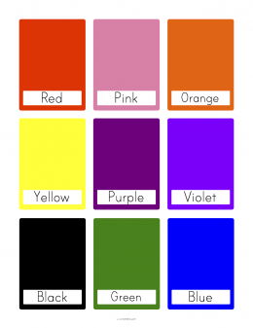
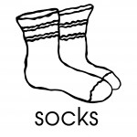
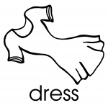

Worksheet (SOS)
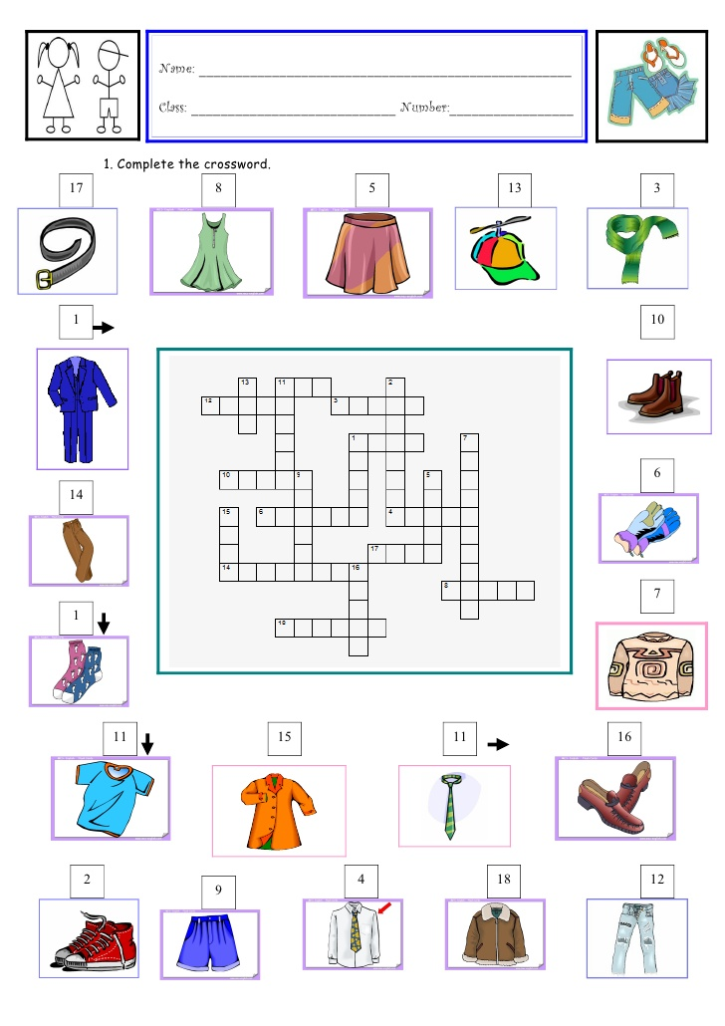
Worksheet (post)
