Listening Lesson Plan
Smart Pig Saves the Day

Instructor:  Eunice | Level:  Intermediate | Students:  12 | Length:  50 Minutes

Materials:
- Idiom worksheet (12 copies)
- Listening CD & CD player
- Listening worksheet (12 copies)
- Six pictures relating to the story
- White board, board markers

Aims:
- To guess what is happening by looking at the pictures
- To predict the words that are going to be heard
- To learn useful expressions for listening and speaking the story
by completing an idiom matching worksheet
- To practice listening to real-life speech
- To be able to pick up details from the real-life material by answering questions in detail
on a worksheet
- To practice speaking by talking with a partner

Language Skills:
- Listening: the speaker’s real-life story
- Reading: idiom worksheet & listening worksheet
- Speaking: prediction, talking with a partner
- Writing: making sentences using idioms learned

Language Systems:
- Lexis: idioms used in the story
- Function: story from the local paper
- Grammar: main clause & subordinate clause

Assumptions:
Students already know:
- how the class is set up and run (there will be a horseshoe arrangement)
- the teacher’s style of teaching and the pace of the course
- all students are Korean and college graduates (Age 24 and up)
- most students know about pet animals

Anticipated Errors and Solutions:

- Students may not be able to follow the passage easily
Let them listen to the passage again until they get the gist of the concept
- Students may not able to pick up details from the listening
Chunk the listening (pause-play-pause-play)

- Students may need more time to work on the idioms
If it takes longer than 5 minutes, cut answer-checking short by verbally sharing the answers
Instead of having students write them on the board

- If time is short,
Cut post speaking activity short and only ask 2~3 students to share their answers

- If students finish their tasks earlier than anticipated,
Ask as many students as possible about their experiences

References:
- TESOL Student Workbook, Teaching Listening “Listening Lesson Plan”
- Can You Believe It? by Jann Huizenga, Oxford University Press

Lead-In
Materials: Board
Time | Set Up | Procedure
3 min | Whole  Class | Hello everyone, how was your yesterday?  Is there anyone who has a pet?  If so, is your pet smart?  So, here’s a question for you all.  Can you tell about a bad situation when you make it end successfully?  ( Eliciting students’ background knowledge to make sense of the listening passage)  Ok, so today, we will listen to a story about a pet.  But first, we will learn some idioms used in the story.

Pre-Activity
Materials: Idioms Worksheet, Board, Six pictures relating to the story
Time | Set Up | Procedure
10 min  2 min | Pairs  Pairs | l. Idioms  Instruction  Work in pairs.  Match the definition in column A to the idiom in column B.  Fill in the blanks with the right number. You have 5 minutes.  (Distribute the worksheets)  Demonstration  Look at the letter “a”…”right, save the day.”  So put the number “2” in the blank before the letter “a”.  CCQ  Who are you working with?  How much time do you have?  What do you write in the blank?  Monitor discreetly. Answer students if they ask questions.  Give time warning: 30 seconds left.  Be flexible with time. Give 1 more minute if they need it.  Check answers: let students write the correct idioms (not the numbers)  on the board (letter “a” idiom already written by teacher)  Go through the idioms one by one.  Elicit the meaning from students  Explain the meaning if necessary.  ll. Prediction  Instruction  Look at these six pictures in chronological order and discuss in pairs what the story seems to be about.  (Show the pictures one by one)  Check your predictions as you listen to the story.

Main Activity
Materials: CD & CD player, Listening Worksheet, Questions in detail, Board,
Six Pictures relating to the story
Time | Set Up | Procedure
10min  18min | Whole  Class  Whole  Class  Pairs  Whole  Class | l. Listening for the Main Idea  Instruction  Put your pens down and listen to the story carefully checking your own predictions.  CCQ  Can you take notes?  What are you supposed to think about?  (Play a CD player without stopping)  Do you want to listen again?  - Yes Have them listen one more time.  - No Have them share their thoughts.  What is the story about?  (Show students the six pictures relating the story again)  Compare with their thoughts from the prediction.  - Just notice the differences  ll. Listening for Details  Instruction  Now listen to the story again and answer the questions on the worksheet.  Work individually.  CCQ  What are you supposed to do?  Are you working alone?  (Distribute the worksheets)  Play a CD player, pausing at the end of each sentence.  Let students write answers as they listen.  Do you need to listen again?  - Yes Play a CD player again  - No Have them share their answers  (Follow the same cycle until finished with the story)  Now compare the answers with your partner.  When you have an agreement, raise a hand of either in a pair and tell the answer to the students.  Pair 1, answer the question “a”.  Pair 2, answer the question “b”  (same for pairs 3-6)  (Put the pictures relating to the story on the board, while students are checking their answers with each other)  Check the answers as a whole class after every pair answers its question.  Listen to the story one last time.  If there is anything missing: pause the CD right there and let students say it out loud.

Post Activity
Materials: n/a
Time | Set Up | Procedure
7 min | Pairs | l. Speak about yourself  Instruction  Share yourself with a partner, answering the following questions.  I like to lie down on/in ___________________________ to rest.  I’m very happy that _______________________ belongs to me.  I never have trouble ___________________________________.  You have 5 minutes.  CCQ  Are you working in pairs?  For how long?  ll. Conclusion  Elicit today’s idioms for students  Give homework  Write one sentence for each idiom you learned today.  Good job today. See you guys on Friday!

Idiom Worksheet
<A> <B>
__ a. produce excellent results when things 1. belong to
are going badly 2. save the day
__ b. find something difficult to do 3. lie down
__ c. be near death 4. be at death’s door
__ d. rest in a horizontal position 5. have trouble doing something
__ e. appear; arrive 6. show up
__ f. be the property of someone

Listening Worksheet
Smart Pig Saves the Day
PITTSBURGH, PA, USA LuLu, a Vietnamese pig, is a very smart pet.
She belongs to Jo Ann Altsman, 57.
One day when Jo Ann was alone at home, she had a heart attack. She had trouble breathing and fell to the floor. She was at death’s door. But LuLu saved the day. The pig ran into the fenced-in yard. Somehow she pushed the gate open. Then she walked into the middle of the road and lay down. A surprised motorist stopped and got out of his car. LuLu got up and led the man into the house. He quickly called an ambulance. When the ambulance showed up, LuLu tried to get in too. “She’s very, very smart,” the lucky owner said later.

Questions in detail about the story
- Who does LuLu belong to ?
- Why was LuLu’s owner at death’s door?
- What did she have trouble doing?
- What did LuLu do to save the day?
- When the motorist got out of his car, what did LuLu do?
- What did LuLu try to do when the ambulance showed up? Why?

Six Pictures relating to the story

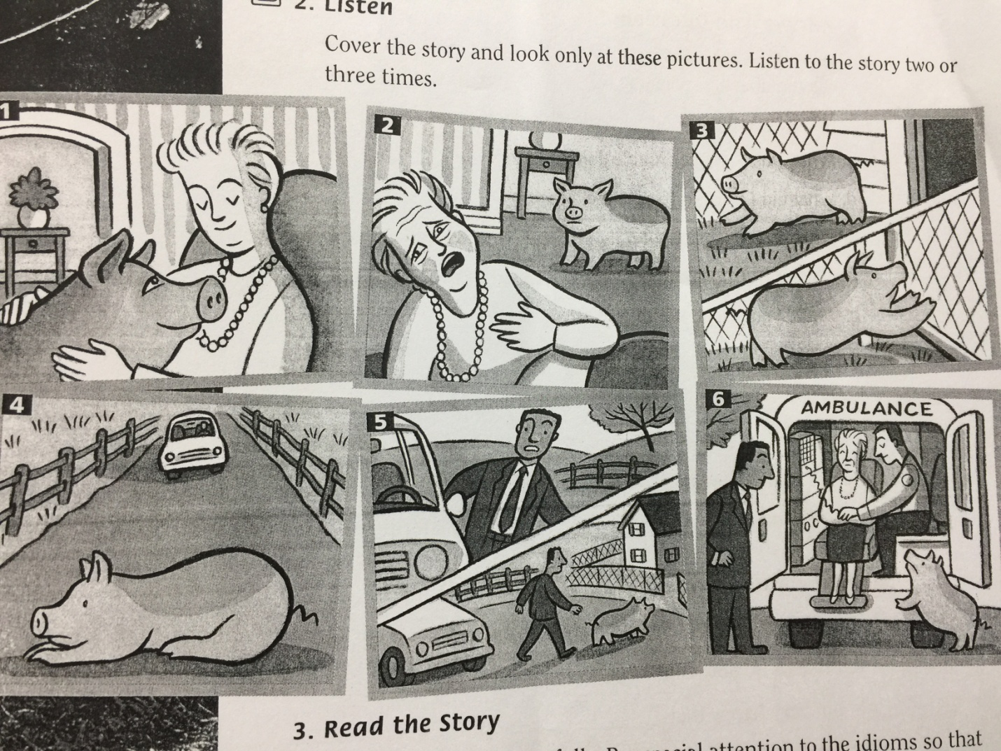

148th WD--Eunice

