Listening Lesson Plan
What do you do.

Instructor:  Stella | Level:  Intermediate | Students:  10 | Length:  50 Minutes

Materials:
- White board, board marker
- Listening CD
- Vocabulary worksheets (14 copies)
- Comprehension worksheets and pictures(14 copies)
- Dialogue text
- Reading Jobs Article (14 copies)

Aims:
- Students will be able to understand complex conversation between two people
- Students will be able to communicate and to receive or give information
- Students will learn new vocabulary and descriptions about jobs
- Students will be able to practice listening from the short conversation with various accents
- Students will be able to practice speaking through discussing with each other
- Students will familiarize using the simple present Wh-questions by using the word do and does

Language Skills:
- Reading: Vocabulary worksheets and article
- Listening: the speakers’ conversation about opinions of jobs
- Speaking: prediction, comparing answers with partner and group work
- Writing: answering the vocabulary sheet and comprehension questions

Language Systems:
- Lexis: describing themselves when they are in various jobs situations
- Function: self-PR and build confidence
- Grammar: by answering the questions through Comprehension worksheets

Assumptions:
- Students can predict their opinions from different types of job
- Students will know what a job is?
- Students will different jobs positions through a real life experience

Anticipated Errors and Solutions:
Students may have trouble to pick up the details from listening
- Chunk the listening(pause-play-pause-play)
Students may not be able to follow the passage easily
- Let them listen to the track again until they get the idea of the content
Students may need more time to work on the adjectives and vocabulary
- If it takes longer than 5 minutes, cut answer-checking short by orally sharing your answers instead of writing on the board
If time is short
- Cut post-activity discussion short and ask 2~3 students to share their opinion about what is their ideal job?
If students finish their tasks earlier than anticipated,
- Ask as many students as possible about their idea of what a job is, and what’s their ideal job is

References:
- TESOL Student workbook “Teaching Listening”
- Interchange Students Book by Jack Richards chapter 8 page 53

Lead-In
Materials: Board, Board pen
Time  5 min | Set Up  Whole Class | Procedure:  Hi! Everyone. How was your weekend? May I know who among of you are working? Here’s my question: Can you define job? What is it? Anyone, can give me three examples of job?  (Elicit the key words and write them on the board)  OK, so today, we will listen to the two persons who are talking about his job. But first, we will learn some vocabulary words with their description.

Pre-Activity
Materials: Vocabulary Worksheets, Pictures to describe
Time  10 min  2 min  3 min  5 min | Set Up  Whole Class  Individually  Whole Class  Pair work  Whole Class  Whole Class | Procedure:  - Job description:  Instruction: Work individually. Write the letter of the correct answer in the blanks. Time limit: 3 minutes  (Distribute the worksheet)  - Demonstration  For example: Look at no.1…”security guard”. So put letter “d” in the blank.  CCQ:  Who are you working with?  How much time left?  Do they have much time?  Monitor the students discreetly. Answer if they have some questions. Give time warning. 1 minute left.  Be flexible with time. If possible, give one minute more.  Check answer: Let students speak the correct answer of each numbers. (no.1 already did by the teacher)  Alright. Let’s proceed to another activity. I want you to think one possible adjective that best describes in each job. And I want you to share it with your partner. And try to discuss why you think like that? I will give you 3 minutes for it.  Monitor discreetly with the students. If they have some questions, feel free to help them. And give some examples for them if they having hard time to describe each job.  Instructions:  I want you guys to write down on the board one adjective in each of the following jobs. And explain in short why you think it best describes on it. Go through their adjective one by one.  - Prediction:  Instructions:  Look at the pictures on the board. There are 4 women who dress according to their jobs. What’s your first impression of them? What do you think of their personality?  Show the picture one by one. Try to describe 1-2 words on each picture.  Check your predictions as you listen through the conversation.

Main Activity
Materials: CD, Dialogue script, Questionnaire
Time  10min  5 min  7 min | Set Up  Whole Class  Whole Class  Whole Class | Procedure:  - Listening for the Main Idea  Instructions:  Put all your pens down. Think about your first impression of the speaker. What is his/her work?  CCQ:  Where are they?  What you think about them?  (Play the CD without stopping)  Do you want to listen again?  - Yes Have them listen one to two more time.  - No Have them share their thoughts.  What do you think about the speaker?  What is his job?  Identify the pictures.  Compare your thoughts from the prediction (if done.)  - Listening for Details  Instructions:  I want you read the dialogue script and practice it speaking with your partner. Role-play it together with your partner.  ( Distribute the dialogue text)  Time limit: 3 minutes  Let’s listen one more time from the audio. After that, we will try to answer together the comprehension questions in the questionnaire?  CCQ  What are we supposed to do?  Are we working alone?  ( Distribute the worksheet)  Try to answer together what is in the questionnaire.  Add follow-up questions if needed.

Post Activity
Materials: Reading article and a sheet of paper
Time  5 min  5 min | Set Up  Whole Class  Whole Class | Procedure:  - Instructions:  I will gonna give you a piece of paper. Think of a short description of a job, but don’t write the name of a job. Teacher will gonna read it in the class. Let the students guess what kind of job it is.  I want you to read the article about jobs. And let’s try to guess who said these things.  ( Distribute the article)  - Conclude lesson:  Know the different kinds of job and describing them using the adjective words.  Improve their listening skills and speaking skills.  WELL DONE. HAVE A GREAT DAY.

Worksheet no.1
Choose your answer inside the box.

___1. Security guard
____2. Pilot
____3. Singer
____4. Chef
____5. Doctor
____6. Nurse
_____7. Teacher
____8. Actress
- A person who teaches especially in a school.
- A qualified practitioner of medicine
- A woman who acts in a play, film, stage
- A person employed to protect a company against intruders
- A person who operates and controls of an aircraft
- A person who sings, especially trained for vocalist
- A professional cook in a restaurant or a hotel
- A person trained to care for the sick

Worksheet no. 2

Questionnaire:

Write your answers on the blanks provided for.

- What is Bob’s job?
- Who is he talking to?
- What are the days he is working?
- How many hours does he work?
- What kind of restaurant he work?

Dialogue script:

My new job.

Listen to the conversation. Check the correct picture of Bob.

Bob: Guess what Jenny? I have a new job.
Jenny: Congratulation
s, Bob! Where do you work?
Bob: At the French restaurant on Center Street.
Jenny: Oh, I know that place. There’s a singer at that restaurant on weekends…, So, are you a waiter?
Bob: No, I’m the chef!
Jenny: The chef? Wow! So, when do you work?
Bob: I work on Fridays, Saturdays, and Sundays.
Jenny: Great! What time do you start work?
Bob: I start work at 4p.m.
Jenny: At four in the afternoon? That’s late. Do you work late, too?
Bob: Yes. It’s a very busy restaurant. I usually finish at one in the morning.
Jenny: One A.M.? Wow! What do you do after work?
Bob: I go home and sleep! I like my job, but after work I’m always tired!

Hand-out no.1

Pictures:

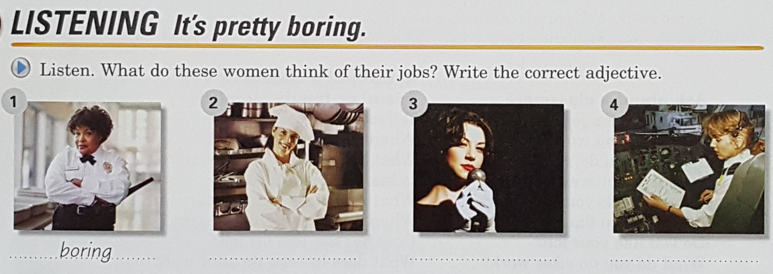

Worksheet no.3

Reading Article:

