☐ Listening ☐ Speaking ☐ Reading ☐ Grammar ☐ Writing

Topic: National Geographic Learning Japanese Puffer Fish

Instructor:  Hyeonjin Lee (Heidi) | Level:  Upper –intermediate | Students:  12 students | Length:  50 Minutes

Materials:
- 8 copies of worksheets #1
- 8 copies of worksheets #2
- 8 copies of worksheets #3
- Realia: picture of Japanese puffer fish
- 8 pieces of a blank sheet of paper to draw a simple magazine
- Computer and TV for video link via YouTube
- White board and board markers
- Dictionaries
- Crayons

Aims:
- To develop listening skills such as listening for gist and for specific information
- To improve vocabulary knowledge of key phrases and lexis used in video
- To practice speaking through negotiation of meaning
- To practice writing a magazine article

Language Skills:
- Listening: the speakers’ explanation and conversation
- Reading: vocabulary worksheet #1,#2
- Speaking: sharing their answer within groups
- Writing: fill in the blank and answer the questions

Language Systems:
- Discourse: video
- Lexis: new vocabularies in the article

Assumptions:
Students already know
- How the class is set up and run (there will be 3 students at each table)
- Four language skills and language systems
- Some students might have eaten Japanese puffer fish

Anticipated Errors and Solutions:
- Students may not be able to watching the video easily
→Play the video again with a subscripts
- Students may not be able to answer the questions from the listening
→Check the listening(pause-play-pause-play)
- If students failed to guess most of the answers
→You may wish to replay the video; otherwise check the answers after with the group
- If students finish their tasks earlier than anticipated
→Help other students who not doing well

References:
- https://www.youtube.com/watch?v=5rFwzi4-oLo
- © Macmillan Publishers Ltd 2008 Taken from the Lesson Share section in www.onestopenglish.com

Lead-In
Materials:

Time | Set Up | Student Activity | Teacher Talk
5min | Whole class | Answering the questions | Hi everyone! How are you today?  Do you guys like to eat fish?  What kind of fish is popular in your town?  Are there any types of fish people don’t eat? Why?

Pre-Activity
Materials: picture of Japanese puffer fish, worksheets #1, white board and board markers, dictionaries
Time | Set Up | Student Activity | Teacher Talk
3min  7min  5min | Whole class  Pairs  Individually  Whole class | Answering the questions  Students should check the words they don’t know using their dictionaries and discuss with partner. | Elicit  (show the students visual picture of Japanese puffer fish)  Do you think what kinds of fish it is?  (answer: Japanese puffer fish)  Have you seen this fish before?  Is anyone have eaten this fish before? If so, how was the taste?  Vocabulary 1  Instruction  Before watching a video, we will have looked some new words. Fill the gaps in the sentences with the correct words from the list above. If you are not sure about the new words you can discuss with your partner and you could use your dictionary to find out the meaning. I will give 5mins to finish it.  (Distribute the worksheet #1)  Demonstration  Look at the first word…”poisonous” it means ~… so put that word in number 3 “if you eat something ˍˍˍˍ, you will become sick or possibly die”  CCQ  Who are you working with?  How much time do you have?  What do you write in the blanks?  Monitoring  Monitor discreetly. Answer students if they ask questions.  Give time warning: 30 seconds left.  Be flexible with time: give 1 more minute if they need it.  Check answers  Correct the answers together.  Go through the all the answers in the worksheet #1.  - Go through the each sentence one by one  - Explain the meaning of words in the box

Main Activity
Materials: worksheet#2, worksheet#3, Computer and TV, white board and board markers

Time | Set Up | Student Activity | Teacher Talk
5 min  5 min  3 min  5 min  4 min  3 min  5 min | Individually  Pairs or group  Whole class  Pairs  Pairs  Whole class  Whole class | Students watching a video and answering the questions  Check their answers with a partner  Answer the questions  Matching the phrases to the definitions | - Watching the video  Instruction  Tell students to watch the video and answer the questions as they watch. All of the questions are in the same order as they appear in the video.  (Distribute the worksheet #2)  CCQ  Do you answer the questions while you watching or after watching?  Are you working in group or pairs?  (Teacher plays the YouTube video, let students answer the questions while watching video)  Do you want to watch it again?  If yes, have them watch one more time.  If no, have them share their answers.  After students have watched the video, ask them to check their answers with a partner. If students failed to guess most of the answers you may wish to replay the video; otherwise check the answers after with the group.  Check answers  Check the answers together.  Go through the all the answers in the worksheet #2.  • Additional questions: Ask students to work in pairs and answer the questions. These are additional questions which provide extra speaking practice for the students; you may wish to monitor and get the best answers to be repeated for the whole class.  - Vocabulary 2  Instruction  Ask students to match the phrases to the definitions. Then ask them to complete the gapped sentences with the appropriate phrase.  (Distribute the worksheet #3)  CCQ  Are you working in groups or pairs?  What do you need to discuss?  (Students can watch the video again to listen for these items - this will practise monitoring for key words.)  Monitoring  Taking care to check that the sentences are grammatically correct.  (This exercise practices manipulation of new lexical items – at these level students should be able to cope with this.  Check answers  You may just get students to check together and then move on.  Go through the all the answers in the worksheet #3.  • Explain the meaning  You may wish to mention that most of these phrases are used in journalism as a way of holding the listeners’ attention. These are mainly metaphorical in meaning. I included despite as many students mess up the form, which you may wish to elicit and practise: despite + n / gerund + , + full clause

Post Activity
Materials:

Time | Set Up | Student Activity | Teacher Talk
5 min | Small groups | Discuss the two questions with group members | Discussion  Instruction  Put students in small groups and ask them to discuss the two questions.  “What other ‘controversial’ or dangerous world delicacies do you know?”  “Should dangerous foods be banned?”  Get some feedback by asking students to report back on others’ comments.

SOS Activity
Materials: a piece of paper, crayon
Time | Set Up | Student Activity | Teacher Talk
5 min | Small groups | Simply drawing the risks involved in eating poisonous foods. | Drawing poisonous foods  Instruction  Ask students to draw a simply magazine. Should draw the risks involved in eating poisonous foods. After drawing, ask them to briefly talk to each other with their magazine. Need to make use of their new vocabulary.

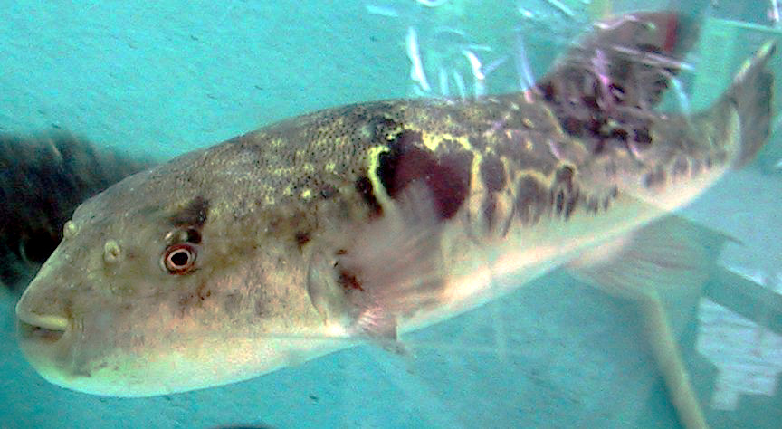
Visual picture of Japanese puffer fish

Worksheet #1
Fill the gaps in the sentences using the following words from the video. Check you understand the meaning of these words.
poisonous anti-toxin scraps (of food) taboo
gills chrysanthemum respirator fatality cyanide
1. Fish use _______________ to breathe under water.
2. The _______________ is a type of flower.
3. If you eat something _______________, you will become sick or possibly die.
4. Something avoided for religious or social reasons is _______________.
5. An _______________ is like a medicine; it will neutralize the effects of a toxin.
6. _______________ means somebody died.
7. _______________ is a poisonous chemical.
8. A _______________ is a machine that helps people to breathe.
9. Small pieces of something, which are often unwanted, are called _____________.

Worksheet #1 [answer]
1. Fish use ___gills____________ to breathe under water.
2. The ___chrysanthemum____________ is a type of flower.
3. If you eat something ___poisonous_________, you will become sick or possibly die.
4. Something avoided for religious or social reasons is ___taboo____________.
5. An ___anti-toxin__________ is like a medicine; it will neutralize the effects of a toxin.
6. ___fatality____________ means somebody died.
7. __cyanide_____________ is a poisonous chemical.
8. A ____respirator___________ is a machine that helps people to breathe.
9. Small pieces of something, which are often unwanted, are called __scraps________.

Worksheet #2
Try to answer these questions.
1. Which is the most expensive fish at Tsukiji market?
2. Why is Matsumoto restaurant famous?
3. What effect did the war have on the number of fatalities caused by eating fugu?
4. What did General Macarthur do about the situation?
5. How many people died between 1945 and 1985 as a result of eating fugu?
6. What should you do if someone eats the poison in fugu?
7. Why is the chrysanthemum a special flower in Japan? (two reasons)
Now discuss the answers to these questions with your teacher or a partner.
1. How does Tom feel about eating fugu?
2. What are the main reasons for the reduction in fatalities from fugu?
3. What happens to the body when fugu poison enters the bloodstream?

Worksheet #2 [answer]
- Which is the most expensive fish at Tsukiji market?
→No fish has a price than the one that’s most taboo – fugu
- Why is Matsumoto restaurant famous?
→ Famous for its careful preparation
- What effect did the war have on the number of fatalities caused by eating fugu?
→People salvaged scraps from the trash and ate poisonous fugu
- What did General Macarthur do about fugu?
→Imposed a license system
- How many people died between 1945 and 1985, as a result of eating fugu?
→2,500 – twenty-five hundred
- What should you do if someone eats the poison in fugu?
→Attach them to a respirator – because the lungs fail
- Why is the chrysanthemum a special flower in Japan (two reasons)?
→National flower and the flower used at funerals
Now discuss the answers to these questions with your teacher or a partner.
- How does Tom feel about eating fugu?
→He says he hasn’t been concerned with the fact that people have died from eating fugu.
- What are the main reasons for the reduction in fatalities from fugu?
→Regulation and education as fugu chefs must get licenses.
- What happens to the body when fugu poison enters the bloodstream?
→Causes paralysis so people cannot move or breathe; not being able to breathe, people then die. However, they are fully conscious until their lungs fail.

Worksheet #3
Match the phrases on the left with the definitions on the right.
(sth) to sky rocket | to beat (sth/sb)
to be crazy for (sth) | to spoil (sth), especially food or blood, by adding a harmful substance
to triumph over (sth) | to like (sth) very much
to taint (sth) | to be able to kill someone or keep them safe
to have (somebody’s) life in (your) hands | to increase dramatically
Now use these phrases in the sentences below.
1. The number of deaths due to fugu poisoning _________________ after the end of the war.
2. Japan is simply _________________ fish.
3. Having a dinner which could kill you is probably the ultimate food taboo, but this time Tom has _________________ the puffer fish.
4. About half of the meat is _________________ by the toxin.
5. Chef Hayashi _________________ Tom’s _________________.
You can check your answers by watching the video again.
Explain the meaning of the following phrases.
Fugu is so ugly that it’s cute.
The chef slices the fugu meat paper thin.
Despite the danger, millions of people still eat fugu.
Fugu is the food version of Russian roulette.
A fugu palace.

Worksheet #3 [answer]
1. The number of deaths due to fugu poisoning sky-rocketed after the end of the war.
2. Japan is simply crazy for fish.
3. Tom has triumphed over the puffer fish.
4. About half of the meat is tainted by the toxin.
5. Chef Hayashi has Tom’s life in his hands.

