- The vocabulary matching worksheet
( Power Step Listening 3 p56 )

Background- read, choose, and write. Then listen and check. T-118
1. In winter, the is cold. When it’s very cold, we say “it’s .”
2. Cleo struck the United States in 1964.
3. In fall, the temperatures . we can see the strong wind the leaves down into big piles.
4. A has strong wind and rain together.
5. A thunderstorm is when there’s thunder, , rain, and wind.
6. For a short period of light or heavy rain, we use the noun .

- Flash cards materials
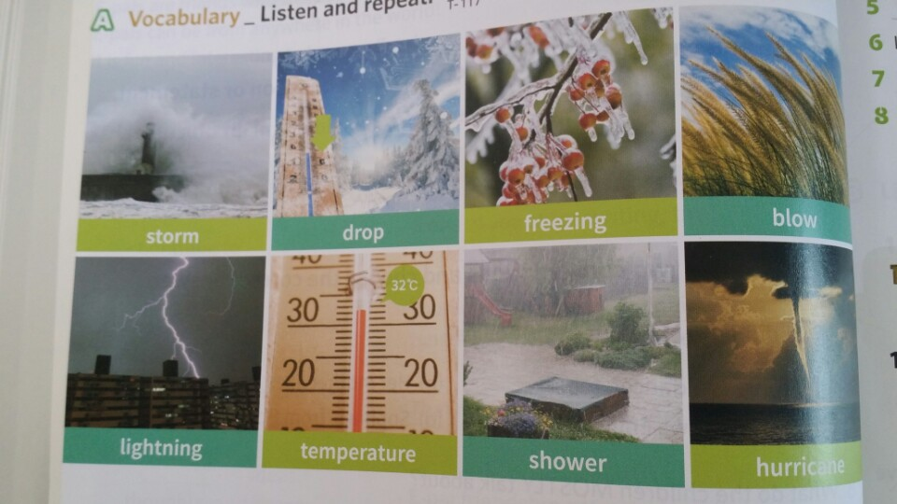

Listening Worksheet
( Power Step Listening 3 p59 )
Good evening, This is your 6:00 p.m. weather report for all the up-to-date weather around the world. In Honolulu, Hawaii, the temperature right now is 23 degrees Celsius. Skies are blue with sunshine. No rain is expected.
Canberra, Australia has temperature of 17 degrees Celsius with strong winds.
London, England’s temperature is 18 degrees Celsius with cloudy skies and rain. Winds are light.
Tokyo is 3 degrees Celsius with temperature’s getting colder throughout the week. The wind is mild.
Beijing is negative 14 degrees Celsius the 15th day of the low zero temperatures. With the wind, the temperature is negative 16 degrees Celsius. That’s pretty cold.
The extreme cold is expected to stay until early next week. On Thursday, you’ll see the temperature arise above freezing. Stay Tune. we’ll have another update for you at 10:00 p.m.

- SOS Activity worksheet
( Power Step Listening 3 P59 )

A Listen. The weather reporter gives an up-to-date weather report about the weaher around the world. When did he give the report? T-125
□ a hourly
□ b 6:00 P.M.
□ c 10:00 P.M.
□ d It did not say.

B Listen again. Check ( v ) the correct answer. T-126
1. Which city has strong winds?
□ a Canberra
□ b London.
□ c Tokyo
2. Which city has the coldest temperature?
□ a Canberra
□ b London.
□ c Tokyo
□ d Beijing

