In this paper, there are 6 pictures of various image. You can choose the one of them, and trying to make a conversation by using tag question!
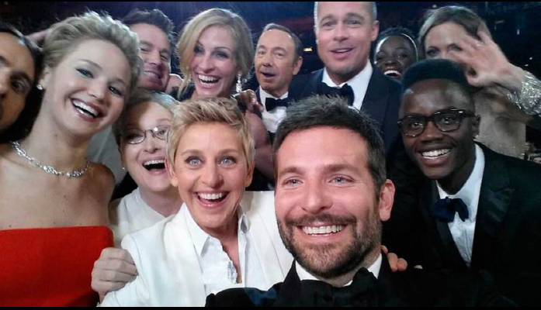
2014. 3.2. The prime minister in the academy awards stars of the dangers while taking selfies

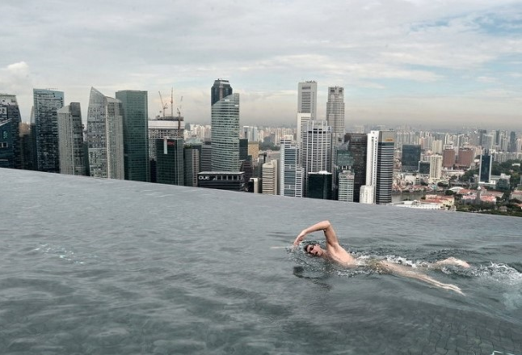
AFP the selected picture of the year 2014
Maria, famous buildings in Singapore on May 20, Bay Sands Hotel rooftop swimming pool and swim in
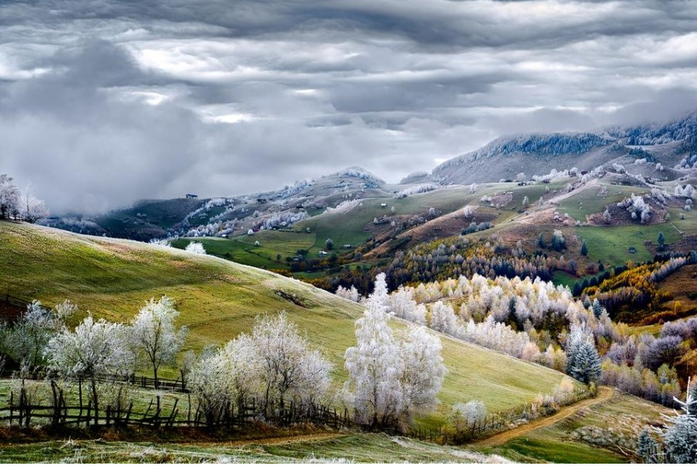
2015 National geographic ‘this year’s best travel photography
Rumania, land of fairy tales – photo and caption by eduard gutescu) the special award winner
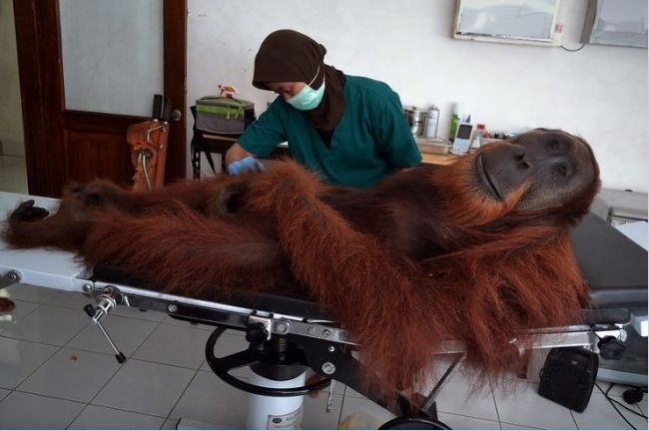
2014 April 16. Protection center for 14 years old, male Sumatran orangutan
Orangutan is being treated. The orangutan is excepted the struggles the bullet for air rifle.
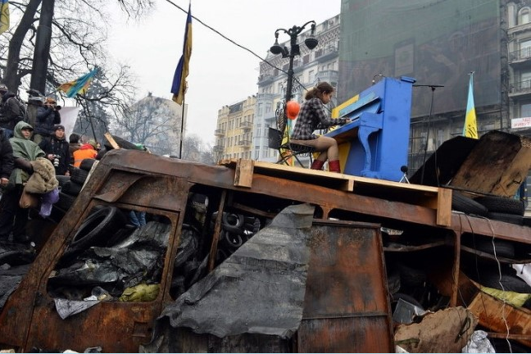
AFP the selected picture of the year 2014 Ukraine, Feb. 10
protesters during clashes with police formed a barricade. The lady is appeasing the site of the tensions The sensitivity of the demonstrations on the piano.
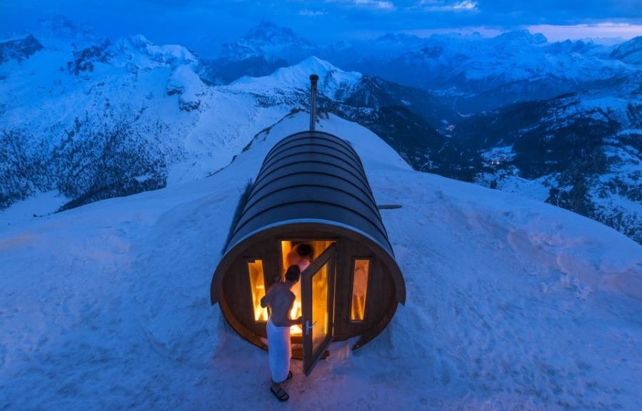
2015 National geographic ‘this year’s best travel photography’
(Sauna in the sky – photo and caption by stefano zardini) the special award winner

