☐Listening ☐ Speaking ☐ Reading Grammar ☐ Writing
Topic: Present Perfect Tense - Experiences

Instructor:  Kate | Level:  Intermediate | Students:  8 | Length:  30 Minutes

Materials: TV screen
White board, board markers
Worksheet A, B (8 copies each)
Questionnaire (8 copies each)

Aims:
Students will clearly understand the meaning and form of present perfect tense by listening to teacher’s explanation and substitution tables.
Students will practice the present perfect tense by answering concept check questions and completing the worksheets.
Students will practice specking and listening ability by sharing ideas in a group.

Language Skills:
Reading: reading worksheets to answer questions
Writing: worksheet answers and doing homework
Speaking: drilling, practice activities, and sharing ideas
Listening: listening to teacher’s instruction/explanation and classmates’ ideas.

Language Systems:
Phonology : drilling
Grammar: use of present perfect tense ‘have/has + PP’
Function: describing an experience in the past

Assumptions:
Students already know :
Students already have learned the past simple in a previous class
Students are over late 20’s
Students have already heard about this expression.

Anticipated Errors and Solutions:
Students may have difficulty in understanding the meaning
→ Teachers provides more examples.
Students may have a hard time drilling
→ Teachers gives the students more chances to practice.
If students need more time to finish their activities and worksheets
→ Be flexible with the time as giving students more time to finish their activity
References:
- https://en.islcollective.com/resources/printables/worksheets_doc_docx/holiday_postcard_17/present-perfect-holidays/27461
- https://en.islcollective.com/resources/printables/worksheets_doc_docx/present_perfect_tense/present-perfect-preintermediate/32584

Lead-In
Materials: Board & board marker
Time | Set Up | Procedure
5 min | Whole Class  Whole Class  Individually | Greeting  Hello everyone.  Review  Do you remember that we had learned previous class? We learned the past simple tense. For example, I say, “I saw a good film last night..”  The past simple is used to talk about things that happened in the past, are finished and have no connection with the present. We usually know when the action happened.  C.C.Q  Is the action in the past? (Y)  Is the action finished? (Y)  Is there any connection with the present? (N)  Do we know when it happened? (Yes, usually)  Eliciting(Contextualization)  It’s such a lovely day today. I wish I were in Paris.  Has anyone been to France?  (A student says “yes”.)  So “the name of the student” has been to France.  And ask the student such as “When did you go to France?” and “How many times did you go to France?”.  Guided warmer activity  Toward the above student, “Other than France, which/what countries did you visit?” And ask every student and write down the name of the country on the board.

Pre-Activity
Materials: Board & board marker, TV screen
Time | Set Up | Procedure
10 min | Whole Whole Class  Whole Class  Whole Class  Individually  Whole Class  Individually | I. Recall  We’ve just talked about the countries we have visited.  So we have been to 15 countries. Great!  In my case, I have been to China. (Looking at the board, saying  “Angela has been to the US.”  “Dami has been to Australia.”  “Angela and Dami have been to the US.”  “Tim has been to Russia.”  II. Reflect  Eliciting the meaning  “Angela has been to the US.” (Pointing at the board)  C.C.Q  Are we talking about the past, present, or future? (Past)  Do we know exactly when Angela wen to the US? (No)  Do we know how many times Angela wen to the US? (No)  Is Angela in the US now? (No)  “I have eaten real Belgian waffles.”  C.C.Q  Do you know when I ate real Belgian waffles? (No)  Do you know how many times I ate real Belgian waffles? (No)  Is this experience about the past or present? (Past)  Eliciting the form  Teacher : Can you say “Angela have been to the US.”?  Ss : No, Angela has been to the US.  Teacher : Angela and Jenna has been to the US?  Ss : No, Angela and Jenna(they) have been to the US.  (using students’ answers to eliciting)  What do you see in the form of this sentence?  Yes, we use has when the person is 3rd person singular and have for other cases.  III. Conclude  1. Meaning  “We have just learned the present perfect tense.  ‘have/has + pp’” (Write them on the board)  OK. Let’s talk about the meaning of the present perfect tense again.  Does Angela have the experience of going to the US?  Ss : Yes, she has.  Like this, the present perfect simple is used to talk about experiences people have had at some time in their lives. (Draw a timeline on the board.)When it happened is not specified. The focus is on the action, not when.  You can also use this tense to say that you have never had a certain experience. We often use ‘never’ for negatives and ‘ever’ in questions.  It can be used with ever and never. e.g. "Have you ever...?" "I've never ...".  For example:  • A: Have you ever met Taylor Swift?  B: No, I have not met her.  • He has never travelled by plane.  This sentence means that he has not had the experience of travelling by plane.  2. Form  We form the Present Perfect with have/has and the past participle.  has → 3rd person singular (he, she, the name)  have → all other forms  PP(Past Participle) can be either regular verb or irregular verb.  C.C.Q  “Can you say ‘My sister have met her favorite singer.”?  Students : No.(Students will answer)  3. drilling  <Simple Variable Substitution Drill>  She We He They You Tim have has been to New York.  Here is a substitution table. Listen to what I say and don’t repeat.  (show students the substitution table)  C.C.Q  What do you do?  (Point to the substitution table while reading)  <Simple Substitution Drill>  I have travel to New York eat sushi ride a horse climb the Eiffel Tower read Harry Porter make a Halloween pumpkin date with a famous person see the Tower of Pisa try bungee jumping play cricket drink root beer see “Gangnam Style” video  OK. Move on to another substitution table. Listen to what I say and don’t repeat. (show students the substitution table)  C.C.Q  What do you do?  (Point to the substitution table while reading)  Now, I will pick some students to repeat individually.  (Point to the substitution table and pick students)  <Transformation Drill>  (show students the substitution table)  Affirmative  I You We They have see Big Ben. eat Tomahawk rib eye. visit the British Museum.  She He Tim has see Big Ben. eat Tomahawk rib eye. visit the British Museum.  Negative  I You We They haven't (have not) see Big Ben.. eat Tomahawk rib eye. visit the British Museum.  She He Tim hasn’t (has not) see Big Ben. eat Tomahawk rib eye. visit the British Museum.  Interrogative  Have you they see Big Ben? eat Tomahawk rib eye? visit the British Museum?  Has she he Tim see Big Ben? eat Tomahawk rib eye? visit the British Museum?  OK. Listen to what I say and don’t repeat.  C.C.Q  What do you do?  (Point to the substitution table while reading) OK, this time please read after me. (All students will repeat the teacher’ saying.  And then, pick some students to repeat individually.  “00, can you make a sentence from this table?”

Main Activity
Materials: Worksheet A&B, Board & board marker
Time | Set Up | Procedure
10 min | Whole Class  Individually  Individually  Pair | Controlled practice 1  we’re going to practice what we’ve just learned  Instruction  You’ll be given a worksheet A. Please write the missing verbs in the questions. Then answer the questions! Remember – if you give extra information, use the past simple. Please do it individually. You have 2 minutes.  C.C.Q  How much time do you have?  Do you work alone?  (Give out the worksheet and run task)  Do you need more time?  (If yes, give 30 seconds extra time. If no, check answers together.)  “Let’s check the answers together.”  Controlled practice 2  Instruction  It’s time to work on worksheet B. Choose the correct sentence and Find the mistake individually and you have 2 minutes.”  C.C.Q  How much time do you have?  Do you work with others?  (Pass out the worksheet and run task)  Do you need more time?  (If yes, give 30 seconds extra time. If no, check answers together.)  “Let’s check the answers together.”  Less Controlled Practice  Now we’re going to do an activity which is “Make me say yes, make me say no”. The rule is simple. You try to ask as many questions as they can to which their partner’s answer is “Yes, I have”. And then switch and do the same thing with “No”. You have 2 minutes and work as pair.  C.C.Q  How much time do you have?  Do you work with others?  (monitor discreetly) After checking the time and move on to the next activity.

Post Activity
Materials: Questionnaire, Board & board marker
Time | Set Up | Procedure
5 min | Whole Class  Pair  Whole Class | Free practice  Instruction  Here is a questionnaire. If your partner answers ‘No’ you get 0 points. If the partner answers ‘Yes’ you get 1 point. If the partner elaborates, you get 2 points. Encourage the students to ask further questions and to gain more information from their partners. You have 3 minutes and work as pair.(When explain this, write on the board. No -> 0 Yes -> 1, 2(elaborate))  C.C.Q  What will you do?  Who do you work with?  How much time do you have?  (Hand out questionnaire to the students)  Demonstration  For examples, When I asked my partner number 1 question, and she answers “no”, we have 0 point. If she answers “Yes”, we get 1 point, if she answers like “Yes, I have. I ate sea urchins last week.), then we 2 points.  (Monitor discreetly)  Feedback  Have you all finished?  (If no, give 30 seconds extra time)  OK, let’s check which group has got the highest score.  Wrap-up  Today, we talked about the present perfect tense when we want to describe an experience in the past.  Next time, we will study more about the present perfect tense having the different meaning like accomplishments, change over time, an uncompleted action you are expecting, and multiple actions at different times.  Assignment : Write about your experiences and your family’s experiences. What have you done? What haven’t you done?  Good job everyone today. See you tomorrow!

SOS Activity
Materials: Post card, TV screen
Time | Set Up | Procedure
5 min | Whole Class | You have received a post card from your friend. Please fill in the blank  individually and you have 3 minutes.  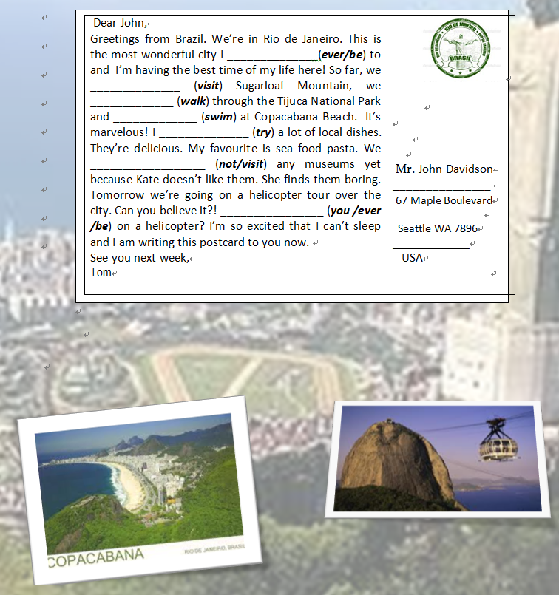

Worksheet A
Write the missing verbs in the questions. Write two extra questions. Then answer the questions!
Remember – if you give extra information, use the past simple.

1. Have you ever been to Paris? Yes, I have! I went last year.
2. Have you ever _________ pizza? _________________________________________
3. Have you ever _________ a ghost? _________________________________________
4. Have you ever _________ a famous person? ___________________________________
5. Have you ever _________ football? _________________________________________
6. Have you ever ________ your teacher a present? _______________________________
7. Have you ever_________ an earthquake? _____________________________________
8. Have you ever_________ about emergency preparation? _________________________
9. Have you ever _________a headache that lasted all day? _________________________
10. Have you ever _________about what you would do if there is a fire? _________________________________________
11. Have you ever_________a lie? _________________________________________
12. Have you ever_________ to learn yoga? _____________________________________

Worksheet B
Choose the correct sentence!
Read the sentences and choose the correct one.
1. a. I have went to three countries in my life.
b. I have been to three countries in my life.
c. I went to three countries in my life.
2. a. My parents have travel around the world.
b. My parents have travelled around the world.
c. My parents travel around the world.
3. a. My best friend never ate pizza with chocolate.
b. My best friend never eaten pizza with chocolate.
c. My best friend has never eaten pizza with chocolate.
4. a. I have never met the Queen!
b. I never meet the Queen!
c. I never have met the Queen!
5. a. Have you ever fell off your bicycle?
b. Did you ever fall off your bicycle?
c. Have you ever fallen off your bicycle?

Find the mistake!
Find the mistake, underline it and write the correct sentence.
6. I have rode a horse and a camel. ____________________________________
7. I have never make a snowman. ____________________________________________
8. My parents never have tried sushi. _________________________________________
9. My sister has go to a concert. _____________________________________________
10. Has your brother ever see a ghost? _________________________________________
Questionnaire
Here is a questionnaire for pairs. If the students answer ‘No’ they get 0 points. If they answer ‘Yes’ they get 1 point. If they elaborate they get 2 points. Encourage the students to ask further questions and to gain more information from their partners.
1. Have you ever eaten anything strange?
2. Have you ever been to hospital?
3. Have you ever stolen anything?
4. Have you ever been somewhere scary?
5. Have you ever met someone famous?
6. Have you ever cooked a meal for more than six people?
7. Have you ever been to a big sports event?
8. Have you ever cheated in an exam?
9. Have you ever helped a charity?
10. Have you ever been embarrassed?
11. Have you ever lived somewhere else?
12. Have you ever run more than 5km?
13. Have you ever seen a ghost?
14. Have you ever travelled to another country?
15. Have you ever met someone you didn’t like?

