Writing & Drama

Topic: Don’t lie

Instructor:  Christine(Kim, junghun)  Elly(Park, seolhee)  Sunny(Bae, sunghee) | Level:  Beginner | Students:  7 | Length:  20 Minutes

Materials: Computer, speaker, Puppets (Father, 2daughters) Handmade ice cream.

Aims:
- Main aim: Ss understand importance of moral honesty in this story.
- Secondary aim: Students will be able to understand importance of forgiving and saying sorry to each other.
- Personal aim:
What I want to demonstrate in this lesson is to give clear instruction and guide students to understand importance of honesty and forgiving each other.

Language Skills:
- Listening: Listen to the story and song play.
- Speaking: Discussion with teacher during the story.
- Reading: Reading song lyrics on the board.
- Writing: N/A

Language Systems:
- Phonology: /r/
- Lexis: sorry lie honesty
- Function: forgive, apology
- Grammar: negative sentence
- Discourse: Drama, Discussion, voice play in a drama

Assumptions:
- Ss do know Pinocchio story.
- Ss may not understand the meaning of honesty.(Too abstract)

Anticipated Errors and Solutions:
Students may not show interest and focus on story.
- Prepare various interesting materials, realistic acting voice for the drama
- Raise simple question to students before drama starts and let them anticipate
the answer
- Review the story with students and ask questions and let them talk

References:
Honesty is true song (https://youtu.be/J7JcXIuRk-k)
Clean up song (https://youtu.be/oY-H2WGThc8)

Lead-In (INTRODUCTION)
Materials:

Time | Set Up | Student Activity | Teacher Talk
1min | Whole class. | Ss answer question. | Narrator:  Hello~ everyone?  Do you have sisters or brothers?  Do they make you angry or sad sometimes?  There was a lovely family in a village. On a lovely Friday mom was out doing her shopping and father was spending time with his two daughters

SCENE 1
Materials: PPT, Puppets, Computer, Speaker

Time | Set Up | Student Activity | Teacher Talk
 | Whole  class | Ss: Clean up  Ss: Clean up  Ss Sing together  Ss: Her sister did not help.  Ss: No! | Father:  Miso and Haengbok,  As you know today is our weekly  ”clean up” day.  Since mom is away, let us clean our house together.  I will go to the garage to clean, could you clean up our living room and your bedrooms together?  Miso/Haengbok:  Sure we can! We will clean up together. Don’t worry.  Narrator: Father goes out  T:  Okay kids  Can you repeat after me.  Say “Clean up”  Okay one more time!  Clean up  Okay let’s sing together!  Model  (Play ‘clean up’ song)  Haengbok:  Hey Miso,  Let’s start to clean our house together.  Miso: no I want to play game.  You clean first. I will help you  Haengbok: Okay. Promise me  Miso: I promise  Narrator: Haengbok cleaned  Narrator:  Haengbok finished cleaning the living room and went to their room.  The room was not clean at all. Miso was just lying down on the bed.  Miso:  I lost my game, I feel really sad now.  I don’t want to clean my room.  Haengbok: But you promised!  Miso: I changed my mind. You clean my room too!  Haengbok: (crying) it’s not fair.  (Haengbok cleaned)  Model: show ppt  T: Why is Haengbok crying?  T: Is that good?  Narrator:  Father came back from garage.  Father:  Wow, the rooms are very clean!  Did you do it together?  Miso: Yes we did!  Haengbok: um…. Yes..  Father: Surprise! I brought ice cream.  Miso/ Haengbok: Yeah!!  Narrator:  Father noticed that Haengbok looked really sad.  He called her to his room and talked.  Father:  What is wrong, darling?  Can you tell me why you look so sad?  Haengbok: Miso didn’t help clean  Father: I see. Thank you for telling me the truth

SCENE 2
Materials: PPT, Puppets, Computer, Speaker

Time | Set Up | Student Activity | Teacher Talk
 |  | Ss: Yes  Ss: Nose grows | Scene 2 Growing nose!  Father: Let us have dinner my darlings.  Miso/Haengbok:  Wow, it looks really yummy!  Father:  Do you know the story of Pinocchio?  Miso/Haengbok: no we don’t  Father:  When Pinocchio lies his nose grows.  Haengbok: The nose grows?  Father: Yes, Look! Like this  Narrator: isn’t it scary?  Narrator:  What happens when you lie?

SCENE 3
Materials: PPT, Puppets, Computer, Speaker

Time | Set Up | Student Activity |  | Teacher Talk
 |  | Ss: I am Sorry.  Ss: I am sorry. | Scene 3  Narrator: Miso woke up really early next morning.  Father: What is wrong, Miso? Are you okay?  Miso:  I could not sleep at all the whole night, Daddy.  Father: Why, what happened?  Miso: I was really scared!  I don’t want to a long nose  Father: Why do you say that?  Miso: I didn’t clean yesterday. I lied  Father: Can you tell me why?  Miso: I wanted to play game.  Father:  I see. Lying is not right. Agree?  We need to be honest each other  Miso, Honesty is true  Something you should do  Never tell a lie, Okay?  Model  (Play “Honest is true” song)  Miso: yes. What should I do now?  Father: How about you say sorry to Haengbok?  Miso: Okay I will. Haengbok I’m sorry.  Heangbok: It’s okay  Father: Good girl.  Narrator: What will Miso say now?  Narrator: say again.

FOLLOW-UP
Materials:

Time | Set Up | Student Activity | Teacher Talk
5 min | Whole  class | Ss: Yes  Ss: No  Ss:  Because her sister lied.  Ss: She said I am sorry.  Ss sing together | Narrator:  Okay everyone, did you enjoy the story?  Narrator: do you think lying is good?  Narrator: why did Haengbok cry?  Narrator:  What did Miso say to Haengbok later?  T: Let’s sing together again  Model  (Play ‘Honesty is true” song)

Scene #1 Clean up song
Clean up, Clean up, everybody Clean up
Clean up everybody Clean up
Clean up everybody Clean up
Time to Clean up

Pick up, Pick up, Everybody Pick up
Pick up Everybody Pick up
Pick up Everybody Pick up
Time to pick up

Scene #3 Honesty is true
Honesty is true
Something you should do
Never tell a lie
Show your family why
They can trust in you
Family Friends
And people that you love
Make sure to treat them kind
With lots of hugs
And make tour you're honest
And you're true
And people will always trust in you
PPT Slide
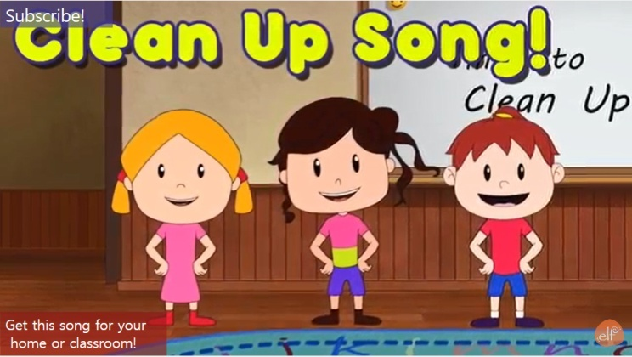
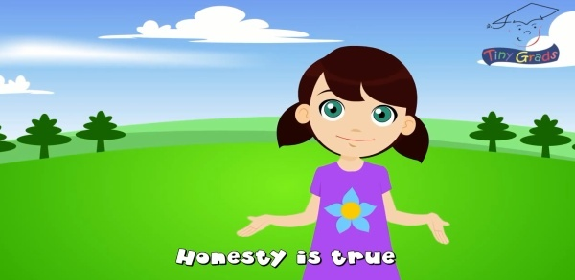
Puppets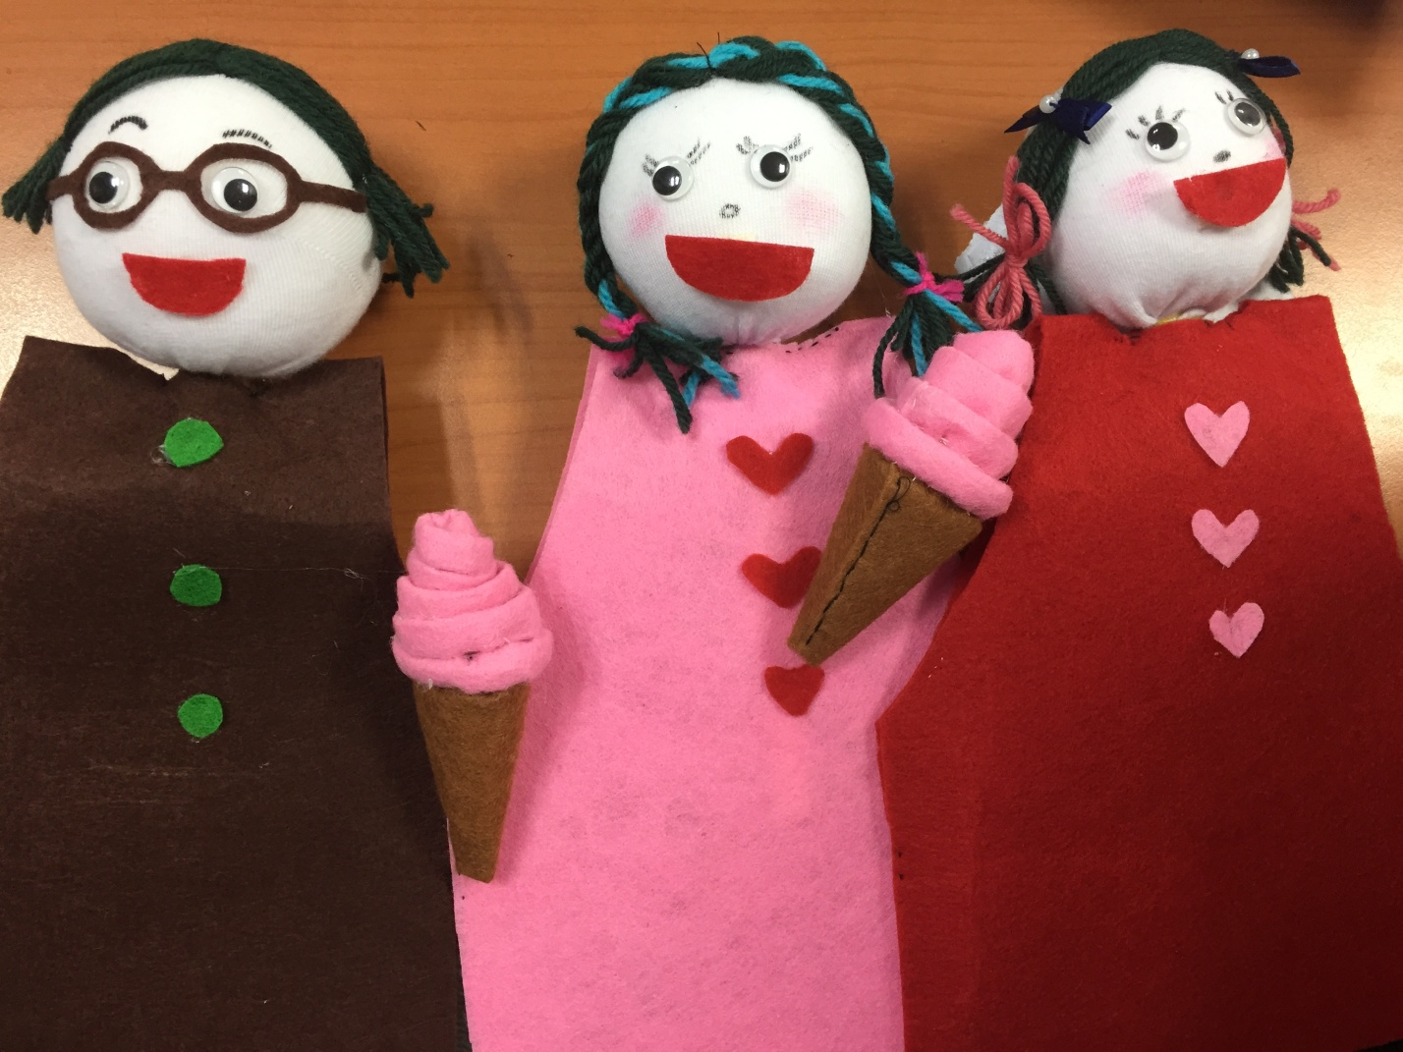
Stage

