Worksheets:

Put a check mark the things you do for each special occasion.

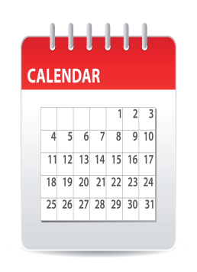 | 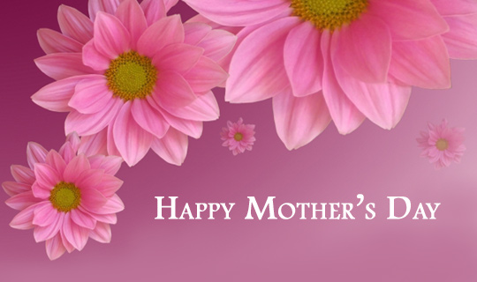 | 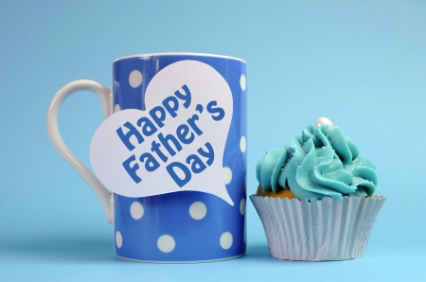 |  | 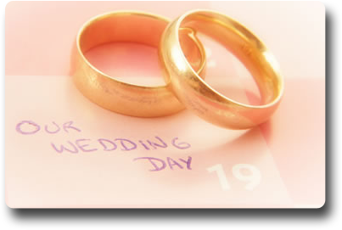
Send cards
Give presents
Take pictures
Sing songs
Dance
Eat cake
Have a party
Have a picnic
Eat special food
Wear special clothes

Celebrations
Birthdays:

Talk to two classmates and find out when their birthdays are. Ask them questions about their birthdays and write down three facts about each.

Name
Birthday
Fact 1
Fact 2
Fact 3

Name
Birthday
Fact 1
Fact 2
Fact 3

Describe a special occasion.

READING:
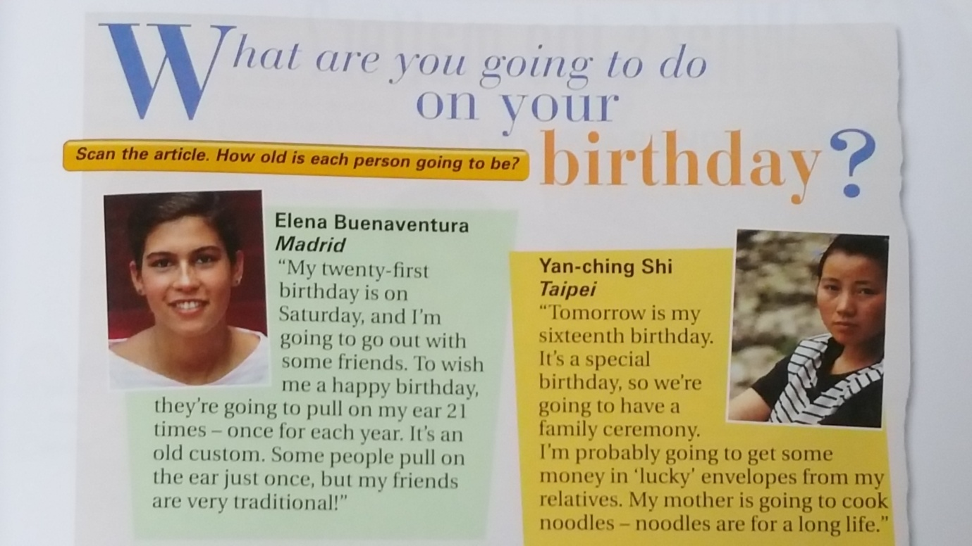
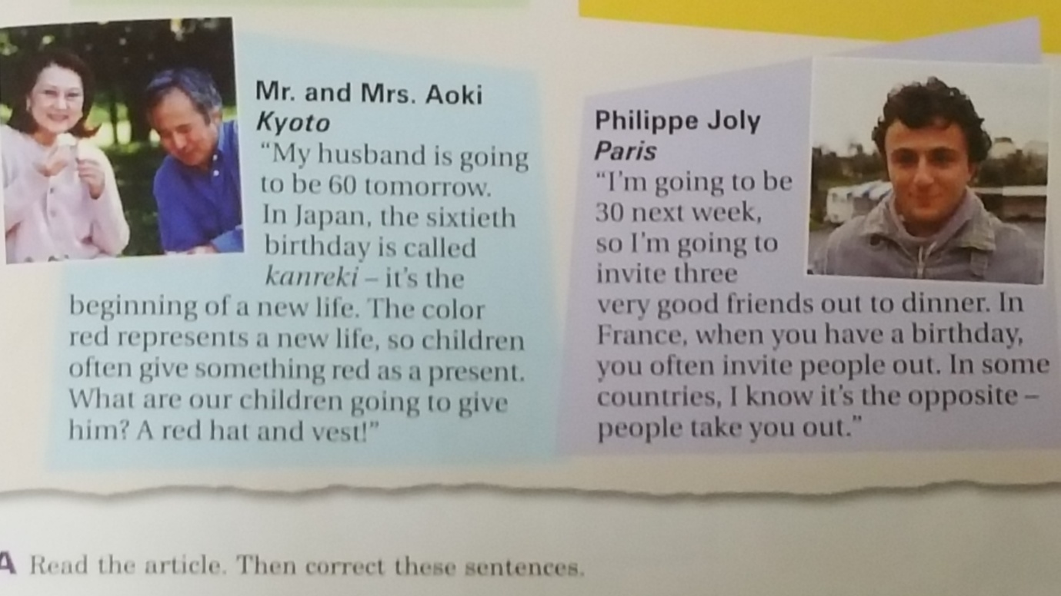
- Read the article. Then correct these sentences.

- To celebrate her birthday, Elena is going to pull on her friends’ ears.

- Yan- ching is going to cook some noodles on her birthday.

- On his birthday, Mr. Aoki is going to buy something red.

- Philippe’s friends are going to take him out to dinner on his birthday.

