1. To drizzle on the top

2. To thaw frozen meat

3. To toss to coat evenly
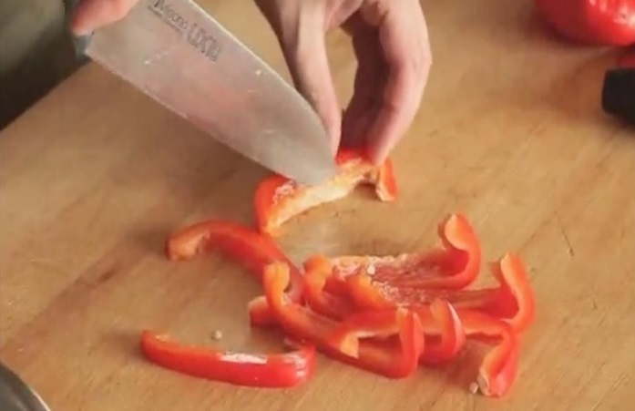
A
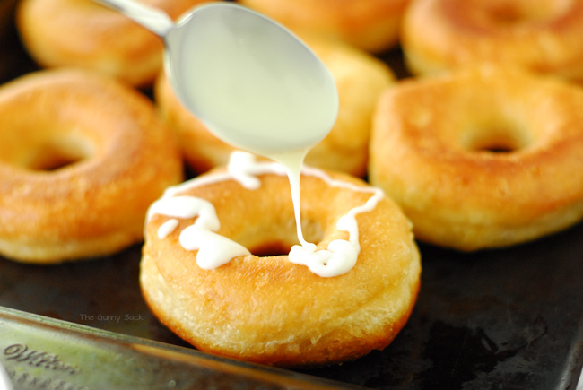
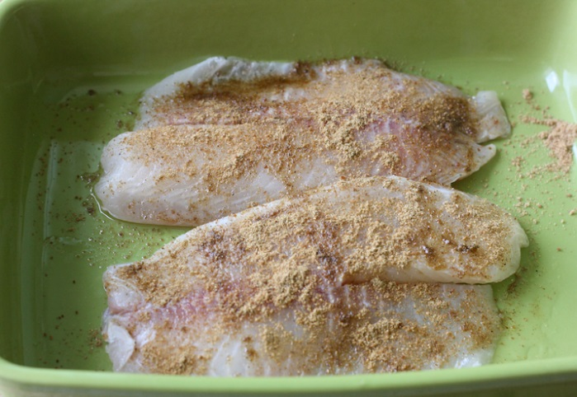
B
C

4. To cut into strips

5. To season with coconut sugar

6. To seed with spoon or knife
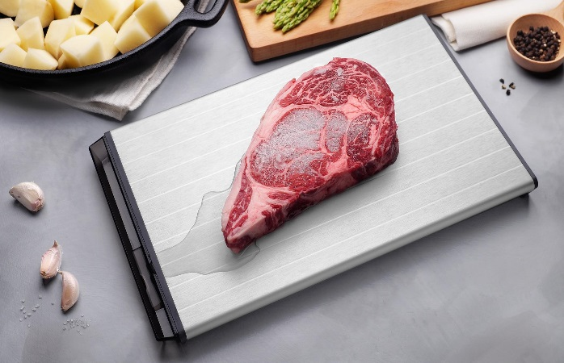
D
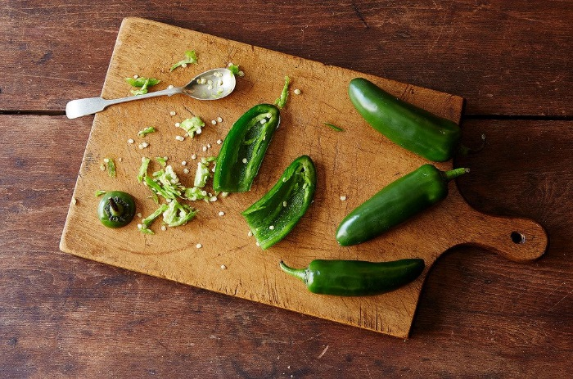
E
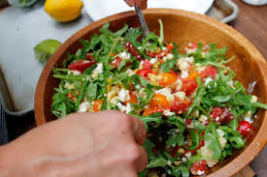
F

310 calories
Total Time: 20 minutes

Cajun Shrimp foil packets are so easy to make, anyone can do it! Spicy shrimp seasoned with Cajun spices, Andouille sausage, and rainbow colored vegetables are baked together in foil pouches. They are fast and easy to make, and can be made ahead and kept in your freezer. When you're ready to cook them, just pop them in the oven – perfect for busy weeknights!

Ingredients:
- 1 tbsp Cajun seasoning
- 24 (1 pound) cleaned large shrimp
- 3 ounces fully cooked Turkey/Chicken Andouille sausage (Applegate), very thinly sliced
- 1 medium zucchini (8 ounces each), sliced into 1/4-inch thick rounds
- 1 large red bell pepper, seeded and cut into thin strips
- 1 1/2 cups corn kernels
- 1/4 cup chopped fresh Italian parsley leaves
- 1/4 cup chopped fresh basil leaves
- 1/4 cup dry white wine, such as Pinot Grigio
- 2 tbsp olive oil

Directions:
- In a medium bowl, combine the Cajun seasoning, salt, and pepper. Add the shrimp and toss to coat.
- Place 4 large (10 x 18-inch) pieces of heavy-duty aluminum foil on a flat surface.
- Divide the sausage, zucchini, bell peppers, and corn among the foil pieces, placing the vegetables in the center of each. Top each with shrimp (about 6), sprinkle each with 1 tbsp of the parsley and 1 tbsp of the basil.
- Drizzle each with 1 tbsp of the wine and about 1/2 tbsp of the oil. Fold each piece of the foil to form a packet, sealing tightly and leaving a little room inside for air to circulate in the packet. The packets may be refrigerated (or frozen) at this stage.
- To cook, preheat the oven to 425F. Arrange the packets on a baking sheet and cook until the shrimp is cooked through and the vegetables are crisp-tender, 13 minutes. Open the packets slowly, being careful of the hot steam. Transfer the shrimp, vegetables, and sauce that has accumulated to individual bowls or rimmed plates.

To freeze and heat:
- Place uncooked packets into sealable plastic bags, keeping them level and upright. (Two packets fit well into a gallon sized bag). Freeze for up to two (2) months. There is no need to thaw before cooking.
- Remove the frozen packets from the bags and place them on a baking tray in a cold oven set to 425F.
- Once oven comes to temperature, continue to cook for 35-40 minutes.

Season food with something:
to add something (ex. salt, pepper or spices and etc.) food in order to improve its flavour
*seasoning powder, seasoning sauce, seasoning oil and etc.

Tbsp: table spoon full
Tsp: tea spoon full

Seed food:
to remove the seeds from food

Strip:
long and narrow piece

Toss food to coat:
to lightly shake from side to side or up and down so that they become covered (with sauce etc.)

Sprinkle:
To scatter (a liquid, powder, etc.) in drops or particles

Drizzle:
To pour or let fall in fine drops or particles

Heavy-duty:
sturdy, strong

Thaw:
to cause to change from a frozen to a liquid or semiliquid state; melt.

