View a biographical overview of Vincent van Gogh's life, and learn about how he discovered art and eventually became one of the most famous artists in the world.
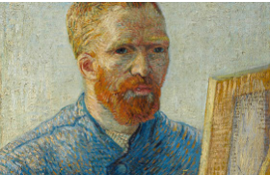
Vincent van Gogh would become one of the most well-known artists in the world. His paintings have become easily recognizable to cultures throughout the world, and he has become the archetypal “tortured artist.”
Van Gogh was born in 1853 and grew up in Holland. He was raised in a religious family with his father being a minister. When his school ended, Vincent followed his uncle’s profession and became an art dealer learning the trade in Holland and then working in England and France. Vincent was successful and initially happy with his work. However, he soon grew tired of the business of art, especially in Paris, and lost interest in the trade. After returning home, Vincent began to study theology. While very passionate and enthusiastic, he failed exams to enter a couple programs. Characteristic of his personality, he was intelligent, able to speak multiple languages, but he did not think that Latin was a language for preaching to the poor. During this period, he worked as a missionary in a coal mining community living with hard working poor common people. As his development as a preacher was stalling, his interest in those around him was increasing. His life as an artist was beginning.
Self portrait as a painter, 1887-1888

In 1880, at 27 years old, Van Gogh entered the Académie Royale des Beaux-Arts in Brussels, Belgium. The following winter, living in Amsterdam, Vincent fell in love, had his heart broken, and began painting. The next few years would result in little success both in love and art.
Van Gogh’s Potato Eaters, his first major work, was painted in 1885. By this time, he was still having difficulty finding love, but was beginning to receive interest in his paintings. He was now fully devoting himself to painting: living frugally, studying color theory, and admiring the works of artists like Peter Paul Rubens. Unfortunately, as would be his entire life, his paintings were still difficult to sell. His brother Theo, an art dealer and the recipient of many letters from Vincent, commented that there should be more color in his work. Van Gogh was painting peasants and rural landscapes using dark earth tones. Around this same time, Impressionism, with its bright vivid colors, was becoming popular.
The next year, Vincent moved to Paris where his art began to take on the style that would make him famous. In Paris, he was discussing art with some of the most avant-garde and influential artists of his time – painters like Gauguin, Bernard, and Toulouse-Lautrec. He was using more color, applying the paint with thick, bold brushstrokes, and painted all that surrounded him. Van Gogh arranged to show his work, to positive reviews, but was still unable to sell any pieces.
One of Van Gogh’s dreams as an artist was to start a colony for artists in Arles in the south of France. Vincent moved to Arles where he was joined by Gauguin. While there, Van Gogh entered the most productive and creative period of his life painting his famous Sunflowers. However, it also was a time of great turmoil for Vincent beginning a period of hospital stays for mental illness and physical decline.
After just ten years of painting and producing some 900 paintings, Vincent van Gogh took his own life in 1890. Never fully appreciated in his own time, it wouldn’t take long for the art world to recognize the genius they lost. Within twenty years of his death, there were memorial shows of his works all over the world – influencing generations of artists to come.

Painting Highlight – landscape, people, flowers and blossoms
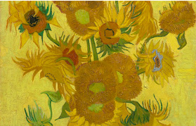  sunflowers January 1889 | 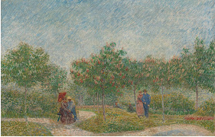  Garden with Courting Couples may 1887
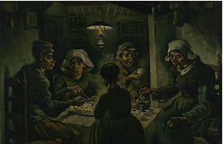  The potato eaters April - May 1885 | 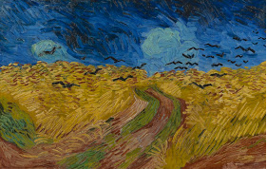 Wheatfield with Crows July 1890
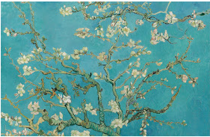  Almond blossom February 1890 | 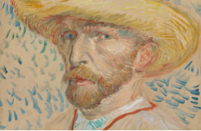  Self portrait with straw hat september1887

In this paper, there are descriptions of 4 paintings by van gogh’s work.
Read carefully and matching a titles and image for each expanation.

The Potato Eaters
Nuenen, April - May 1885 Vincent van Gogh (1853 - 1890)
oil on canvas, 82 cm x 114 cm
Van Gogh Museum, Amsterdam (Vincent van Gogh Foundation)
Van Gogh saw the Potato Eaters as a showpiece, for which he deliberately chose a difficult composition to prove he was on his way to becoming a good figure painter. The painting had to depict the harsh reality of country life, so he gave the peasants coarse faces and bony, working hands. He wanted to show in this way that they ‘have tilled the earth themselves with these hands they are putting in the dish ... that they have thus honestly earned their food’.
He painted the five figures in earth colours – ‘something like the colour of a really dusty potato, unpeeled of course’. The message of the painting was more important to Van Gogh than correct anatomy or technical perfection. He was very pleased with the result: yet his painting drew considerable criticism because its colours were so dark and the figures full of mistakes. Nowadays, the Potato Eaters is one of Van Gogh’s most famous works.

Sunflowers
Arles, January 1889 Vincent van Gogh (1853 - 1890)
oil on canvas, 95 cm x 73 cm
Van Gogh Museum, Amsterdam (Vincent van Gogh Foundation)
Van Gogh’s paintings of sunflowers are among his most famous. He did them in Arles, in the south of France, in 1888 and 1889. Vincent painted a total of five large canvases with sunflowers in a vase, with three shades of yellow ‘and nothing else’. In this way, he demonstrated that it was possible to create an image with numerous variations of a single colour, without any loss of eloquence.
The sunflower paintings had a special significance for Van Gogh: they communicated ‘gratitude’, he wrote. He hung the first two in the room of his friend, the painter Paul Gauguin, who came to live with him for a while in the Yellow House. Gauguin was impressed by the sunflowers, which he thought were ‘completely Vincent’. Van Gogh had already painted a new version during his friend’s stay and Gauguin later asked for one as a gift, which Vincent was reluctant to give him. He later produced two loose copies, however, one of which is now in the Van Gogh Museum.

Almond Blossom
Saint-Rémy-de-Provence, February 1890 Vincent van Gogh (1853 - 1890)
oil on canvas, 73.3 cm x 92.4 cm
Van Gogh Museum, Amsterdam (Vincent van Gogh Foundation)
Large blossom branches like this against a blue sky were one of Van Gogh’s favourite subjects. Almond trees flower early in the spring making them a symbol of new life. Van Gogh borrowed the subject, the bold outlines and the positioning of the tree in the picture plane from Japanese printmaking.
The painting was a gift for his brother Theo and sister-in-law Jo, who had just had a baby son, Vincent Willem. In the letter announcing the new arrival, Theo wrote: ‘As we told you, we’ll name him after you, and I’m making the wish that he may be as determined and as courageous as you.’ Unsurprisingly, it was this work that remained closest to the hearts of the Van Gogh family. Vincent Willem went on to found the Van Gogh Museum.

Wheatfield with Crows
Auvers-sur-Oise, July 1890 Vincent van Gogh (1853 - 1890)
oil on canvas, 50.5 cm x 103 cm
Van Gogh Museum, Amsterdam (Vincent van Gogh Foundation)
Wheatfield with Crows is one of Van Gogh's most famous paintings. It is often claimed that this was his very last work. The menacing sky, the crows and the dead-end path are said to refer to the end of his life approaching. But that is just a persistent myth. In fact, he made several other works after this one.
Van Gogh did want his wheatfields under stormy skies to express 'sadness, extreme loneliness', but at the same time he wanted to show what he considered 'healthy and fortifying about the countryside'.
Van Gogh used powerful colour combinations in this painting: the blue sky contrasts with the yellow-orange wheat, while the red of the path is intensified by the green bands of grass.

*references : Vangoghgalleryhttp://www.vangoghgallery.com/misc/biography.html/ Vangoghmuseum https://www.vangoghmuseum.nl/en/search/collection?q=&artist=Vincent+van+Gogh&genre=self- portrait

