■ Listening ☐ Speaking ☐ Reading ☐ Grammar ☐ Writing
Topic: Talk about people’s appearance
(through Sherlock Holmes story)

Instructor:  Terry Lee(이태완) | Level:  High-intermediate | Students:  12 | Length:  50 minutes

Materials:
- Audio book from Youtube (Sherlock Holmes, The red-headed league, first part)
- Pictures of Sherlock Holmes (3 ones)
- Appearance – example sheet
- Work sheet #1, #2
- White board and markers
- TV or projector, sound speakers

Aims:
- To learn and express the expression of appearance
- To speak confidently the expression of appearance
- Can listen to the text carefully and understanding
- To understand the meaning of vocabularies and idioms in text.
- To understand the context comprehensively.

Language Skills:
- Listening : Listening to text, group working
- Reading : Following the example and work sheet.
- Speaking : Discussion on group working, talking with T, Ss
- Writing : Fill in worksheet, using the typical expressions

Language Systems:
- Lexis : On example sheet, In text.
- Phonology : Practicing new vocabulary
- Function : asking questions, answering on discussion
- Grammar : Present perfect, Could/Would, Exclamatory sentence
- Discourse : In text, Comprehensive.

Assumptions:
- Students roughly know “Sherlock Holmes”.
- Students can listen to English at least low-intermediate level.
- All students are high school or college students.
- Students are aware of the expressions of appearance but not deeply.

Anticipated Errors and Solutions:
- Some Ss will have the difficulty in listening to the text.
Try to give one or two chances of listening, however, Ss have a difficulty, teacher give a sentence. But this is a last resort.

- Ss cannot imagine the words of appearance.
Teacher will help Ss give the example sheets and do more eliciting works.

References:

Youtube : https://www.youtube.com/watch?v=lg88SAAcCyQ (from start to 3:03)
Learn English online : https://learnenglishteam.blogspot.kr/

Lead-In
Materials: Picture of Sherlock Holmes

Time | Set Up | Student Activity | Teacher Talk
3 mins | Whole class | Listen and warm-up | Procedure  T:  Hello, everyone. How was your weekend?  Today we’ll talk about some stories and people’s appearance.  First, please look at these pictures.  From those pictures, which words come up to you?  (Expected answers : Sherlock Holmes, Novel, Movie, UK drama, detective series, Robert Downey JR, etc.)  Well, we’ll have a listening class one of part of ‘Sherlock Holmes’.

Pre-Activity
Materials: Picture of “Red-headed league”, example sheet of “appearance”

Time | Set Up | Student Activity |  | Teacher Talk
3 mins  5 mins  5 mins | Whole class  Groups  Whole  class | Guessing and warm-up  Discuss and guess  Share | Procedure  T:  And I have one more picture.  Please look at this.  What do you think about this picture?  (expected answers: red-headed league, sounds like weird, one story of Sherlock Holmes, the red-headed guy is in picture, etc.)  Yes, that is one story of Sherlock Holmes.  ‘the red-headed’ means just people who have the red color hair. This is one kind of the expression about people’s outer appearance.  Instructions  Ask students to discuss with group members, list up the expression or words used in person’s appearance.  Everything is OK, like hair, eyes, face, clothes, height, body type, first impression, etc.  CCQ  - Are you working with your group?  - How much time do you have?  Instructions  5 minutes later, T ask Ss to share their results and T write on the white board.  Show Ss the example sheet that T prepared.  Comparing the list on white board with the example sheet.  Add some more words & expressions  or explain the meaning of unfamiliar words.

Main Activity
Materials: Audio from Youtube (main script), Work sheets #1,2

Time | Set Up | Student Activity | Teacher Talk
6 mins  10 mins  10 mins | Individuals  Individuals  Whole class | Listen  Listen and dictation  Discuss, answer | 1. Listen carefully the whole text.  Instructions  In first stage, we are going to listen to given whole text from story of Sherlock Holmes. Please listen carefully about whole story.  CCQ  - What is an overview or sketchy of this script?  - What is your feeling from this story?  Instructions  T gives Ss the questions which is including the basic information.  An overview, atmosphere, topics  T may evaluate the level of understanding.  To encourage the weaker Ss on listening, “We have more chance to listen, don’t worry”  2. Listen one more time.  Fill in the blank in #1 worksheet.  Instructions  Listen one more time.  Ask Ss to listen carefully to concentrate on details and the expressions.  And ask Ss to fill in the blank in #1 worksheet.  CCQ  - Who are the characters of this story?  - Which words were used to how they look like?  - Are you catching up some more details of story?  - Did you complete to fill in blank? Is there any difficulties?  - Do you want to listen one more time?  Yes > Listen one more time.  No > Proceed next step.  3. Learn the words, idioms, grammar  CCQ  - Did you find the expressions used to how they look like?  - Please tell T the blank you can’t fill in or unfamiliar words and idioms.  Instructions  T share with Ss.  : fat, with a red face, bright red, red-headed  And related to our pre-activity.  T give Ss some guidance or explanation.  - Words  : Nod to someone, knees, run the finger down, chronicle, vacancy, salary, assistants  - Grammar and idioms  Present perfect usage in script.  Could/ would you please~?  For oneself  “What a strange advertisement”  - exclamatory sentence

Post Activity
Materials: Work sheets #1, example sheet of “appearance”

Time | Set Up | Student Activity | Teacher Talk
6 mins  2 mins | Pair working  Whole class | Speak, discuss | 1. Production activity in pair.  Instructions  T ask Ss to make the pairs. 2 or 3 Ss in  one pair is the best.  Talk with partner using the expressions  learned today.  Describe someone’s appearance.  The person doesn’t have to be a person  in this classroom or your partner. Anyone  is OK.  T give some guidance of today idioms.  e.g.>  Could/ would you please~?  For oneself  “What a strange advertisement”  - exclamatory sentence  Ask Ss to have a trial with these idioms in  pair work.  CCQ  - Who are you working with?  - Is it possible to use today expressions?  2. Wrap-up the class  Procedure  T:  Today we talked about the expressions  used how people look like.  And draw out some idioms from Sherlock  Holmes text.  Try to use in your real situations.  Thank you. See you tomorrow.

SOS Activity
Materials:
Work sheet #2

Time | Set Up | Student Activity | Teacher Talk
10 mins | Individuals  &  Whole class | Listen, Write, Guess, Speak | 1. Comprehension Questions  If there are enough time, due to any  reasons, proceed worksheet #2, comprehension questions.  Instructions  T passes out the worksheet #2,  And ask Ss to turn over the script sheet.  And look through work sheet #2,  Give the question whether Ss can answer or listen to the text one more time.  And then, answer the questions on sheet, share and tell the story.

Attach picture #1. Pictures of “Sherlock Holmes”

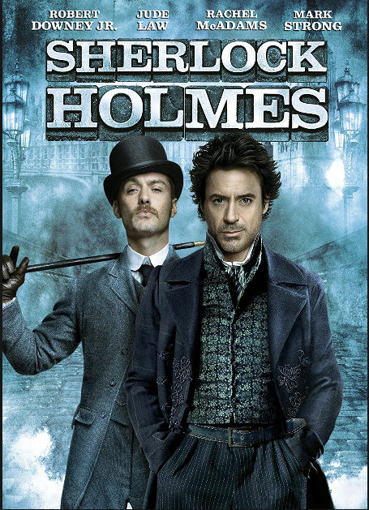

Attach picture #2. Pictures of “Red-headed league”

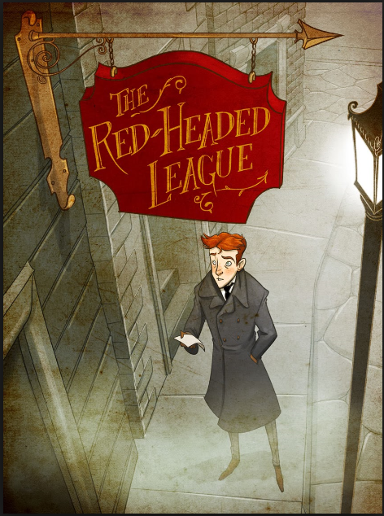

Attach picture #3. The example sheet of extpressoins.
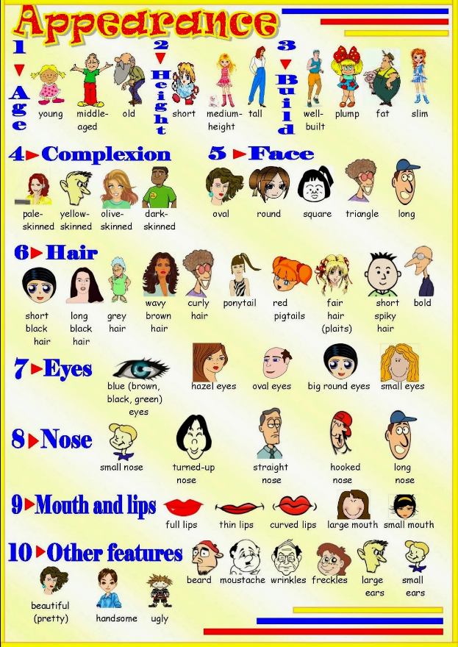
Work sheet #1. Fill in the blanks.

After my , I lived with my wife in another part of London. My friend, Sherlock Holmes, live in his apartment in Baker Street. One day, in the
of 1890, I decided to visit my friend. But when I arrived at his apartment, I found he already had a visitor. This visitor was an man. He was ,
with . But the most unusual thing about him was his hair. The color of the old man’s hair was .
“I’m sorry, Holmes,” I said. “I didn’t know you were busy, I’ll wait in the next room”
But Holmes didn’t want me to . He pulled me into the room and closed the door.
“This is my friend, Dr. Watson,” he said to the old man. “Dr. Watson has me with many cases. Perhaps he can also help me with yours.”
“I’m very interested in your cases, Holmes,” I said.
“This is Mr. Jabez Wilson,” went on Holmes. The old man me.
“Mr. Wilson has come to me with a very unusual story. It’s the most interesting problem
.
Mr. Wilson, could you please tell your story again from the beginning. I’d like Dr. Watson to hear it.”
Mr. Wilson pulled an old newspaper out of his pocket. He opened the paper on his
and turned to the advertisement page.
He the advertisements and pointed to one of them.
“Here,” he said. “This is how everything began.
Read it Dr. Watson.”
I took the newspaper from Mr. Wilson. It was The Morning and was two months old. I read the advertisement.
LEAGUE : Another is open for someone wishing to become a member of the league. – four pounds a week. All men, over 21 years old, should come on Monday at 11 am to this address: Duncan Ross, The Red-Headed League, 7 Pope’s Court, Fleet Street, London.
“What a advertisement,” I said. “Whatever can it mean?”
Holmes laughed. (hahahahaha..) “It’s very unusual, isn’t it,” he said.
“And now, Mr. Wilson, tell us your story.”
“Well,” began Mr. Wilson, “I have a small shop in Saxe-Coburg Square, in the City of London. But business hasn’t been good for some time and I don’t make much money any more. but now I can only pay one (……..)”

Work sheet #2. Comprehension Questions
1. Who is the main speaker?
2. List up the characters name in story.
3. What are they mainly discussing?
4. When was the exact year this story happened?
5. The visitor, how did he look like?
6. Why did Holmes ask the visitor to tell his story once again?
7. According to the advertisement, what kind of people were “the league” gathering?

<Recording script>
Story to learn English
The red-headed league

After my marriage, I lived with my wife in another part of London. My friend, Sherlock Holmes, continued to live in his apartment in Baker Street. One day, in the autumn of 1890, I decided to visit my friend. But when I arrived at his apartment, I found he already had a visitor. This visitor was an old man. He was fat, with a red face. But the most unusual thing about him was his hair. The color of the old man’s hair was bright red.
“I’m sorry, Holmes,” I said. “I didn’t know you were busy, I’ll wait in the next room”
But Holmes didn’t want me to leave. He pulled me into the room and closed the door.
“This is my friend, Dr. Watson,” he said to the old man. “Dr. Watson has helped me with many cases. Perhaps he can also help me with yours.”
“I’m very interested in your cases, Holmes,” I said.
“This is Mr. Jabez Wilson,” went on Holmes. The old man nodded to me.
“Mr. Wilson has come to me with a very unusual story. It’s the most interesting problem I’ve heard for a long time. Mr. Wilson, could you please tell your story again from the beginning. I’d like Dr. Watson to hear it.”
Mr. Wilson pulled an old newspaper out of his pocket. He opened the paper on his knees and turned to the advertisement page. He ran his finger down the advertisements and pointed to one of them.
“Here,” he said. “This is how everything began. Read it for yourself, Dr. Watson.”
I took the newspaper from Mr. Wilson. It was The Morning Chronicle and was two months old. I read the advertisement. THE RED-HEADED LEAGUE : Another vacancy is open for someone wishing to become a member of the league. Salary – four pounds a week. All red-headed men, over 21 years old, should come on Monday at 11 am to this address: Duncan Ross, The Red-Headed League, 7 Pope’s Court, Fleet Street, London.
“What a strange advertisement,” I said. “Whatever can it mean?”
Holmes laughed. (hahahahaha..) “It’s very unusual, isn’t it,” he said.
“And now, Mr. Wilson, tell us your story.”
“Well,” began Mr. Wilson, “I have a small shop in Saxe-Coburg Square, in the City of London. But business hasn’t been good for some time and I don’t make much money any more. I used to have two assistants, but now I can only pay one (……..)”
(3:03)

