Listening ☐ Speaking ☐ Reading ☐ Grammar ☐ Writing

Topic: Am I Missing Something?

Instructor:  Phoebe | Level:  High-Intermediate | Students:  12 | Length:  50 minutes

Materials:
- Computer, speaker and screen
- Video Clip (Q&A)
- Worksheet #1, #2 and #3 (12 copies)
- Board, board markers

Aims:
- To learn speaking and listening skills about a tendency to leave out words we think are unnecessary (ellipsis)
- To practice how to use ellipsis
- To learn listening skill through a semi-authentic material (Video Clip)

Language Skills:

- Listening: Joshua, who has Asperger’s Syndrome, interviews his mother about his feeling
- Reading: Short reading material regarding children with Asperger’s syndrome
- Speaking: Sharing students’ thoughts and opinions with other classmates and have group discussions on ‘what if’ scenario given

Language Systems:

- Lexis: vocabulary and expressions related to emotions/feelings insight
- Grammar: find correct sentence through worksheet #1
- Function: omission and substitution of words in context
- Discourse: context comprising ellipsis

Assumptions:
- Students know how the class is set and run
- All students are used to speak with their thought to their mates in English
- Students acknowledge about the concept for producing natural sounding language in terms of speaking and listening
- They are all adults

Anticipated Errors and Solutions:
- Students may feel difficulties in understanding concept of ellipsis
- Encourage students to produce ‘short answers’ and show them how much can be achieved with the right intonation
- Students may not be able to understand for more details from the listening
- Chunk the listening (pause – play – pause – play)
- Students may need more time to work on their worksheets
- Let students have more time (5 mins in max) and leave unfinished tasks as for their homework

References:

https://www.youtube.com/watch?v=eO7sKVKMO2s
http://www.k12reader.com/worksheet/dot-dot-dot-the-ellipsis/view/
https://elt-resourceful.com/category/discourse/

Lead-In
Materials: Board, Board markers

Time | Set Up | Student Activity | Teacher Talk
5 min | Whole Class | Answer the questions | Hello everyone, how was your weekend? The weather was weird on the weekend though. It rained heavily and then shined right after!  Does anyone prefer rainy days? Or shiny days? Oh, (Student A) likes rainy days but (Student B) doesn’t!  (Elicit questions for requesting something & write them on the board)  (Show students some examples of ellipsis using ‘but’)  Like I said, where words are omitted because the meaning is clear, we call them ‘ellipsis’. Today, we will watch beautiful video clip which we can catch some ellipsis structure and do some exercises!  But first, we will practice some questions and answers.

Pre-Activity
Materials: Board and board markers, Worksheet #1

Time | Set Up | Student Activity | Teacher Talk
5 min  7 min | Whole Class  Individually | Listen carefully and answer to the teacher’s questions  Complete worksheet #1 | Demonstration:  I will write down few example sentences in full and we can find few words which are potentially unnecessary to be there! Or we can rephrase them into much simpler ones! Let’s try!  Examples)  - I went to the bakers to get some wholemeal rolls and (I went) to the butchers for lamb chops.  - The dark-haired girl (who is) standing over there just smiled at you.  - He said he likes red cardigans but I don’t like red cardigans  Instruction:  Distribute worksheet #1 to the students  CCQ  Are sentences in the worksheet in completed form?  How many questions can you see?

Main Activity
Materials: Computer, speaker, beam projector, Worksheet #2

Time | Set Up | Student Activity | Teacher Talk
3 min  7 min  13 min  6 min | Whole Class  Whole class  Individually  Individually | Answer to the teacher’s questions  Watch the first section of the video clip and follow the teacher’s instruction  Watch the rest of the video clip and follow the teacher’s instruction | I. Watch the Video Clip (First section)  Elicit  Talk with students about ‘Asperger’s Syndrome’ very briefly  Instructions  “Watch the first section of the video. I will pause when the first section runs out and then try to find five things about Joshua.”  Pause the video clip (to 0.29 min)  “What were the five things you found through the video clip?”  II. Watch the Video Clip (Whole section)  Instructions  “Ok, now, watch the rest of the section and then note down the five main questions that Joshua asks his mum to your worksheet #2”  Hand out worksheet #2 to the students  CCQ  Will Joshua tell mum certain things or ask his mum?  Who will answer to Joshua’s questions?  Play it one more time if required  “Ok, class. What were the five things you heard from Joshua?”  “Also, what do you think each question Joshua asks might tell you about his life? What do Sarah’s answers tell you about the relationship between her and Joshua?”  (If the students feel difficulties in above questions, move on to next instruction)  Instruction  “Now, we will watch the video one more time and try to fill in the blank in the second section of the worksheet #2”  CCQ  Does anyone not have second section of the worksheet #2?  How many times are we going to watch the video for this time?  (Play the video clip and monitor discreetly by walking the class)

Post Activity
Materials:

Time | Set Up | Student Activity | Teacher Talk
3 min  1 min | Whole class  Whole class | Discuss with the teacher  Listen to the teacher and follow the instruction. | Instruction  “Imagine you were going to interview a parent. What questions would you like to ask?”  “Okay. This is the last thing that you will do for today’s lesson. Go home and practice what we learnt today, ‘ellipsis’, by worksheet #3 as your homework!”

SOS Activity
Materials: Worksheet #3 (Reading passage)

Time | Set Up | Student Activity | Teacher Talk
5 min | Individually | Read the passage and answer to the questions | “Read the short text in worksheet #3 describing ‘Asperger’s Syndrome’ we just watched. After you read it, please write down your answers to the paper”  CCQ  What does the text describe about?  Does anyone not have your utensil with you?

Worksheet # 1
▶ Choose the right answer (you can circle one or erase wrong one)

- Harry did his homework, even though he didn’t want to / didn’t want.
- She said she could use a computer but it was obvious that she.couldn’t use / couldn’t.
- We can't repair your car today but we can / we can repair tomorrow.
- You don't work as hard as.you should / you do.
- I don't know if I'll pass all my exams but I hope / hope to.
- Although I could have gone to university, I haven’t / didn’t.
- Simon broke his brother's computer but he didn't mean to / mean to break.
- She should get a job but she didn’t / won’t.

Worksheet # 2
- Note down 5 main questions that Joshua asks his mum.

- We often miss out words or phrases if the meaning is clear (ellipsis). Look at the following extract. What words are ‘missing’ that could be in the brackets [ ] ?

J: Have you ever lied to me?
S: I probably have [ ], but I try not to lie to you even though sometimes the questions you ask me make me uncomfortable.

- In fact, Sarah often includes words or phrases where others might miss them out. People with Asperger’s can have difficulties in inferring meaning, and this may be a strategy she has developed. Look at these examples and bracket [ ] any words or phrases Sarah uses which could be omitted without changing the meaning.

- J: On a scale of 1 to 10 how do you think your life would be different without animals?
S: I think it would be about an 8 without animals because they add so much pleasure to life.

- J: Have you ever lied to me?
S: I probably have, but I try not to lie to you even though sometimes the questions you ask me make me uncomfortable.

- J: I think it feels like everyone seems to like Amy more. Like, it seems like she’s, like, the perfect little angel.
S: Well, I can understand why you think that people like Amy more…

Worksheet # 3
Read the following short text about Asperger’s. Which features of the syndrome does Joshua appear to have?
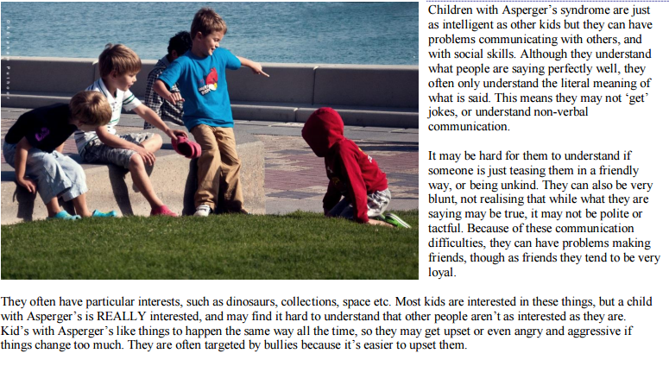
- Why do you think children who are different can have ‘a tough time socially’?

- Sarah says ‘The people who take the time to get to know you, love you.’ How can schools help children to understand and get to know each other better?

