☐ Listening ■ Speaking ☐ Reading ☐ Grammar ☐ Writing

Topic: Talking about movies

Instructor:  Eun Sun Yang | Level:  Pre-Intermediate | Students:  2 | Length:  35 Minutes

Materials:
- White board and markers
- Worksheet (one for each student)
- Matching activity worksheet (2 copies)

Aims:
- To tell and match movie genres by doing an activity to match movies with their genres.
- To recognize and make use of simple expressions to ask or to describe place and time by doing information gap activity questioning and answering with a partner.
- To practice describing some features of movies to others by doing an activity to make a partner guess the movie’s title based on their description.

Language Skills:
- Speaking: talking about movies listed on the sheet and from their own experiences with a partner
- Listening: listening to teacher’s elicitation and partner’s speaking
- Writing: writing a few sentences to describe a great movie that have seen
- Reading: reading the information and instruction from the worksheet

Language Systems:
- Vocabulary: movie genres
- Function: asking for information and giving information, asking or describing the movie
- Grammar: asking questions for place, time, and actors

Assumptions:
- Students get the general idea of what is being said.
- Students can read and write simple texts and is able to hold a basic conversation.

Anticipated Errors and Solutions:
- Students may not be able to catch the information provided by a partner, since they are not familiar with those words or their pronunciation is incorrect.
-> beside them, monitor their discussion and when necessary, help them catching the information by adding some more supportive explanation or by correcting pronunciation
- When writing descriptions about a movie that they have seen, they may lack language or expression useful for their description.
-> before start, give them some examples that they can use and during their work, let them feel free to ask for help
- Students take longer to guess the movie.
-> Encourage students to describe further besides reading those sentences they wrote.

References:
http://www.handoutsonline.com/fs/movies_1.pdf

Pre-task
Materials:

Time | Set Up | Student Activity | Teacher Talk
2 min. | Whole class | Greeting | Hi, everyone!  Have you seen any movies lately? Or do you have any favorite movie?  (If anyone tells any movie, ask him/her which type of movie it is, what it is about, and/or what he/she liked about it.)  Today, we will talk about movies.

Task Preparation
Materials: Worksheet, Matching Activity Worksheet, Board

Time | Set Up | Student Activity | Teacher Talk
3 min.  5 min. | Whole class  Individual  Pairs  Whole class  Pairs  Whole class | Brainstorming  Discussion  Matching activity & Discussion | (Hand out a worksheet to each student.)  Please have a look at the worksheet that you are just given.  Instruction  First, we will start with taking about movie genres. How many different kinds of movies can you write in English? Take a minute to list kinds of movies that you can think of in English in the box of your worksheet.  CCQ  What will you do?  How much time do you have?  (Students work individually.)  Compare your list with your partner to see what you missed.  Let’s list them up on the board.  (Write on the board genres of movies as students say.)  Instruction  (Hand out matching activity worksheet for matching activity.)  Work in pairs to match movie with its genre. You have 5 min. to work on this.  CCQ  Who do you work with?  How much time do you have?  Are you done?  Now, we will move to the next activity.

Task Realization
Materials: Worksheet, Board

Time | Set Up | Student Activity | Teacher Talk
5 min.  5 min.  10 min. | Pairs  Individual  Pairs | Information gap  Writing  Speaking | Instruction  Now, we will do an activity called information gap to talk about movies. Since each worksheet has different information, you should not look at your partner’s sheet.  You will find the missing information and fill in the table by asking your partner questions on the information that you need.  Demonstration  For example, if you need the information of place, ask your partner “Where is the movie set?”. To ask time when movie is set, your question would be “When is it set?”, and to ask actors who are in the movie, ask “Who’s in it?”.  I will give you an example for the movie “Star Wars”.  (Write on the board the below,  Star Wars / in space / a long time ago / Mark Hamil)  Work in pairs and fill in the table with the missing information. You will have 5 min.  CCQ  Are you allowed to look at your partner’s sheet?  How can you get the missing information?  How much time do you have?  Instruction  Now, think of a great movie you have seen and write 3-5 sentences about the movie. Be careful not to write the movie’s title. You will have 5 min.  Demonstration  For example, I would like to describe a movie as follows,  This movie is a type of romantic movie.  This movie is about love stories for several couples.  This movie starts Hugh Grant.  Instruction  Read your movie description to your partner and let your partner guess the movie title.

Post Activity
Materials: None

Time | Set Up | Student Activity | Teacher Talk
5 min. | Whole class |  | Error Correction & Feedback  I hope today’s activity helped you to talk about movie to others.  Did you enjoy this activity? Did you have any difficulties? What, if anything, was difficult for you during today’s class?  (Have students analyze their difficulties or errors made during the class. Discuss any commonly made errors or difficulties you or your students noticed during task-realization.)  You did a good job. Have a good day!

SOS Activity
Materials: None

Time | Set Up | Student Activity | Teacher Talk
 | Whole class | Free discussion | Let’s more talk about movies, anything that you would like to share with your classmate, such as the worst movie that you have ever seen or the movie that you are looking forward to seeing shortly.

Attachment #1: Worksheet
Attachment #2: Matching Activity Worksheet

Movie Genres : Matching Activity
Action | Adventure |  | Animation |  | Biography
Comedy | Detective |  | Fantasy |  | Horror
Romantic | Science Fiction |  | Super Hero
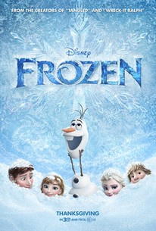  a. Animation |  | 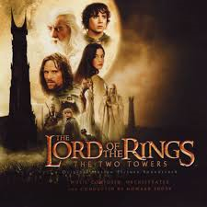  b. Fantasy |  | 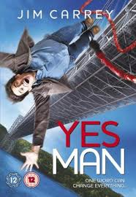  c. Comedy
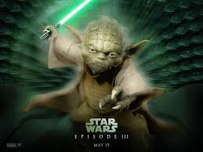  d. Science Fiction |  | 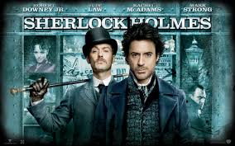  e. Detective |  | 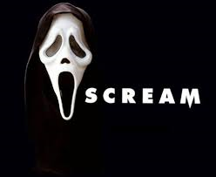  f. Horror
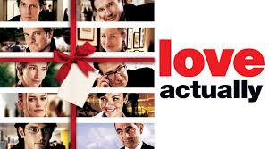  g. Romantic |  | 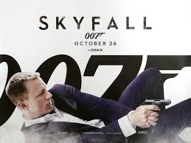  h. Action |  | 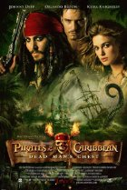  i. Adventure
j. Biography |  | 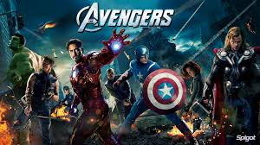  k. Super Hero

