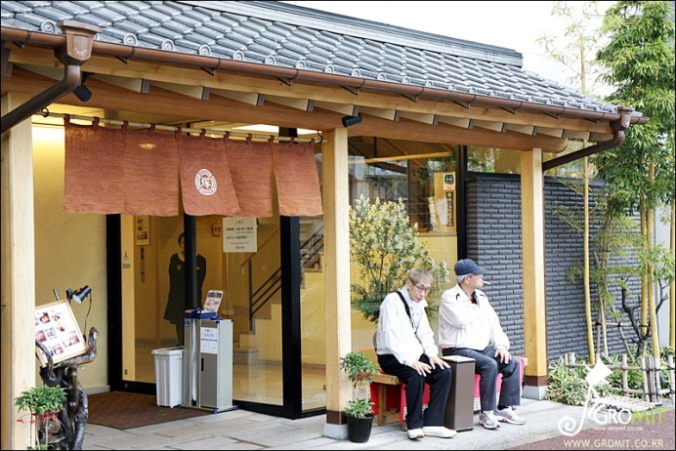 picture A

Waiter/waiteress | Guest
- I’m sorry, but it’s a reserved seat.  - Are you expecting any more guests?  - Yes, sir/mam. We’ve been expecting you.  - Would you like to sit by the window?  - I’m afraid we’re full now, but one should be available soon.  - It’ll be less than 15 minutes.  - We’ll call you as soon as your table is ready.  - you will get a table right away.  - Would you like smoking or nonsmoking?  - Would you like to have a high char?  - How about sitting at one of those tables? | - How long is the wait?  - Can you put me on the waiting list?  - Isn’t it our turn yet?  - I have a reservation for 8:00  - I didn’t make a reservation, but do you have a table for us?  - Can we move away from the door?  - Can we have a bigger table?  - Yes, there will be one more person.  - May we have another table?  - Will you escort him/her to my table when he/she gets here.

Make your Dialog

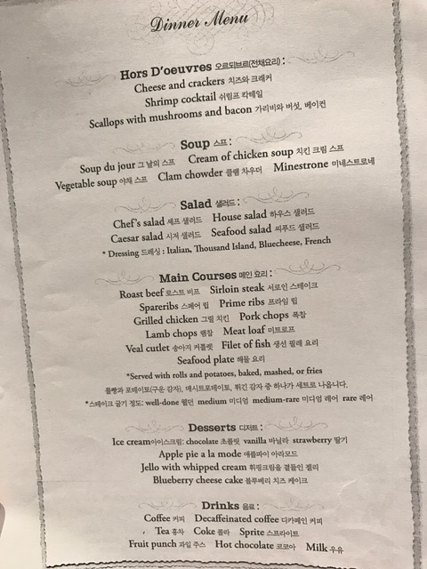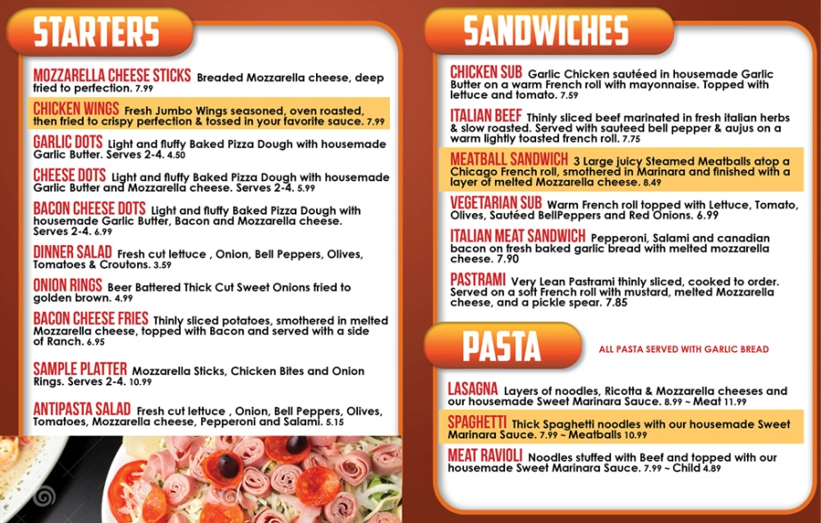

pictureB
Waiter/waiteress | Guest
- Are you ready to order now?  - Anything to drink?  - How would you like the steak done? (rare/medium/well-done)  - How would you like your eggs cooked?  ( fried/sunny-side up/once over/over easy/ scrambled egg/hard-boiled egg/ soft-boiled egg)  - Would you like dessert?  - Okay, I’ll bring it right over.  - Our lunch menu is listed on the right.  - How about new york steak?  - Number5 is our most popular dish.  - Okay, take your time.  - With milk or lemon?  - What kind of dressing would you like? | - Can I have the menu please?  - What do you recommend?  - What is today’s special?  - We’ll let you know when we’ve decided  - I’ll take that please.  - What’s that dish over there? It looks delicious  - What kind of beer do you have?  - Could I see your wine list?  - I’ll order dessert later.  - What is fast?  - I’ll pass.  - We’re ready to order now.  - I need another couple of minutes.  - With milk, but on the side, please.  - Thousand island/ Caesar salad dressing/ Balsamic vinaigrette/ Ranch dressing
Make Your Dialog

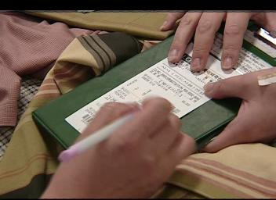 picture C

Waiter/waiteress | Guest
- Here you are.  - How will you pay for it?  - Would you like your receipt?  - We’re terribly sorry. We charged you for 3 beers not 2.  - It’s the VAT(value-added tax)  - You have to pay in advance.  - Are you paying together or separately?  - At the end of this hallway is the cashier.  - One check or separate checks?  - How is everything? | - May I have the bill?  - Check please  - Is the service charge included?  - Let’s go dutch.  - Make out separate checks please?  - Where’s the casher?  - I’ll pay by cash.  - I’m afraid this bill is not correct.  - What’s this extra charge for?  - Do I pay you now?  - Yes, please / no, thanks.  - Keep the change.

Make Your Dialog

