☐ Listening ☐ Speaking ☐ Reading ■Grammar ☐ Writing

Topic: Trip to Australia (the present and past tense of be-verb)

Instructor:  Chloe, Claire, Terry | Level:  False Beginner | Students:  12 | Length:  30 minutes

Materials:
Pictures of Australia ( for eliciting the sentence)
Given dialog
4 copies of practice work sheets (#1~4)
White Board and board markers
Substitution table, Time line

Aims:
Ss can understand the concept of be-verb.
Can understand the concept of the present & past tense of be-verb.
Can speak to loudly and confidently by using be-verb.
Can write confidently by using be-verb.
Can match the subject and be-verb form correctly in sentence.

Language Skills:
Speaking : Drilling, practice activity and sharing own idea
Listening : Listen to the teacher’s instruction, explanation
Reading : Reading given dialog and practice worksheets to answer question
Writing : Worksheet answers and composing sentences in be-verb

Language Systems:
Lexis : Learning new words that are used as be-verb
Phonology : Drilling
Grammar : Knowing the pattern on making present and past be-verb
Function : Describing own sentence related to present and past be-verb

Assumptions:
Ss have little familiarity with basic English words.
Ss will have a curiosity about Australia and travel.
Ss have a basic and common background on Australia.

Anticipated Errors and Solutions:
Ss cannot understand teacher’s speaking or dialog contents.
→ T speaks to clearly and slowly, repeats or gives instructions on dialog.

Ss are difficult to follow and fill in the work sheets.
→ T will give more time or instructions.
Or will give a guidance individually.

References:
“Next stop 5” , Viv Lambert, Macmillan

Lead-In
Materials: Pictures of Australia
Time | Set Up | Student Activity | Teacher Talk
4 min | Whole class |  | Procedure:  <Greeting>  Hi, Everyone! How are you today?  How was your weekend?  <Eliciting>  Please see these pictures.  What do you think about the pictures where they are?  (Ss answer might be ‘Australia’. If there are wrong answers, T will elicit or draw out the answer.)  Yes, you’re right. Today we’ll talk about trip in Australia and learn the basic contents of grammar.

Pre-Activity
Materials: Given dialog
Time | Set Up | Student Activity | Teacher Talk
3 min | Whole  class | Reading with Teacher | Procedure:  T:  Ok, I’ll give you guys one dialog between one daughter and mother during a trip in Australia.  I(T) will be a mother and you(Ss) are the daughter , ‘Mia’.  Please go ahead, Mia is first.  (T and Ss will have a dialog together.)  CCQ  Who is the Ss role?  What are you supposed to do with me?  After reading the dialog, T asks some questions to Ss.  What was Mia doing mainly?  Where is Mia?  Why was Mia so excited?

Main Activity
Materials: Given dialog, white board and marker
Time | Set Up | Student Activity | Teacher Talk
10 min | Whole class |  | Procedure:  <Instructions>  T will give Ss the explanations and instructions regarding Be-verb present and past tense.  T : We call this word a be-verb. Please repeat after me.  “Be-verb.” (Ss repeat)  Be-verb is a verb shows action or a state of being. The be-verb must match subjects.  Present  I am  He/ she / it is  There is / are  We form the simple present by using the basic verb “AM, ARE, IS”  ‘I AM happy today . She IS happy today . We ARE happy today.’  To explain that something happens all the time, repeatedly, usually, or is a fact  ‘Where is Mia ?’  ‘She is in Australia !’  CCQ  Are there any kinds of expressions about be verb present?  What does it mean by be-verb present tense?  Past  I/ He/she / it was  You/ we / they were  There was /were  We form the simple past by putting ‘WAS/ WERE.’  ‘I WAS happy yesterday . She WAS happy yesterday. We WERE happy yesterday.’  To show that an action happened in the past and is completely finished actions in the past.  and use past simple tense when we talk about complete.  CCQ  Are there any kinds of expressions about be verb past?  What does it mean by be-verb past tense?  The simple present tense is used to describe an action that is regular , true or normal  1. Use the simple present to express the idea that an action is repeated or usual.  The action can be a habit, a hobby, a daily event or something that often happens  2. Facts or generalizations : the simple present can also indicate the speaker believes that a fact was true before, is true now , and will be true in the future.  Seoul is the capital of korea  Windows are made of glasses  3. Sometimes use the simple present to express the idea that an action is happening or is not happening now.  I am here !  She is not here now !  We will figure out by practicing the sample sentences.

Post Activity
Materials: Worksheets
Time | Set Up | Student Activity | Teacher Talk
7 min  3 min  2 min | Whole class  Whole  class  Whole class | Work sheet  Teacher’s wrap up | Controlled Practice  (Prepare)  <Instruction>  -Distribute the worksheets-  I have here 3 copies of your grammar worksheet. You can also find here some more useful be-verb that we didn’t encounter today. It has several blanks for you to fill in using the be-verb.  You have 6 minutes to answer the 3 copies of worksheets.  CCQ  1. What will you do?  2. How long is the answering?  (monitor discreetly)  T: Time’s up! I already checked your answers on activities while you are working. Now let’s answers the worksheets and share. Please draw your answer on the board.  T: Thank you for participating! Please go back to your seat!  We will read description of the girl on the blank paper together.  (Wrap up)  T: Did you understand well this class today?  Are there any questions?  That’s all what we prepared for grammar  lesson! Thank you for listening!  Everyone good job today. I feel so happy to see that everyone understand our lessons well.

SOS Activity
Materials: Extra worksheets, white board and marker
Time | Set Up | Student Activity | Teacher Talk
1.Use more extra 2~3 copies of grammar worksheet. Those also include be-verb present and past tense comprehensive questions.
2.The another plan involves the general verb present tense.
Using the simple present to express the idea that an action is repeated or usual.
The action can be a habit a hobby a daily event or something that often happens
- I play soccer.
- School opens every morning at 7.

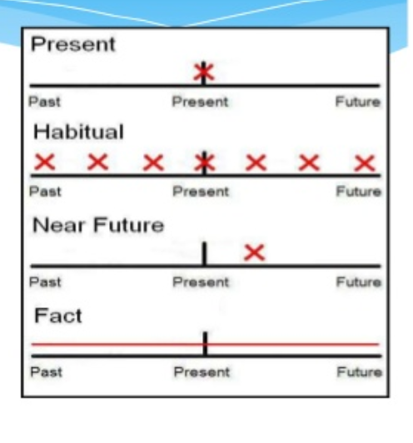

(DIALOG in pre-activity)

Mia : Hi Mom. It`s me! I`m in AUSTRALIA!
Mom : Hello. Mia ! It`s night time here. I was sleeping when you called.
Mia : Oh, sorry . Mom . I forgot about the time.
Mom : It`s OK. While you were eating breakfast, we were eating dinner. And while you were visiting places, we were going to bed !
Mia : Oh yes ! Hey listen Mom! We did diving at beautiful coral reef!
Mom : Wow ! Was it fun ?
Mia : Yes it was great. We wore wetsuits, snorkels, and masks.
I was looking at the colorful coral when I saw a shark.
Mom : You were swimming with sharks?
Mia : Yes ! But it`s OK Mom. I was diving with an instructor when we saw the shark. These sharks aren`t dangerous! They`re friendly.
Mom : Are you sure ?
Mia : Yeah Mom ! I`m sure. Go back to bed now. Good night!
Mom : Good night !

