☐ Listening ☐ Speaking ☐ Reading ☐Grammar ☐ Writing

Topic: What food do you like?

Instructor:  Amy (Eunjoo Kim) | Age : 8 yrs +  Level: Primary schoolchild | Students:  6 | Length:  30 Minutes

Materials:
- Pictures of food (Tomato, Carrot, Broccoli, Spagehtti, Rice, Bread, Banana, Orange, Apple, Milk, Meat, Fish)
- Pictures of grocery, , Vegetable, Fruit, Grain, Protein and Basket
- Food flash card (Shirimp, Tea, Banana, Noodle, Garlic, Milkshake, Fish, Candy, Octopus, Jam, Orange, Rice)
- Magic pen
- 6 bucket list sheets
- 6 Lunchbox
- Glue
- TV
- Computer
- Marker
- Whiteboard
- Food writing activity sheets
- Song ‘Do you like broccoli ice cream?’(2:42)

Aims:
- Main aim: Ss will learn different types of food by doing the ‘Making a Lunchbox Activity’
- Secondary aim: Ss will practice answering the question ‘Do you like…’ by singing the “Do you like broccoli ice cream?” song.
- Personal aim: Ss can know how to eat healthy food with fun instead of pressure.
Language Skills:
- Listening: Ss listen to a song, T’s questions and S’s think what food they like.
- Speaking: Ss sing a song, ask questions and answer friend’s think.
- Reading: Read food names, Activity title, song lyrics.
- Writing: Friend’s name on the plate.

Language Systems:
- Phonology: Yummy [|jʌmi], Yucky [|jʌki]
- Lexis: Food, Lunchbox, Vegetable, Fruit, Grain, Protein, Tomato, Carrot, Broccoli,
Spagehtti, Rice, Bread, Banana, Orange, Apple, Milk, Meat, Fish, Shirimp, Tea, Noodle, Garlic, Milkshake, Candy, Octopus, Jam, Yummy, Yucky, Ice cream, Soup, Doughnut, Juice, Popcorn, Pizza
- Function: Questioning& Answering, Distinguish food types, Discuss each think
- Grammar: Do you like OOO? & Yes, I do/ No, I don’t, Antonym(Yucky & Yummy)
- Discourse: Distinguish food types to buy some food at a virtual grocery

Assumptions:
- Ss have understood each food names.
- Ss could write friend’s name and food names friend like.
- Ss can distinguish food types of ingredients.

Anticipated Errors and Solutions:
Ss can’t know and read ‘Yucky’ not familiar word.
→ T shows a word car and let them know how to read comparing ‘Yummy’.
Ss can’t remember song at once.
→ T shows a example to sing a song first slowly.
Ss may confuse types of food ingredients.
→ Divide foods under each types.

References: https://www.youtube.com/watch?v=frN3nvhIHUk
‘Do you like broccoli ice cream?’(2:42)

Lead-In
Materials:
- Song ‘Do you like broccoli ice cream?’(2:42)
https://www.youtube.com/watch?v=frN3nvhIHUk
- TV
- Computer
Time | Set Up | Student Activity | Teacher Talk
5min | Whole class | Greet to teacher.  Answer to the questions.  Sing along together.  Any answer to the questions.  Answer to the question.  “Food!”  Read title.  “‘What food do you like?”  Read a word.  “Yucky [|jʌki]”  Read a word again.  “Yucky [|jʌki]”  (Any answers)  “Broccoli Ice cream!”  “Bad taste!”  “Dislike”  “Yucky [|jʌki]”  “Yummy [|jʌmi]”  “Yucky [|jʌki]”  “Yummy [|jʌmi]”  “Yummy”  “Yucky” | Greeting & Rapport  “Hi, everyone! I’m Amy.”  “How are you today?”  “Have you had lunch?”  “What did you eat?”  “Pizza? Do you like pizza?”  “Tell me what food you like or dislike.”  “Many different foods are there, right?”  “How about looking at different foods with a song?”  “Let’s sing a song together!”  “It will be fun, I promise.”  “Are you ready? Let’s start!”  Eliciting to Sing & CCQ  T sings along a food song on the TV with Ss and ICQ about food names.  “How was it? It’s fun?”  “What did you hear in this song?”  “Answer me anything you listened.”  “Oh, Broccoli! Ice cream! Yucky....etc..”  “You had listened many words about food.”  Eliciting to read & CCQ  T writes title as ‘What food do you like?’ and elicit to read.  “So, friend, Can you guess what we will learn about..?”  “Right!”  “Can you read this?”  “Good!”  Eliciting to Read & Gramma  “By the way, there was a funny word.”  “Did you see this?”  T shows two word card as YUCKY  “How can we read this..?  “Yucky [|jʌki]”  “Repeat.”  “Yucky [|jʌki],”  “Good.”  “When did you hear ‘Yucky’?”  “Right!”  “Someone feels to get bad taste,  They said ..?”  “Right!!”  “The other way, who knows what we say if we feels to get good taste..?”  “Yes, you are smart.”  “You already know it.”  T shows two word cards as YUCKY vs YUMMY  “YUCKY and YUMMY, they have same sounds.”  “Can you read this card..? Good!  “Read again.”  “And tell me again.”  “At a time, someone ‘like’ some food, they say..”  “The other way, someone dislike some food, they say..”  “Good job!”

Pre-Activity
Materials:
- White board
- Marker
Time | Set Up | Student Activity | Teacher Talk
8min | Whole class  Individual student | Answer the questions  Read two sentences.  Answer the questions  Listen to teacher.  Sing a song with two given cards.  Answer “Yes, I like. Yummy.” Or ‘No, I don’t. Yucky.” With holding matched card. | Warm up for topic  “Now, I wonder about your food.”  “What food do you like?”  “Or what food don’t you like?  “When you say yummy or yucky?”  “Can you tell me with same song?”  “It will be fun, won’t it?”  “First, practice slowly.”  “Let me show you.”  Demonstration  T shows two word cards and lead to sing a song ‘Do you like broccoli ice cream?’  “ Do ♬ you ♬ like ♬ shrimp?”  “Yes, ♬ I do ♬ Yes, ♬ I do.”  “ Do ♬ you ♬ like ♬ milkshake?”  “Yes, ♬ I do ♬ Yes, ♬ I do”  “ Do ♬ you ♬ like ♬ shrimp milkshake?”  “ No ♬ I don’t ♬ it’s ♬ Yucky!  Easy? Next we can enjoy a game!  Explanation  T shows 6 pairs word cards on the board and explain to enjoy a game.  - Sing a song with two these given word, everybody.  - And the one person answer to  “Do you like OOO + OOO?” as  “Yes, I like or No, I don’t.” as your feeling.  - The last, if you feel good taste, say  “Yummy.” But you feel bad, say  “Yucky,” with holding your ‘Yummy or Yucky’ card and then pass to next person.  “Easy? Good.”  “Can we start? Ready?”  “Start to sing a song everybody.”  “And first answerer is Ally~”  T distributes ‘Yummy & Yucky’ cards and proceeds song activity pointing given two word on the board.

Main Activity
Materials:
- Pictures of food ingredients for making lunch box
- Plates
- Magic pen
Time | Set Up | Student Activity | Teacher Talk
10min | Whole class  Pair of  students | Make a couple and say hello.  Listen to explains.  Answer the questions.  Say hello to friend.  Read  “what food your friend like..”  Listen to the T.  Write friend’s name.  Talk free to get know what food my friend like.  Write 4 food names on the bucket list sheet.  Come out to the board grocery  And get food pictures.  Post food pictures on the lunchbox.  Answer some questions  Talk free.  Write “To friend name” on lunchbox. | Introduce & ICQ  T Introduce how to do main activity makes teams and makes each greet.  “it was fun, right?”  “Now we know how to question and answer about food.”  “This time, ask to your friends ‘What food do you like?’ directly’”  “And then, you can give a present a lunchbox for your friend.”  “Do you want it? Good!”  “What I say we will do?”  “Shopping a lunchbox?”  “Make for me”  “No~ make for friend.”  Grouping S-S & ICQ  T posts grocery pictures for making lunchboxes on the board.  T makes a team and distributes 6 bucket list sheets.  “At first, Let’s decide your partner by 2, 2, 2.”  “And say hello with your friends.”  Guess & CCQ  “Can you read title of your sheet?”  “Good.”  “And guess what you will do.”  “Yes, catch food secrets of your friend with questions and answers.”  Explain to write  Follow this.  - Fill the blank with your friend’s name.  - Ask about 4 food what your friend like, each other.  - You should answer among each food types at a grocery, equally.  - Write down answers on your bucket list.  “Can you do that?  “Start! Talk with your friend.”  Free talking & Monitoring  T checks all sheets get answers.  T sometimes help to free talk.  Explain & do Activity  T distributes empty lunchboxes.  “All you knew food what your friend want to.”  “Right?”  “From now, go shopping to the grocery to buy some food for your friend!”  “Come out to the board grocery!  Hurry up! Time sale!  All are free!”  “After shopping, Make a lunchbox for your friend!”  Monitoring & Review  “You done?”  “Great!”  “Ally, for whom you made a lunchbox?”  “Oh, you love Jina.”  “Can you tell me what food you like Seol hee?”  “It looks good.”  “You choose different foods equally?”  “Wow,It’s good for your health.”  “It’s time to present to your friend.”  “Write your friend’s name on the cover of lunchbox.”

Post Activity
Materials:
- Lunch box that Ss made
- Glue
Time |  | Set Up | Student Activity |  |  | Teacher Talk
2min |  | whole class | Answer some questions.  Read bucket list  Explain the why.  Talk free about feeling.  Turn back 4 food pictures  Answer some questions.  Clap their hands to each other.  Answer some questions.  Say good bye. |  |  | Wrap up & CCQ  “Now, every body have your own lunchboxes?”  “Check your name all were there!”  “All you have what you told to your friend?”  “Compare with a bucket list.”  “Jeroh, can you read your bucket list and check all you want were there?  “Good!”  “Eujin, can you explain why you like those food?”  “Mica, can you share your feeling after make lunchbox?”  “Thank you.”  “Everything is perfect?”  “Good!”  “Are you happy?”  “Clap your hands to all us?”  Feed back & Review  T reviews today’s lesson and share feelings after class.  “Today we learn about what?  “Food. Right.”  “What word was the best impressive you learn today?”  “All was fun?”  “Yes, me too.”  “I’m happy we shore healthful food.”  “Tomorrow we can enjoy time together with more fun.”  “Are you looking foward to do?”  “Me too!”  “See you tomorrow and take your delicious lunchbox, don’t forget it.”  “Bye friends~!!”
SOS Activity
Materials:
- Food writing activity sheets
Time | Set Up |  |  | Student Activity | Teacher Talk
5min | Whole class |  |  | Answer the questions | Talk free about topig  “OK, everyone. Especially let me know about more food list that you like or dislike.”  “On this sheet, write details.”  “I wonder about it.”  “Think about many kinds of food and write down.”  “And then share of your list to your friends.”  “Something would be exactly same, Something would be different.”  “It will be fun, surely.”
Examples of Materials
- Song ‘Do you like broccoli ice cream?’

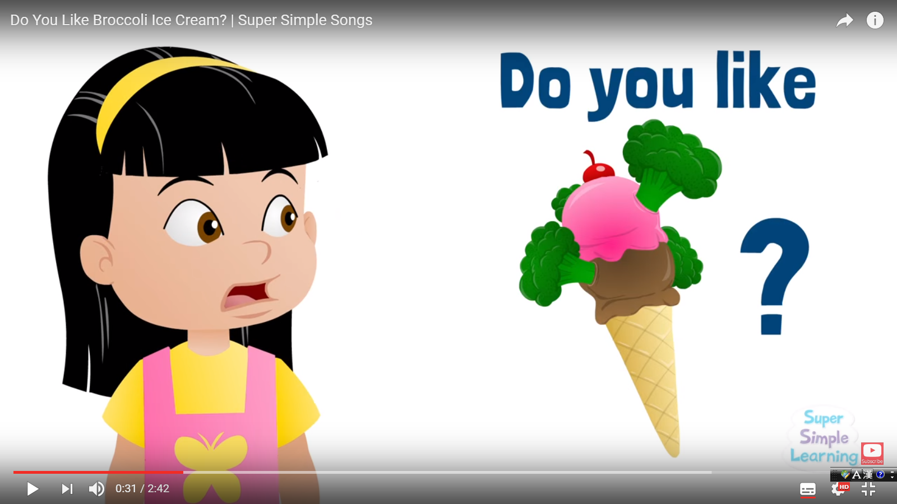

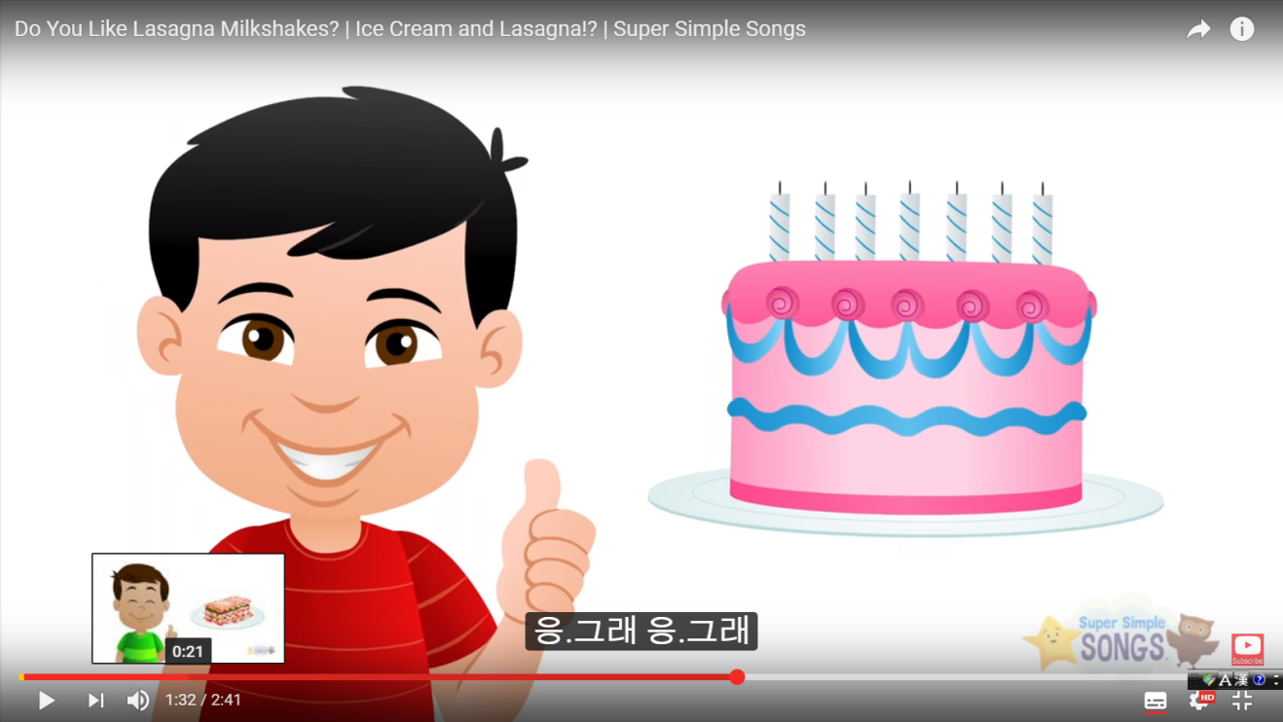

- Pictures of food name card for Pre-activity
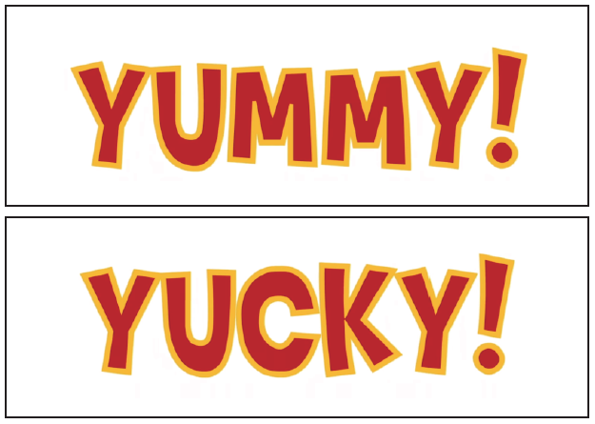

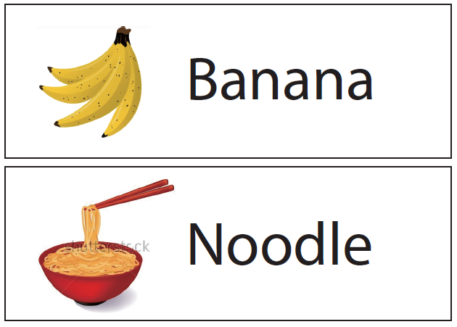

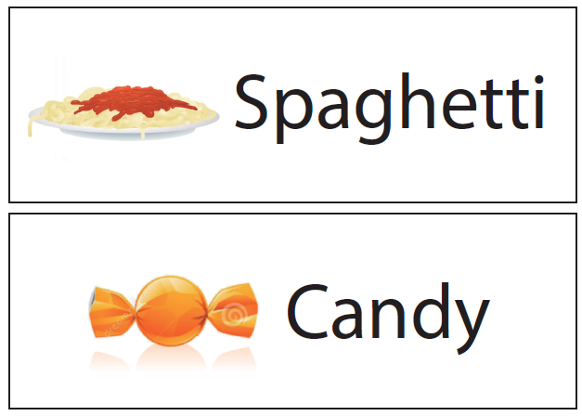

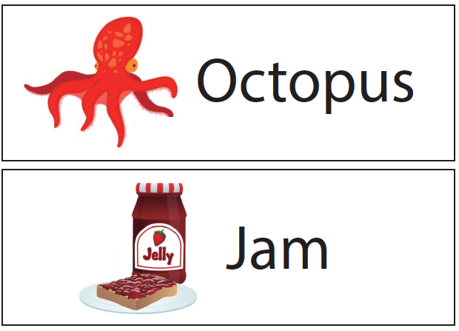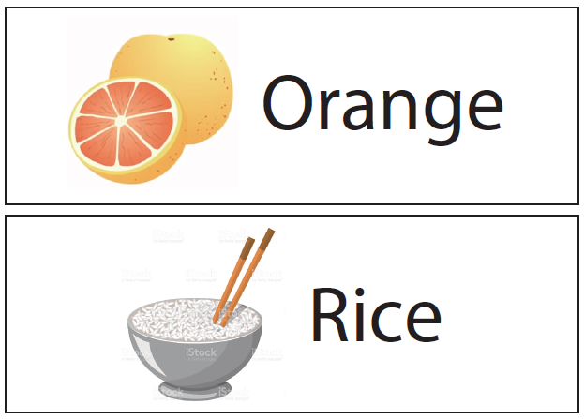

- Pictures of food ingredients for making lunchbox

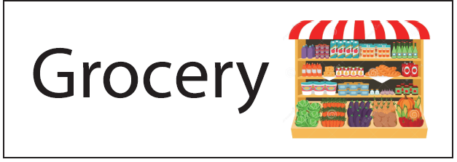

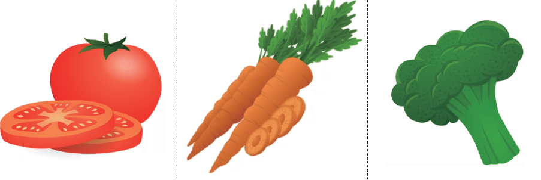

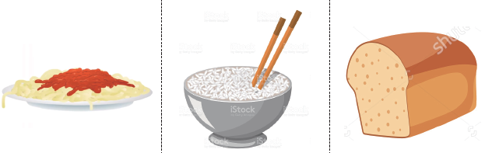

- Lunchboxes for examples

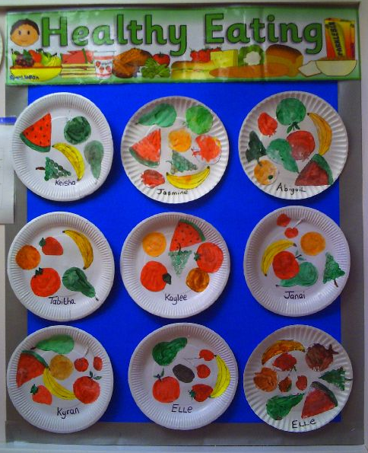

- Bucket list sheets

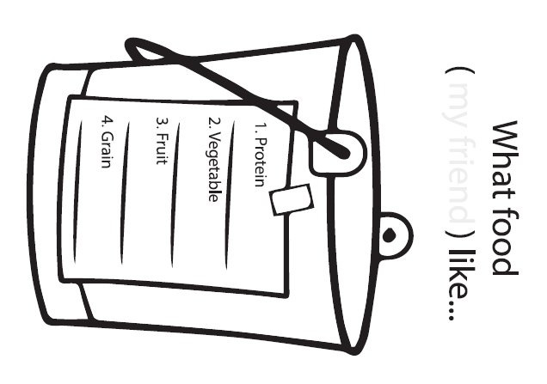

- Food writing activity sheets

