☐ Listening ☐ Speaking ☐ Reading ☐ Grammar ☐ Writing

Topic: The Effect of caffeine on the body.

Instructor:  Claire | Level:  Intermediate | Student:  14 | Length:  30 Minutes

Materials:
Photos including explanations
Matching worksheet
Article, White board, makers

Aims:
Ss will improve reading comprehension skill
Ss express information what they get from the reading passages
Ss will practice speaking about prounciation by the article.
Ss will study new vocabulary about general work by the text

Language Skills:
Listening : Listen to teacher's pronunciation
Reading : Read the article
Speaking : Conversation with students, Ss will say their opinion.
Writing :Writing students worksheet.

Language Systems:
Phonology : Students will learn how to pronounce words that they did not know thorugh
The article.
Lexis : Students will understand each words meaning by the matching worksheet
Grammar : Students will use present tense in discussion activity
Discourse : Communication with others

Assumptions:
Ss are at the intermediate level.
Ss might know most vocabularies from the passages.
Ss are interest the information in article.

Anticipated Errors and Solutions:
If students have difficult reading, teacher can help them guess from the text
Teacher prepare for the printed photos in case the computer doesn't work well
If students might now understand the rule of given activity, Ts will give an example.

References:
http://www.healthline.com/health/caffeine-effects-on-body
http://cafe.naver.com/0101010110
http://www.webmd.com/diet/caffeine-myths-and-facts#1

Lead-In
Materials:
None needed
Time | Set Up | Student Activity | Teacher Talk
1min | T - SS | Guiding question | Good morning!!  How do you feel ?  (student answers) and why?  If you feel sleepy when you studying  How can you deal with that?  (student answers)  Ok, thank you  Introducing today's topic:  Okay, today we will talk about that

Pre-Activity
Materials:
Pictures of drinks, matching worksheet, computer, projector.
Time | Set Up | Student Activity | Teacher Talk
3 min  5 min  3 min | T- SS  Individually |  | 1,Brainstorming  Before we start warm up, i'll show some pictures. and then you need find some a common thing among them  2, vocabulary  Okay, let's learn vocabularies that will help you  To read the text.  I'll give you a matching worksheet  You will need match with correct definition  You will be given 5 minutes and will individually.  CCQ  So what are you doing?  How many minutes do we have?  Are you working in pair? ( No)  Individually? ( Yes)  (Monitor students, answer question if any)  3 more minutes..2 more minutes. 1 mins.. and times up!!  Ask volunteers  (Have student share the answers)  Draw out the answers on the board  Thank you for participating !  Good job!

Main Activity
Materials: article about caffeine drink

Time | Set Up | Student Activity | Teacher Talk
2min  3min  1 min  6 min | T-SS  Individually  TS-SS  In pairs | Discussion | (Distribute the article to SS)  Instruction  Alright, here some article about the effect of caffeine, i will 3 min to read it individually.  And you should underline the part of text which you have experienced that kind of symptom before.  Demonstration  For example,  "Too much caffeine can give you a headache"  It says on the second paragraph. if you are relevant to that, you will underline there  CCQ  So, what will you do?  (read the article)  How much time do you have?  What do you underline?  For example,  Too much caffeine can give you a headache  You underline here  (Run Task)  Feedback  Would you like to have more time?  (if yes- give 30 seconds extra reading time  instruction  Ok time's up!  With some discussion questions,  Please discuss and please share your opinion  With your partners in a group.  I will give you 7 minute to work with your partners  CCQ  What should you do?  Are you working in pairs? (yes)  How many minute do you have? (7 minutes)

Post Activity
Materials: more article, paper -writing task

Time | Set Up | Student Activity | Teacher Talk
3 min | individually |  | Look at this article.  There are many effect of caffeine.  You will summarize it individually  And share your own answer with the class  I'l give you 3 minutes.  For example,  Now, people usually drink coffee. Many people believe that the drinks help me think clearly and fell more awake. Also, caffeine may improve long-term memory.  (Run Task)  1 minutes left,,  Share the answer with the class  Excellent!  Closing  It;s time to wrap up!  We talked about " the effect of caffein"  Did you enjoy it?  Everyone did a good job!  See you next time!

Effects of Caffeine on the Body
Caffeine is a naturally occurring substance found in many plants, including coffee beans and tea leaves. Kola nuts and cacao pods also contain caffeine. Caffeine can also be man-made, and it is added to many of our foods and drinks. Many over-the-counter and prescription medications contain caffeine. According to the U.S. Food and Drug Administration (FDA), about 90 percent of the world’s population ingests some form of caffeine. In the United States, about 80 percent of us take in some caffeine every day.
According to the Mayo Clinic, it’s safe for most healthy adults to consume up to 400 milligrams of caffeine per day. How much caffeine each beverage contains varies a lot, so reading labels is important. There’s also a great variation in the amount of caffeine an individual can tolerate without unpleasant side effects. If you consume roughly the same amount of caffeine every day, you can develop a tolerance to it. Your tolerance level is affected by your age, body mass, and any health conditions you may have. Caffeine can also interact with certain medications.

Central Nervous System
Caffeine reaches your brain quickly and acts as a central nervous system stimulant. The most noticeable effect is alertness. It can help you feel more awake and less tired, so it’s a common ingredient in medications to treat drowsiness.
Caffeine and headaches have a complicated relationship. Too much caffeine can give you a headache. However, your body develops a tolerance to caffeine. If you normally consume caffeine and stop suddenly, it can cause a headache. Caffeine is used in some over-the-counter and prescription-strength headache and migraine remedies.
Despite the common wisdom of drinking coffee to recover from too much alcohol, caffeine doesn’t actually help your body process alcohol any faster.
If you’re not used to it, caffeine can give you the jitters. If you have an anxiety disorder or sleep disorder, caffeine may make it worse.
Symptoms of caffeine withdrawal include anxiety, irritability, and drowsiness. In some people, sudden withdrawal may cause tremors.
It’s also possible to overdose on caffeine. Symptoms of an overdose include confusion and hallucinations. An overdose can result in death due to convulsions.
Digestive and Excretory Systems
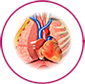Caffeine raises the amount of acid in your stomach and may cause heartburn or upset stomach. It’s also a diuretic, triggering your body to get rid of water. That’s why it’s not a great thirst quencher. Extra caffeine doesn’t get stored in your body. It is processed in the liver and exits in your urine.
If you have stomach problems, like acid reflux or ulcers, ask your doctor if it’s okay to have caffeine. Large doses of caffeine cause you to lose too much water, especially when consumed in conjunction with exercise.
Withdrawal from caffeine can cause nausea and vomiting. Symptoms of caffeine overdose include diarrhea, excessive thirst, and increased urination.

Skeletal and Muscular Systems
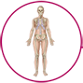Caffeine in large amounts may interfere with absorption and metabolism of calcium. This can contribute to bone thinning (osteoporosis).
Symptoms of caffeine withdrawal include achy muscles. An overdose can cause muscle twitches.
Reproductive System
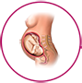Caffeine travels within the bloodstream and crosses into the placenta. Since it is a stimulant, it can cause your baby’s heart rate and metabolism to increase. Too much caffeine can also cause slowed fetal growth and increase risk of miscarriage. In most cases, a little caffeine is safe during pregnancy.

Discussion question
- Does anybody know? What else can be helpful to focus on their work and study?
- Without coffee, what food can be help for your concentration
- If you have any your own method to concentrate on your work and study .Please tell us.

VOCABULARIES

(A) Substance (B) Ingest (C) Tolerance
(D) Stimulant (E) Drowsiness (F) Diuretic
(G) Placenta (H) Metabolism

1.[ ] : is the consumption of a substance by organism.
2.[ ] : is the state of putting up with, conditionally.
3.[ ] : is an overarching term that covers many drug including those that increase activity of body.
4.[ ] : is a state of strong desire for sleep, or sleeping for unusually long periods.
5.[ ] : is ant substance that promotes diuresis, that is, the increased production of urine.
6.[ ] : anything that has mass and takes up space or a material with a definite chemical composition.
7.[ ] : is an organ that connects the developing fetus to the uterine wall to allow nutrient uptake, provide thermo-regulation to the fetus, waste elimination.
8.[ ] : is the set of life-sustaining chemical transformations within the cells of living organisms.

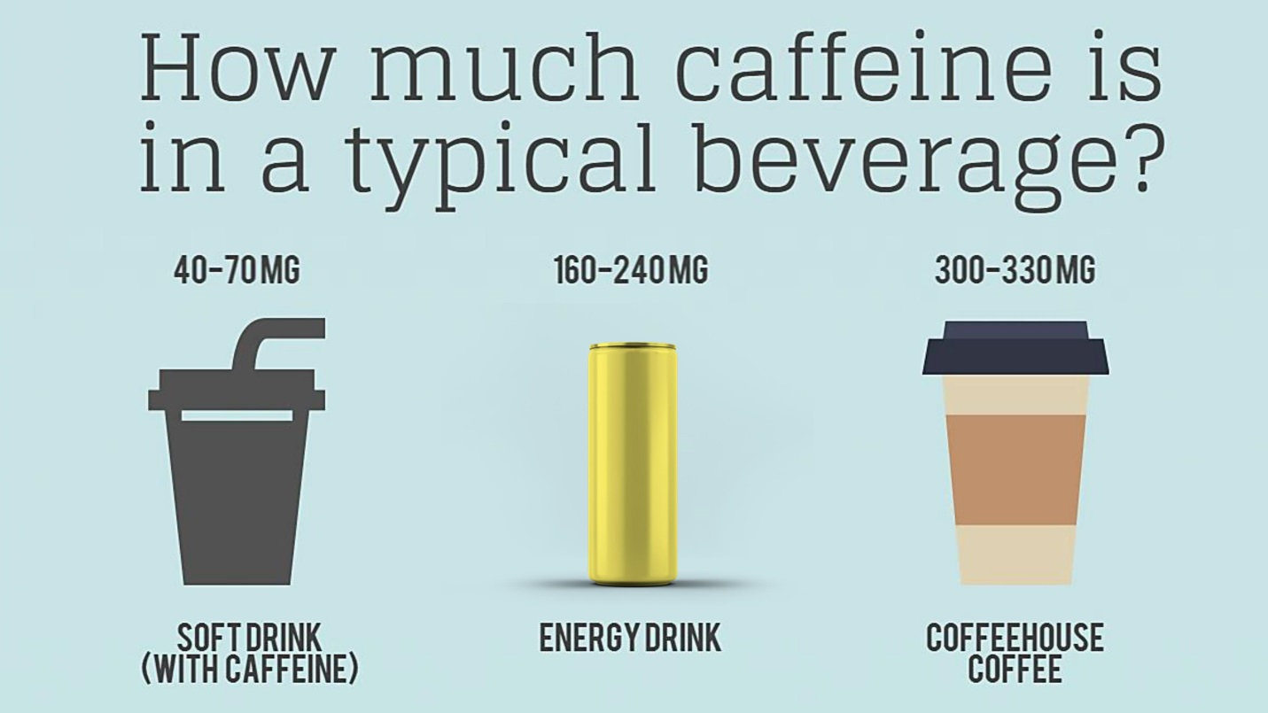
Study Finds Caffeine Improves Long-Term Memory
- Many people say they cannot start their day without first having a cup of coffee or tea. People say these drinks help them think clearly and feel more awake. This is because of caffeine, a substance found in some plants. Caffeine helps to give a jump start to the nervous system.
- Now, a report says it may also improve long-term memory. The report was published earlier this year in the journal Nature Neuroscience.
- Mike Yassa is a neurobiology professor at the University of California, Irvine. He and other researchers wanted to know if caffeine could improve a person’s memory.
- They asked a group of individuals to learn something new. Then, the same people were given caffeine, the active ingredient in coffee, tea and chocolate. Professor Yassa explains.
- “So after you learn anything, it takes some time for that memory to strengthen and become resistant to forgetting. And over the first 24 hours is actually where most of the forgetting happens. So that is where we wanted to intervene with caffeine and see if we can help reduce this forgetting to some extent.”
- According to Dr. Yassa the first 24 hours are when we are most at risk of forgetting something new we’ve learned. That is the time to drink a strong cup of coffee or tea, or eat some chocolate.
- This is what he and his team did. They took 160 caffeine-free people and showed them pictures of everyday objects. These people were asked if the objects could be found inside the house or outdoors.
- Then some of the subjects were given a caffeine pill. The others were given a placebo -- a pill containing nothing.
- Twenty-four hours later, the subjects were shown the exact same images from the day before. They were also shown images with slight differences, and some completely new images.
- Both groups correctly identified the exact same and completely new pictures. But those who took the caffeine pill were better at spotting the pictures that were slightly different.
- Professor Yassa says their answers helped to show the effects of caffeine on memory.
- “When they actually had to make a memory judgment and say, 'Is this the same item I have seen before or not?' that was a really important bit of information for us. And we find that if they are on caffeine they are much more likely to make the right decision.”
- The amount of caffeine the researchers used in the study was similar to one cup of strong coffee.
- The researchers did not see any improvement to memory from smaller doses of caffeine or when it was given an hour before viewing the images

