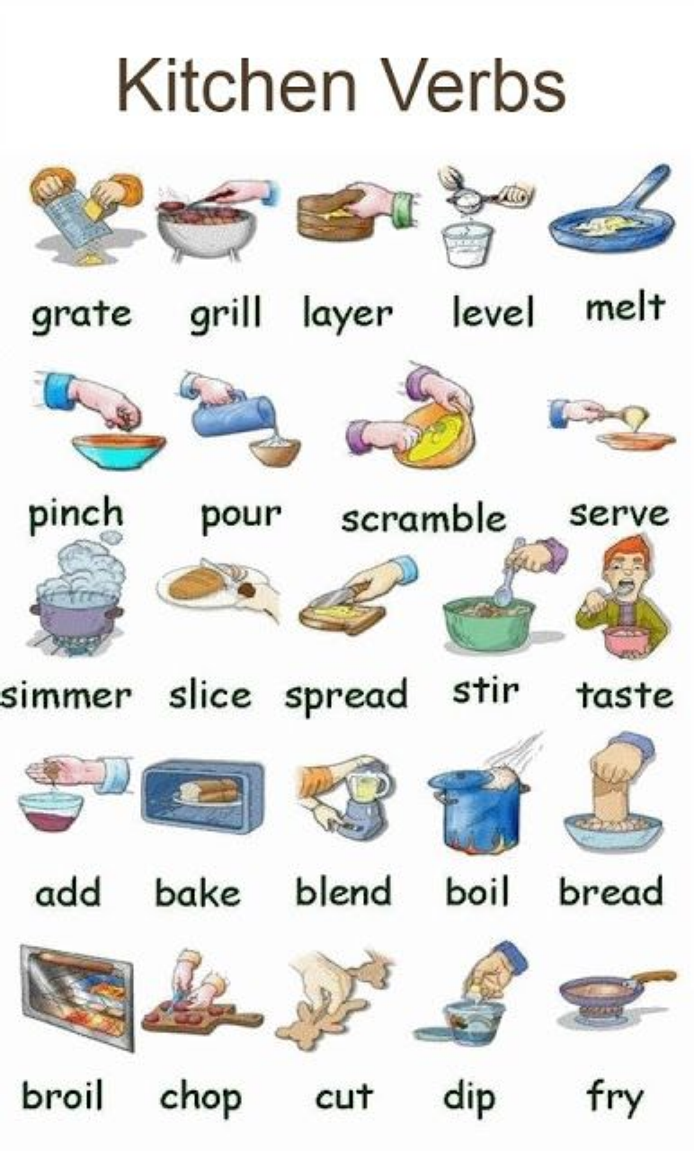

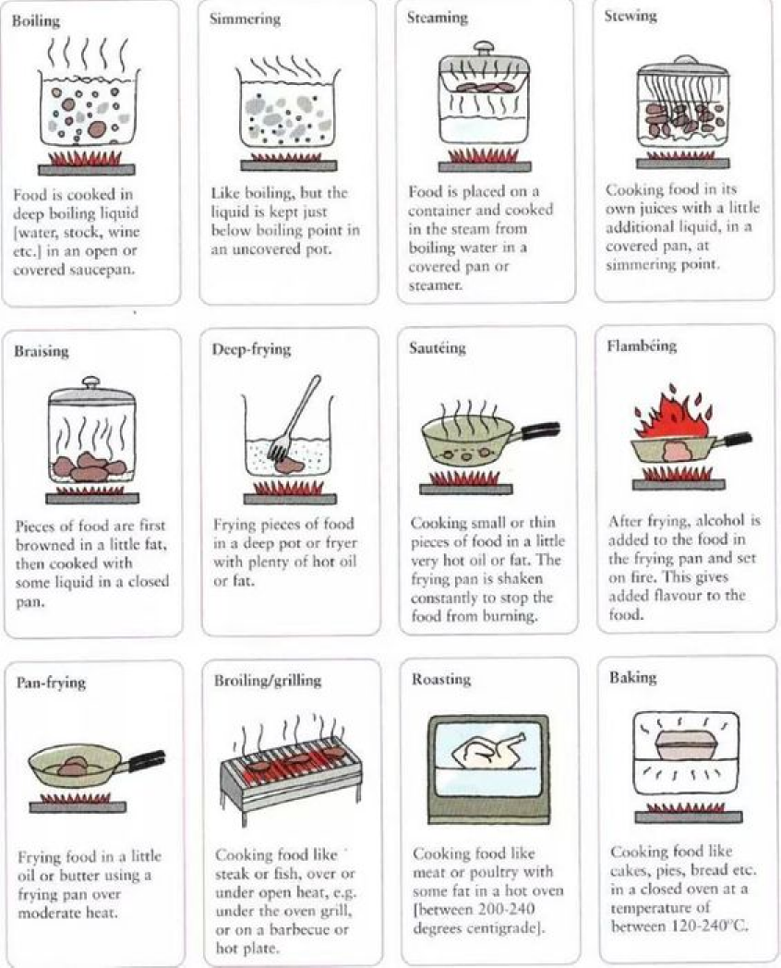

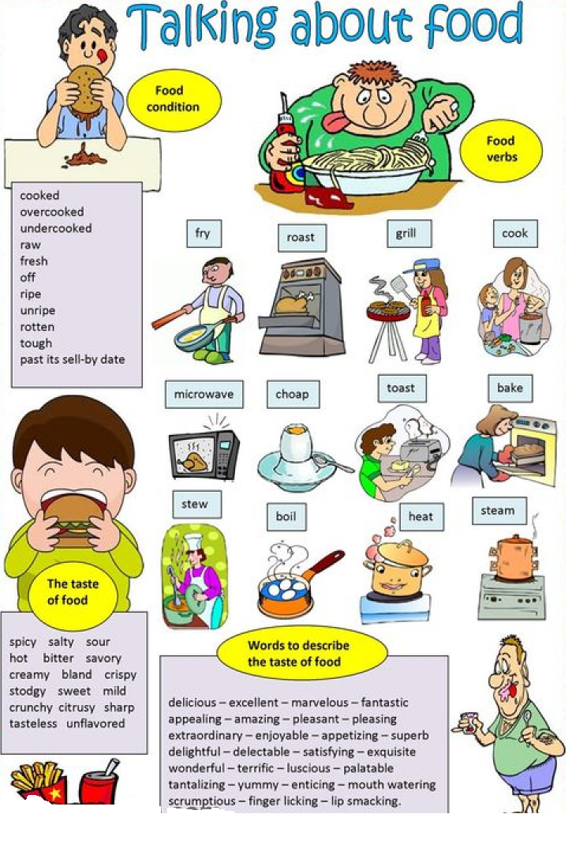
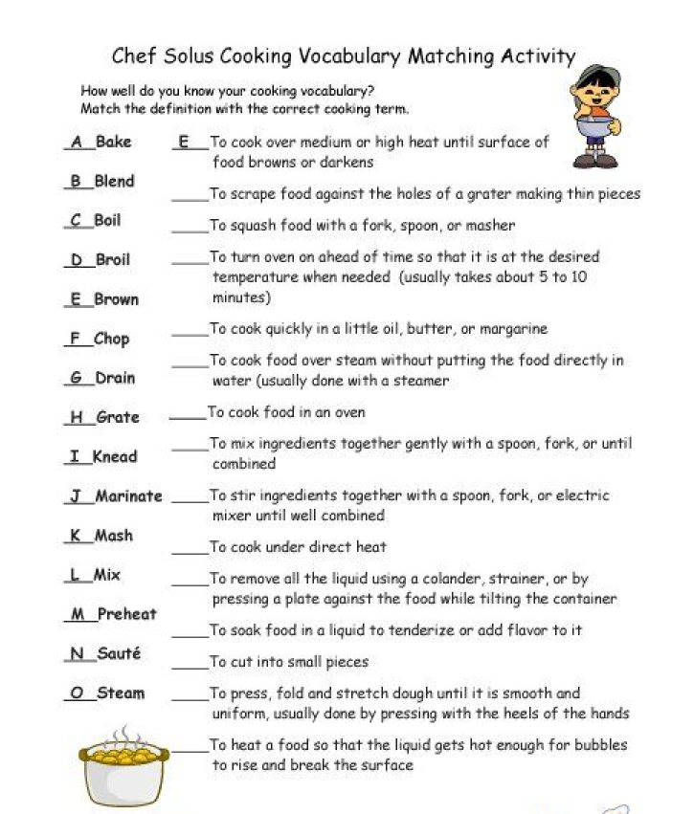

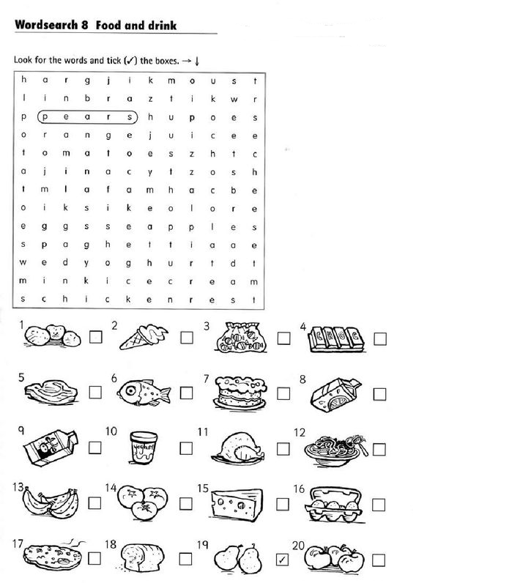

Pita bread – pocket bread
A pita is kind of bread that has a “pocket” in the middle.
The word pita comes from the Greek meaning “bread pie “people often call it pocket bread. It is considered the best alternative to the sandwich.

Pita bread is a very simple kind of bread to make.
The flour is mixed with water. It is then rolled out very thin.
Next it is placed on a hot surface. The water in the dough quickly turns to steam which makes a bubble inside the bread. This is how the bread gets its pocket.

It is simple kind of bread with a space in the middle.
You can put anything in the middle. People put meat, vegetables, and sauce inside a pita.
Best of all, because It has a pocket,
it doesn`t fall apart like a sandwich does.
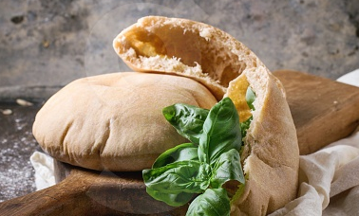
Work sheet

Write the correct word

An area that is empty or available
Answer is ______________________

To put different things together to make something new
Answer is ______________________

A thick liquid that is served with food
Answer is _________________

A food made by mixing flour and water and then baking it
Answer is ____________________

Mixture of flour, water, and sometimes also fat and sugar. It can be cooked to make bread, cookies, etc
Answer is ____________________

The gas that water becomes when it boils
Answer is _________________

Bread in the shape of a circle which can be spilt open and filled with Food
Answer is ______________________

Work sheet 1

True or false

1. people call a pita pocket bread because of its shape
T / F
2. Because of its pocket. pita bread is a little difficult to make
T /F
3. Pita bread with meat and sauce in it easily falls apart like a sandwich.
T / F

Comprehension!
1. what is this passage about ?
a. Why pita bread has a pocket in it
b. What pita bread is and how to make it
c. How pitta bread is different from a sandwich
2. Choose the word that can best replace “alternative”
in paragraph
a. option b. feature c. recipe
3. what is true about pita bread according to the passage?
a. you should place the dough on hot water and steam it
b. you need to make a bubble inside the bread.
c. you need to roll out the dough a little thick to make a pocket

work sheet 2
Summary
Complete the chart.

Pita
A bread that has a ____________ in the middle
From the Greek meaning __________________
The best ___________________ to the sandwich
Very ____________________ to make

How to make
Mix the ____________ with water
Roll it out very _______________
Place it on a hot ________________
Make a _____________ inside the bread
Put meat , vegetables, and ______________ inside a pita

Pita
Bread mix
Roll out
Steam
Pocket
Space Meat vegetable sauce

Work sheet 3

“You can put anything in the middle. People put meat, vegetables, and sauce inside a pita.”
(Chloe )
Stir- Fry(볶다) ground or minced beef in a pan
- add little bit of radish 깍두기kimchi broth(stock)
Sautéed(조금볶다) garlic mushroom
Grate cheese – put it in a bowl
chop up- 1 head of lettuce. 1 tomato and 1 onion put them on a plate . / mash or slice of avocado .
the hot meat will melt the cheese, next put in the tomato onions and lettuce etc. plus ! some taco sauce on the top enjoy!

Create your own pita bread inside !
Start !

