Listening ☐ Speaking ☐ Reading ☐ Grammar ☐ Writing

Topic: Let us sing and dance with the syllable song.

Instructor:  Yujin Cho | Level:  Beginner | Students:  12 | Length:  50 Minutes

Materials:
- Vocabulary worksheet with syllable (Appendix 1)
- Vocabulary pictures (Appendix 2)
- White board, bard markers
- Laptop, projector
- Youtube listenig video clip (Appendix 3)

Aims:

- To learn new vocabulary
- To understand English syllable
- To practice how to pronounce vocabulary and write exact spell
- To practice listening with syllable
- To practice listening and writing with group members

Language Skills:

- Reading : vocabulary and vocabulary syllable worksheet
- Listening : teacher’s explanation about syllable and pronunciation of vocabulary
- Speaking ; Pronouncing vocabulary, singing English song, and expressing students’ experience
- Writing : vocabulary that is given by teacher

Language Systems:

Lexis : vocabulary used in conversation
Function : Understanding vocabulary with syllable
Discourse : Game, singing and following dance routines

Assumptions:
Student already know :
- basic vocabulary
- how to write a spell
- the teacher’s style of teaching and the pace of the course
- what consonant and vowel are

Anticipated Errors and Solutions:

- Students may have difficulty in understanding syllable game.
→ Teacher shows how to play the game by writing an example word at the board.

- Students might not fully understand the vocabularies in the worksheet.
→ Ask a certain student to stand up to express the meaning of vocabulary

- Some students maybe passive attitude to do dance.
→ show how to do action by approaching them.

- If students finish their game earlier than anticipated.
→ Have them check syllable of vocabulary thoroughly again.

References:

Dictation (Practice listening, writing & speaking) Easy ESL Games Video#23
https://www.youtube.com/watch?v=cNJyVKRU_Qg

Learn Syllables | Syllable Song or Clap, Stomp and Chomp | Jack Hartmann
https://www.youtube.com/watch?v=vlBc703kYMg

Lead-In
Materials: no materials needed

Time | Set Up | Student Activity | Teacher Talk
2min | Whole  class | Share what they did during weekend | “Good morning, everyone! How are you? Did you have great weekend? Has anyone traveled some special place?”

Pre-Activity
Materials: Board and board markers

Time | Set Up | Student Activity | Teacher Talk
10min | Whole  class | Listen teacher’s explanation about syllable | Instruction  “I will explain syllable in words”  Elicit  “What is word comprised of?”  Elicit student’s answer  “Word consists of a consonant and vowel.”  Question about the meaning of syllable.  Show students vocabulary sheet.  “Do you know syllable?”  “Syllable is a word or part of a word which contains a vowel sound. So it is important to know syllable to listen and speak English.”  “Depending on the number of vowels, the number of syllables varies.”  “I will give you 1, 2 and 3 syllables words”  Explain and have students listen the syllables in 1, 2 and 3 (Appendix 1).  Write “Dog” as the example of 1 syllable word.  “Listen and repeat this word”  Write “Ap-ple” as the example of 2 syllables.  “Listen and repeat this word”  “As you can see, we pronounce apple with two syllables.”  Write “Sat-ur-day” as the example of 3 syllables.  “Listen and repeat this word”  CCQ  “What is the meaning of syllable?”  “What do you do in the board?”  “Can you distinguish syllable when you hear the words?”

Main Activity
Materials: Board and board markers, vocabulary worksheet with syllable and picture (Appendix 1 and 2), laptop and projector

Time | Set Up | Student Activity | Teacher Talk
13min  10min  10min | Groups  Whole  Class  Whole  class | Listen vocabulary  Guess, share and write answers  Listen audio and repeat  Watch video and follow dance | 1. Vocabulary Game  Instruction  “I will introduce vocabulary game to you.”  “Let’s make three groups and choose one writer in each group to write word at board.”  “I will pronounce one word. Then, you can write word with syllabic sign after listening. The fastest group wins.”  Make three groups and gather students at board.  Teacher shows vocabulary picture while pronouncing (Appendix2).  Students write word the word as quickly as possible.  Teacher shows syllable worksheet as an answer (Appendix 1).  CCQ  “Good job, everyone.”  “Do all of you understand syllables and pronunciation?”  “How many times you can write the exact spell?”  “Can you distinguish syllable in words?”  2. Listen to the syllable song  Instruction  “Let’s go back to our seats”  “Now, we will listen syllable song that sings many words that we just wrote.”  Turn on the laptop to listen to the syllable song from Youtube (Appendix 3)  After listening to the syllable song  “We will listen again the song. In this time, please try to sing along to the song”  CCQ  “What do you listen to?”  “Have you heard every words that you wrote at board?”  “Can you hear words in any music?”  “Can you take notes?”  3. Sing and Dance with the syllable song  Instruction  Turn on the laptop to listen to the syllable song from YouTube (Appendix 3)  Explain movements that appear in song lyrics (clapping, stomping and chomping with one’s arm).  “Do you know how to clap, stomp and chomp like in song lyrics? Let’s do this fun movement. Let’s get together in the middle of the classroom.”  “Follow my motion.”  Show the syllable song from YouTube (Appendix 3)  “I will show you the syllable song in video.”  “Please, sing and dance like the video.”  Repeat the syllable song and encourage students sing and dace actively  CCQ  “Can you follow the motion in video?”  “What words do you listen in video?”

Post Activity
Materials: Vocabulary sheet with syllable and picture (Appendix 1 and 2)

Time | Set Up | Student Activity | Teacher Talk
5min | Whole  class | Share experience | Instruction  Make students share their feelings and  understanding  “It was very fun. Also you will improve  listening skills while you listen to many  words in many songs”  “It is very important to understand syllable  for listening and speaking.”  Check answers  “How did you feel about dancing and  singing?”  “Did you find syllable while you listen to the  song?”  Conclude lesson  Elicit today’s words for students  “Let’s review the words we learned today”  Summarize today’s lesson by checking  useful information and vocabularies from  video and instructions.

SOS Activity
Materials: The syllable song video (Appendix 3)

Time | Set Up | Student Activity | Teacher Talk
5min  ~  6min | Individually | Volunteer’s sing and dance | Elicit  “Who do you think was the best at the sing  and dance?”  “Can any of you try to sing and dance  along, following video?”  Choose some volunteers among students  and let them show their sing and dance to  the students.

Appendix 1
Vocabulary worksheet

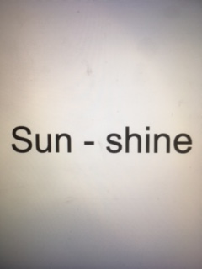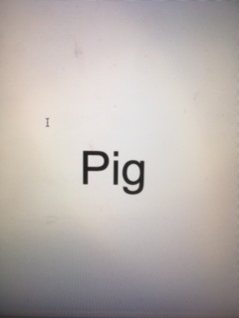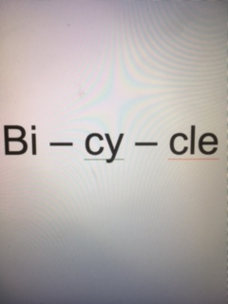

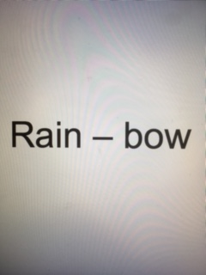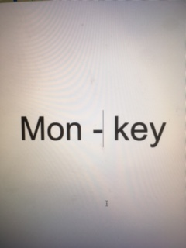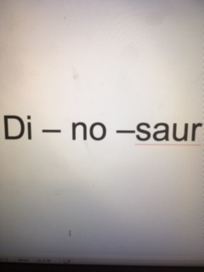

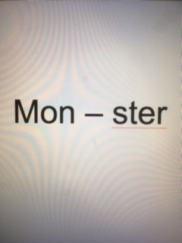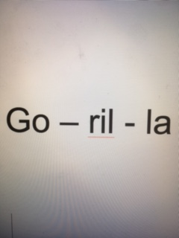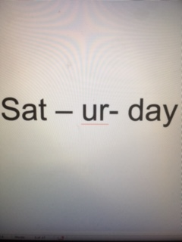

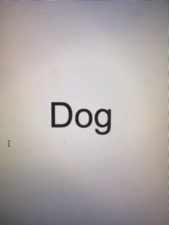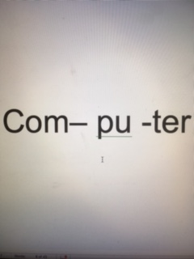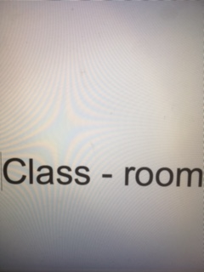

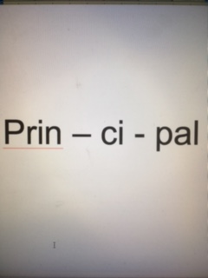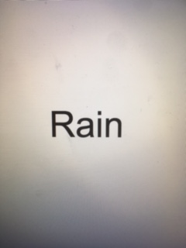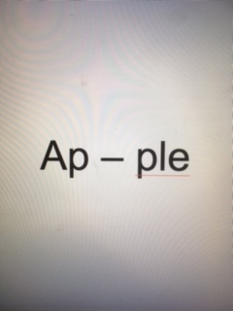

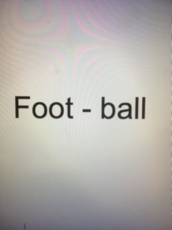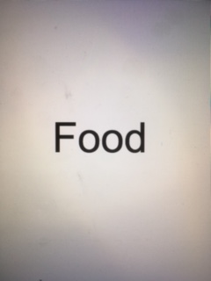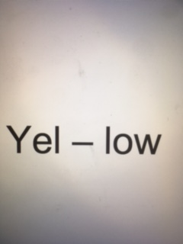

Appendix 2

Vocabulary Picture

 | 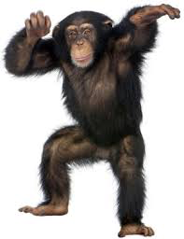 | 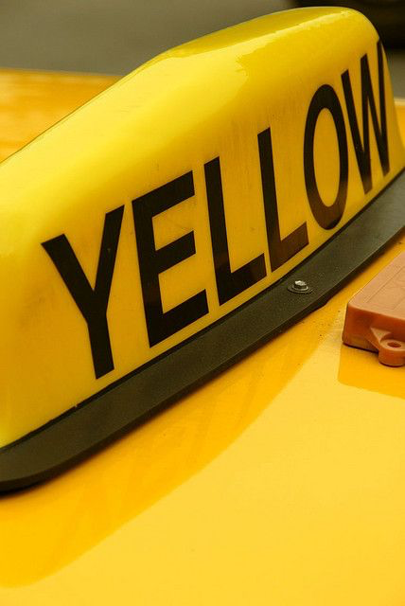
classroom | monkey | yellow | dog
 |  | 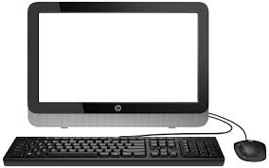
Saturday | rainbow | computer | food
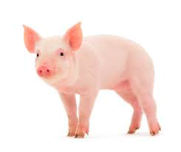 | 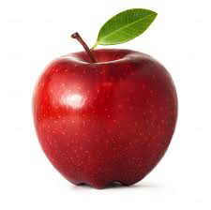
pig | apple | principal | football

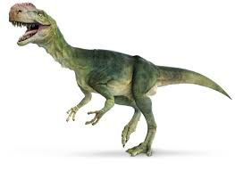
dinosaur | rain | sunshine | gorilla
 | 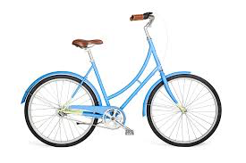
monster | bicycle

Appendix 3
The Syllable Song - YouTube https://www.youtube.com/watch?v=vlBc703kYMg

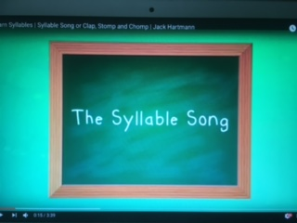

Lyrics:
Chorus
Make your hands Clap, Clap, Clap
Make your feet Stomp, Stomp, Stomp
Make your arms Chomp, Chomp, Chomp
Now listen carefully
Everybody follow me and
Move, Move, Move to the syllables in words
Let’s clap!
Class – room(clap clap) Mon - key(clap clap) Yel - low(clap clap) Dog (clap) Sat – ur - day(clap clap clap) Rain - bow (clap clap)
(Repeat Chorus)
Let’s stomp!
Com – pu – ter (stomp stomp stomp) Food (stomp) Pig (stomp) Ap – ple (stomp stomp) Prin – ci - pal (stomp stomp stomp) Foot - ball (stomp stomp)
Let’s chomp!
Di – no – saur (chomp chomp chomp) Rain(chomp) Sun - shine (chomp chomp) Go – ril – la (chomp chomp chomp) Mon - ster (chomp chomp) Bi – cy – cle (chomp chomp chomp)
(Repeat Chorus)

It’s Fun!

