☐ Listening ☐ Speaking ☐ Reading ☐ Grammar ☐ Writing

Topic: Take a bath

Instructor:  Mica | Level:  Preschool | Students:  6 | Length:  30 Minutes

Materials:
- Lap top computer (to connect yu-tube)
- 3 big pictures
- 3 magic boxes including bath items (8 pictures)
- Flash cards 20set (post activity)
- 1 Baby puppet

Aims:
Main aim - Students can express ‘can bath verbs’ through singing a ‘bath song’

Secondary aim- Students can express action verbs related to bath/health through the whole activity

Personal aim – Students can express various nouns related to our heath/bath

Language Skills:
Listening – Students listen to the ‘bath song’

Speaking – Students speak to the lyrics of the ‘bath song’

Reading – Students read the lyrics of the ‘bath song’

Writing – None to discuss for this class.

Language Systems:

Phonology- The pronunciation of th in word endings

Lexis- Bath: bathtub, soap bubbles, towel

Grammar- auxiliary verb + general verb – I can wash + N

Function- Expressing taking a bath

Discourse- Role play

Assumptions:
- Students already know the hello song with dance routine as results of every day repeat.
- Students already know the words whole group, individually, pairs.
- Students already learned body words as face, hair, feet, hands etc.
- Students are already familiar with matching card game. So, they understand some game words as the ‘face down’ & ‘turn up’.

Anticipated Errors and Solutions:

- Some students may not understand rule of activity.
Encourage students understand to show examples as demonstration.
Monitor students during each activity so that give them help properly.

- Some students may have difficult to catch up new vocabulary.
Encourage them to just follow singing a song with fun.

- Students may not understand what order means.
Explain again with easy word.

References:
- Song- The bath song
https://www.youtube.com/watch?v=HVYXHMY7wvo
- Post activity game idea
http://www.anglomaniacy.pl/pdf/bathroomM.pdf
- Google images for images related to body/bath.

Lead-In
Materials:
- Lap top computer to turn on the y-tube ‘the hello song’

Time | Set Up | Student Activity | Teacher Talk
1m | Whole  Class | S: Hello! Mica.  Students sing ‘the hello song’ with dance routine. | Greeting!  T: Hello! Nice to see you!  Rapport  T: Let’s start ‘the hello song’.  Here we go!  (Sing together with dance routine while listening the music).  -Sing a song-

Pre-Activity
Materials:
3 Magic boxes, Bath items (pictures), Big pictures (for CCQ)

Time | Set Up | Student Activity | Teacher Talk
7 min  5min | Whole  Class  Pair works | Each student answer for teacher’s questions.  S: No  S: Washing the dishes.  S: Wash the dishes.  S: No.  S: Wash clothes.  S: Doing laundry.  S: Do the laundry.  S: Yes.  S: Bathtub.  S: Take a bath.  S: Wash my hands!  Etc.  S: Box.  S: Jelly! Toys!!  Puppet!! Etc.  S: Soap!!  S: Wash!  S: Bubble!!  S: Wipe our body  S: Towel!  S: Tooth brush and tooth paste.  S: Take out shampoo and wash my hair!  S: No. Pair!!  S: What order means?  S: No. | Warm up /Elicit  Making clap sounds to make students focus on teacher.  T: S1, how are you today?  What did you do before you come to the school?  S2, what do you do first after you come back home?  S3, what do we do if our body is dirty?  (Above questions are to elicit ‘wash our body’ or ‘take a bath/shower’)  Yes, we need to do wash our body.  We need to take a bath.  CCQ  Show the picture ‘washing dishes  T: Is this picture the taking a bath?  What is she doing?  Yes, she is doing washing the dishes.  (put ‘wash the dishes’ on the board)  Repeat, wash the dishes.  Show the picture ‘do the laundry with washing machine’.  T: Is this picture the taking a bath?  What is he doing now?  Yes, she is doing the laundry with a washing a machine.  (put ‘do the laundry’ on the board)  Repeat, do the laundry.  Show the picture ‘taking a bath’  T: Is this picture taking a bath?  Yes, the boy is taking a bath.  Do you know what is it? (pointing a bathtub)  Let’s say, bathtub. We can also simply say bath.  (put ‘take a bath’ on the board)  Repeat after me. Take a bath.  What do we do when we take a bath?  (Show actions together to help to take out answers. Then put the flash cards on the board.)  Yes, we wash our hands/knees/hairs/shoulders/face/feet.  You all know what you do during bath time.  Show ‘the magic box’  Do you know what is this?  It’s a magic box.  What are in this box?  Guess.  Take out a soap flash card from the magic box.  What’s this?  Yes, it’s a soap.  When we use this?  Yes, we need soap when we wash our hands and face.  What can we make with this soap?  Guess.  Take out bubble flash card from the magic box.  Do you know what is it?  Yes, it’s a soap bubble.  After taking a bath, what should we do?  Yes, we need to dry our body.  What do we need to dry our wet body?  Yes, we need towel.  We also need to brush our teeth.  What do we need to brush our teeth?  Take out tooth brush and tooth paste from the box.  Yes, we need tooth brush and tooth paste.  Demonstration  Now, we are going to have a fun activity with the magic box.  We’ll work with pair.  You two partner. You two partner. You are two partner each other.  One person is a mom.  The other person is a child.  The child just came back home from the outside. And this child is very dirty like this. (show dirty puppet)  So, mom order the child like this ‘wash your ****’ (or brush your teeth. Dry your body etc).  (Put the ‘order sentences’ on the board)  Then child need to follow what mommy said.  If mommy said, Jina, wash your hands.  And Jina takes out soap from the magic box. And Jina says “I wash my hands with soap”.  (Put the ‘answer sentences’ on the board)  If mommy said, wash your hair, then what you need to do?  Yes, take out hair shampoo from the magic box. And you need to say with action. I wash my hair with shampoo.  Say bath/time/bath/time/bath/time.  Who said bath? You are mom.  Who said time? You are child.  ICQ  Are you working individually?  Yes, we work with pair.  The child will give an order to mommy?  That means, can child say mom ‘wash your hands like this way’?  No, mommy will give an order to the child.  Ok, I’ll give you 3 min.  If you have any trouble, ask me.  Ok, let’s start!

Main Activity
Materials:
- Lap top computer to turn on the y-tube ‘the bath song’

Time | Set Up | Student Activity | Teacher Talk
2min  2 min  8min | Whole  Group  Whole  Group  Team | S: Yes, it’s fun.  S: No.  S: We can!!  Students sing a song after teacher with actions.  Students listen what teacher said, and follow the instruction.  S: I can wash my hair.  S: Team A  S: No  S: Yes!  S: Changed the role!  S: Yes!!  Students sing a song with dance with two times. (switch role after finish once)  S: Yes!! | Clap hands so that students can listen what teacher say.  T: Time is up. Is it fun?  But, are you babies like this?  (show baby puppet with crying sound)  No, you are kids.  You became sisters and brothers.  So, can you wash your body by yourself? Or should your mommy wash you?  Yes, we can wash our body.  Today, we’re going to learn the bath song. (use board to explain lyrics)  This song starts like this.  Can you wash your hair?  And then we can answer ‘I can wash my hair’.  Can you wash your feet?  And then we can answer ‘I can wash my feet’ ..  So ‘can you wash-?’ this phrase will be repeated.  And ‘I can wash-’ we repeat this phrase.  When you sing a song, you also need to do action together.  Let’s repeat and follow me.  (Repeat above sentence and let students follow it)  Ok. Everybody stand up, and come out in front.  Let’s start the bath song.  Turn on the Yu-tube from the lap top computer. Everybody sing a song following the Yu-tube.  Repeat this song once with a hole group.  -Sing a song-  Clap hands so that students can listen what teacher say.  We’re going to have a team play with this song. Let’s say take a/bath/take a /bath.  Who said take a? Ok. Stand in a line here. You are Team A.  Who said take bath? Ok, stand in a line here. B team.  Team A ask the question as this following a song.  Can you wash your hair?  And team B will answer as this.  I can wash my hair.  After singing a song, you’re going to switch the role.  So, team B ask the question.  Can you wash your hair?  How can team A answer?  Yes, I can wash my hair.  ICQ  Who will ask a question first?  Yes. Team A starts first.  Are you going to sing the bath song with hole group?  No, we’ll sing a song with two teams.  Do we need to do with dance?  Yes, sure.  After finishing the singing once, what should we do?  Yes, switch the role.  OK. Are you ready?  Let’s start.  Here we go!  Turn on the Yu tube.  Teacher also sing a song with dance routine together to guide students.  Clap hands so that students can listen what teacher say.  Ok. You were so great!  Now can you take a bath by yourself?  Very good.  Let’s have a seat.

Post Activity
Materials:
- Flash cards (20 set)

Time | Set Up | Student Activity | Teacher Talk
7min | Whole  Group | S: No.  S: Yes.  S: Two!  S: Player who collected the most matching cards.  S: To keep clean  S: We’re sick if we don’t keep clean our body. | T: I’ll show you flash cards related to the bath/body. You need to say the word what it is.  Show some flash cards.  (If students can’t say right answers, teacher need to give students several hints so that they can guess it)  Very good.  Now, we’re going to have a game with hole group.  Come out and have a seat with circle shape.  Demonstration  (show action with explanation)  Take these cards first.  Let’s make all cards are placed face down on the desk first.  A player turns up two cards, if they math, the player can take them.  If they don’t match, the cards are flipped over and it’s the next player’s turn.  The player who collected the most matching cards is winner.  ICQ  Are these cards faced down?  Are these cards faced down?  How many cards you can turns up?  I turned up two cards like this. Can I take them?  Who is winner?  Ok, let’s start.  Game is keep going when there is left cards anymore on the desk.  Wow, you took the all matching cards.  Who collected the most matching set?  A, how many matching set do you have? (ask same question to all students.)  So, who is winner?  Yes, A is winner.  Very good.  Let’s have a seat.  We learned about the taking a bath today.  Why do we need to take a bath or take a shower?  Yes, we need to keep clean our body.  But why should we keep clean our body?  Yes, it’s for our heath.  Did you enjoy class today?  You were so great.  Now, time is up.  Good bye everyone.  See you next time!

SOS Activity
Materials:
Work sheet
Time | Set Up | Student Activity | Teacher Talk
Take this work sheet.
What can you see?

Yes, a kid is taking a bath in bathroom.
Let’s paint color.
And let’s write words according to the dots.

Materials…
- 3 big pictures
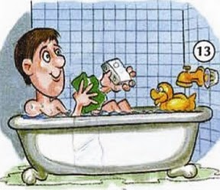
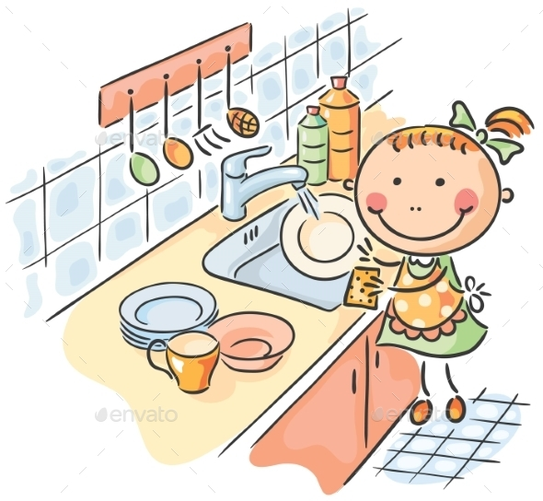

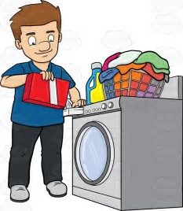

- Bath items (8pictures)
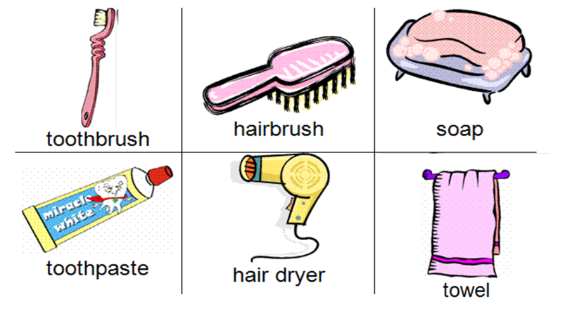

- Flash cards(20set)

- Song lyrics
*Hello song
Hello!
Hello!
Hello, how are you?
(Repeat)
I'm good!
I'm great!
I'm wonderful!
(Repeat)
Hello!
Hello!
Hello, how are you?
(Repeat)
I'm tired.
I'm hungry.
I'm not so good.
(Repeat)
Hello!
Hello!
Hello, how are you? (Repeat 3x)
*The bath song
Can you wash your hair?
I can wash my hair.
Can you wash your feet?
I can wash my feet.
Can you wash your face?
I can wash my face.
Can you wash your knees?
I can wash my knees.
I can wash my hair.
I can wash my feet.
I can wash my face.
I can wash my knees.
This is the way we take a bath.
Can you wash your shoulders?
I can wash my shoulders.
Can you wash your toes?
I can wash my toes.
Can you wash your hands?
I can wash my hands.
Can you wash your nose?
I can wash my nose.

*SOS worksheet

-PPTs
-Pictures of flashcards
-Pictures of eliciting pictures
-Photos of puppets
-Photos of game materials
-Photos of realia
-Song lyrics
-Chant words
-SOS worksheets (S and T (with answers) copies)

EVERYTHING *^^*

