☐ Listening Speaking ☐ Reading ☐ Grammar ☐ Writing

Topic: What is the place you are looking for?

Instructor:  Yujin Cho, Denise Park | Level:  Lower Intermediate | Students:  4 | Age:  14~17 | Length:  35 Minutes

Materials:

- Map for activity and game (one for each student)
- Vocabulary worksheet 1,2,3
- Example sentences paper
- Drawing lots papers and small basket
- White board, board markers

Aims: At the of following lesson

- Ss will learn how to give direction correctly in English.
- Ss will be familiar with important vocabulary related to direction.
- Ss will interact cooperatively in communicative situations by exchanging direction.
- Ss will learn how to use preposition of place to give directions.

Language Skills:

- Reading : vocabulary and vocabulary syllable worksheet.
- Listening : teacher’s elicitation, instruction, direction.
- Speaking : asking and giving direction, answering from teacher’s question.

Language Systems:

Lexis : vocabulary in giving direction
Function : asking and giving direction.
Grammar: preposition (From, in, on, up, by)

Assumptions:

- Ss already know basic vocabulary.
- Most students can listen and speak English but not very accurately.
- Ss already know the teacher’s style of teaching and the pace of the course.
- Ss have experience to give direction.

Anticipated Errors and Solutions:

- Students may have difficulty in understanding activity.
→ Teachers will demonstrate how to give direction on the map with example.

- Some students may not actively participate in group work.
→ Encourage hesitant student by asking his/her idea.

- Students may not be familiar with building and street name.
→ Check the concept with students by asking if they already knew the word before starting the activity.

- If students finish their game earlier than anticipated.
→ Have them check phrase and preposition that we learn today.

References:

Map for game 1
https://en.islcollective.com/resources/printables/worksheets_doc_docx/directions/imperative-giving-directions/13590
Map for game 2
http://tx.english-ch.com/teacher/jocelyn/level-b/practice-giving-directions/
Example sentences paper
http://eslforeveryone.com/asking-and-giving-directions/
Vocabulary
https://www.easypacelearning.com/all-lessons/english-level-2/1288-asking-and-giving-directions-conversation-english-lesson

Pre-Task
Materials: N/A
Time | Set Up | Student Activity | Teacher Talk
5 min | Whole  class | Listening to the teacher’s instructions. | Procedure:  <Greeting & Brief Rapport>  Hello, how was your week? Did anything special happened last week? It is very hot, isn’t it? But our classroom is cool so let’s wear a smile during class.  <Elicit>  Do you like traveling? Have you ever asked for directions when traveling? Or maybe you encountered a traveler asking for directions? Have you ever given directions to help a traveler?  (Listen to the students’ answers)  I see you’ve all experienced it. But when we must give directions in English it’s no easy. Then, what helped you? That’s right. The map. With a map, it is much easier to give directions.  <Introduction of Task>  Today, we will become a traveler and ask directions, find places. We will work in groups to play this game. Also, we will learn how to give directions in English.

Task Preparation
Materials: Map for game 1, Example sentence paper, Drawing lots paper, board and marker
Time | Set Up | Student Activity | Teacher Talk
7 min | Groups | Listen to the teacher’s directions.  Study the keywords.  Doing a mock game.  Look at the map. | 1: Demonstration  <Instructions>  Let me explain how to get to the place I’m going to. From now, with the map in hand, try to guess where we are going. I am not going to tell you about our destination. Just how to get there. All you have to do is to follow directions and guess the place.  (Distribute maps of activity and give them time to find the place)  Where do you think this is? What can you find there? What kind of building do we have there? Ok, now listen to the places I’ll be telling you and guess where it is.  Check the words if they are not familiar with.  Did you find it? Are you looking for it? Let’s look at the words I explained to you. Which words were mentioned? What are the words you need to know to give directions or understand directions?  (Guide them to use all of the key vocabulary)  -turn left, turn right, go straight ahead,  go pass, cross, at the corner of, next to, opposite, between.  <CCQ>  Do you see the map often?  When do you use it?  Have you ever found a place with a map?  Do you get confused with left and right on a map?

Task Realization
Materials: map for game 1, map for game 2, Drawing lots paper, vocabulary worksheet
Time | Set Up | Student Activity | Teacher Talk
9 min  9 min | Whole  class | Play games in groups | 2: Play games in groups  <Instructions>  Now is time to play. I will give you the same maps. you will make two teams. You will share the map and one team will give directions and the other team must guess the destination.  <CCQ>  Do you usually check the street names?  Do you know what’s in your neighborhood?  <Game 1> A team Guide / B team Guess  A Team will first pick the destination and will start to give directions. Just don’t tell the destination. B Team listens to A team and if you know the answer say it.  (If B team can’t guess the answer, the teacher will guess together once more.)  B team Good Job! A team is great at giving directions.  Shall we pick another place? B Team can pick and A team will find the place again.  <Game 2> B team Guide / A team Guess  Everyone did a great job. Let’s switch roles. Now, B team guides and A team will guess B team’s destination.  (It is the same game; each team needs to find the place within a specific time frame.)  Handover another map of activity for more exercise.  -Same rules with first activity.

Post-Task
Materials: board, marker, worksheet
Time | Set Up | Student Activity | Teacher Talk
5 min | Whole  Class | Listen to the teacher and share thoughts. | <Feedback>  How was the game! Did you have fun? Was it difficult to give directions? Was it hard to guess the destination? What did you think of while playing the game?  (Students’ answer)  <Language Focus>  I bet it was hard both ways. Giving directions in English is not easy. It must have been hard to use the new phrases to give directions. It is very important to know phrase verbs. Now you know how to help foreigners who need directions.

Map for game 1

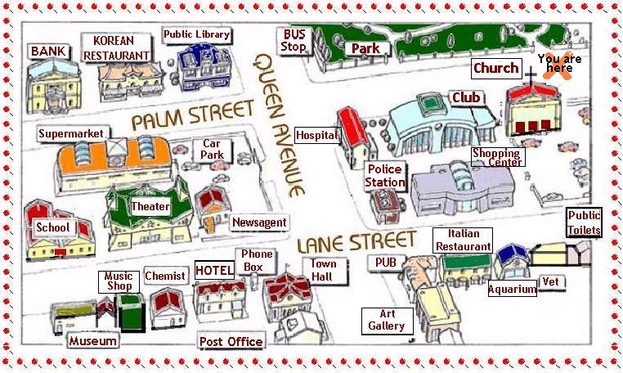

MAP for game 2

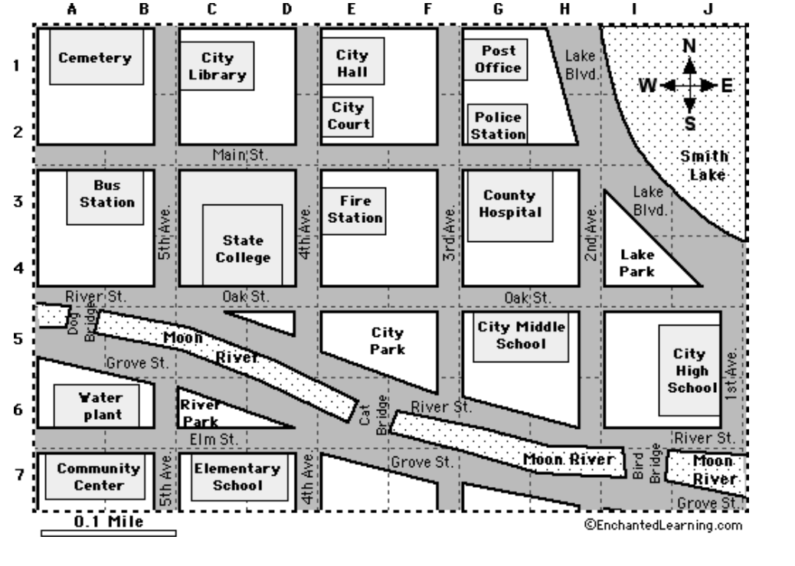

Asking and giving directions

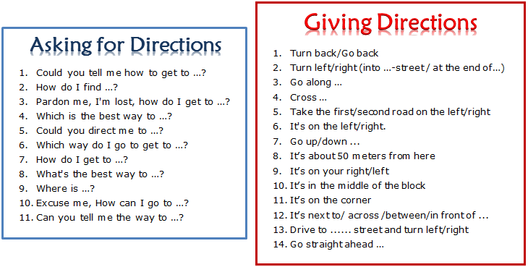

Vocabulary 1

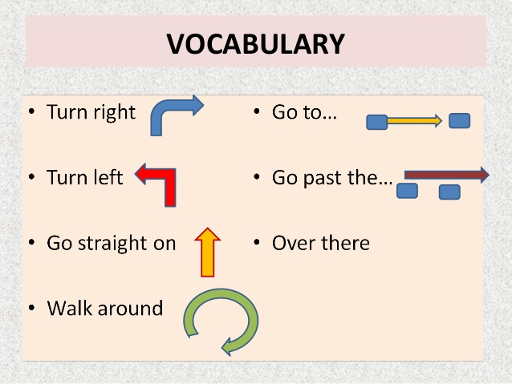

Vocabulary 2

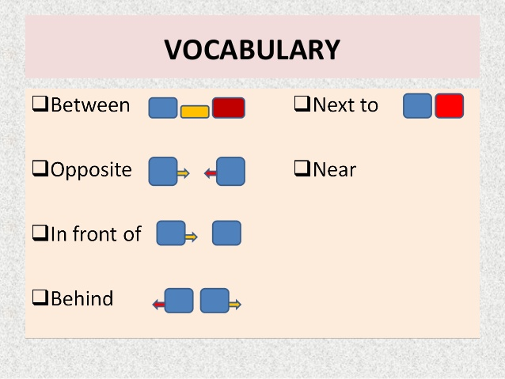

Vocabulary 3

