Worksheet 1
MATCHING VOCABULARY
Match the words with the proper meaning of the words.

1. Branch ㆍ |  | ㆍ | a. Hard solid non-metallic mineral matter of which rock is made, especially as a building material
2. Button ㆍ |  | ㆍ | b. A roughly cylindrical open container with a handle, made of metal or plastic and used to hold and carry liquids
3. Bucket ㆍ |  | ㆍ | c. Construct (something) by putting parts or material together
4. Stone ㆍ |  | ㆍ | d. A small disc or knob sewn on to a garment, either to fasten it by being pushed through a slit made for the purpose or for decoration
5. Build ㆍ |  | ㆍ | e. The power of apparently influencing events by using mysterious or supernatural forces
6. Scarf ㆍ |  | ㆍ | f. A part of a tree which grows out from the trunk or from a bough
6. Magic ㆍ |  | ㆍ | g. Squeeze (someone) tightly in one's arms, typically to express affection
6. Hug ㆍ |  | ㆍ | h. A length or square of fabric worn around the neck or head

Snowman image
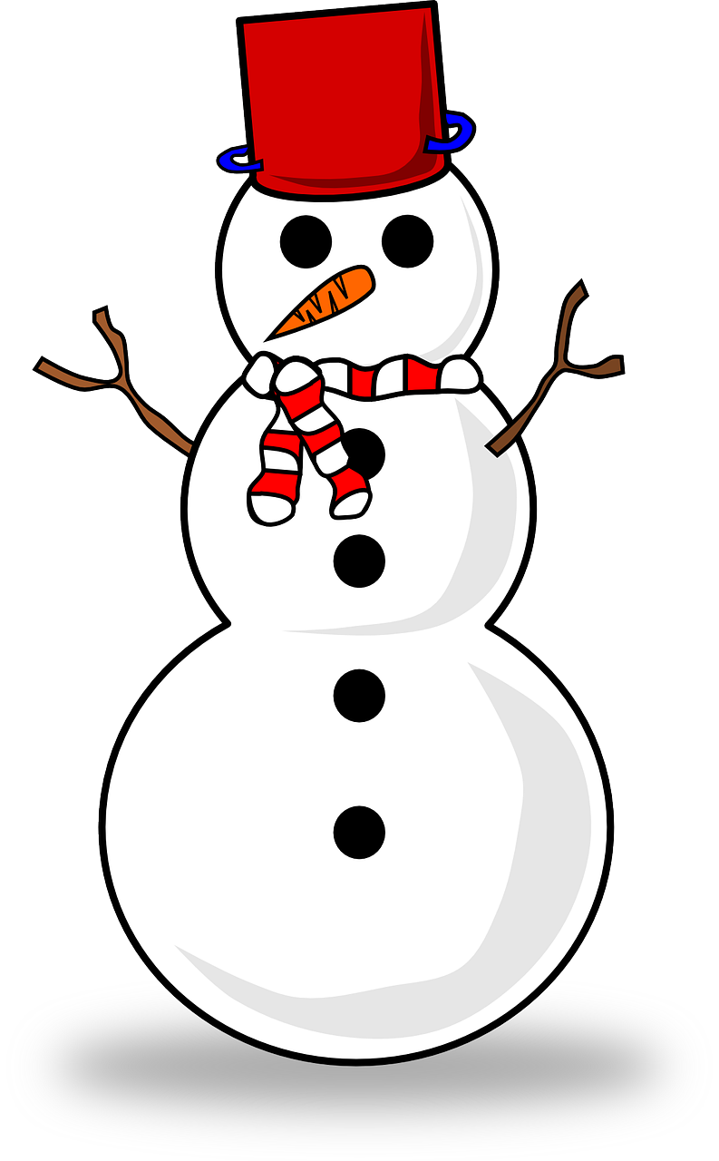
Flash Cards
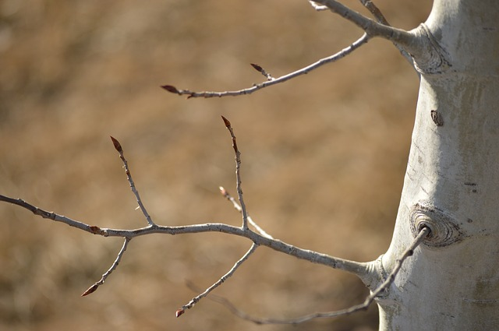 | 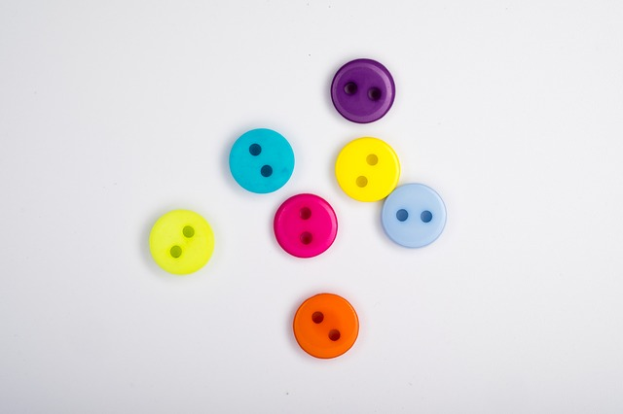
Branch | Button
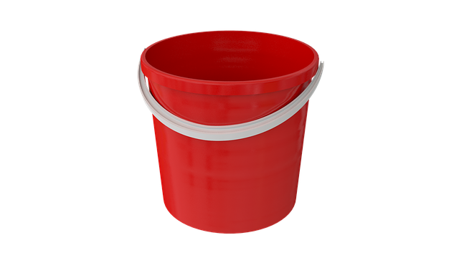 | 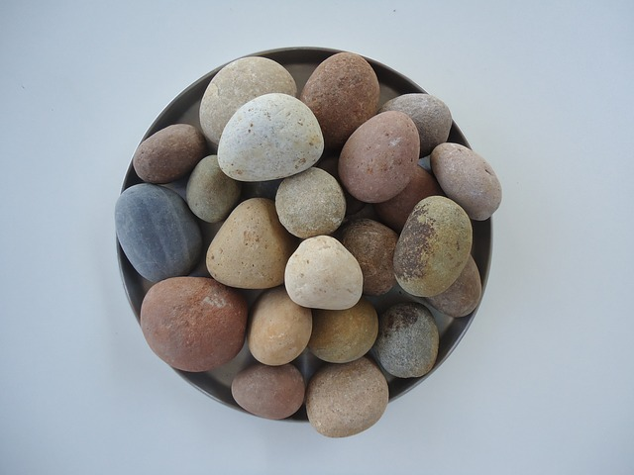
Bucket | Stone
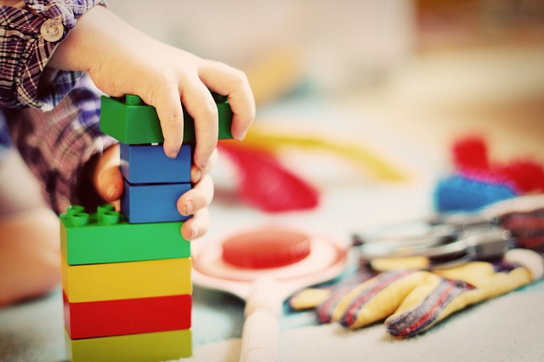 | 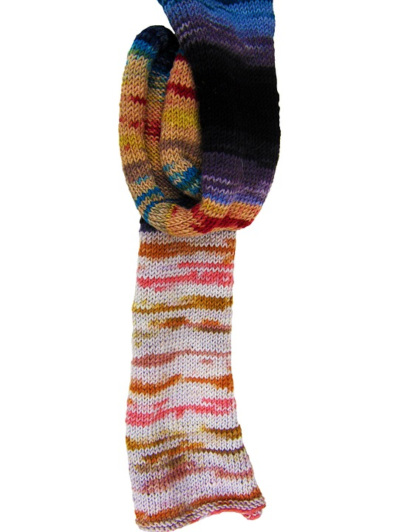
Build | Scarf

Worksheet 2
Filling the gaps

Anna: Elsa! __________, Wake up, Wake up!
Elsa: Anna, go back to sleep
Anna: I just can't! The sky is __________, so I'm awake! so we __________!
Elsa: Go play by __________
Anna: Do you want to __________ a snowman?
Anna: Come on, Come on, Come on, Come on!
Anna: Do the __________, do the magic!
Elsa: Ready?
Anna: This is __________!
Elsa: Watch this!
Elsa: Hi, I'm Olaf and I like warm __________
Anna: I love you Olaf!

Script

Anna: Elsa! Wake up, Wake up, Wake up!
Elsa: Anna, go back to sleep
Anna: I just can't! The sky is awake, so I'm awake! so we have to play!
Elsa: Go play by yourself
Anna: Do you want to build a snowman?
Anna: Come on, Come on, Come on, Come on!
Anna: Do the magic, do the magic!
Elsa: Ready?
Anna: This is amazing!
Elsa: Watch this!
Elsa: Hi, I'm Olaf and I like warm hugs
Anna: I love you Olaf!

