Name | Identity & Reason for visit | Item(s) | 8:00 pm | 8:30 pm

Name: Wally
1) You are a good friend of Mr. Grim’s son, Todd Grim. You often travel together. You are at the mansion because you want to invite Mr. Grim’s son to go hunting with you next month in Africa.

2) Items: a cobra– you brought it to give to Todd as a present. The snake has no poison. You also have your hunting knife in your bag.

8:00 pm: you lost the snake, so you were looking for the snake in the billiard room
8:30 pm: you found your snake in the library.
Name: Dr. Watkins
1) You are Mr. Grim’s doctor. You came to the party because are very worried about his health. Mr. Grim has a very bad heart. You were worried that he might have a heart attack.

2) Items: You have medicine in your bag.

8:00 pm: you were in the powder closet with Grim. And they told about Grim’s health. After then you and Mr. Grim parted after talking to each other.
8:30 pm: you were in the hall with the people.
Name: Morgan Franklin
1) You are Mr. Grim’s business partner. Secretly, you hate him. You wish he were dead so you could control the company.

2) Items: your computer and knife for opening envelopes.

8:00 pm: you were still at work. You didn’t arrive at the party until 8:30 pm.
8:30 pm: you told with Todd about his promotion will successful later in the lounge.
Name: Todd Grim
1) You are Mr. Grim’s son. You are a traveler. You have traveled the world. You recently just came back from a trip to Japan. You are at the mansion because you live there. Your friend named Wally is also visiting the mansion.

2) Items: wasabi, yukata, samurai sword

8:00 pm:
8:30 pm: [take 8:30 room card]

Name: Takeshi Fujimoto
1) You are Mr. and Mrs. Grim’s personal fitness trainer. You are in very good shape. You have a black belt in karate. You came to the mansion because Mrs. Grim’s wife (Wanda) invited you. Secretly, you have been in a romantic relationship Wanda for a year, but Mr. Grim doesn’t know.

2) Items: energy drink, jump rope, manga

8:00 pm: [take 8:00 room card]
8:30 pm: in the basement (with Wanda)
Name: Wanda Grim
1) You are Mr. Grim’s wife. You are rich, but you are not happy with Mr. Grim. He’s boring, and you’re bored. Secretly, you are in a romantic relationship with your fitness trainer, Takeshi Fujimoto. You like the excitement of having a secret lover.

2) Items: mobile phone, a book about yoga

8:00 pm: [take 8:00 room card]
8:30 pm: in the basement (with Takeshi)

Mystery in Mr. Grim’s Mansion – Game

“You were invited to stay at Mr. Grim’s large mansion for the weekend. Many other guests were invited too.”

Step 1: distribute character cards + props in the hall

“It’s Sunday at 9 pm. Suddenly, the butler, Barton, calls all of you to the living room.”

Step 2: announcement
"I am the butler. Mr. Grim is dead, and I believe one of your killed him!
No one is leaving here until we find out who it was! You are all suspects. If you can’t find out how he died, then I’ll call the police and you are all going to jail!"
You all knew him someway.Interview each other and find out: your names, jobs, and relationship was like with Mr. Grim, and if they brought anything to the party.

Step 3a: announcement
“I found the body 8:15 pm. This was after dinner.”

Find out where everyone was before and after this time. Ask them what they were doing.
Step 3b: distribute room cards to each student.

Step 4: announcement
“The body was found in the study. There was no blood anywhere or on the body."
Please think about it. That is all the information I have. Discuss in groups. If you think you know what happened, please come see me.

Answer: Mr. Grim found the snake in the study at 8:15. He had a heart attack and died.

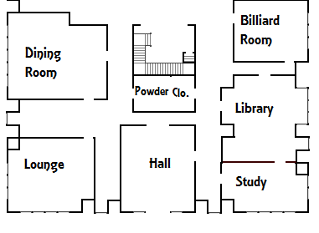

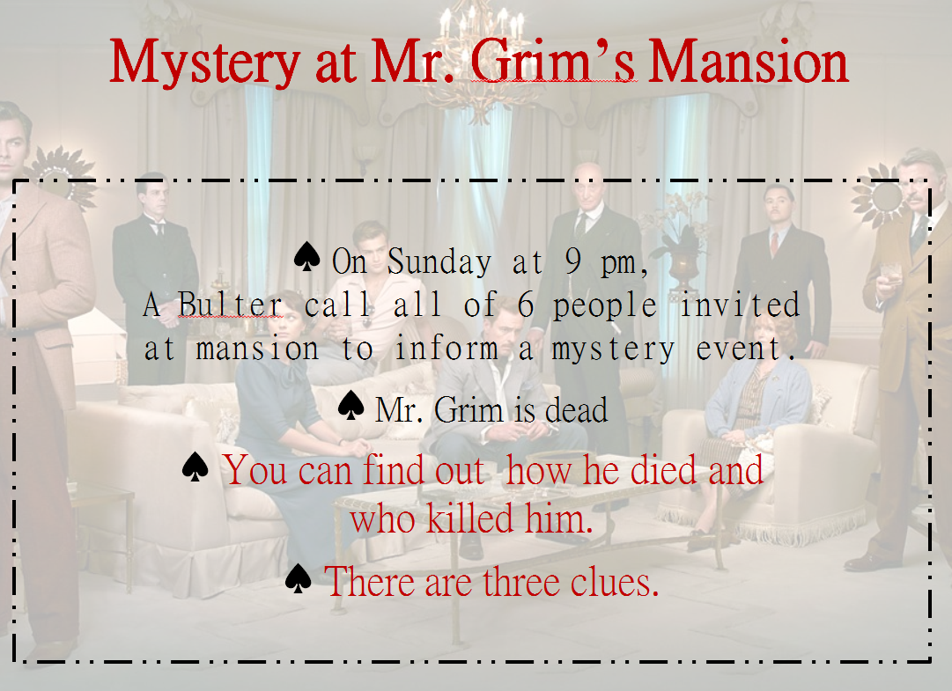
PPT

PPT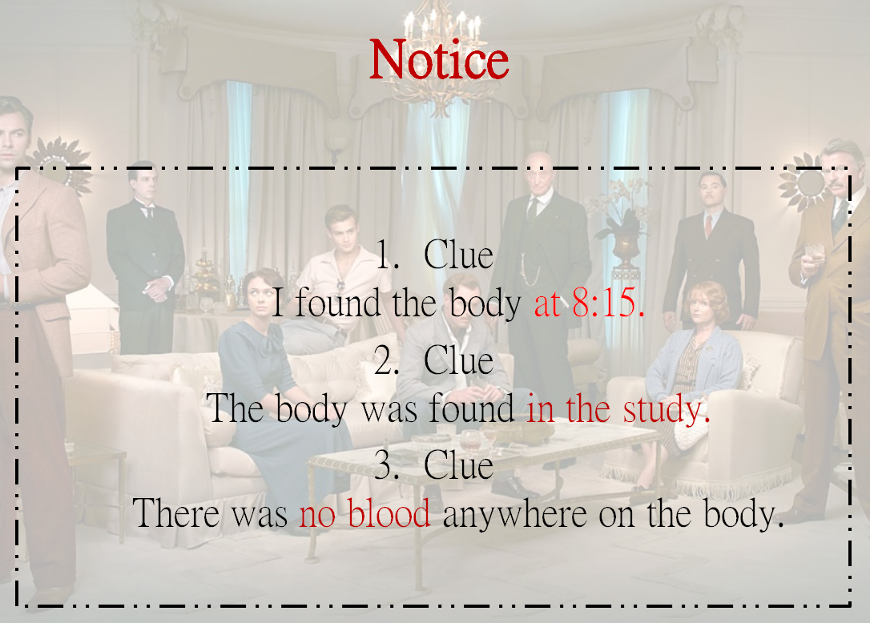
PPT 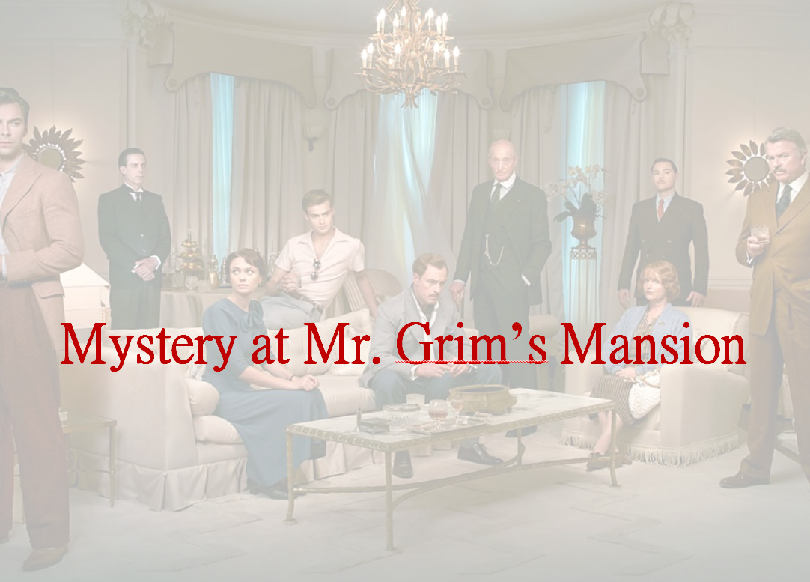 PPT 