☐ Listening ☐ Speaking ☐ Reading V Grammar ☐ Writing

Topic: Active vs Passive voice

Instructor:  Denise | Level:  Lower Intermediate | Students:  10 | Length:  40 minutes

Materials:
- Power Point Presentation File with Picture
- Computer, Beam Projector, White board, board markers
- Worksheet for Controlled Practice 1,2 and Less controlled practice

Aims:
-Ss will be able to distinguish active and passive voice through teacher’s example.
-Ss will be able to change active voice to passive voice and the other way around by learning the grammar rule and activity with worksheet.
-Ss will know when passive voice is used.
-Ss will recall the present & past tense and past participle what they learned in former class through exercising how to form passive voice.

Language Skills:

-Reading : Reading worksheets to answer questions, and context
-Listening: Teacher’s explanation about rule of passive voice and sample context
-Speaking: Discuss with partner, and answer the question
-Writing :Taking note while doing activity with partner, and write correct answer on the worksheet

Language Systems:

-Phonology: Drilling
-Lexis: Word and vocabulary in the worksheet.
-Grammar: Form of active passive voice.
-Function: Describing situation with passive voice

Assumptions:
- Students already know how the class set up and run
- Students have learned present & past tense and past participle.
- Students are teenager

Anticipated Errors and Solutions:
-Students may have difficulty in understanding the meaning.
>> Teacher provides more examples.
-Some students are shy to speak during the drill.
>> Encourage hesitant student to have more chance to practice.
-If students need more time to finish their activity
>> Ask if they need more time, and be flexible to give more time to finish.
If students finish their task earlier than expected
>> Give additional picture to describe with passive voice.

References:

Picture in power point presentation
https://blitzmetrics.com/identifying-and-eliminating-passive-voice/

Worksheet 1 (Controlled Practice 1)
https://www.espressoenglish.net/passive-voice-examples-exercises-present-past/

Worksheet 2 (Controlled Practice 2)
http://www.teachingideas.co.uk/vocabulary/active-voice-and-passive-voice

Worksheet 3(Less Controlled Practice )
http://www.mes-english.com/flashcards/passive.php

Grammar Lesson Plan example in student manual from TIMES MEDIA

Lead-In
Materials: Computer, Power Point Presentation, Beam Projector

Time | Set Up | Student Activity | Teacher Talk
5 min | Whole Class | Answer for teacher’s question.  Look at the picture at the power point presentation, and listen for teacher’s story | <Greeting>  Good Morning everyone. How was your weekday?  <Eliciting>  Do you like cookie? I love chocolate cookie, and I always have full of cookies in the jar. My brother visited my house, and he ate all of cookie from the cookie jar. He stole my cookies!  (Show picture that will have hand stealing the cookie from Cookie Jar, and  show the context for Active and Passive.  My brother stole the cookie from cookie jar  The cookie was stolen from the cookie jar by my brother. Explain the difference between these two sentences. And tell students today’s topic.)

Pre-Activity
Materials: Computer, Power Point Presentation, Beam Projector, White board and markers

Time | Set Up | Student Activity | Teacher Talk
5min  3min | Whole Class | Answer for teacher’s question.  Listen for teacher’s explanation.  Look at substitution table  Repeat after the teacher | As you can see these sentences, can you identify any pattern?  Can you see how the verb in active voice is transformed when it changed to passive voice?  CCQ  From this sentence, can you figure out whether it happens in past or present?  Do you know sentence in active is “stole ”and when it is changed to passive, the verb is transformed to stolen, what are these different?  Form  In active voice, “my brother” is who did the action which is called subject, and the cookie is object that is receiving action.  To form passive sentence, we take the object here is cookie and put at the first of sentence following by to “be verb”. Key point is form of “to be verb” should be same tense as verb in the active sentence.  Here we put “was” since the “stole” is past simple tense, and next to “be verb” we’re using past participle which is third tense of verb. Do you remember what we learned the first second and third of verb in last class? The subject in active voice “my brother” you can eliminate it if it is not sure who did it  Drilling  <Active voice>  My brother (He) stole cookies  ate  will buy cookie  will make  <Passive voice>  Cookie, Cookies was stolen were stolen by my brother  was eaten  were eaten  Will be bought  Will be made  (show students the substitution table)  Now listen what I say and repeat after me.  (Point to the substitution table while whole class repeat, and point some students to repeat individually)

Main Activity
Materials: Worksheet for Controlled Practice 1,2 and Less Controlled Practice

Time | Set Up | Student Activity | Teacher Talk
4min  6min  9min | Individully  Individully  Pair | Complete worksheet 1  Complete worksheet 2  Work with partner to describe picture. | Controlled Practice 1  I’ll give you multiple choice worksheet. Choose the correct answer individually. You have 3 minutes.  (Distribute worksheet to each students)  CCQ  Do you do alone?  How much time do you have?  (Wander around and monitor discreetly.)  Give time warning  You have 1 minute left. If anyone needs more time, I’ll give you 30 seconds to complete  Lets check the answer together.  Controlled Practice 2  You will have another worksheet to practice. Fill the blank and make full sentence on the worksheet. You will do this individually. You have 5 minutes.  CCQ  How much time do you have?  What do you do?  (Wander around and monitor discreetly, and answer the question if some students asked)  It seems that everyone has finished.  (Point some students and ask what correct answer is)  Less controlled Practice  You will have pictures and describe pictures by using passive voice structure. We will do with your partner next to you. I will give you 8 minutes.  CCQ  What do you do?  What do you alone?  1 minute left. If anyone needs more time, I’ll give you 1 more minute.  (Pick each group and ask the answer)

Post Activity
Materials: N/A

Time | Set Up | Student Activity | Teacher Talk
8min | Individually ->  Pair | Make sentence individually and share the idea with partner | Now I want you to do make your own situation and make active and passive structure. You need to make 3 sentence each. And you share your sentence with your partner next to you. You will have 5 minutes.  CCQ  How many sentences do you need to make?  What do you alone?  (Monitor actively. Sometimes join the pair, and move to next pair)  Let’s have each one’s idea. (Point each student and have them to speak their idea.)  Did you have fun today? Do you all feel more confident to use the active and passive voice? Today, we concentrated on making passive voice with present, past simple verb and future verb. You will learn how to form passive voice with present and past perfect, and present and past continuous next class.  See you next week.

Controlled Practice 1

Question 1
Active: People speak Portuguese in Brazil.
Passive: Portuguese ___________ in Brazil.
A | is speak
B | is spoke
C | is spoken
Question 2
Active: The staff cleans all the hotel rooms daily.
Passive: The hotel rooms _________ daily.
A | are clean
B | are cleaned
C | is cleaned

Question 3
Active: We update the company website frequently.
Passive: The company website ___________ frequently.
A | are updated
B | is updated
C | was updated
Question 4
Active: People see this beach as the most beautiful in the country.
Passive: This beach __________ as the most beautiful in the country.
A | is seen
B | is saw
C | is see

Question 5
Active: Somebody ships the products via express mail.
Passive: The products ___________ via express mail.
A | are shipped
B | is shipped
C | were shipped
Question 6
Active: A friend gave me this sweater.
Passive: This sweater ________ to me by a friend.
A | is given
B | was gave
C | was given

Question 7
Active: A famous author wrote these letters.
Passive: These letters _________ by a famous author.
A | were wrote
B | was written
C | were written
Question 8
Active: The teachers chose her to receive the award.
Passive: She __________ by the teachers to receive the award.
A | was chosen
B | was chose
C | were chosen

Controlled Practice 2

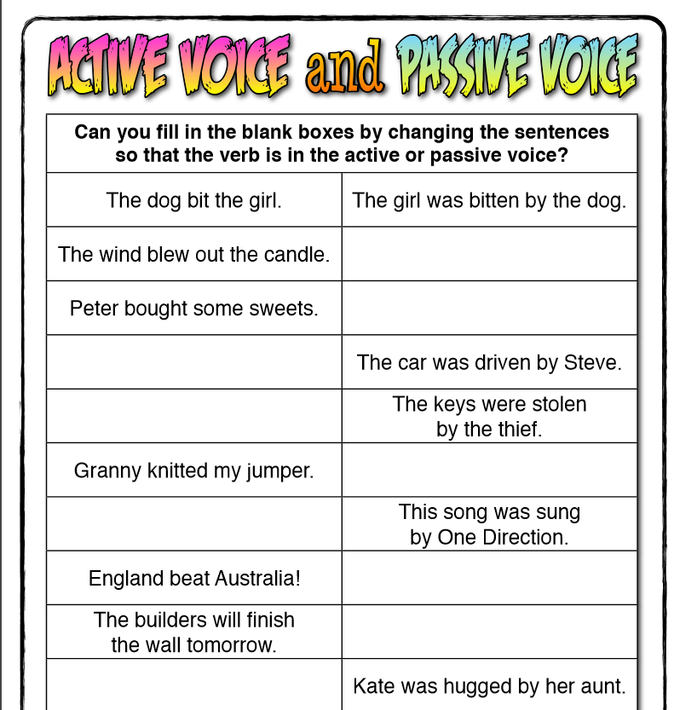

Less Controlled Practice

