☐ Listening ☐ Speaking ☐ Reading Grammar ☐ Writing
Topic: I will or I am going to

Instructor:  Clarius | Level:  Pre intermediate | Students:  7 | Length:  50minutes

Materials:
- Computer. Screen
- Projector
- White board, board markers
- Worksheets #1, #2, #3, #4, #5, #6
- Picture #1

Aims:

- To learn the difference between ‘(be)going to’ and ‘will’ as future action
- To be able to use ‘(be)going to’ and ‘will’ in accordance with the right context
- To be able to write a sentence in future tense

Language Skills:

- Reading: Reading conversation and exercises
- Listening: Listening to other students in discussion
- Speaking: Making and speaking a sentence with ‘(be)going to’ and ‘will’
- Writing: Writing sentence with ‘(be)going to’ and ‘will’

Language Systems:

- Grammar: Learning ‘will’ and ‘going to’ and using them in the right context
- Phonology: Learning pronunciation through exercises
- Lexis: Phrases related to express the future
- Function: Selecting right form of grammar, completing the sentence with writing and speaking the right form
- Discourse: Speaking with ‘(be)going to’ and ‘will’ (Pair discussion)

Assumptions:

- Students understand the meaning of future happening and situations
- Students are aware of the formula of the future tense sentence
(S+to be+going to+V infinitive / will+V infinitive)
- Students understand the usage of ‘be going to’ and ‘will’ to some extent

Anticipated Errors and Solutions:

- Students may have difficulty understanding the different timing of ‘be going to’ and ‘will’
- Teacher will draw a diagram in order to help the students’ understanding and ask the students to write it down on their handout

- Students may not know the formula of the future tense sentence
When needed, teacher will shortly explain the grammatical principle of ‘be going to’ and ‘will’. (S+to be+going to+V infinitive / will+V infinitive)

References:
- Pictures
- https://www.google.co.kr/url?sa=i&rct=j&q=&esrc=s&source=images&cd=&ved=0ahUKEwiZsO2fy67VAhVBnZQKHSDgDi8QjBwIBA&url=https%3A%2F%2Fhowheasked.com%2Fwp-content%2Fuploads%2F2013%2F12%2FSurfing-Marriage-Proposal-_-Cool-Marriage-Proposal-Ideas_1074.jpg&psig=AFQjCNH25Ictt9RqKzV9QtmJnBEBd-4aIg&ust=1501420997159070
- https://www.google.co.kr/url?sa=i&rct=j&q=&esrc=s&source=images&cd=&ved=&url=https%3A%2F%2Fs-media-cache-ak0.pinimg.com%2F736x%2F5b%2Ff9%2Fe9%2F5bf9e994e30912e83103942dd0b5969e.jpg&psig=AFQjCNH25Ictt9RqKzV9QtmJnBEBd-4aIg&ust=1501420997159070
- https://howheasked.com/wp-content/uploads/2013/12/Surfing-Marriage-Proposal-_-Cool-Marriage-Proposal-Ideas_1125.jpg

- Exercise
- http://www.better-english.com/grammar/willgo.htm
- http://www.perfect-english-grammar.com/will-or-be-going-to.html
- http://www.englisch-hilfen.de/en/exercises/tenses/will_going_to_future.htm
- Cutting Edge(Longman)

Lead-In
Materials: Board, Board markers, Picture #1, Worksheet #1
Time | Set Up | Student Activity | Teacher Talk
5min | Whole class | Listen to the instruction  Answer the question  Listen to the instruction | Hello, everyone. Did you have nice weekend? Today, I’m going to explain you a very useful, but a slightly tricky grammar.  Now, let me show you a picture.  (Distribute picture #1)  What is the man doing?  Students: Proposing to a woman.  Correct. The man is proposing to the woman. And what is the man probably saying to her?  Students: Will you marry me?  Yes. The expression for proposing is ‘Will you marry me’ But, how would it be when he says ‘Are you going to marry me?’ ‘Will’ and ‘going to’ express both the future, but why does it sound different?  That’s what we are going to learn today.  (Distribute worksheet #1)  But, before we start today’s lesson, I will show you a graph which points out the wide spectrum of usages of ‘will’ and ‘to be going to’:  (If needed, brief explanation of differences between of ‘will’ and ‘to be going to’)  Now, back to our example.

Pre-Activity
Materials: Computer, Speaker, Worksheet #2, #3
Time | Set Up | Student Activity | Teacher Talk
5min  5min | Whole  Class  In pairs  Whole  Class  Individual | Listen to the instruction  Discuss in pairs  Answer the question  Students read the explanation together  Students draw the diagram on their handouts | Instruction  (Distribute worksheet #2)  Now, There are two conversations on the handout.  In the first conversation, Helen says ‘We will invite’, but in the second conversation she says ‘We are going to invite’. Discuss with your partner and guess the different usage of ‘will’ and ‘(be) going to’.  (After 3 minutes)  Team 1, what do you think is the difference? What about Team 2/3?  Great! You had a good guess.  Now, take a look at the Worksheet #3.  Here is stated the different usage of ‘will’ and ‘(be) going to’.  Let’s read them out loud together.  (Teacher asks students to read out loud)  So, ‘will’ and ‘(be) going to’ are used different according to the time of decision.  (Teacher draws a diagram to help the understanding)  <will>  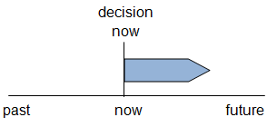  <be going to>  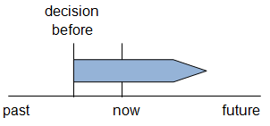  Please write the diagram in the empty space on your handout.

Main Activity
Materials: Whiteboard, Board marker, Worksheet #4,#5
Time | Set Up | Student Activity | Teacher Talk
2min  3min  10min  5min | Whole class  Individual  Whole  class  Whole  class  Individual  Whole  class | Listen to the instruction  Conduct the exercise  Answer and compare the answer with others  Listen to the instruction  Conduct the exercise  Answer the question  /Compare answer with others | - Choosing right expression  Instructions  Now, let’s do some exercise.  (Distribute worksheet #4)  There are 5 sentences in your handout. Select between ‘will’ and ‘(be) going to’ based on the time of decision.  You have 5 minutes.  CCQ  What are you supposed to do?  How much time do you have?  (After 3 minutes)  Ok, let’s see the answer together.  - Nr 1. I don’t know how to use this camera. It’s easy. I will/ going to show you.  (Teacher asks the students to read the sentence together)  - Writing sentences with given information  Instructions  (Distribute worksheet #5)  Now let’s do the next exercise. There are 5 dialogues. You need to write a sentence with the given subject and verb. Think thoroughly if you are going to use ‘will’ or ‘(be) going to’  Teacher walks around and check how the students are doing the exercise  Alright, it seems like you are done.  Do you need more time?  Yes → give few more minutes  No → Ok, Sam, please read the first sentence. Then Olivia, please read the second sentence.  Correct answer → Great. I am going to watch the television. (Repeat the answer)  Wrong answer → Any other idea? In this case you need to use ‘am going to’, because it was decided before the television was turned on.

Post Activity
Materials: Worksheet #6
Time | Set Up | Student Activity | Teacher Talk
10min | In pairs  Whole  Class  Whole  class | Listen to the instruction  Conduct the card game  Answer the question  Listen to the instruction | Instructions  For the last activity, let’s see if you understood the difference between the two expressions. It’s a pair work, and I am going to distribute some cards to each group.  (Teacher distributes Worksheet #6)  Turn over the cards at first.  Now, flip cards over in turn, and make a sentence with ‘will’ or ‘(be) going to’. Listen to your partner’s sentence and see if it’s correct.  (Teacher walks around and listen to the students)  (After 10 minutes)  Was there any sentence you were not clear?  (Teacher selects some of the cards and ask the answer to the students in order to check their comprehension)  Great job. Today you have learned the difference between ‘will’ and ‘(be) going to’ as future action.  Please reviews today’s learning and see you next time.

Picture #1
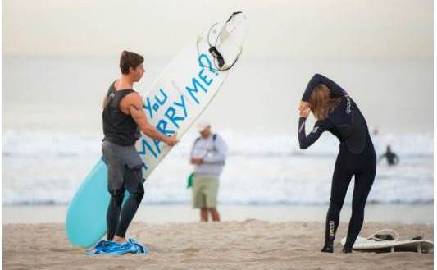

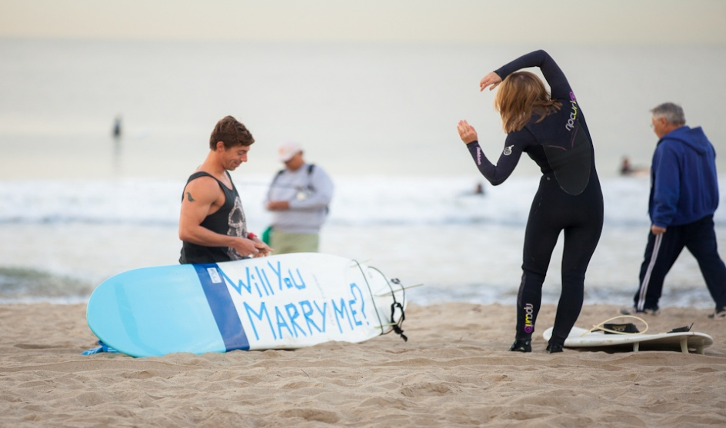

Worksheet #1

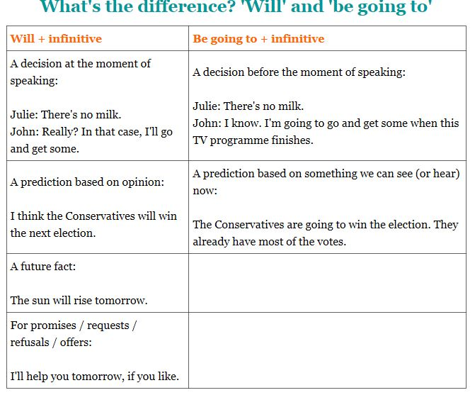

http://www.perfect-english-grammar.com/will-or-be-going-to.html

Worksheet #2
Direction: Read the conversation and discuss the difference between ‘will’ and ‘going to’ with your partner.

Worksheet #3

Will
We use ‘will’ when we decide to do something at the time of speaking. The speaker has not decided before. The party is a new idea.
Draw the diagram here

(be) going to
We use ‘(be) going to’ when we have already decided to do something. Helen had already decided to invite lots of people before she spoke to Dave.
Draw the diagram here

Worksheet #4
Direction: Choose the right expressions according to the context.

- I don’t know how to use this camera. It’s easy. I will/ going to show you.

- Marvin will/ is going to throw a party next week.
- It's really hot in here. I will/am going to put an the air-conditioning.
- We are going to fly / will fly to Venice in June.
- Paul's sister is going to have/will have a baby.

Worksheet #5
Direction: Complete the sentence using will or going to.

- A: Why are you turning on the television?
B: ________________________________ the news. (I/ watch)

- A: Oh, I have just realized that I let my wallet at home.
B: Really? Well, don’t worry. _______________________ you some money. (I / lend)

- A: What would you like to eat?
B: ___________________________ a sandwich, please. (I/have)

- A: Where are you going? Are you going shopping?
B: Yes. ___________________________ something for dinner.(I/buy)

- A: Did you post the letter for me?
B: Oh, I’m sorry. I completely forgot. __________________________ it now. (I/do)

Worksheet #6
I feel really tired. I think I ______ go to bed. | Where are you going?  I _________visit a customer.
Do you want me to help you?  No thanks. John ______ help me. | Would you prefer tea or coffee?  I ______ have some coffee, please.
Would you like to come to my house for dinner and talk about this?  Good idea. I ______ bring some wine. | I've already decided.  I ______ buy a new car
What are your plans for next week?  I ______ to fly to New York on business. Probably on Tuesday but I haven't bought my ticket yet. | What are your plans for the holidays?  I ______ visit my parents for a few days and then go walking in Scotland.
Why are you wearing your best suit?  I ______ have lunch with my biggest customer. | Do you want to have the chicken or the beef?  I think I ______ have the beef.

