☐ Listening ☐ Speaking Reading ☐ Grammar ☐ Writing

Topic: The people’s century

Instructor: Clarius | Level: Intermediate | Students: 7 | Length: 45 minutes

Materials:
- Computer
- Speaker , Screen
- Projector
- White board, board markers
- Worksheet #1, #2, #3, #4

Aims:

- To be able to match the reading material with the right picture
- To be able to understand the detailed information of the article
- To learn expressions in past

Language Skills:

- Reading: Reading articles
- Listening: Listening to other students in discussion
- Speaking: Presenting the summary of the article to other students
- Writing: Revising false information about the article

Language Systems:

- Lexis: Vocabulary and idioms in past tense related to history
- Grammar: Learning expressions in past tense
- Function: Matching paragraphs with right pictures, Finding and correcting false information
- Phonology: Learning pronunciation by reading out loud
- Discourse: Pair conversation by using time expressions phrases

Assumptions:

- Students have certain knowledge of world history
- Students understand the past tense
- Students are aware of the verb form in past tense

Anticipated Errors and Solutions:

- Students may have few historical knowledge
- Have the students guess the time of images in pair / Teacher provides brief explanation of each picture and period

- Students may not know some words and the verb in past tense
- When needed, teacher will shortly explain how to form a verb in past tense (-ed)
and explain the unknown words

References:

- Pictures
- https://s-media-cache-ak0.pinimg.com/originals/7d/a9/07/7da907ac24d38dab58ff383351fee3f5.jpg
- http://cdn.static-economist.com/sites/default/files/imagecache/full-width/images/2013/03/blogs/prospero/20130309_bkp506.jpg
- http://mymodernmet.com/wp/wp-content/uploads/archive/Jitr3nz3U0wa3WEHrXOs_HippieFashion1.jpg?width=721
- https://www.google.co.kr/url?sa=i&rct=j&q=&esrc=s&source=images&cd=&ved=0ahUKEwjc9L2qvK7VAhXMS7wKHRkOB9YQjBwIBA&url=https%3A%2F%2Fs-media-cache-ak0.pinimg.com%2F736x%2Fc8%2Fd0%2F0a%2Fc8d00a2d5bfdf2ccfbed17716f36c2e7--coal-miners-west-virginia.jpg&psig=AFQjCNEAk_xQ8JNGiWsLrQkVU2xF9xsTAA&ust=1501416998967648
- http://i.dailymail.co.uk/i/pix/2008/01_04/gunnersDM2301_468x280.jpg
- https://i.ytimg.com/vi/d0stAxe3uvM/maxresdefault.jpg

- Cutting Edge(Longman) : Upper Intermediate pg.6.7

Lead-In
Materials: Board, Board markers, Worksheet #1
Time | Set Up | Student Activity | Teacher Talk
5 min  5 min | Whole class  In pairs  Whole  class | Answer the questions  ‘Reading’ the pictures and discuss the sequence of pictures in pair  Answer the question | Hello, everyone. How was your weekend?  I saw the movie ‘Dunkirk’ last week. Have any of you watched that movie too?  ‘Dunkirk’ is a movie about evacuation of English soldiers during the World War II. It is tragic and heart breaking, but it is still a history we need to know. So, today I prepared something that we could learn along with history by reading of some newspaper articles.  Before we read these newspaper articles I’m going to give you some pictures, and I want you to guess the chronological order of the pictures.  Try it with your partner..  (Teacher distributes photographs of Worksheet #1)  (You have 5 minutes)  Students discuss in pairs the order of pictures.  Okay. Team 1, what is the order of the pictures? What about Team 2/3? It seems every team has a bit different idea.  The right order is 6-3-5-1-4-2.  (Teacher writes the numbers on the board and briefly explains the pictures)

Pre-Activity
Materials: Computer, Speaker, Worksheet #2
Time | Set Up | Student Activity | Teacher Talk
5 min  5 min | Whole  Class  Whole  class  Whole  class | Listen to the instruction  Answer the question  Compare the answer with their own answer | Instruction  Now, I am going to show you short note about each picture.  (Distribute worksheet #2)  Now, You try to match the notes with the pictures.  (You have 5 min)  Which picture matches with note A?  (Teacher asks, and students answer)  Great! Picture 1 matches with D, picture 2 with F, picture 3 with B, picture 4 with E , picture 5 with C and picture 6 matches with note A.  (Teacher writes the answer on the board)  So, the final order is A-B-C-D-E-F.  World War I took place in the 1910s, so it is the first one. And then B was in 1930, so it is the second. Then C is about World War II, so it’s about the 1940s. Then D, the economic development in Japan was in 1950s.The hippy syndrome was raised in the 60s, and the feminist movement was raised in the 70s.

Main Activity
Materials: Whiteboard, Board marker, Worksheet #3
Time | Set Up | Student Activity | Teacher Talk
8 min  5min | Individual  Whole class | Listen to the instruction  Read worksheet #3  Explain paragraphs and match with proper pictures | - Reading and matching the paragraphs with pictures  Instructions  Now, we had an overview of each period of the pictures. I am going to hand out the extracts from interviews with these people. You will work individually. Please, read it thoroughly. After you reading it, you will try to match the paragraphs with pictures.  (Distribute worksheet #3)  I give you 8 minutes to read and to match.  CCQ  What are you supposed to do?  (Teacher walks around and see how the students are doing the exercise)  (After 8 minutes)  - Explaining paragraph with his/her own word and matching with pictures  Instructions  Ok, are you done?  Ok, John, could you briefly explain paragraph A and match it with picture? Thank you. Jane, what is paragraph 2 about?  (If needed, teacher provides brief feedback of each paragraph)

Post Activity
Materials: Worksheet #4
Time | Set Up | Student Activity | Teacher Talk
7min  5 min | Individual  Whole  class | Listen to the instruction  Conduct Worksheet #4  Answer the question  /Compare answer with others | - Correcting false information  Instructions  For the last activity, take a look at worksheet #4. There is wrong information in each sentence, so correct them. This is an individual work.  You have 5 minutes.  (Teacher walks around and listen to the students’ conversation)  Ok, Let’s see the answer together. Tell me what wrong is. What is wrong in number 1? (Listen to the students’ answer and tell the answer)  Great job. Today you have practiced reading comprehension and learned expressions in past tense. Please reviews today’s learning and see you next time.

Worksheet #1
Direction: Take a look at the pictures and discuss the sequence with your partner.
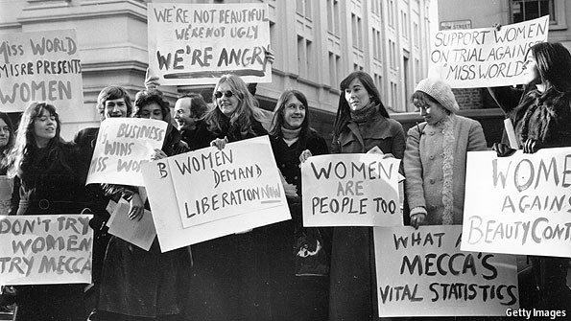
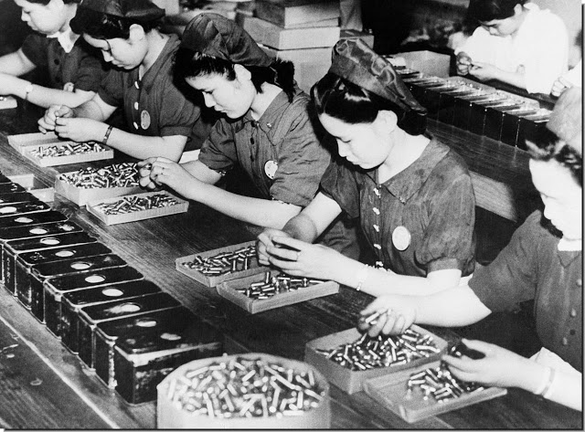

[문서 인용문이나 흥미로운 부분에 대한 요약을 입력하십시오. 문서의 원하는 위치에 텍스트 상자를 넣을 수 있습니다. 인용문 텍스트 상자의 서식을 변경하려면 [텍스트 상자 도구] 탭을 사용하십시오.]

1
2

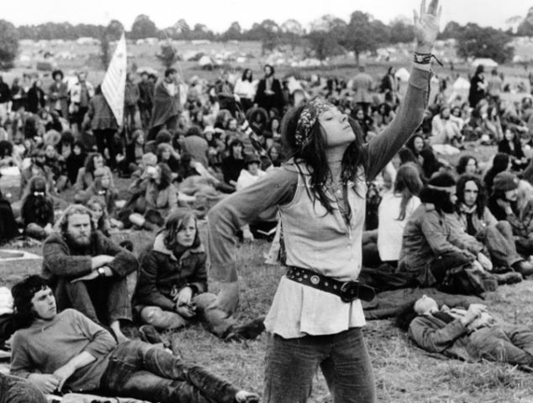
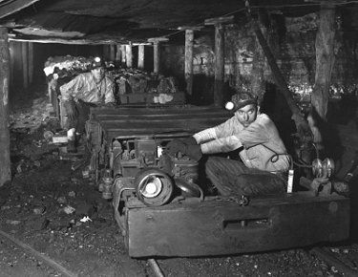

4
3

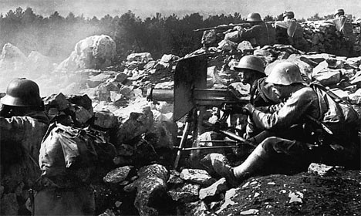
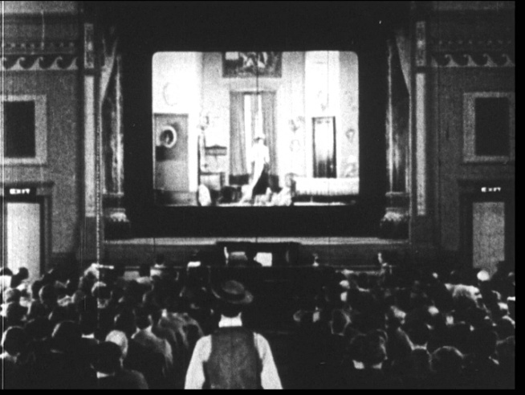

5
6

Worksheet #2
Direction: Read the 6 paragraphs below and match them with the right pictures.

[B]
Yvonne Mouffe grew up in a coal producing area of Belgium in the 1930,
a decade of economic depression and industrial unrest.
[A]
Ernst Weckerling was a German infantryman during World War I, when nearly nine million men died.

[D]
Suezo Uchida worked in a factory in Japan in the 1950s, a time when the Japanese economy grew very fast.
[C]
Luigi Cavaliere was a cinema projectionist in Rome during
World War II.

[F]
Jaqui Ceballos was a feminist in the United States in the 1960s and 1970s.
[E]
Ron Thelin was a hippy who dropped out of college in San Francisco
in the late 1960s.

Worksheet #3
Direction: Read extracts from interviews with these people, and match them with the photographs.
[A] Everybody wanted to have some fun, and the only thing available was the cinema. Television was not yet available. In the cinema, even if they were not well equipped, people would queue up anxiously waiting to watch the movies. Going to the movies was a party. Everybody wished to forget about the ugliness of the war.

[B] I usually went to the company at eight o’clock. I continued working until nine in the evening. That was the usual day. On one day only-Wednesday-I came home at four o’clock. That was the working situation then. I was a workaholic. I worked almost all Sundays, too. I had no time to talk to my family.

[C] It seemed like anything was possible. Every kind of character seemed to appear on the street, because you could dress however you wanted. I opened a shop selling books, drugs, records. There was even room for meditation. We put ‘free’ in front of everything we sold. We were exploring what freedom and a free society was.

[D] The air was full of smoke and fumes from the constant firing of the French guns. The crater I was in was so deep that the breeze couldn’t blow the fumes away. We were thirsty and hungry. We had to fight and to fight. It was terrible.

[E] At protest marches we threw our garments and cosmetics into the trash can. We threw bras, stockings and high-heeled shoes. They were oppressive items for women. It was a feeling of power, that we all wanted to change society and that we could do it. And it was a worldwide movement, especially in the western world.

[F] I can remember there was only one room. We used to cuddle up to each other to keep warm. There were nine children, and we slept on the floor. Father worked in the mines but during the strike they received nothing at all, so we had nothing but potatoes to eat and from time to time some bread.

Worksheet #4

Direction: Find the wrong information in the sentence and correct it properly.

- People preferred cinema than television because of the wide screen.

- The theater was well equipped with brand new devices.

- People liked to watch war film at the cinema.

- In 1950s, people in Japan were forbidden to work more than 8 hours a day.

- Hippies had a unified dress code and pursuit freedom.

- The condition for soldiers that fight in World War II was suitable.

- The feminist movement was limited to certain countries.

- The feminist wore make-up and put on high-heels as a symbol of protest.

- In the 1930s, people who worked at the mine were provided with enough food.

