■ Listening ☐ Speaking ☐ Reading ☐ Grammar ☐ Writing

Topic: Try something new for 30 days

Instructor: Mr. Tim | Level: Intermediate | Students: 9 | Length: 50 minutes

Materials:
- Idioms worksheet - 9 copies
- Fill in the blank – 9 copies
- Board and marker
- Listening file (without script)

Aims:
- To improve listening skill using the worksheet
- To learn and apply the planning skill in reality by watching the video
- To practice and learn about the vocabularies in conversation by listening the real-life speech
- To practice speaking by discussing with classmates in group

Language Skills:
- Listening : Listening the audio in video
- Writing : Filling the blank
- Reading : Reading the script after filling the blank
- Speaking : Discussion with classmates in a group

Language Systems:
- Lexis : Idioms used in the video
- Phonology : Listening the pronunciation
- Discourse : Group Discussion

Assumptions:

- Students already know what to do when they receive the worksheet
- Students already know they will watch the video without the script
- Students already have experience in making plans in their real life.

Anticipated Errors and Solutions:

- If time is running out, shorten the discussion time (cut-off plan)
- If time is enough, ask for volunteers or pick the students from the group to share their ideas to the classmates (SOS plan)
- If students have hard time of thinking the plan, provide them an example for them

References:

- Video clip : https://www.ted.com/talks/matt_cutts_try_something_new_for_30_days#t-3860

Lead-In
Materials: n/a
Time | Set Up | Student Activity | Teacher Talk
3 mins | Whole Class | Greeting | Good day everyone, how are you?  How do you usually plan and spend your time to make your plan work?  Do you have any special method to follow the plan well?  (Wait for students’ response)  Today we are going to watch the video of the subject “Try something new for 30 days” from Ted talk.  Before we watch the clip, we will go over the words that we will learn today

Pre-Activity
Materials: Idiom/vocabulary worksheet, board and marker
Time | Set Up | Student Activity | Teacher Talk
7 mins  15 mins | Whole  Class  Individual  Whole  Class | Receive the worksheet  Check the words individually  Talk freely about the meanings of words and idioms they predicted. | Please check the words on the worksheet that we will learn today. You have 7 minutes to go over the idioms and vocabularies.  Also, please take the survey test “Are you in a Rut?” and sum up the numbers that you get from the scale, 1 is the least and 3 is the most  The “Are you in a Rut?” test (the range is from 1 to 3)  1. I don’t challenge myself  2. I make excuses easily  3. I feel bored  4. I put off hard project to the last  5. I like to stay in the routine life  (Distribute the worksheet and monitor the students)  CCQ  How much time do you have?  What do you need to do with the survey test?  Now let’s go over the words briefly one by one before we watch the video. (write down the word and meaning on the board if students cannot answer)  - Go through the idioms and words  - Elicit the meaning from students  - Explain by using the sentences, dialogue in similar situation, image or synonyms.  1. stuck in a rut : remaining in the negative situation in life. -> image / dialogue / survey  Davina: I am so bored.  Jade: Why?  Davina: Every day I do exactly the same things over and over. I wake up, go to work, come home late, watch TV and then go to bed. I have such a boring life.  Jade: You should try something new if you feel so.  CCQ  What did you recognize from the dialogue?  Who is stuck in a rut now?  What did you get for “Are you in a Rut?”  Who has more than 8? Did someone get less than 8?  - If more than 8 is major : I guess most of the students are stuck in a rut in these days  - If less than 8 is major : I guess most of the students do know how to use their time well  2. to follow in the footsteps of : to do same thing that someone did before.  Ex) To follow or not to follow in the footsteps of parents.  3. It turns out : to happen in a particular way or to have a particular result, especially an unexpected one. (synonyms: As it is~)  Ex) He was expecting to have completed his training by now. It turns out, he’s only halfway through it.  4. desk-dwelling : a dwelling is a house or a place to live in. People spend so much time sitting at their desks in their offices. (a computer nerd = someone who likes computers and technical things and doesn't have great social skills) -> show an image to students  5. to end up : to finally be in a place or situation.  Ex) If you don't know what you want, you might end up getting something you don't want.  6. from scratch : from the beginning without using things that already exist.  Ex) Starting from scratch  7. sleep-deprived : the condition of not having enough sleep -> show an image to students  8. sustainable : able to be maintained or kept going, as an action or process  Ex) The extreme diet is not sustainable over a long period  9. to stick : to continue trying hard to do something difficult/new  Ex) He tends to stick to the recipes  10. give it a shot : to attempt to do something. (synonyms: give it a try~)  Ex) Think less, do more. Just give it a shot (give it a try)  CCQ  - Why are we checking the words before watching the video?
Main Activity
Materials: Video, fill in the blank worksheet
Time | Set Up | Student Activity | Teacher Talk
4 mins  10 mins | Whole  Class  Individual  Whole  Class | Watch the video  Receive the worksheet and fill out the blanks while listening. | 1. Listening for the context  Put your pens down and flip your worksheet we worked on. Let’s watch the video based on the words we learned.  (Turn on the video clip using the projector)  2. Listening for the details  This time, please try to fill out the blank as much as possible by listening it again. Please do not see the worksheet when we watch the video.  (Distribute the fill in the blank worksheet to students)  Do you want to listen again?  - Yes: once more  - No: check the answers with students they filled out.  Let’s check the answers together.

Post Activity
Materials: board and marker
Time | Set Up | Student Activity | Teacher Talk
10 mins  1 mins | Groups  Whole  Class | Talk about the things they want to do for 30 days with their classmates in a group (3 people in a group) | What are the small sustainable things you want to do for next 30 days?  Please talk with your group for 10 minutes about this and share the reasons for choosing it.  (Monitor students’ discussion carefully and give a advice or examples if they do not know what to talk; have jogging every morning, read the book at least 30 minutes before going to bed, try to think 10 minutes before buying something by online)  CCQ  - What do you do?  - How much time do you have?  Hope it was good time for you to think about the value of time and the image of your changed habits after it was done.  See you all tomorrow.
SOS Activity
Materials: board and marker
Time | Set Up | Student Activity | Teacher Talk
10 mins | Individual | Volunteer if they like to share their ideas with the classmates | Share students’ ideas  Take 3 volunteers from each group.  (If there are volunteers, ask them to share their ideas. If not, try to ask the weaker students from the group)

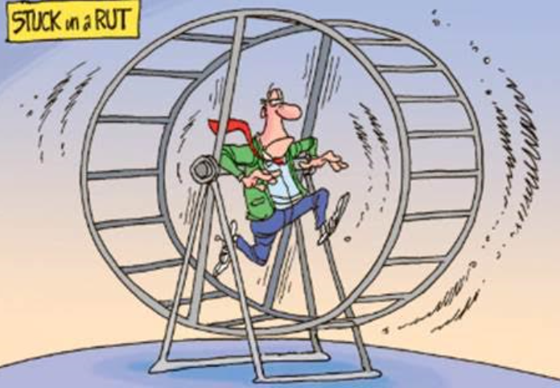
<Image of “stuck in a rut”>
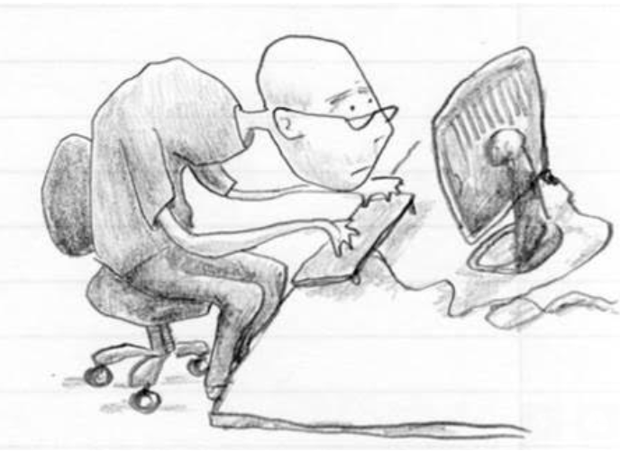
<Image of “desk-dwelling”>
<Image of “sleep-deprived”>

Worksheet (Fill in the blank)

A few years ago, I felt like I was . So I decided the great American philosopher, Morgan Spurlock, and try something new for 30 days. The idea is actually pretty simple. Think about something you’ve always wanted to add to your life and try it for the next 30 days. , 30 days is just about the right amount of time to add a new habit or subtract a habit like watching the news from your life. There are a few things I learned while doing these 30-days challenges. The first was, instead of the months flying by, forgotten, the time was much more memorable. This was part of challenge I did to take a picture every day for a month. And I remember exactly where I was and what I was doing that day. I also noticed that as I started to do more and harder 30-day challenges my self-confidence grew. I went from computer nerd to the kind of guy who bikes to work for fun. Even last year, I hiking up Mt. Kilimanjaro the highest mountain in Africa. I would never have been that adventurous before I started my 30-day challenges. I also figured out that if you really want something badly enough, you can do anything for 30 days. Have you ever wanted to write a novel? Every November, tens of thousands of people try to write their own 50,000 word novel in 30 days. It turns out, all you have to do is write 1,667 words a day for a month. So I did. By the way, the secret is not to go to sleep until you’ve written your words for the day. You might be , but you’ll finish your novel. Now is my book the next great American novel? No. I wrote it in a month. It’s awful. But for the rest of my life, if I meet John Hodgman at a TED party, I don’t have to say, “I’m a computer scientist.” No, no, if I want to I can say “I’m a novelist.” So here’s one last thing I’d like to mention. I learned that when I made small, changes, things I could keep doing, they were more likely to stick. There’s nothing wrong with big, crazy challenges. In fact, they’re a ton of fun. But they’re less likely . When I gave up sugar for 30 days, day 31 looked like this. So here’s my question to you: What are you waiting for? I guarantee you the next 30 days are going to pass whether you like it or not, so why not think about something you have always wanted to try and for the next 30 days. Thanks.
Idioms / Vocabularies

1. stuck in a rut : remaining in the negative situation in life.

The “Are you in a Rut?” test (the scale is from 1 to 3 – 1 is least / 3 is most)
1. I don’t challenge myself
2. I make excuses easily
3. I feel bored
4. I put off hard project to the last
5. I like to stay in the routine life

2. to follow in the footsteps of : to do same thing that someone did before.

3. It turns out : to happen in a particular way or to have a particular result, especially an unexpected one. (synonyms: As it is~)

4. desk-dwelling : a dwelling is a house or a place to live in. People spend so much time sitting at their desks in their offices.

5. to end up : to finally be in a place or situation.

6. from scratch : from the beginning without using things that already exist.

7. sleep-deprived : the condition of not having enough sleep

8. sustainable : able to be maintained or kept going, as an action or process

9. to stick : to continue trying hard to do something difficult/new

10. give it a shot : to attempt to do something. (synonyms: give it a try~)

