☐ Listening ☐ Speaking ☐Reading Grammar ☐ Writing

Topic: I stop smoking. I stop to smoke.

Instructor:  Choi Sung Sik | Level:  Low Intermediate | Students:  6 | Length:  40 minutes

Materials:

- White board and 3 board markers ( Red , Blue, Black )
- Worksheet
- Youtube

Aims:

- Student will understand difference between 'TO + Verb' and ' ~ING'
- Students will know the form of the 'TO + Verb' and ' ~ING'
- Student will practice using 'TO + Verb' and ' ~ING' by worksheet

Language Skills:

- Reading: Students READ worksheets to answer questions
- Listening: Students LISTEN teacher’s instructions and classmates’ ideas
- Speaking: Students SPEAK their own ideas
- Writing: Students WRITE answers on a worksheet and do their homework

Language Systems

- Phonology: drilling
- Grammar: use of 'TO + Verb' and ' ~ING'
- Function: describing situation using 'TO + Verb' and ' ~ING'
- Discourse: practicing dialog

Assumptions:

Students already know
- most of the words in worksheets and dialog.
- how to express their ideas.
- when to use 'TO + Verb' and ' ~ING' roughly

Anticipated Errors and Solutions:

- Students may have difficulty in understanding the meanings in worksheets

→ Explain worksheets in detail.

- Students may need more time to complete their worksheet

→ Give 3 more minutes to do their worksheet ( Maximum 7 minutes )

- Students may finish their worksheet earlier than I anticipated (SOS plan).

→ Give students more time to share their ideas.

- Students may difficulty in understanding the recognizing the picture in the worksheet because of the black and white photos

→ Show the pictures on the board using beam projector which can show the picture in original color..

References:
https://www.youtube.com/watch?v=uMGjN8-9IG0

Lead-In
Materials: Youtube, Worksheet
Time | Set Up | Description of activities
5min.  15mins.  5mins | Whole Class  Whole Class  Whole Class | Eliciting  Hello, how was your week?  It was very cold, and still cold now. isn’t it?  How did you come to school today?  Did you come here by bus ?  Do you listen to music when you are coming?  Well, I will recommend really good song today.  Warm Up  (Play YouTube)  This is a band and they very famous.  This song is one of my favorite song.  Is anyone know the name of this song?  Yes ! Good !  The name of this song is "I was born to love you"  Eric ! What do you think about this song name?  Isn't it so sweet?  I think so too.  We are going to talk about in more detail about this song and the name of this song.  Specially, we are going to focus on 'to' in the song name.  'TO' is very commonly used word and there are many usages but today we are going to focus on comparing with '-ING'  Let’s find the differences between 'TO' and 'ING'.  After finding those differences, let’s practice using them.  (Giving worksheets)  Here is worksheets.  Don’t worry about the grammar.  Just try to figure out what is more natural to use in a sentence  CCQs  - The name of this song is 'I was born loving you' right?  (If a student says 'yes' then tell them the song name again)  The word 'TO' is not frequently used right?  (If a student says 'yes' then tell them at least 5 examples using 'TO')

Group Work
Materials: Worksheets
Time  13mins. | Set Up  Whole Class | Description of activities  Group work  Now everyone look at the worksheet and compare with your friends' worksheet.  And talk about the reason you choose that answer.  Let’s make the class into two groups and share worksheets each other for 10 minutes.  (After 10 minutes)  Did you find any differences between you and your friends?  CCQs  What do we discuss?  How much time did you get to discuss?

Explanation
Materials: Worksheet, board and board marker
Time | Set Up | Description of activities
10mins. | Whole class | Explain on the board when to use 'TO' and when to use 'ING' ( using the examples on the worksheet)

SOS Activity
Materials: 6 copies of game worksheets for A and B.
Time | Set Up | Description of activities
5mins ~ | Two groups | Talk about how often you use the word 'TO'.  And think more about the usage when you use that word.  Find some common rules.

Worksheet

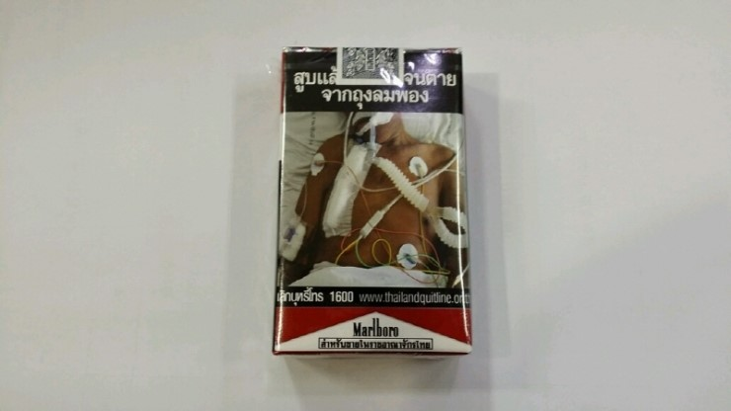

Oh my god ! , I think I should stop ( to smoke , smoking )

If it stops ( to rain , raining ) , we will go outside.

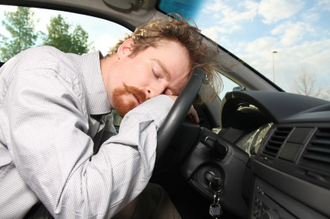

You look really tired. I think you should stop ( to drive , driving )
( to take a nap , taking a nap )

You better stop ( to eat , eating ) chickens before bed. It is not good for your health.

I was born ( to love , loving ) you

