Bingo worksheet

Matching worksheet
Match pictures to words.
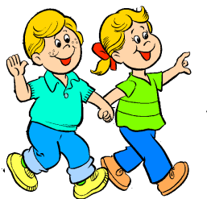
1. o o Fishing

2. o o Singing

3. o o Walking

4.
o o Shopping

5.
o o Eating
6.
o o Swimming
Fill in the blanks
Change the words in the parentheses to gerund forms.
1. Michelle enjoys to the music. (listen)
2. is good for you. (read)
3. My favorite hobby is . (walk)
4. She is interested in a doctor. (become)
5. Mary keeps about her problems. (talk)
6. gifts on Christmas Day is a common practice of our family. (exchange)
7. Mathew is really good at . (cook)
8. I’m sick of hamburgers every day. (eat)
9. She enjoys . (paint)
10. John tried his on pizza at Pizza Cap. (make)
11. Rachel had fun jewelries. (make)
12. a novel must be really difficult. (write)

