☐ Listening ☐ Speaking Reading ☐ Grammar ☐ Writing

Topic : Try reading article and menu in English.

Instructor:  Choi Sung Sik | Level:  Elementary | Students:  4 | Length:  40 Minutes

Materials:

- White board, markers
- Worksheets

Objectives:

- Students will know how to read English Menu.
- Students will know how to read English Article.
- Students will practice reading English with their friends.
- Students will be able to read and answer the question about what they read.
- Students will improve their reading skills by working on a worksheets.
- Students will work cooperatively in a group so that they can learn English with fun.

Language Skills:

- Reading : Reading the article and menu.
- Listening : Teacher’s examples and explanation about the materials.
- Speaking : Asking and answering the questions with their friends and with teacher.
- Writing : Writing the answers on a worksheets.

Language Systems:

Lexis : vocabulary used in worksheets.
Phonology : Practicing pronunciation of new words.
Function : Explaining their individual ideas about the question in the worksheet.
Discourse : Sharing ideas about article and menu.

Assumptions:

- Students already know how to read basic English sentence.
- Students already know what Comprehension Question is.
- Students already know each other so that they can work together with fun.

Possible Problems and Solutions:

- Some students may have difficulty in reading English articles

→ Explain the new words and read the article together.

- Some students may take longer than expected to complete the worksheets.

→ Let their partner to help each other.

- Some students may finish the main article earlier than expected.

→ Let him/her read the article again until other students finish their worksheet.

References:

http://www.pictame.com/tag/%EC%98%81%EC%96%B4%EB%A9%94%EB%89%B4%ED%8C%90

Pre-Task
Materials: White board, markers and eraser.

Time | Set Up | Procedure
2 minutes  2 minutes | Whole Class  Whole class | GREETING  Good morning, everyone!  How are you?  Did you have great weekend?  Did anyone did something special?  ....  ( talk with students )  ....  Today, we will read some English materials.  INTRODUCTION  .Have you guys ever read menu in English?  Tell me about your story.  Where was it?  How was it?  Was it delicious?  Was it hard to understand menu in English?  ....  ( talk with students )  ....

Task Preparation
Materials: White board, markers, worksheets

Time | Set Up | Teacher Talk
10 minutes  7 minutes | Whole Class  Group(pairs) | Instruction  (hand out the worksheet#1)  First, we will read the articles that you can see right in front of you guys. Try to understand the menu. After reading, I’ll ask some questions about the menu and also you guys will ask each other too.  You’ll have 8 minutes to read your menu.  You can start reading now.  GROUP ACTIVITY  Now here is a mission.  You guys are in the restaurant with your partner who can not read English so you have to recommend the menu to your partner by reading the menu by yourself.  If you guys have any difficulty doing this please tell teacher for help.  I will give you 5 minutes to have a conversation.  CCQs  - Should you guys talk with your partner?  - Are you guys have 8 minutes to talk?  - Do you have to write something when doing group work?  - If you need help what would you do?

Task Realization
Materials: White board, markers, worksheets

Time | Set Up | Teacher Talk
7 minutes  10 minutes | Whole  Whole Class | Instruction  OK good job.  I have something to ask to all of you guys.  Have you ever read article in English?  Oh great.  Then let's have a time to read English article.  It is not that hard to read so don't worry about it.  Even it is a little bit hard for some students,  Just try to read sentence by sentence.  You guys have 5 minutes to read from now on.  CCQs:  - How much time do you have to read article?  - If some of you guys are not familiar with English article then those students can read other things.. right?  GROUP ACTIVITY.  All right.  We will start activity with the article that you guys just read.  First of all, you guys have learned the Comprehension question right?  Comprehension question is like Literal, Interpretive, Applied questions.  (write down on the board)  OK now, make one LITERAL, one INTERPRETIVE, one APPLIED question and share with your partner.  Anyone who were absent from class yesterday may ask teacher to explain what Comprehension question is.  I will give you guys 8 minutes to work together and ask teacher if anyone has some problem making the questions.  ( Look around and see if someone made wrong question and give FEEDBACK to students)

Post - Task
Materials: White board, markers, worksheets

Time | Set Up | Procedure
2 minutes | Whole Class | Feedback  All of you guys did great job than I expected.  ( Pick the best Comprehension Question among the students and show that question to the all students and PRAISE him/her )  Have a good lunch !

SOS Activity
Materials: Worksheet
Time | Set Up | Procedure
2 minutes | Whole Class | Here is a mission.  Suppose, your partner is saying "The coffee is too bitter I like sweet drinks".  Now, your partner is going to order new menu.  Tell me about your ideas what to recommend among the menu ( WORKSHEET ) you have.  I will give a candy to student whom volunteer to this mission.  Oh thanks ! Stand up and tell me about it.  ( Give him / her a candy)

Worksheet

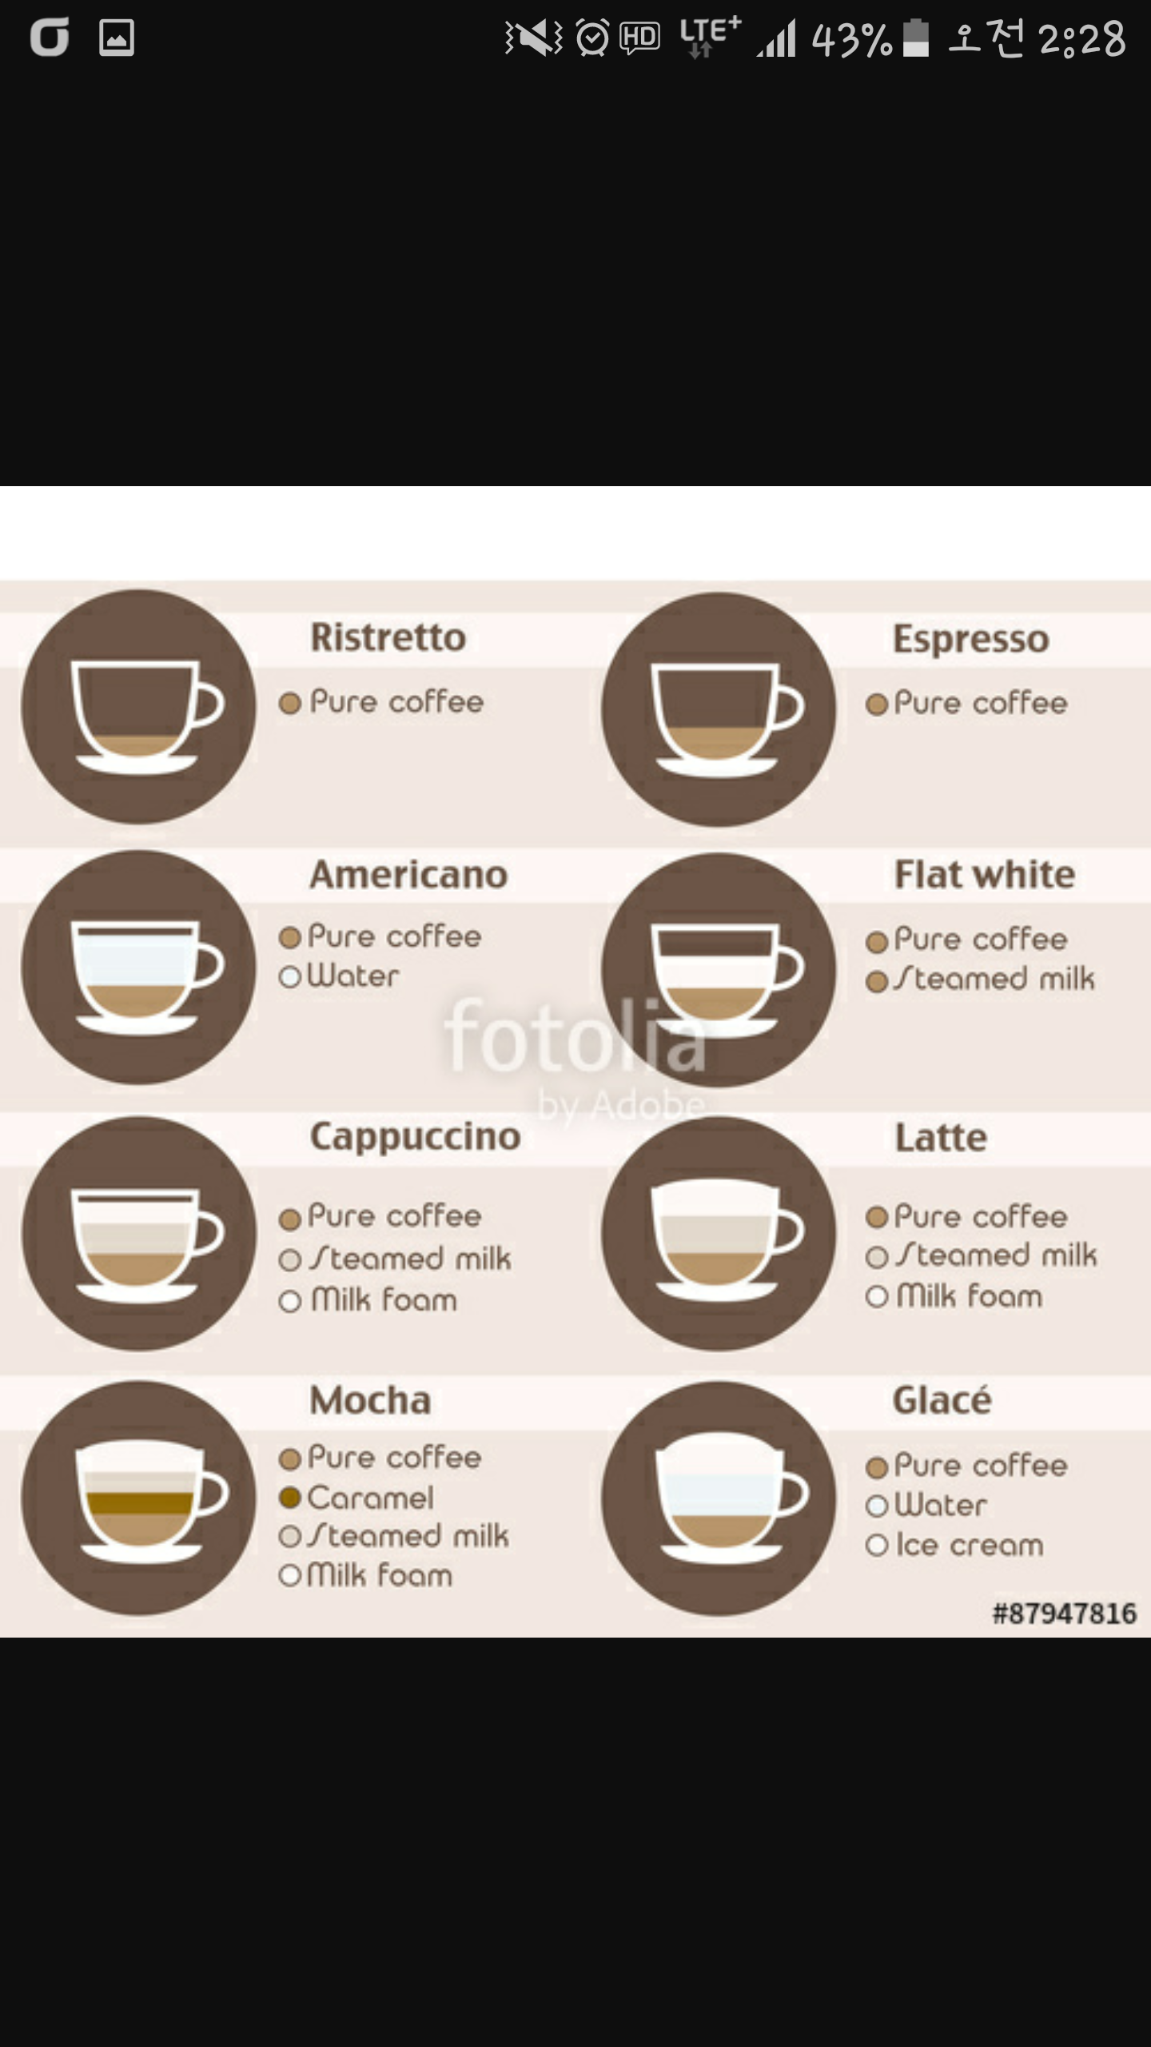

Worksheet

