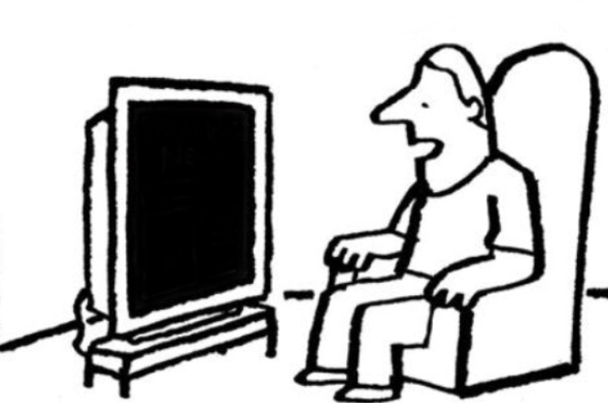
The Color TV
Jim is looking out his window. He sees two men in his neighbor’s driveway. The men are carrying a big color TV. They are carrying the TV to a truck. Jim opens his window.
“Hey!” he says to the two men, “Are you TV repairmen?”
“Yes,” the men answer.
“Are you going to fix that TV?” Jim asks.
“Yes,” the men answer again.
“My TV is broken,” Jim tells the men.
“Can you take my TV, too?”
“Sure,” the men say. “We can take your TV.”
Jim gives the men his color TV. The men put the two TVs in the truck and drive away. Jim never sees his TV again. The two men aren’t TV repairmen. They are robbers.

Worksheet #1
REMEMBERING DETAILS
Which sentence is correct? Circle a or b.
- a. Jim sees two cars in his neighbor’s driveway.
b. Jim sees two men in his neighbor’s driveway.
- a. The men are carrying a big table.
b. The men are carrying a big color TV.
3. a. Jim asks the men, “Are you going to fix that TV?”
b. Jim asks the men, “Are you going to watch that TV?”
4. a. Jim tells the men, “My TV is broken.”
b. Jim tells the men, “My TV is old.”
5. a. The men put the TVs on the truck and pay Jim $25.
b. The men put the TVs on the truck and drive away.

Worksheet #2
REVIEWING THE STORY
Write the correct word on the line.

Jim sees two men in his neighbor’s driveway. The men are _______________ a big color TV. Jim thinks the men are TV _______________. He gives them his ___________________. Jim never sees his TV again because the men are ____________.

Worksheet #3
DISCUSSION
When robbers go into a house, what do they take? Money? Jewelry? Brainstorm with your partner. Make a list of what you think robbers take below this.

-
-
-
-
-
-
-

Worksheet #4
WRITING
Choose one picture to write about. People in the picture are the robbers! Write three sentences about that person.
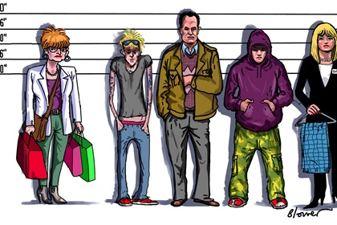
1.
2.
3.

Worksheet #5
MATCHING
Match the words and the pictures. Write your answer on the line.
neighbor driveway carry
fix repairman robber

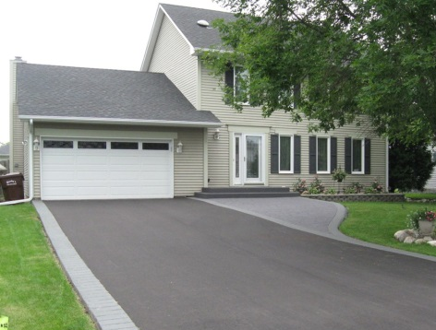
1. 2.
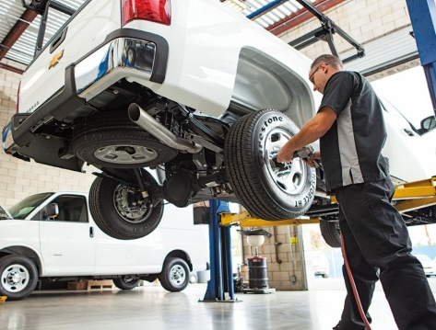

3. 4.
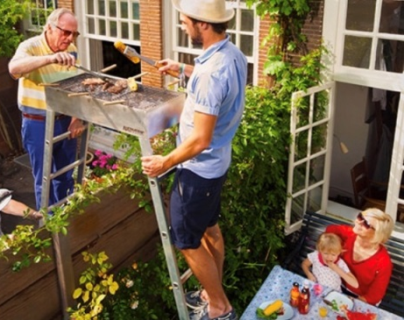

5. 6.

