- Match the words in bold to their synonyms.
- Wade through a) tricky
- Treacherous b) avoid
- Cunning c) to walk with effort through a substance, such as water
- Evade d) designed
- Fashioned e) allow
- Enable f) smart

Worksheet#1
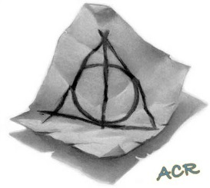
Read the text.
The Tale of the Three Brothers
There were once three brothers who were traveling along a lonely, winding road at twilight. In time, the brothers reached a river too deep to wade through and too dangerous to swim across. However these brothers were learned in the magical arts, the three brothers simply waved their wands and made a bridge appear across the treacherous water. They were halfway across it when they found their path blocked by a hooded figure. It was Death and he felt cheated.
Cheated because travelers would normally drown in the river, but Death was cunning. He pretended to congratulate the three brothers on their magic and said that each had earned a prize for having been clever enough to evade him.
The oldest brother, who was a combative man, asked for a wand more powerful than any in existence: a wand that must always win duels for its owner, a wand worthy of a wizard who had conquered Death! So Death crossed to an elder tree on the banks of the river, fashioned a wand from a branch that hung there, and gave it to the oldest brother.
The second brother, who was an arrogant man, decided that he wanted to humiliate Death even further, and asked for the power to recall loved ones from the grave. So Death picked up a stone from the riverbank and gave it to the second brother, and told him that the stone would have the power to bring back the dead.
Finally Death turned to the third brother. A humble man, and also the wisest of the brothers, and he did not trust Death. So he asked for something that would enable him to go forth from that place without being followed by Death. And Death, most unwillingly, handed over his own Cloak of invisibility.
Then Death stood aside and allowed the three brothers to continue on their way and they did so, talking with wonder of the adventure they had had, and admiring Death’s gift.
In due course the brothers separated, each for his own destination.
J.K. Rowling The Tales of the Three Brothers
What do you think will happen next? Where will they go? Who will they meet? How will they use their magical prizes? Write your story (90-100 words).

http://busyteacher.org/23941-the-tale-of-the-three-brothers-jk-rowling.html

