Group A

It was a cold,
dark night

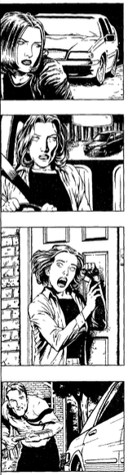
It was a cold dark evening in November. It was six o’clock and people were going home from work. Vanessa was driving out of the town. She was in a hurry, but she wasn’t going home. She stopped to buy a bottle of wine, and then got back in the car and continued driving.

Where was she going?
She was driving to her friend’s house to have dinner. Her friend’s name was Martin. He was a farmer and he lived in the country.
Vanessa was listening to the radio. She began to relax after a hard day at work. She was driving past some trees when suddenly she hit something in the road. She stopped and got out of the car.

What did she see?

Why was the van following her?
Vanessa was sure that the driver of the car was following her because the dead dog was his, and he was angry. Now he was flashing his lights.

What did Vanessa hear on the radio?

Who did Vanessa think of the man in the car? And What did she do?
Vanessa felt very afraid. Now she was sure that the man in the car was murderer! She drove faster. Martin’s farm was very near now but the black car was right behind her! At last she arrived at Martin’s farm. She got out of the car and ran up to the door. She rang the doorbell. “Martin! Help! Help!” she shouted.

What did Martin do when he heard Vanessa’s shouting?

Who do you think the man was?
“That man is the murderer who escaped from prison last night.” Vanessa shouted. “He was going to kill us.” ”No, no!” said the tall man. “I am not the murderer. The murderer is in there, in back of your car!

When did the murderer get into Vanessa’s car?

Group B

It was a cold,
dark night

It was a cold dark evening in November. It was six o’clock and people were going home from work. Vanessa was driving out of the town. She was in a hurry, but she wasn’t going home. She stopped to buy a bottle of wine, and then got back in the car and continued driving.

Where was she going?

What did she see?
There was a dog lying in the road. It was dead. Vanessa moved the dog to the side of the road and then continued her journey. Suddenly she saw in the mirror that there was a black car behind her. When she turned right the car turned right and when she turned left the car turned left too. It was following her!

Why was the van following her?

What did Vanessa hear on the radio?
Vanessa drove faster but the car drove faster too. Suddenly the seven o’ clock news started on the radio. It said: ‘The police are looking for a murderer who escaped from prison last night. Be careful! He is very dangerous.’

Who did Vanessa think of the man in the car? And What did she do?

What did Martin do when he heard Vanessa’s shouting?
Martin was in the kitchen making the dinner when the doorbell rang. He heard Vanessa shouting, so he ran to get his shotgun. He opened the door. At the moment the black car stopped next to Vanessa’s car. A tall man got out.

Who do you think the man was?

When did the murderer get into Vanessa’s car?
“I was driving behind you.” the tall man said. “and I saw you stop when you hit the dog. There was a man behind a tree. I saw him get in your car. I recognized him from the newspaper. He’s the murderer who escaped from prison last night. That’s why I was following you.” Martin ran to the car with his shotgun. He opened the back door.

